Climate Information and Prediction Services for Fisheries
The case of Tuna Fisheries

Jean-Luc Le Blanc¹ and Francis Marsac²

School of Ocean and Earth Science
Southampton Oceanographic Centre, UK
²HEA-IRD, Montpellier, France

Introduction

“More Fish for Canada’s Future!” said Canadian Minister of Fisheries and Oceans, David Anderson, when signing the Pacific Salmon Treaty with the United States in 1999. Let’s try to have more fish for the world’s future, or at least not less! This is the challenge that we have to take up.

The motivations are mainly:
- the increasing trend of total fishery catches (figure 1);

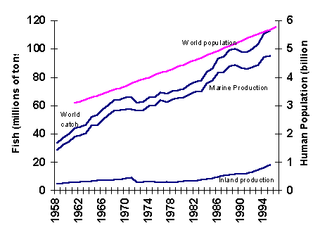Figure 1. (source FAO, 1996)

- the growing population, particularly in coastal areas where most of the big cities are located (figure 2).

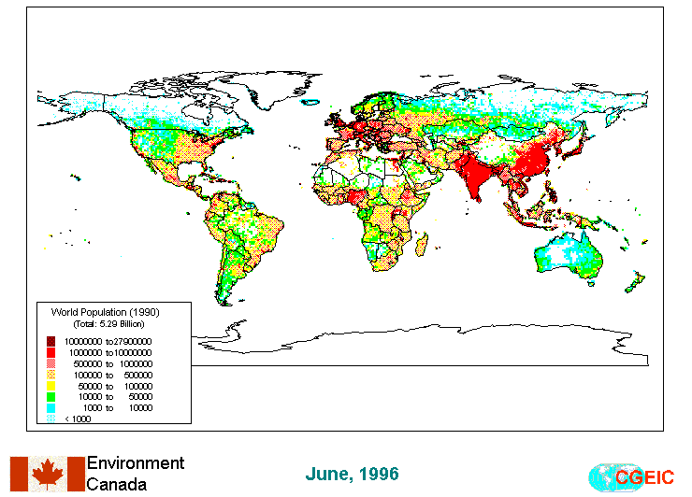

Figure 2. Global Population for 1990.
Without becoming over-pessimistic, there are two ways to face the problem:
- by going back to times when the coasts where inhabited by only small communities of people who used traditional techniques and fished for their own consumption;
- by adapting to natural or human-induced changes through forecasting and prediction.

It is understood that the first approach is impossible to apply while the second relies upon international and inter-disciplinary collaboration and shared information between scientists and users: the purpose of this paper.

In the first part of this paper, several case studies concerning tuna fisheries are presented as a basis for discussion.

  - Why tunas?

Tuna catches throughout the world have been constantly increasing since the beginning of the 1950’s (figure 3).

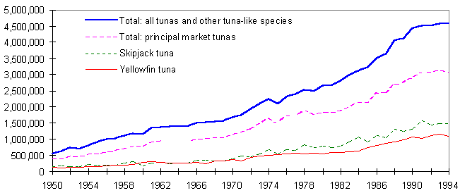
Figure 3. (source FAO, 1997)

Inter-tropical tunas - which are the subject of the studies presented in this paper – reached a level of 2,8 million tons in 1993 (Fonteneau, 1997). The tunas (Thunnini) include the most economically important species referred to as principal market tuna species because of their international trade for canning and Sashimi (raw fish is regarded as a delicacy in Japan and recently, in some other countries) (Majkowski, 1997; Doumenge, 1998). Tunas are highly migratory pelagic (open sea) species and are distributed, albeit irregularly, throughout the world ocean, between 50°S and 50°N latitude; they constitute a very valuable subject for scientific study, because of their ecological, economic and social importance. (Fonteneau, 1997).

It is not within the scope of this paper to describe in detail the physiology of the different types of tunas. Generally, the principal market tuna species are highly resistant to exploitation due to very high fecundity, wide geographical distributions and adaptation for opportunistic behavior. The dynamics of tuna populations make them highly productive. With proper management, they are capable of sustaining very high yields relative to their biomass (Majkowski, 1997). However, the species most desired for the Sashimi market (Bluefin, Bigeye, Billfish) are heavily exploited, some being over-exploited or even depleted. The status of other tuna and tuna-like species is highly uncertain or simply unknown. Therefore, the intensification of their exploitation raises a concern.

  - Fisheries Conservation and Management

Some States whose vessels fish tuna and tuna-like species cooperate regarding conservation and fisheries management within the framework of the Commission for the Conservation of Southern Bluefin Tuna (CCSBT), the Inter-American Tropical Tuna Commission (IATTC) in the eastern Pacific, the International Commission for the Conservation of Atlantic Tunas (ICCAT) and the Indian Ocean Tuna Commission (IOTC). Industrial tuna fleets are highly mobile and the principal tuna market species are intensively traded on the global scale. Also, tuna research, conservation and management problems are similar in all oceans. Therefore, there is a need for exchange of information and collaboration on the global scale regarding tuna fisheries, which can be achieved within the legal framework of the United Nations Convention on the Law Of the Sea (UNCLOS) adopted in 1982.

  - The Agreement on High Seas Fishing

In the decade following the adoption of UNCLOS, fishing on high seas became a major problem. The Convention gave all States the freedom to fish without regulations on high seas. Coastal States complained that fleets fishing on high seas were reducing catches in their domestic waters. The problem centered on fish populations that "straddle" the boundaries of countries' 200 mile exclusive economic zones (EEZ) such as cod, pollack, tuna and swordfish which move between EEZ and the high seas. At the Earth Summit - the UN Conference on Environment and Development, held in Rio de Janeiro in June 1992 - Governments called on the United Nations to find ways to conserve fish stocks and prevent international conflicts over fishing on high seas. The UN Conference on Straddling and Highly Migratory Fish Stocks held its first meeting in July 1993 and a legally binding Agreement was opened for signing on 4 December 1995. The 50-article Agreement legally binds countries to conserve and manage fish stocks in a sustainable way and to settle peacefully any disputes that arise over fishing on the high seas. Specifically, the treaty:
- establishes the basis for the sustainable management and conservation of the world's fisheries;
- addresses the problem of inadequate data on fish stocks;
- provides for the establishment of quotas;
- calls for the setting up of regional fishing organizations where none exist;
- tackles problems caused by the persistence of unauthorized fishing;
- sets out procedures for ensuring compliance with its provisions, including the right to board and inspect vessels belonging to other States;
- prescribes options for the compulsory and binding peaceful settlements of disputes between States.

Thus, tuna fisheries constitute a scientific, economic, social and political framework depending greatly on climate. However, this factor is often not taken into account. In the past, the influence of climate on fisheries was considered as "noise" and therefore neglected but since climatic data and knowledge are more available, fisheries biologists can take climatic effects into account.

The case of Indian Ocean tuna fisheries was chosen to show relationships between climate and fisheries. Data - and its processing - necessary for such studies will be described and the discussion will be extended to the Atlantic Ocean. Finally, requirements for future progress in fisheries research and enhanced integration of climatic services in fisheries management will be proposed.

- TUNA-ENVIRONMENT RELATIONSHIPS: El Niño and Yellofin tuna in the Indian Ocean

The case study presented here concerns the tuna fisheries within the Indian Ocean. However, similar examples can be found in the Atlantic and Pacific Oceans and could be generalized to other fisheries with suitable interpretation. Only main results are stated here; the readers are invited to look at references for full details.

2.1. Interannual climatic conditions in the Indian Ocean related to ENSO.

The El Niño-Southern Oscillation (ENSO) phenomenon has effects in the Indian Ocean which influence tuna fisheries either directly through "catchability" (the ability to catch fish) or indirectly by affecting the fish stocks. Two fisheries techniques are predominant in the Indian Ocean: purse seine and longline. Modern purse seines have an average vertical drop of 200 meters, while longlines can be set at depth as deep as 400 meters. Therefore, "catchability" depends on the upper-layer depth and differs according to the fishing gear that is used.

The Indian Ocean surface waters are monsoon driven. The strong monsoon winds induce currents which are favorable to fisheries (figure 4a), such as the Somali coastal upwelling during the Southwest monsoon (summer) (region 1, figure 4b), strong convergent patterns northwest of Madagascar (region 3, figure 4b) as well as divergent waters between the westward south-equatorial current and the eastward Wyrtki Jets flowing at the equator during the inter-monsoon periods (April and October) (region 2, figure 4b).

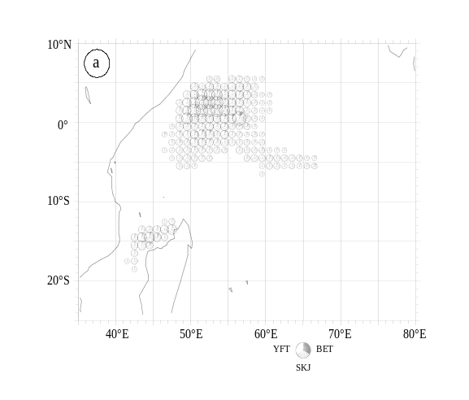Figure 4a. Geographical distribution of logs catches in the purse seine fishery : average 1984-1994. The reference circle stands for 2000 metric tons.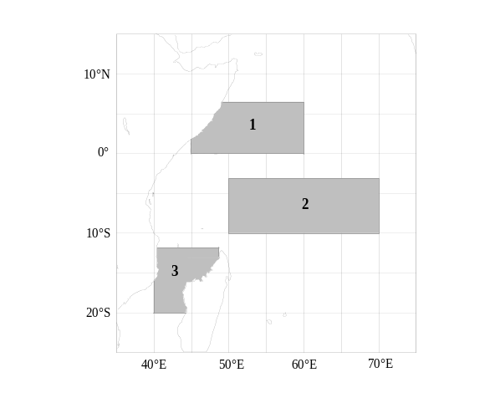Figure 4b. Tuna fisheries regions in the Indian Ocean (source Marsac & Le Blanc, 1997).

During El Niño, monsoon conditions are altered particularly at the equator. Strong easterlies due to high pressure over Indonesia replace the complex equatorial monsoon winds, inducing coastal and equatorial upwelling. Sea Surface Temperature (SST) rises (figure 5) and the thermocline deepens from east to west (figure 6 and 7).

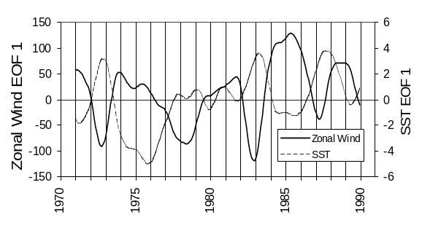Figure 5. Time series (12 months-Hanning filtered) of first EOF of SST and zonal wind (minus=easterlies) in the 5°N-5°S/50°E-90°E region.
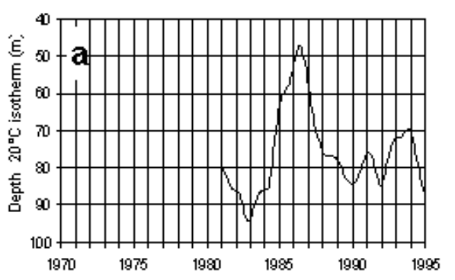Figure 6. Time series (12 months-Hanning filtered) depth of isotherm 20°C in meters for the region between 3°S-10°S/50°E-70°E (region 2 of figure 4b).
El Niño years are 1972, 76, 82/83; La Niña are 1974, 85/86 (source Marsac & Le Blanc, 1997).

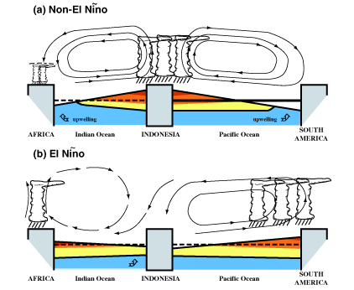
Figure 7. Schematic diagram of the large scale differences along the equator between (a) normal periods and (b) El Nino. (source Webster et al.,1998)
2..2. Effects on Tuna Fisheries

- Effects on catchability

Since tuna more or less follow the thermocline, catchability is increased in shallow upper layers. Ekman pumping, i.e. vertical currents, associated to movements of the thermocline, therefore influence the fishing conditions: upward (downward) motion or upwelling (downwelling) is favourable (unfavourable) to the purse seine technique using big nets at the surface of the ocean (figure 8).

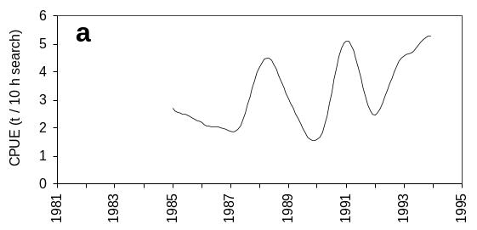
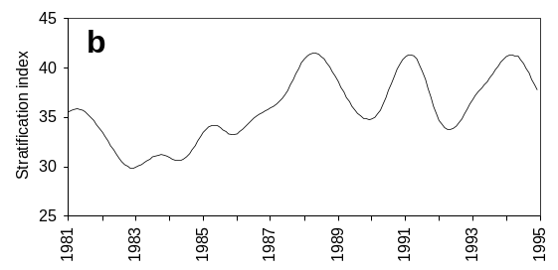
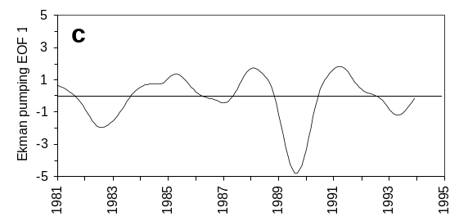
Figure 8. (a) Catch Per Unit Effort index of adult yellowfin (age 3+), (b) stratification index, and (c) Ekman pumping first EOF in the region 2 of figure 4b (3°S-10°S/50°E-70°E). (source Marsac & Le Blanc, 1997)

The large-scale effects of such interannual variations on tuna fisheries are shifts of catches. The 1997/98 El Niño consitutes a good example of such a shift: usually fishermen do not travel east of 70°E and load there fish the Seychelles or Madagascar. In 1997/98, because of a tilt of the thermocline (figure 7), no fish were caught in the western Indian Ocean and fishermen went as far as the Indonesian coast and landed their catches in Thailand (figure 9).

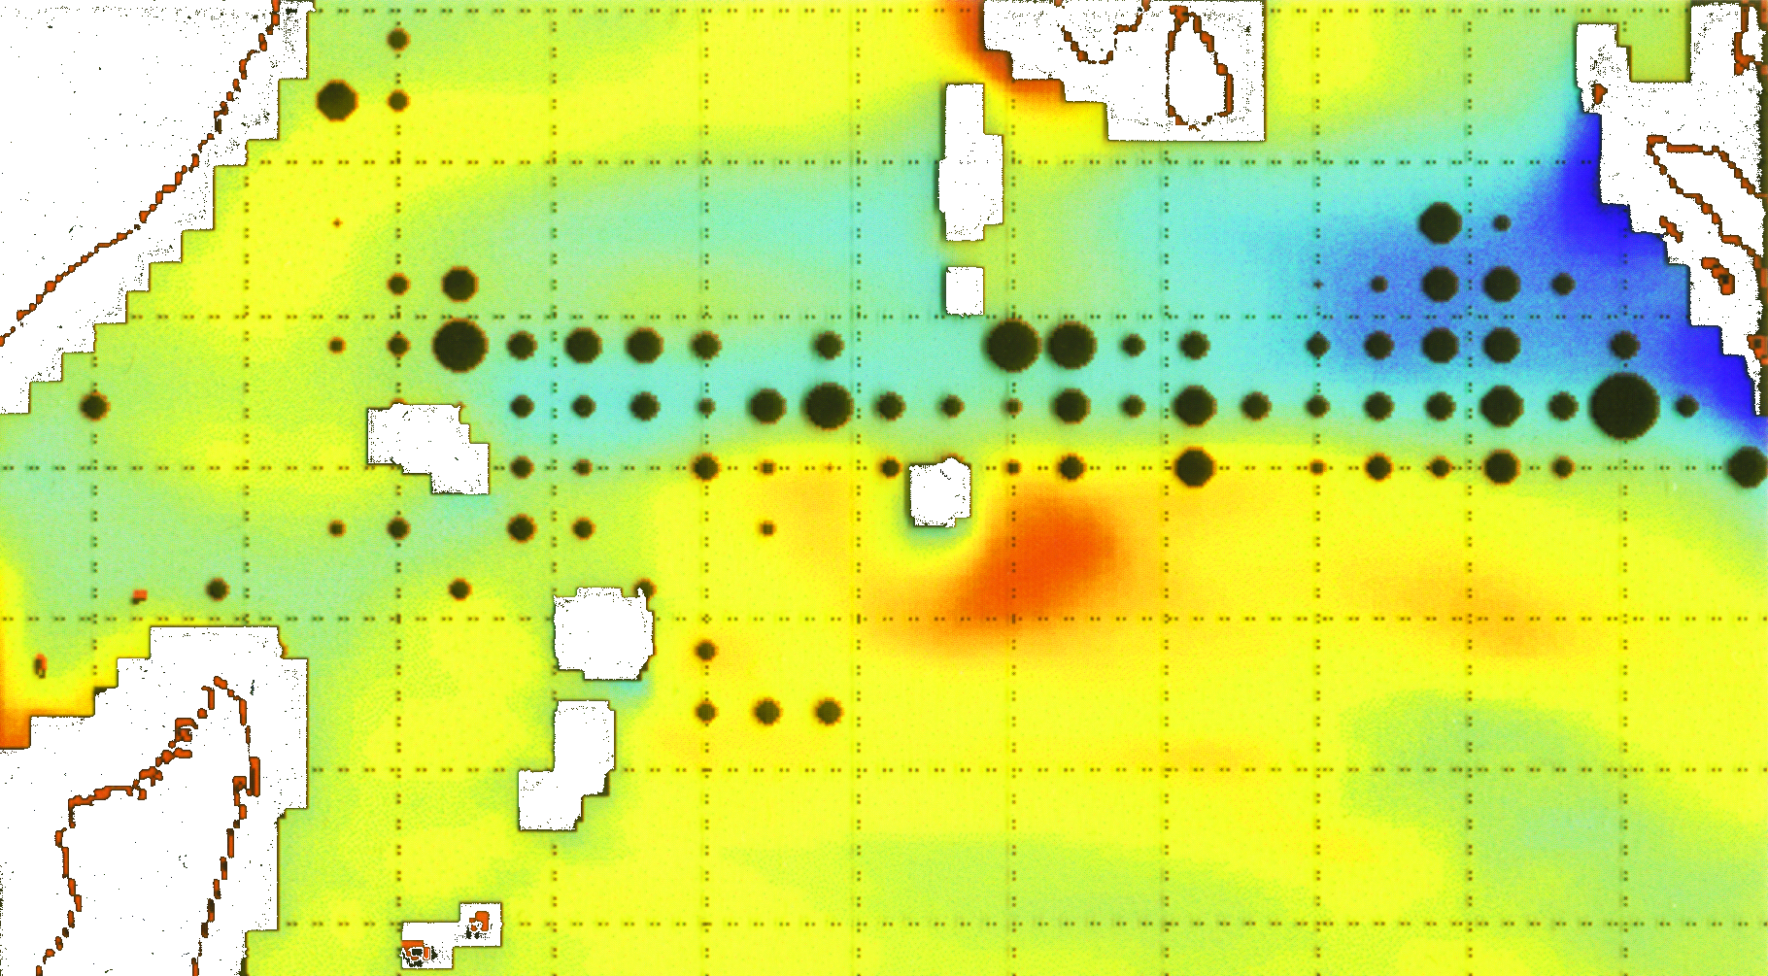

Figure 9. January 1998 tuna catches and sea level in the tropical Indian Ocean - upper-layer depth (blue = shallow, red = deep) from shallow-water numerical model forced by FSU winds. (source: personnal).

- Effect on recruitment

The term recruitment refers to the quantity of younger fish surviving the various egg, larval, and juvenile stages, to begin to be captured in a fishery and be commercially interesting. Like most fish, tuna experience a critical larval phase that is controlled by different bio-physical processes such as enrichment, concentration and retention (Bakun, 1995). Enrichment is the result of upwelling and/or mixing that brings nutrients in the surface layer and consequently boosts the primary and secondary production (phytoplankton and zooplankton). Then, production needs to be concentrated to be fully available to higher trophic levels (larvae feeding upon zooplankton). Finally, the batches of larvae and their preys should not be scattered by strong currents but would benefit from small scale gyring circulation which maintain them in the appropriate habitat, namely the retention area.

Turbulent mixing within the water-column (considered as being proportional to the third power of the wind speed near the sea surface ) is an important factor charcterizing enrichment, concentration and retention. A too weak turbulence will enhance the spatial integrity of the larvae batches but enrichment will be the limiting factor. Conversely, strong turbulence will generate a significant enrichment but the larvae will be dispersed and their habitat destroyed. (Cury and Roy, 1989; Marsac and Le Blanc, 1998). Strong (weak) turbulence is correlated with low (high) SST.

Turbulence in the Indian Ocean is shown on figure 10. It is strongest in the Somali basin and weakest along the equator and in the Mozambique channel. The time series shows a positive trend since the mid 70s (associated with a positive trend in the wind speed) with two collapses in 1992 and 1996.

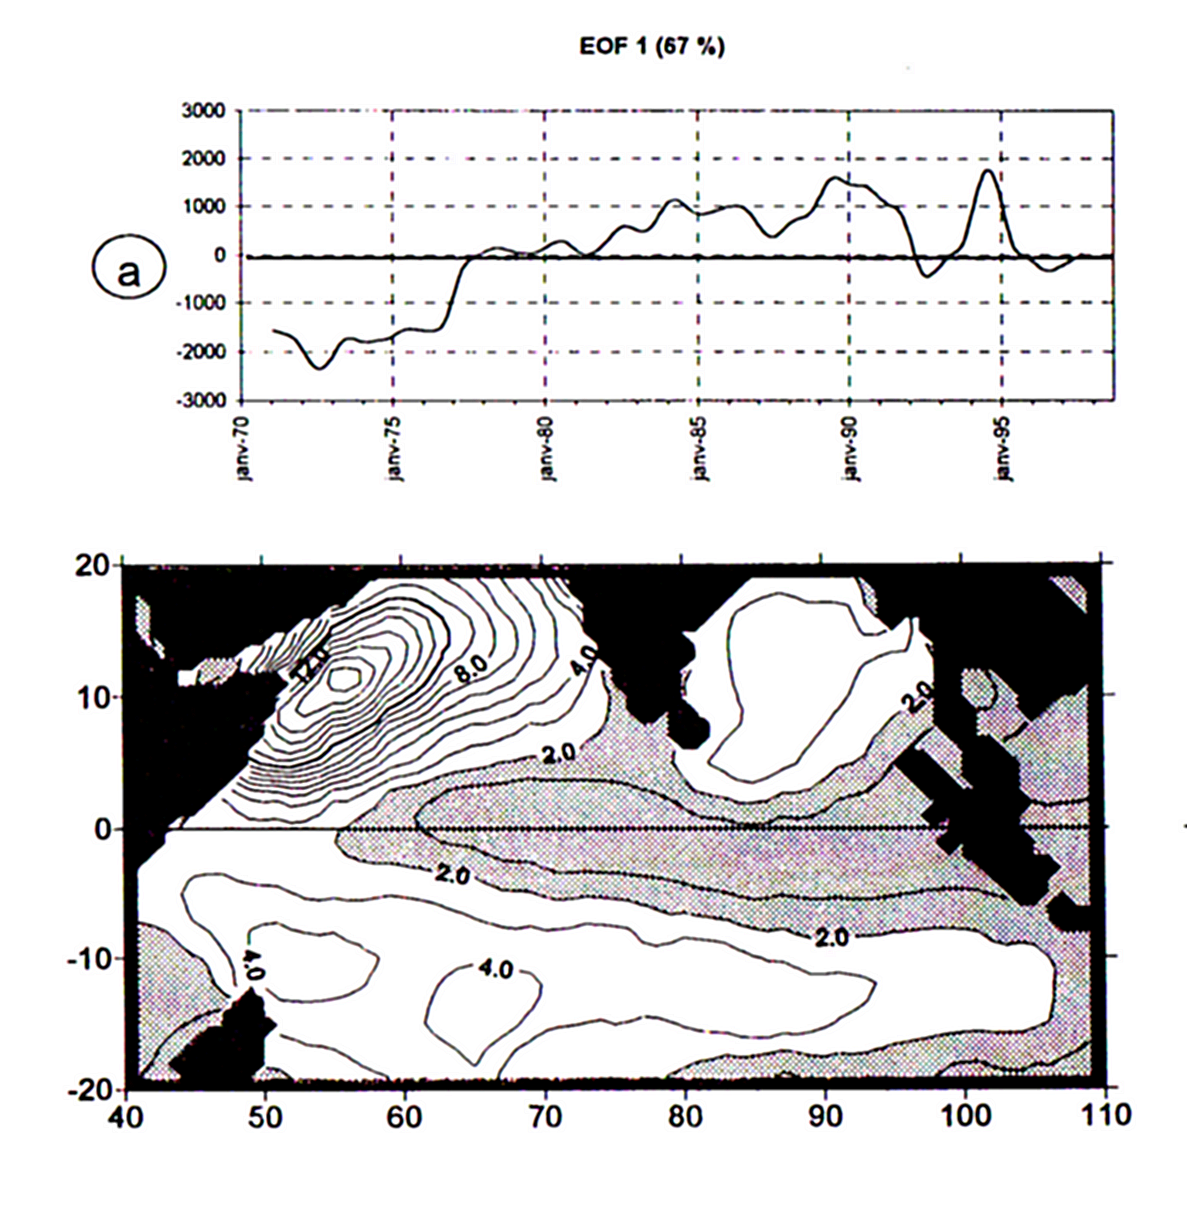
Figure 10. 1st EOF analyses of the turbulence (wind speed cube) in the Indian Ocean. Time series coefficients (a) and spatial pattern of the variability (b). The time series is filtered on 12 months using a low pass cosine filter. (Marsac and Le Blanc, 1998).

Tuna have adapted their reproductive strategy to the environmental conditions: the spawning period appears to be well in phase with high SST and low turbulence (figure 10); the spawning grounds are located within the wind convergence area, where the wind, and consequently turbulence are weakest (figure 11).

- Time and space scales

Thus, effects of climate on fisheries have many different time and space scales ranging from small events such as storms, seasonal regimes such as the monsoon, interannual phenomenon such as ENSO, to decadal and longer variations. Each have specific effects on fisheries at all levels: from migration behavior and reproduction success to catchability and fisheries success. Figure 12 is a schematic diagram summarizing these links between climate and fisheries as a function of time and space scales.

Such links are called functional relationships, i.e. relationships based on biological and physiological response linked to specific environmental changes and not merely on correlations between parameters.

The understanding of functional relationships are very important for the right interpretation and prediction of effects, given specific climate conditions. Inferences drawn from comparisons of habitat climatology with characteristics of migration and timing of life-cycle events can yield important insights into the processes regulationg recruitment that might well be difficult if not impossible, or very expensive, to generate in other ways (WMO, 1994).

Figure 11.

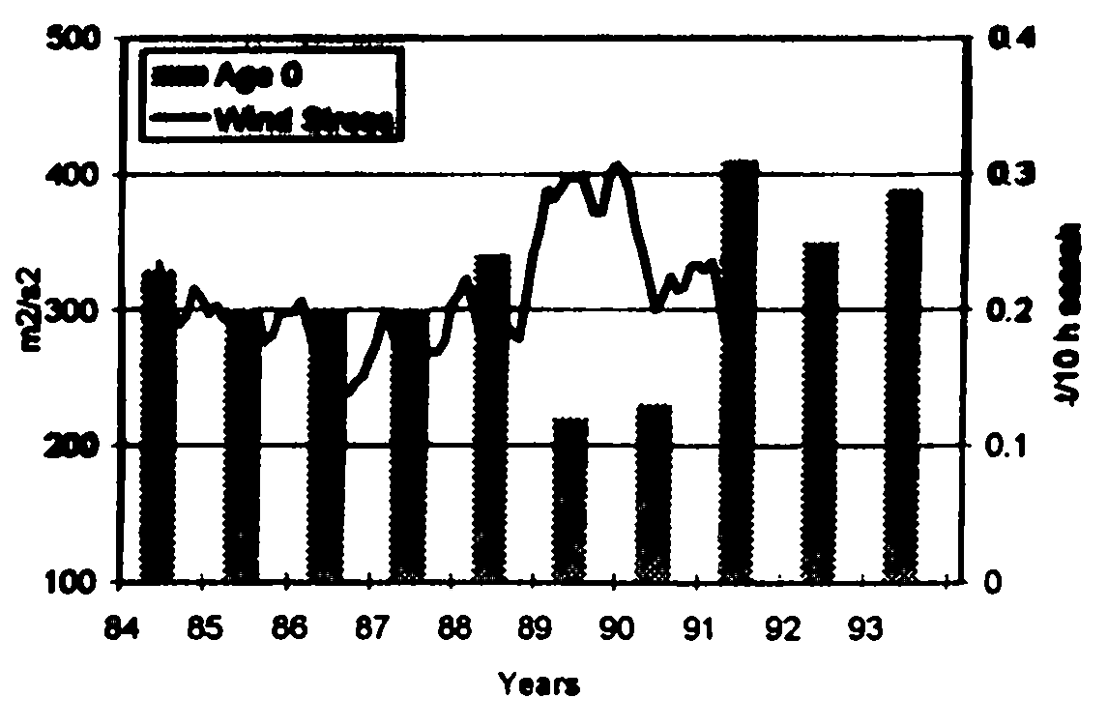
(a) Annual estimates of yellowfin recruits CPUE in the purse seine fishery and wind stress in the area 0°-10°S/50°E-70°E. (source: Marsac).
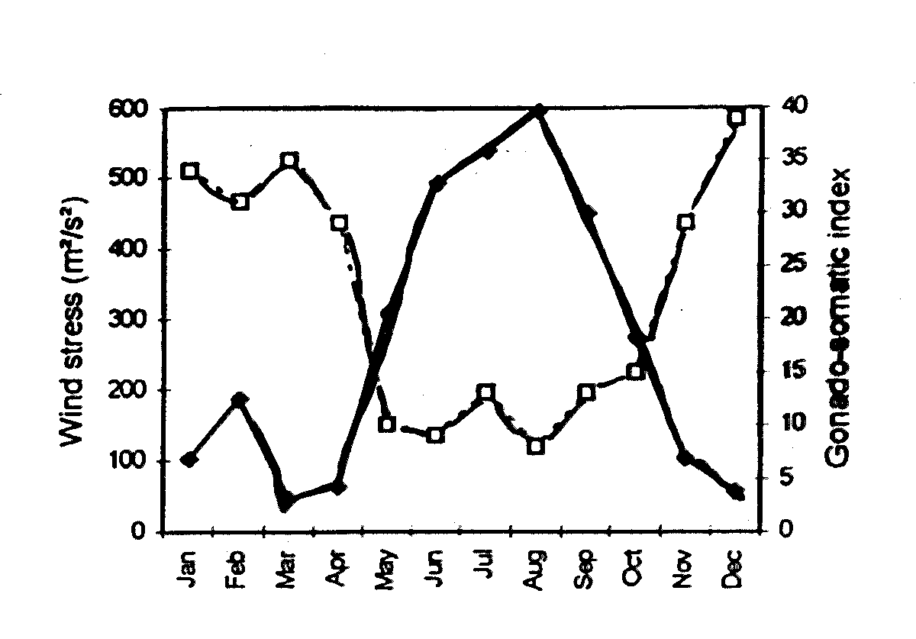
(b) Relationship between the wind-stress (plain) and the spawning activity of yellowfin tuna (dashed) in the area 0°-10°S/50°E-70°E. (source: Marsac).

- DATA AND DATA PROCESSING

Parameters under consideration are:
- Ekman pumping
- Turbulence
- SST
- Depth of the thermocline

3.1. Wind data

Ekman pumping and turbulence are deduced from wind-stress and wind respectively. The different sources of wind data are commonly:
- The Florida State University (FSU) wind stress data set
- The European Community Medium Weather Forecast (ECMWF) wind reanalyses
- The ERS-2 Scatterometer wind data
- The Comprehensive Ocean Atmopshere Data Set (COADS) historical data
- the Servain data set (Servain et al., 1987) for the Atlantic Ocean.

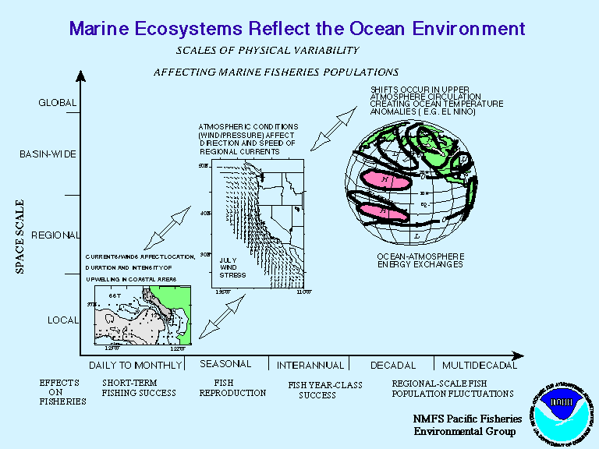

Figure 12. Different Space and Time scales in fish/environment relationships.

The FSU source was used for the Indian Ocean studies; COADS and Servain were used for similar studies in the Atlantic Ocean. These data sets, their processing and their quality will be discussed below.

3.1.1. FSU Wind stress data and Ekman Pumping

- Data set description and limitations

At the Florida State university (FSU), monthly pseudo-stress observations are pooled in 1° latitude by 1° longitude bins from raw ship wind data. Follows a statistical outlier procedure to remove extreme data, then the grid is filled and objectively analyzed by 1° square (Legler et al., 1989; Stricherz et al., 1993). Data are available since 1970 up to present on a monthly basis, for the region 30°S 30°N, 30°E-120°E and are provided in ASCII format.

Observations are from ship reports and are therefore not homogeneously distributed (figure 13) resulting in regions of the Indian Ocean with poor data quality, for instance the south-east region or the Bay of Bengal.

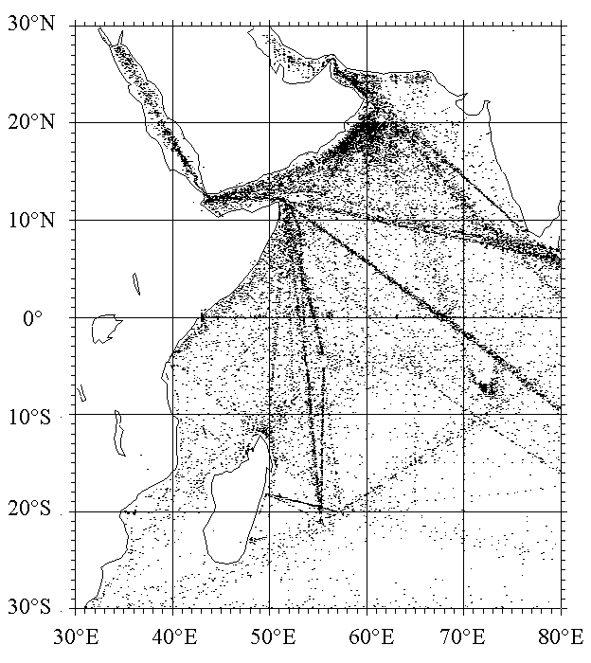
Figure 13. Geographical distribution of XBT casts in the western Indian Ocean from 1980 to 1994.

Heterogeneousness in data distribution is important when the set is used for numerical modeling purpose. Difference in wind-stress may induce different oceanic responses - areas with scarce observations show less standard variations in their response than the shipping routes (Delecluse, personal communication) - and increase incertitude upon the outputs.

- Ekman pumping

Ekman pumping (figure 14) was computed using pseudo-wind stress decomposed into zonal (T_{x}) and meridian (T_{y}) components :

T_{x}=uV, T_{y}=vV ,

with u and v being the zonal and meridian components of the wind, and V the magnitude of the horizontal wind speed (V²=u²+v² and T_{x}²+T_{y}²=V⁴).

The wind stress on the sea surface results from the Smiths (1980) drag coefficient:
C_{d} = (0.61+0.063V)/1000 for V>10m.s⁻¹,
else C_{d}=1.24.10⁻³.

The wind-stress was calculated using the following equations:
τ_{x} = ρ_{a} C_{d} u|V| = ρ_{a} C_{d} T_{x}
τ_{y} = ρ_{a} C_{d} v|V| = ρ_{a} C_{d} T_{y}
τ = ρ_{a} C_{d} V²
where τ_{x} and τ_{y} are the zonal and meridian wind stress respectively, ρ_{a} is the air density which is assumed to be constant: ρ_{a} = 1.25 kg/m³.

The vertical velocity at the bottom of the Ekman layer is computed from the wind stress, with the following momentum balance in the surface Ekman layer:
−ƒV = τ_{x} / ρ (1) (1)
ƒU = τ_{y} / ρ (2)2 (2)
where U, V are respectively the eastward and northward volume transport in the upper layer, ƒ is the Coriolis parameter, and ρ is the sea water density which is assumed to be constant: ρ = 1025 kg/m³. Note that the « upper layer » is considered as being the layer affected by the wind ; it is similar, in theory, to the Ekman layer but does not necessarily equate to the mixed layer.

The continuity equation integrated on the Ekman layer gives:
δU/ δx + δV/ δy = w_{z=depth of the ekman layer} (3)
with w characterising the vertical speed (assumed to be equal to 0 at the sea surface).

Then (1), (2), (3) lead to:
w_{z=del} = [curl(τ)] / ƒρ + βτ_{x} / ƒ²ρ
curl(τ)=δτ_{y} / δx - δτ_{x} / δy
β=δƒ / δy = 2.3.10⁻¹¹ s⁻¹
w_{z} is also called « Ekman pumping ». With the z axis directed upwards, a positive w_{z} is an upward motion (upwelling at the bottom of the Ekman layer and divergence at the sea surface) and a negative w_{z} is a downward motion (downwelling and convergence at the sea surface). Note that this calculation is not possible at the equator where ƒ equals zero.

3.1.2. COADS and data processing

- The data set

When compared with COADS in the period 1970-1990, the FSU scalar wind turns to exhibit the same changes but the estimated intensity is weaker.

COADS wind data were not used for the Indian Ocean study but for a similar study of Bigeye tuna in the Atlantic Ocean (Marsac, 1999). Since data requirements and use for fisheries studies are similar in either ocean, this example is presented for information.

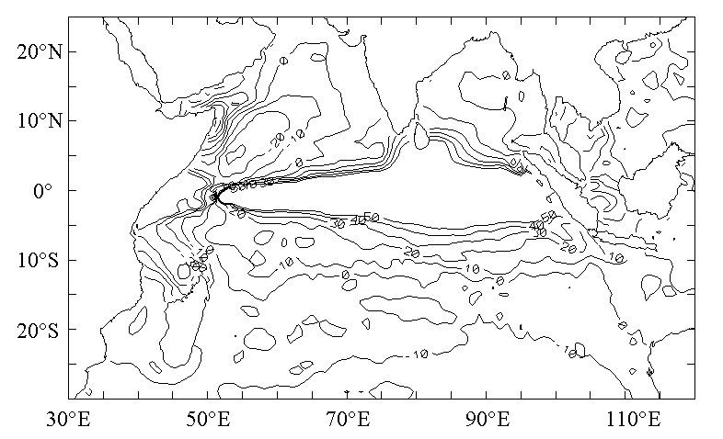
Figure 14. Ekman pumping climatology, computed from FSU wind-stress for the period (1970-1994). Units are in cm.day⁻¹. The patterns within the equatorial band (3°S-3°N) should not be considered.

COADS gather individual observations by ships of opportunity or others. The original release covered the 1864-1990 period, but a wider density of observations are now available for the 1950-1995 period (release 1b). The extracting software CODE (Mendelssohn and Roy, 1996) was used (the release 1b extracting software works only on Macintosh at present).

Even though this data set is exhaustive, one should bare in mind several discrepencies which were already noticed by Roy and Mendelssohn (1998) particularly with concern with the wind. Observations in COADS are either directly measured (from anemometers) or estimated (generally from the state of the sea). It has been shown that measured values were higher than the estimated ones. Further more, the quantity of both types of observations is not equal in time and space. Measured observations tend to be more numerous in recent years. Using both types of observations will ultimately result in a positive trend in the wind time series. Therefore, only estimated observations were used because they are better distributed.

- Data processing

As for FSU data, observations are mainly done by ships of opportunity and are therefore unevenly distributed in space and concentrated along ship routes. Observations within areas relevant to fisheries may be very scarce or nil. For the purpose of the study, data were extracted in 2° (longitude x latitude) per month strata; strata with at least 10 observations were considered and the mean value within each stratum was calculated. Time series were analyzed using:
- Smoothing of extreme values (exponential smoothing taking into account a defined annual cycle)
- Seasonal decomposition with an additive model (Makridakis et al., 1983)
- Spectrum analyses to extract dominant frequencies.

- Results for the tropical Atlantic Ocean

The Empirical Orthogonal Functions for the tropical Atlantic wind are shown in figure 15. It is worth noting the positive trend which is also found in the Indian Ocean (with FSU data) and confirmed by other authors (Ward and Hoskins, 1996) using sea level pressure.

3.1.3. The Servain data set for the Atlantic Ocean

For specific fisheries relevant regions, namely the south-equatorial Atlantic, where COADS observations were too scarce, the Servain data set was used for the period 1969-98. In the north-equatorial Atlantic, both COADS and Servain data sets were used and showed general good agreement and similar trends and cycles. However, COADS winds are stronger than the Servain ones by approximately 1m.s⁻¹.

In conclusion, fish are sensitive to weather, but also to seasonal and interannual variations as well as long term trends in winds. Therefore, the accuracy of the observations and their processing is very important for the interpretation of fish behavior and stock assessment.

3.2. Sea Surface Temperature (SST)

SST data used for the studies presented above are from COADS and, as for the wind-stress, they were monthly averaged in 2° (longitude x latitude) square boxes. Most recent data were downloaded from the COADS web site (http://www.cdc.noaa.gov/coads/).

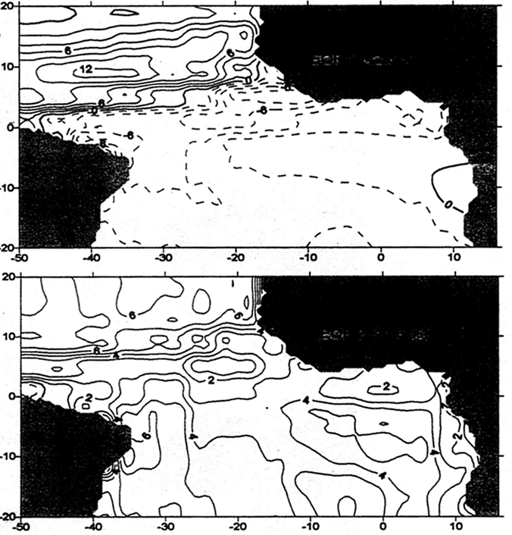
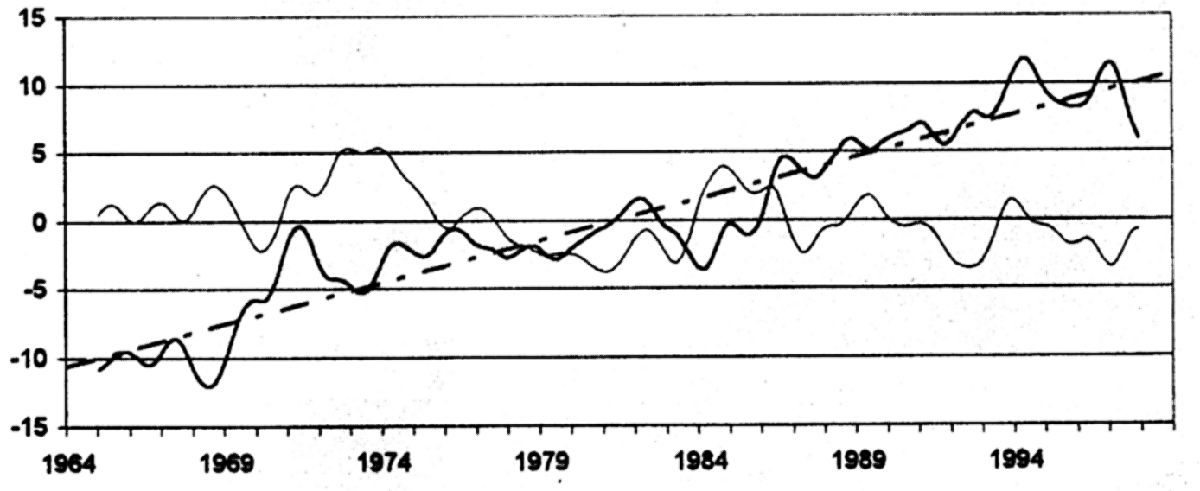
Figure 15. Wind EOF for the tropical Atlantic. top= 1st EOF; middle=2nd EOF; bottom= time series of 1st EOF=normal, and 2nd = sharp. (source Marsac, 1998)

- Empirical Orthogonal Functions (EOF)

As for the wind, Empirical Orthogonal Function (EOF) method was used to analyse the variability of the SST. This method which has been used for a long time by meteorologists (Lorentz, 1956), splits the original field into orthogonal eigenvectors or EOFs. Each EOF is the product of time function and associated space pattern and explains a percentage of the variability of the data. The largest percentage of variance allows identification of the main physical mechanisms in process in the field under study. EOFs can be calculated in several ways (Complex EOF, Rotational EOF, etc.) and their analyses varies depending the method in use. Here we use a simple method which enables easy analysis of the functions. To reconstruct the original field, one has to multiply the time function by the space function. For instance, a negative anomaly in time is a negative anomaly in the function if the space pattern is positive.

- Results for the tropical Atlantic Ocean

SST for the tropical Atlantic Ocean is shown in figure 16. A slight positive trend is also noticeable and SST are anti-correlated with winds, i.e. when the wind is strong (weak), SST is low (high), consistent with the fact that strong winds enhance vertical mixing in the water column and hence, reduce heat content within the upper-layer.

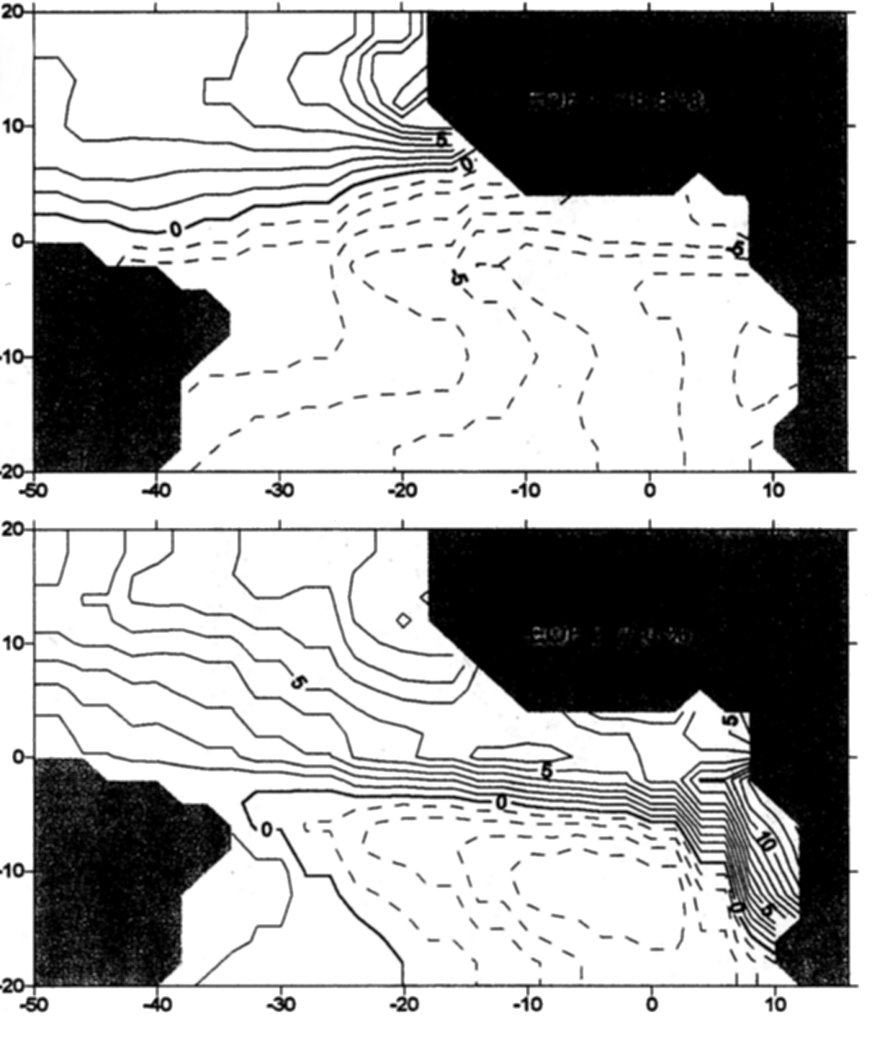
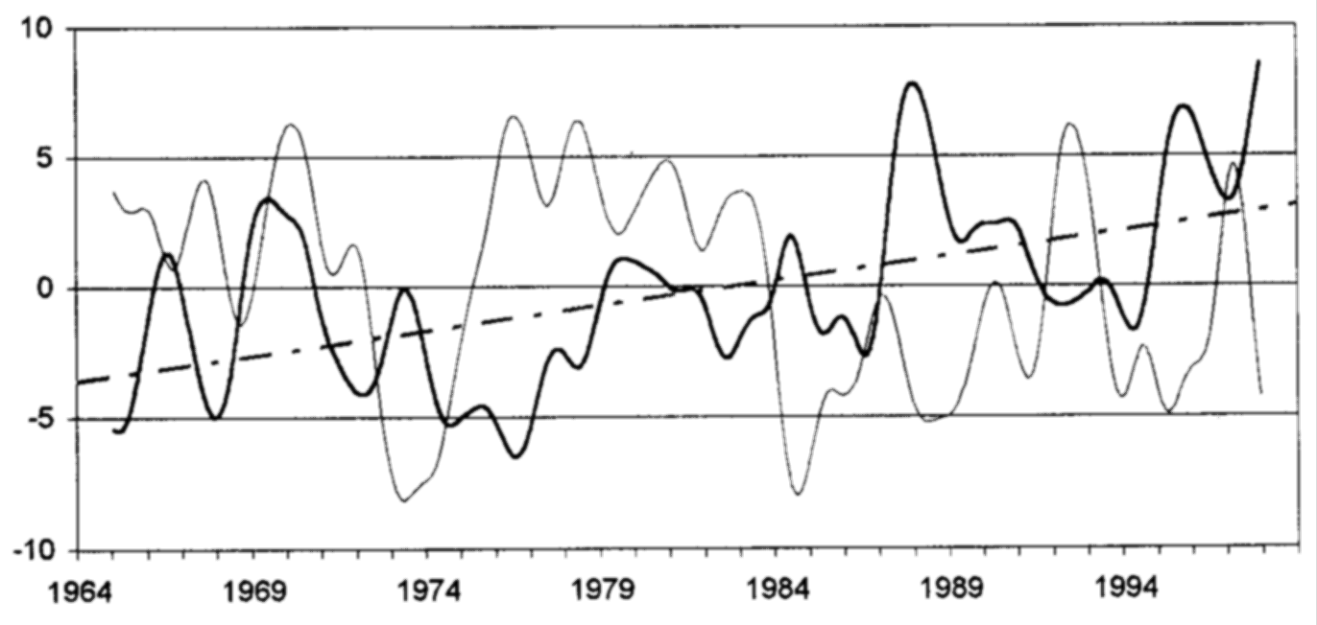

Figure 16. EOF analyses for SST in the tropical Atlantic. Top=1st EOF; Middle=2nd EOF; Bottom=time series of 1st EOF=normal and 2nd = sharp.

3.3. Depth of the Thermocline

The depth of the thermocline can be defined in different ways. Here, it will be assimilated with the depth of the 20°C isotherm. The temperature profiles come from Expandable Bathythermograph (XBT) and CTD (Conductivity, Temperature and Depth) casts (figure 13). The XBT casts were undertaken within the 10 years (1985-1995) TOGA (Tropical Ocean Global Atmosphere) program, involving ships of opportunity. Within the region 2 (figure 4b), the data are supplemented by a monitoring carried out by IRD (Institut de Recherche pour le Developpement - France) with the co-operation of some purse-seiners in the fishing grounds. These data also enable to compute a stratification index (IST; figure 8b) defined a follow:

IST = 100 . (Log ZGT - Log GT) ⁻¹

GT : Maximum gradient in the thermocline (°C/10 m);
ZGT : Depth where GT is found (meters)

This index combines both intensity of the thermal gradient and its depth. In the equatorial area, the higher the value, the stronger the stratification in the upper layers.

- FUTURE APPLICATION OF CLIMATIC DATA

The examples above show how climatic data can be used in fisheries-environment relationship studies. This application by biologists shows the scientific benefit that the integration of climatic data may provide. However, to quote Fonteneau (1997): "Fortunately, access to [these] data is not restricted by confidentiality, but their use in fishery-related studies is still difficult. The first problem when using these data is the selection of the environmental parameters that are ecologically relevant to tunas, and the extraction of these data from the worldwide oceanographic data bases. The second difficulty lies in the integration of the data to represent tuna data and environmental parameters in a clear and consistent fashion, and then in carrying out analyses combining these two types of data."

The study presented above is a good example representing the difficulty arising from data processing into parameters relevant to fisheries or simply for extracting some knowledge on the historical climatic conditions. Therefore, many biologists are reluctant to include substantial environmental information in their research, even though the climatic parameters relevant to fisheries are identified. These are turbulence, Ekman pumping, SST and thermocline depth, and could be made available in a more accessible and elaborated way.

4.1. GAO: a tool at the service of fisheries biologists

A tool named GAO (Gestionnaire d'Application Océanographique) was produced by Marsac (Marsac, 1998) for fisheries biologists. It provides formatted ASCII files of surface and subsurface parameters - for the Indian Ocean and the Atlantic Ocean - that can be imported in spreadsheets or statistical analysis packages as well as maps representing the distribution of stations and profiles (figure 13). It also processes OGCM model (OPA, Blanke and Delecluse, 1993) outputs as well as wind-stress into EOF analyses. Soon, it should also include new developments on automated Ekman pumping calculations and EOF analysis (under constraint of large internal memory) and integrate climatological fields for assessment of anomalies.

Table 1 is a summary of parameters and sources used for the Indian Ocean and Atlantic Ocean by Marsac and Le Blanc (1997).

Table 1 - Summary of parameters and sources used by oceanic area

Area | Boundaries | Period | Parameters | Data source
Equator | 5°N-5°S / 50°E-90°E | 1970-1990 | Zonal wind | COADS⁽¹⁾
 |  | 1970-1990 | Sea surface temperature | COADS
Seychelles | 3°S-10°S / 50°E-70°E | 1970-1993 | Sea surface temperature | COADS
 |  | 1970-1994 | Scalar wind | FSU⁽²⁾
 |  | 1970-1994 | Depth isotherm 20°C | GAO⁽³⁾
 |  |  | Stratification index | GAO
 |  | 1972-1994 | Indian Ocean Index | this paper
 |  | 1984-1994 | Purse seine statistics by 1°square-fortnight | IRD⁽⁴⁾
Western Tropical | 10°N-10°S / 40°E-75°E | 1970-1993 | Indian Ocean Index | this paper
 |  | 1970-1993 | Longline statistics by 5°square-month | IPTP⁽⁵⁾
Whole Indian Ocean | Mahé (Seychelles)  Darwin (Australia) | 1972-1995 | Sea Level Pressure | Seychelles meteorological office  NOAA
Equatorial Atlantic | 5°N-5°S / 36°W-10°E | 1980-1990 | Zonal/Scalar wind | Servain (1996)
 |  | 1980-1993 | Purse seine statistics by 1°square-fortnight | IRD

Keys:
(1) Comprehensive Ocean-Atmosphere Data Set
(2) Florida State University
(3) Gestionnaire d’Applications Océanographiques
(4) Institut de Recherche pour le Développement
(5) Indo-Pacific Tuna Project

4.2. Climate Information and Prediction Services (CLIPS) for Fisheries

4.2.1. Near-Real Time Data

The step further is to make climatic information and scientific results available to fishermen, fisheries managers and authorities. Until now, near real time data available for fishermen were mainly remote sensing parameters (Laurs, 1997) such as SST (AVHRR) (figure 17), sea color (CZCS, SeaWifs) (figure 18), wind speed and direction (ERS1-2) and sea level (TOPEX/POSEIDON).

While historical data are useful for scientific research, near-real time data are useful for minimizing the search component of fishing effort. To achieve sustainable fisheries through responsible fisheries, both types of information are necessary: research on historical records may be used to interpret near-real time maps and to draw conclusions on the impact of climate on fish stocks, their distribution and their health.

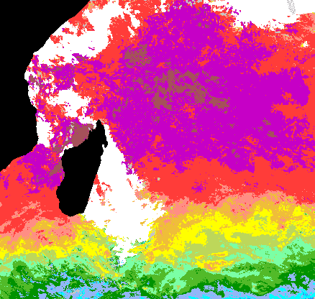

 C°

Figure 17. SST (in C°; white are clouds).) map (1st June 1998) of the south-western Indian Ocean from IRD/SEAS (La Réunion).
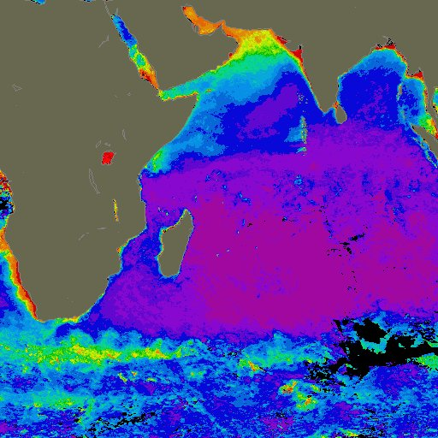 | 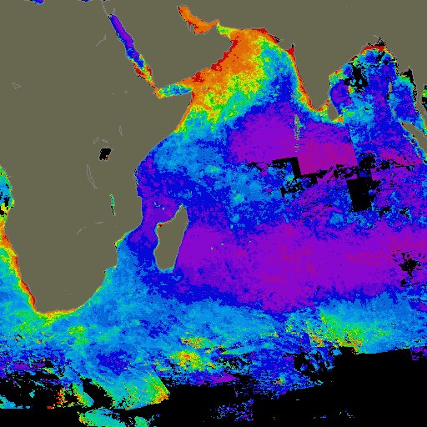
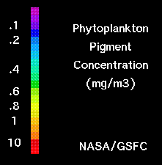 | Figure 18. Nimbus-7 Coastal Zone Color Scanner data acquired between Noverber 1978 and June 1986: mean winter (left); mean summer (right).

4.2.2 Numerical Models

- Physical numerical models

The key to long-term fisheries management and planning is prediction. This can only be done by extrapolating near-real time data or by numerical modeling. Several circulation models exist from simple shallow-water models (1 or 2 layers, few parameters, small region) to General Circulation Models (GCM) (many layers, all parameters, global). Our interest is in forecasting and therefore, ocean models should be forced by atmosphere model outputs: this is progressively achieved by coupled ocean-atmosphere models.

However, even though GCMs or coupled ocean-atmosphere models may provide a more accurate solution, they are heavy to use and require powerful computers with big storage capacity. On the other hand, simple, or mechanistic models may be easier to understand and operate, provide results sooner, and may be more enlightening, but may miss important details (figure 9) (Boehlert, 1997).

- Coupled Bio-physical models

Today, inter-disciplinary collaboration between oceanographers and meteorologists has been extended to biologists and several coupled bio-physical or bio-geochemical models have been used in fisheries studies. Lehodey et al. (1998) have developed such a model for predicting skipjack tuna forage distributions in the equatorial Pacific. The OPA GCM from LODYC (Laboratoire d'Océanographie Dynamique et de Climatologie), was used to predict the water dynamics. A high resolution of OPA (1/3°longitude x 1/3°latitude, 16 vertical levels in the upper 150 m; Blanke and Delecluse, 1993) was forced at the surface with the 5 day winds deduced from the ERS 1 scatterometer and with fresh-water and heat fluxes based on these winds, on Reynolds' SST (Reynolds and Smith, 1994), and on output fields of the atmospheric model Arpège-Climat (Dequé et al., 1994). This forcing allowed a 3 year simulation from April 1992 to June 1995.

The OGCM was coupled to a bio-geochemical model to predict primary production (Stoens et al., 1998) and hence, Skipjack tuna forage. The simulated Skipjack tuna forage production combined with other environmental parameters, such as temperature and dissolved oxygen concentration should lead to a realistic habitat index useful for large-scale spatial models of tuna populations (Lehodey et al., 1998).

4.3. Partnerships in fisheries issues

- Meeting the Agreement on High Seas Fishing

In order to meet with the objectives of The Agreement on High Seas Fishing (UNCLOS), partnership between scientists and decision-makers (fishermen, fisheries managers and fishing authorities: the fisheries community), should be encouraged. Fisheries biologists and oceanographers may collaborate with scientists from National Meteorological and Hydrological Services (NMHS) to develop "user-friendly" tools and services for the fisheries community.

Tools and services could be based on the knowledge acquired through research and on modeling outputs. They could be presented in visual formats such as maps, time series (SOI type), animations, etc.

- The WMO CLIPS project

The ultimate goal of the CLIPS project within the WMO World Climate Applications and Services Program was defined as to "provide the best possible climate information, including expectations of future conditions, to improve economic and social decisions, and which will reduce risks and improve economic vitality as well as the quality of life." (WMO-No.864).

Thus, the CLIPS project is a perfect framework to implement such partnerships on a global scale (figure 19) with priority to highly vulnerable human populations - for instance Small Island Developing States (SIDS) which depend mostly on fisheries and climate- and focusing on critical fisheries, namely highly commercial species targeted by industrial fisheries.


REPRODUCTION
NUTRITION
RECRUITEMENT
MIGRATION
EXTREME WEATHER EVENTS
SEASONS
INTERANNUAL
DECADAL
FISH STOCK ASSESSMENT
CLIMATE
FISHING
ACTIVITY
FISH
BEHAVIOR
DIFFERENT TIME AND SPACE SCALES
FISH STOCK
MARKET DEMAND
FISHING CONDITIONS
CATCHABILITY
PLANNING
Figure 19. Schematic Diagram showing Climate-Fisheries and Market relationships.
- REFERENCES

Agreement for the implementation of the provisions of the United Nations convention on the Law of the Sea of 10 December 1982 relating to the conservation and management of straddling fish stocks and highly migratory fish stocks. UN Conf. On Straddling Fish Stocks and Highly Migratory Fish Stocks. 6th session , New-York, 1995. A/CONF.164/37.

Bakun, A., 1995: The Callifornia current, Benguela current and southwestern Atlantic shelf ecosystems: a comparative approach to identifying factors regulating biomass yields. In Large marine ecosystems: stress, mitigation and sustainability. Am. Assoc. For the Advancement of Science. 199-224

Blanke, B. and P. Delecluse, 1993: Variability of the tropical Atlantic Ocean simulated by a general circulation model with two different mixed layer physics. J. Phys. Oceanogr. 23: 1363-1388.

Boehlert, G. W. and J. D. Schumacher, 1997: Changing oceans and changing fisheries: environmental data for fisheries and management. NOAA Techn. Memorandum NMFS. NOAA-TM-NMFS-SWFSC-239. Pp. 146.

Code of Conduct for Responsible Fisheries: FAO Fisheries Department. Twenty-eighth Session of the FAO Conference on 31 October 1995.

Cury, P. and C. Roy, 1989: Optimal Environmental Window and Pelagic fish recruitment success in upwelling areas. Can. J. Fish. Aquat. Sci., 46: 670-680.

Dequé, M., C. Dreventon, A. Braun, and D. Cariolle, 1994: The ARPEGE/IFS atmosphere model: a contribution to the French community climate modeling. Clim. Dynam.10: 249-266.

Doumenge, F., 1998: L'histoire des pêches thonières. Proceedings of the ICCAT Tuna Symposium. Madrid 1998.

Fonteneau, A., 1997: Atlas of tropical tuna fisheries. World catches and environment. ORSTOM editions. Paris, 1997.. pp.192.

Guide to the Applications of Marine Climatology. WMO-No. 781.

Laurs, R.M., 1997: Overview of Satellite Remote Sensing applications in fisheries research. In Changing Oceans a,d Changing Fisheries: Environmental Data for Fisheries Research and Management. NOAA Techn. Memorandum NMFS. G.W. Boelhert and J.D. Schumacher, p.9-16.

Le Blanc J-L, 1997: "Climate Information and Prediction Services for Fisheries". WMO/TD-No.788; WCASP-39.

Le Blanc J-L, R. Payet, F. Marsac, 1997: "Climate Change and Fisheries in the Seychelles: A contribution to enable the Seychelles National Cimate Committee to prepare its first national communication to the UNFCCC (UN-Framework Convention on Climate Change).

Legler, D. M., I. M. Navon, and J. J. O'Brien, 1989: Objective analysis of pseudo-stress over the Indian ocean using a direct-minimization approach. Mon. Wea. Rev., 117, 709-720.

Lehodey, P., J-M. André, M. Bertignac, J. Hampton, A. Stoens, C. Menkes, L. Memery and N. Grima, 1998: Predicting Skipjack tuna forage distributions in the equatorial Pacific using a coupled dynamical bio-geochemical model. Fish. Oceangr. 7: 3/4, 317-325.

Lorentz, E., 1956: Empirical Orthogonal Functions and statistical weather predictions. Rep. N°1, Statistical Forecasting Program, MIT; pp. 49.

Majkovski, 1997: Global resources of tuna and tuna-like species. In FAO Fisheries Circular No. 920 FIRM/C920. ISSN 0429-9329; by Marine Resources Service, Fishery Resources Division, Fisheries Department, Rome, 1997.

Makridakis, S.G., S.C. Wheelwright, and V.E. McGee, 1983: Forecasting: methods and applications (2nd ed.) New-York, Wiley.

Marsac, F. and J-L Le Blanc, 1997: Interannual and ENSO-associated variability of the coupled ocean-atmosphere system with possible impacts on the yellowfin tuna fisheries of the Indian and Atlantic Oceans. ICCAT Symposium, Açores (Portugal); June 1996. ICCAT Coll. Vol. Sci. Pap. L(1): 345-377.

Marsac, F., 1998: GAO : an oceanographic applications manager for fisheries biologists. 7th Expert consultation on Indian Ocean Tunas, Victoria, Seychelles, 9-14 Nov. 1998, IOTC, TWS/98/39: 14p.

Marsac F. et J-L Le Blanc, 1998 : « Dynamics of ENSO events in the Indian Ocean : to what extent would recruitment and catchability be affected. » IOTC 7th Expert Consultation on Indian Ocean Tunas. Victoria, Seychelles ; 9-14 Novembre 1998.

Mendelssohn, R. and C. Roy, 1996: Comprehensive Ocean Data Extraction Users Guide. U.S. Dep. Comm., NOAA Techn. Memo. NOAA-TM-NMFS-SWFSC-228, La Jolla, CA. Pp 67.

Oceans and the Law of the Sea: Report of the Secretary General. UN General Assembly. A/53/456.

Reynolds, RW. and T.M. Smith, 1994: Improved global sea surface temperature analyses using optimum interpolation. J. Clim. 7: 929-948.

Roy, C. and R. Mendelssohn, 1998: The development and use of a climatic database for CEOS using the COADS dataset. In Global versus Local Changes in Upwelling Systems. M.H. Durand, P. Cury, R. Mendelssohn, C. Roy, A. Bakun, D. Pauly (eds). p.27-24.

Servain, J., M. Séva, D. Lukas and G. Rougier, 1987: Climatic data of the tropical Atlantic wind stress and sea surface temperature 1980-1984. Ocean-Air Interactions, 1: 109-182.

Sharp, G.D., 1992: Climate change, the Indian Ocean tuna fishery, and empiricism. In Climate Variability, climate change and Fisheries. M. Glantz, (ed) p. 450.

Stoens, A., C. Menkes, Y. Dandonneau, and L. Memery, 1998: New production in the equatorial Pacific: a coupled dynamical-biochemical model. Fish. Oceanogr. 7 : 3/4, 311-316.

Stepping Forward: Implementation of the WMO CLIPS project. World Meteorological Organization. WMO-No.864.

Stricherz, J., D. M. Legler and J. J. O'Brien, 1993: Atlas of Florida State University Indian Ocean Winds for TOGA 1970-1985, Florida State University, Tallahassee, FL.

Ward, M.N. and B.J. Hoskins, 1996: Near surface wind over the global ocean 1949-1988. J. of Climate. 9 : 1877-1895.

Webster, P.J., J.P. Loschnigg, A.M. Moore, and R.R. Leben, 1998: The Great Indian Ocean Warming of 1997--1998: Evidence of Coupled Oceanic-Atmospheric Instabilities. Submitted to Nature, July 1, 1998.

Woodruff, S.D., R.J. Slutz, Jenne and P.M. Steurer, 1987: A Comprehensive Ocean-Atmosphere Data Set. Bull. Amer. Meteor. Soc., 68; 81-82.

EOF: Empirical Orthogonal Function (please see chapter 3.2. for methodology details).
Catch Per Unit Effort (CPUE): catch divided by the fishing effort of the gear.
Stratification Index: combines intensity of the thermal gradient and its depth. The higher the value, the strongest the stratification in the upper layers.
Ekman pumping: vertical velocity deduced from the curl of the wind stress; positive (negative) means upward (downward) motion and associated divergence (convergence) of surface waters.

