DEVELOPMENT OF A SEA ICE MOTION DATABASE
FROM 85.5 GHz SSM/I IMAGERY

Tom A. Agnew*
Environment Canada,
Downsview, Canada

1. Introduction

The relatively long record of passive microwave satellite data (from 1979 to present) has been used by several investigators to monitor the variability and trend in sea ice cover in the Arctic and Antarctic over the last 20 years (Gloersen and Campbell, 1991; Maslanik et al, 1996, 1999; Cavalieri et al, 1997, Bjorgo et al, 1997). It is only recently that this satellite record has been used to estimate large scale sea ice motion (e.g., Agnew et al, 1997; Kwok et al, 1998).
The earlier passive microwave sensor, called the Scanning Multichannel Microwave Radiometer (SMMR), covers the period from 1979 to 1987 and has a spatial resolution of 25 km at 37 GHz. The more recent Special Sensor Microwave Imager (SSM/I) covers the period 1987 to the present and has improved resolution of 12.5 km at 85.5 GHz. Although these resolutions are coarse, coherent motion of the sea ice pack can be obtained in sequential daily average images. The main advantage of these sensors is the long, almost continuous satellite record and daily global coverage with little obstruction of cloud during autumn, winter and spring months of each hemisphere. This large scale all-weather coverage provides an advantage over the NOAA AVHRR _____________________
Address for Correspondence: Environment Canada, 4905 Dufferin Street, Downsview, Ontario, Canada, M3H 5T4
satellite series and the long historic record provides an advantage over synthetic aperture radars such as ERS-1 and 2 and RADARSAT. Passive microwave also provides more comprehensive spatial coverage for estimating ice motions than is presently available from traditional Arctic and Antarctic drifting buoys. This makes it valuable for the development of a long period ice motion data set which can be used for large scale ice budget studies, sea ice/climate model validation, and sea ice/climate process studies.
Most methods for estimating ice motions from passive microwave data are based on identifying the maximum cross correlation (MCC) between search areas in consecutive images. Individual unique features are not followed over time. The method also involves some filtering of erroneous ice motions based on spatial and temporal continuity. Results using this method are presented and discussed in this paper. There has been some work done on wavelet methods which follow movement of particular wavelet-defined locations over time (Liu and Cavalieri, 1998). This method is not discussed here.

2. Sea Ice Motion Estimation

A detailed description of SSM/I data processing and the MCC method are provided in Agnew et al. (1997) and only the main steps will be outlined here. Development of the data base uses daily average SSM/I brightness temperature data obtained on CD-ROM from the National Snow and Ice Data Center (NSIDC, 1994). Only the horizontally-polarized 85.5 GHz data are used. A neighbor-substitution algorithm is used to fill in occasional missing pixels and bad scan lines in the CD-ROM data obtained from NSIDC. The cross correlation search begins with the identification in each image of sharp features referred to as seed locations. These are usually large multiyear ice floes or large ridged ice fields which produce a distinctive signature in the imagery. Based on seed locations, adjacent areas are searched using MCC applied to a search window. The search is guided by seed location displacement vectors and a knowledge of the maximum displacement that can be expected for ice motion. Estimation of ice displacement between images is done approximately every 6 pixels (75 km). As applied here, the MCC method is completely automated and contained in a software package called Tracker (Hirose et al., 1991). Ice motions are estimated sequentially every four days. An error correction procedure is applied to check for consistency of displacement vectors with surrounding vectors. Results are compared with drifting buoys from the International Arctic Buoy Program. Most of the buoys used are located in the western Arctic Basin.
Figure 1 shows a comparison of estimated displacements from SSM/I imagery using the MCC method with estimated displacements from Arctic buoys for the period December, 1993 to January, 1994. An overall correlation of 0.75 and an average vector magnitude error in ice velocity of 3.5 km-day⁻¹ (4.0 cm-s⁻¹) is found. There is a tendency to over estimate ice displacement as compared to buoys by 14% (Agnew et al., 1997). A detailed example of four-day ice motions over the Arctic Basin are shown in Figure 2. Ice motions vectors are shown as a small circle and tail. The small circle marks the beginning of the motion. The vector displacements from SSM/I imagery are in yellow and the ice motion from Arctic drifting buoys, which act as ground truth, are in red. The large black circle in the center is a data-void region of the satellite. The surface pressure pattern averaged for the four-day period, using the NCEP re-analysis, is also super imposed over the Arctic Basin. The close alignment with the ice motion confirms other studies indicating that 60 to 80 % of sea ice motion over the central Arctic Basin (away from coastal regions) is explained by the surface geostrophic wind (Thorndike and Colony, 1982).
One limitation on development of the data base is atmospheric moisture attenuation of the 85.5 GHz channels in summer. Current development of the data base does not produce reliable estimates during summer for this reason. Improved filtering methods and use of 37 GHz data may provided useful ice motions. This has not been done as yet.
Coarse resolution of the SSM/I imagery is a second limitation on the accuracy of the ice motion estimates. Some improvements can be made in the MCC method by subpixel over-sampling (Kwok et al., 1998) but standard errors of 3.5 km-day⁻¹ indicated above are difficult to improve on. Increasing the time interval between images can increase the magnitude of sea ice displacements. However, this will reduce the time resolution and increase errors in the cross correlation method by providing more time for ice surface features to be modified or distorted in the second image. In the development of this data base, a constant four-day separation between images was felt to be a good compromise between these two effects. Even with a four-day separation between images, weak sea ice motion situations are not well handled. Incorporation of other
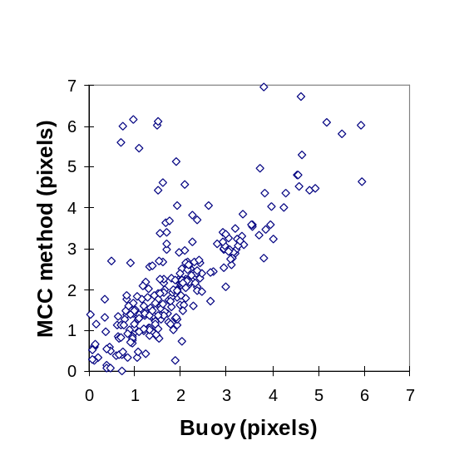
Fig. 1. Scatter plot of estimated ice displacement, measured in 12.5 km pixels units, versus buoy drift. A total of 391 comparisons were made.

ice motion information such as Arctic buoys in an optimal interpolation scheme is possible but has not been done. The incorporation of other ancillary information such as geostrophic wind (surface pressure) is also possible but not recommended since this would impose an assumption of geostrophic control on the ice motion which is not valid near the coast. Near the coastline, the no-slip boundary condition increases internal stresses in the ice by several orders of magnitude as ice compactness and thickness increase with onshore winds. As a result, the relationship between ice motion and wind stress is much more complicated than a simple linear relationship with geostrophic wind.
No single processing method or optimal interpolation scheme using ancillary data is likely to be best for all applications. Climate modelers and other users with a long time scale perspective may prefer a highly filtered data set consisting of blended ice motions including buoy data and surface pressure fields for climatologies or monthly mean ice motions in the central Basin. Other applications such as case studies of ice-atmosphere-ocean-interaction and large lead formations events may require minimal filtering and merging with other types of data. The approach being taken in developing this data base has been not to blend results with other data sets. This makes the data base more suitable for the study of extreme events such as the formation of large leads over the Arctic Basin and ice drainage events.

3. Applications

The forcing of the sea ice against the northern coastlines of North America and Eurasia by surface wind results in fracturing and shearing of the ice pack on a large scale. This can result in the formation of very large leads which radiate out into the Basin hundreds of kilometers. The formation of these large leads results from differential sea ice motion which can be measured using SSM/I imagery. Fig. 3 shows the western part of the Canadian Archipelago and a large area of the western Arctic Basin in November, 1998. Four-day ice motions vectors from SSM/I for the November 3 to 7 period are shown. Ice motions to the left and right of the image are quite different leading to ice divergence and the formation of a large arch-shaped lead radiating into the Arctic Basin from Prince Patrick Island in the Canadian Archipelago. The detachment and clockwise rotation under atmospheric forcing of the ice pack to the left of the lead is seen. Average clockwise rotation of the ice is about 7 km/day. Ice motions on the other side of the lead are small or undetectable indicating that this part of the ice pack was more or less stationary. The mean surface pressure contours over the 4-day period shows that atmospheric wind stress is forcing the pack up against the Canadian Arctic Islands on the right side of the lead but little or no motion occurs as stress within the ice pack counteracts the wind stress. Sea ice to the left of the lead is not constrained by the coastline and moves in clockwise rotation under atmospheric forcing typical of the Beaufort Sea Gyre. Fig. 4 is a NOAA AVHRR infrared image which shows in more detail the location of Prince Patrick Island and the lead which radiated almost 1000 kilometers into the Basin. The formation of these large leads in winter makes an important contribution to the heat and moisture budget of the Arctic Ocean and to sea ice production rates (Agnew et al., 1999).

- Summary and Conclusions

Satellite passive microwave estimates of sea ice motion are an important enhancement to the record from Arctic and Antarctic drifting buoys which is at present the only long term record of sea ice motion. Development of the data base has two limitations. The first is poor ice motion retrievals in summer due to atmospheric moisture attenuate especially at 85.5 GHz. This might be overcome be using the 37 GHz channels. The second is coarse resolution of the passive microwave imagery, which limits reliable estimates to moderate to strong ice motion. The merging of ice motion estimates with drifting buoy data and perhaps other data such as surface pressure may overcome some of these difficulties. The decision to incorporate other ice motion information will depend on the particular application. Climate modelers, which require monthly mean fields or even longer mean ice motion climatologies, may want blended vectors. Others investigators looking into case studies or sea ice process studies may want minimum filtering and merging with other data sets.

Acknowledgments

The author would like to thank the National Snow and Ice Data Center for providing the processed SSM/I data on CD-ROM and the Polar Science Center, Seattle Washington for providing the Arctic Buoy data for development and evaluation of the data base. The author would also like to thank Dr. James Maslanik for his helpful discussions. This work is supported in part by the Canadian Panel on Energy Research and Development.

Bibliography

Agnew, T. A., H. Le, and T. Hirose, 1997.Estimation of Large Scale Sea Ice Motion from SSM/I 85.5 GHz Imagery, Annals of Glaciology, 25, 305-311.

Agnew, T. A. , H. Le, and M. Shokr, 1999. Characteristics of large Winter Leads over the Arctic Basin from 85.5 GHz DMSP SSM/I and NOAA/AVHRR Imagery, Can. J. of Remote Sensing, 25, No. 1, 12-20.

Bjorgo, E., O. M. Johannessen, and M. W. Miles, 1997. Analysis of merged SSMMR-SSM/I time series of Arctic and Antarctic sea ice parameters 1978-1995, Geophy. Res. Let., 24, 413-416.

Cavalieri, D. J., P. Gloersen, C. Parkinson, J. Comiso, and Zwally, 1997. Observed Hemispheric Asymmetry in Global Sea Ice Changes, Science, 278 (Nov 7), 1104-1106.

Gloersen, P. and W. J. Campbell, 1991. Variations of extent, area, and open water of the polar sea ice covers:1978-1987, In: Weller, G., C. L. Wilson and B.A.B. Severin, (eds.), International Conference on the Role of the Polar Regions in Global Change, June 14-15, 1990, Univ. of Alaska, Fairbanks, Vol. I, 4-12.

Hirose T., T. Heacock, and F. Lee, 1991. Advances in Sea Ice Tracking Algorithms. In Franklin, S., D. Thompson and J. Francis, eds. Proceedings of the 14th Canadian Symposium on Remote Sensing, 6-10 May, Calgary, Alberta, Canada, 292-295.

Kwok, R., A. Schweiger, D. Rothrock, S. Pang, Kottmeier, 1998. Sea Ice motion from satellite passive microwave imagery assess with ERS SAR and buoy motions, J. Geophy. Res., 103, C4, 8191-8214.

Maslanik, J., M. Serreze, and R. Barry, 1996. Recent decreases in Arctic summer ice cover and linkages to atmospheric circulation anomalies, Geophy. Res. Let., 23,13,1677-1680.

Maslanik, J., M. C. Serreze, R., and T. A. Agnew, 1999. Record Reduction in Western Arctic Sea-Ice Cover in 1998: Characteristics and Relationships to Atmospheric Circulation, Geophy. Res. Let, 26, 13, 1905-1908.

Liu, A.K. and D. J. Cavalieri, 1998. On sea ice drift from the wavelet analysis of the Defense Meteorological Satellite Program (DMSP) Special Sensor Microwave Imager (SSM/I) data. Int. J. Remote Sensing, 19, 7, 1415-1423.

National Snow and Ice Data Center (NSIDC), 1994. DMSP F-11 SSM/I , Polar Regions, University of Colorado, Boulder, CO 80309-0449, USA, pp. 80.

Thorndike, A. S. and R. Colony, 1982. Sea Ice Motion in Response to Geostrophic Winds, J. Geophys. Res., 87, 5845-5852.

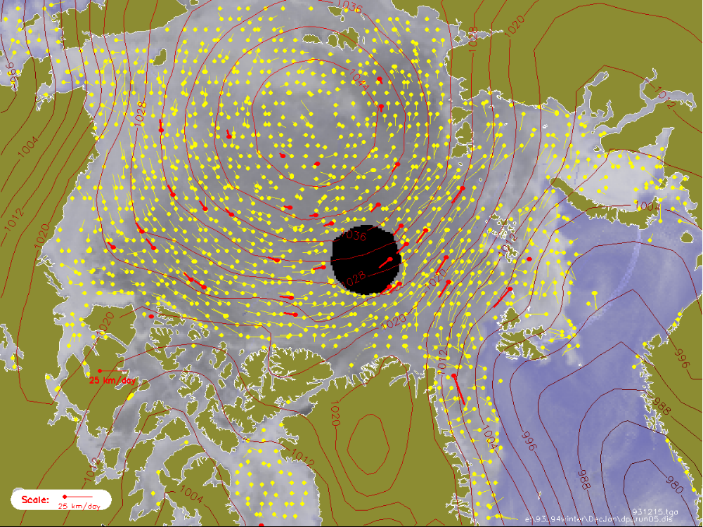
Fig. 2. Four-day ice motion vectors for January 13 to 17, 1994. The small circle marks the beginning of the
displacement vector. Buoy motions over the period are shown in red.
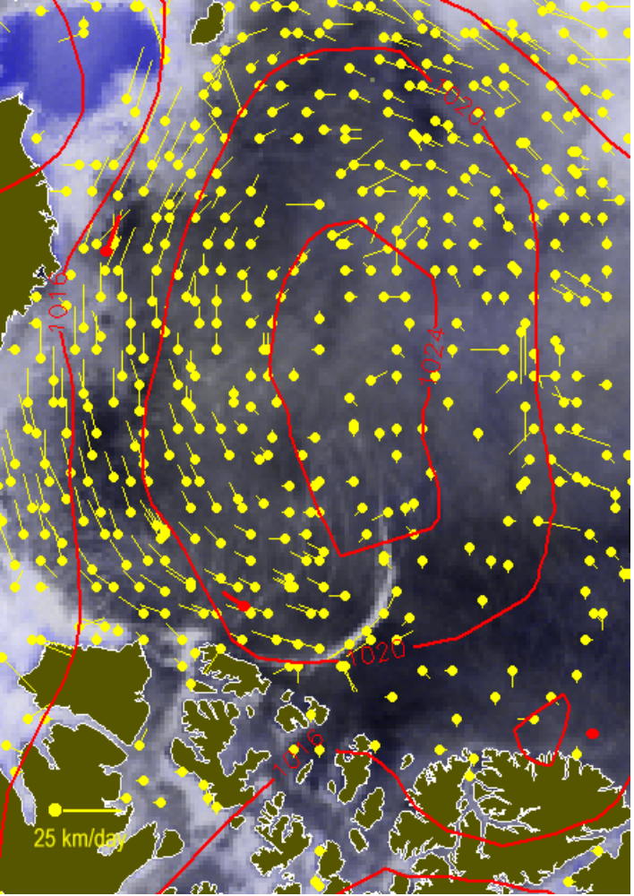
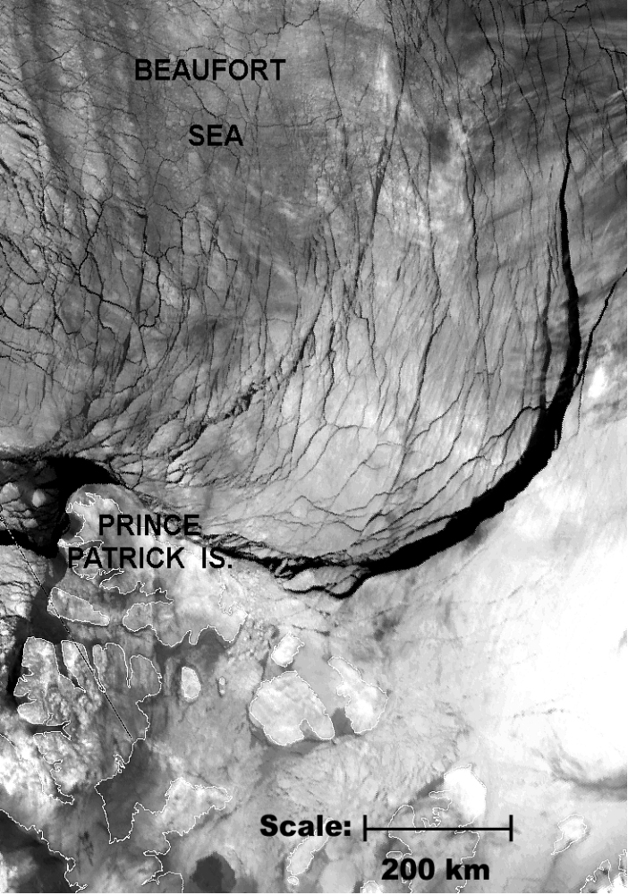
Fig 3. Four-day ice motion vectors from November 3 to 7, 1998 Fig 4. NOAA AVHRR infrared image for November 6, 1988
obtained from daily SSM/I 85.5 Ghz imagery. showing the arch-shaped lead extending into the Arctic Basin.

