Global Collecting Centres as a Focus for Data Dissemination and Data Quality

V. Wagner ¹

Global Collecting Centres act as focal points in the marine meteorological dataflow and in a supervising function for a minimum quality standard of the data in the Marine Climatological Summaries Scheme of WMO.

The Marine Climatological Summaries Scheme (MCSS)
Main intentions of the scheme are:
- to provide marine meteorological data as much as achievable and of good quality from the worldwide oceans and adjacent waters in non real time mode but on an acceptable time scale.
- to provide climatological summarized statistics for selected ocean areas worlwide on a defined time scale („Summaries“).

At present the main data platform in this scheme is provided by the voluntary observing ship fleet, which is maintained by the Contributing Members (ca. 50 nations) (Fig.1). The Scheme works under the auspices of WMO/CMM.

Data flow and Data management within the CMM/MCSS
The marine data flow from ships (Fig. 2) can be considered on two branches:
- a real time branch (World Weather Watch), where data arrive in near real time at the National Meteorological Services (NMS) e.g.via Inmarsat for insertion in the GTS. The data volume is mostly not complete and subject to errors (transmission, formal, etc)
- a non real time branch, where data coming in to the NMCs, the so called Contributing Members under the MCSS via the PMO Services or other links. Data are mostly complete, but also subject to errors. Here is the starting ponit of the MCSS data flow.

CMs are requested to apply an internationally agreed and well defined Minimum Quality Control (MQC) on their data which ideally leads to a correction of suspect data and a flagging according to MQC-regulations, and then handing them over to the GCCs. The GCCs prove that MQC has really been applied to the data and after that review circulate them to the Responsible Members on a quarterly basis for archiving and climatological statistical processing.. The GCCs also give any assistance if problems of any kind occur with the data or the MQC procedures.

For reasons of redundancy there are two GCCs: GCC-UK and GCC-Germany. They co-operate very closely with identical software. They permanently update each other respective to data contributions and data problems. Each centre would be in the position to act for each other if required, but normally they act under a task sharing scheme in being main focal points for a subset of CMs and RMs, altouhg all data are sent to both GCCs at the same time.

Data Contributions
- Data are coming in currently all over the year (Fig . 3). Most countries contribute on a quartely basis, some contribute anually. There were contributions from 19 countries out of a potential ca. 50 contributors during the last 5 years. 10 countries contributed to the GCCs constantly each year since 1994.
- The total contributions vary from year to year (Fig. 4) and may stabilize at a mean number of ca. 1.4 Mio. datasets per year.
- The spatial coverage (Fig. 5) is of course analogue to the shipping lines and do not vary substantially from year to year.
- The age of the observations may reach back into the 1980ies in individual cases. As a whole the situation improved since 1994 (Fig. 6), so that at present ca. 70 % of the data are not older than two years and ca. 90 % not older than 3 years.

--------------------------------------------------------------------------------------------------------

¹ German Weather Service

Data Quality
CMM agreed for a minimum quality level for VOS-Data in the MCSS in 1989 which was included in the Manual on Marine Meteorological Services. This Procedure contains a well defined flagging instruction. Thus Contributing Members are requested to apply the Minimum Quality Control on the data and to correct suspect values where possible before sending them out to the GCCs.
Nevertheless GCCs have to prove, that MQC has been applied. During the last 5 years the amount of data not meeting these requrements became less. In 1998 the error rate reduced to about 1% ranging between 0.1% and 2.7% with individual contributions. GCCs normally correct errors in organizational data (where possible) to come into the position to start the MQC processing. GCCs introduce flags, where contributed data were without any flag information.
Greater problems with data sets are settled between the GCCs and the Contributing Members concerned on a bilateral basis.
GCCs still experience duplicate data which may come from a special practice to transform GTS data into the IMMT formate and stamping all these observations with the own country code. This normally collides with original contributions in the GCCs..

Data Despatch
GCCs despatch all data on a qurterly basis in April, Juli, Octobre and end of Decembre, comprising 3 files: the first holding all those reports which passsed MQC unopposed, the second those which were rejected because of errors and the third holding informations on rejected observations. It is up to each Responsible Member to decide how to proceed with these data, either ignoring or correcting them.

Conclusion
Most contributors are applying MQC before sending their data to the GCCs. Best results can be reached if data are corrected instead of being only flagged as „doubtful“ or „erraneous“. This can be done most competently by the Contributing Members themselves
A good preventing tool may be the results of the quality monitoring activities by WMO and e.g. UK . Another developement is the use of software-aided data typing on bord of ships. One of these is e.g. the Turbo software available as WMO freeware and usable on seperate notebokks given to ships by the Contributing Members through their PMOs or for direct use on existing board computers. This software allows each observation to be checked along the lines of the WMO MQC befor sent out onto GTS or coming back for archiving.
It has been proven that this kind of quality checked, archived data are an adequate means for climate research. Thus all countries having marine meteorological data from ships available are invited to contribute this information for the benefit of meteorological and oceanographic climatological knowledge and research.

Abbreviations
CMM = Commission for Marine Meteorology
GCC = Global Collecting Centres
GTS = Global Telecommunication System
MCSS = Marine Climatological Summaries Scheme
MQC = Minimum Quality Control
NMS = National Metorological Service
PMO = Port Meteorological Officer
VOS =Voluntary Observing Ship
WMO = World meteorological Organization
WWW = 1. World Weather Watch, 2. World Wide Web (internet)

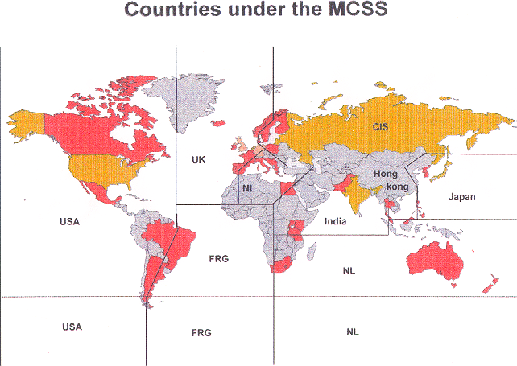

Fig. 1: Marine Meteorological Summaries Scheme (MCSS).
Contrib. Members (coloured), Respons. Members (yellow), GCCs (orange).
Solid lines: Areas of Responsibility.

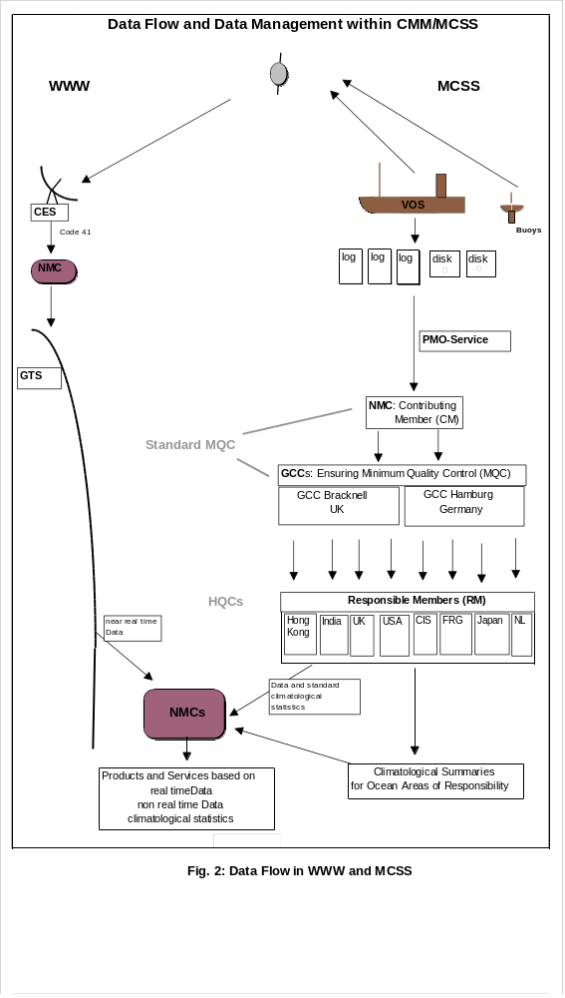

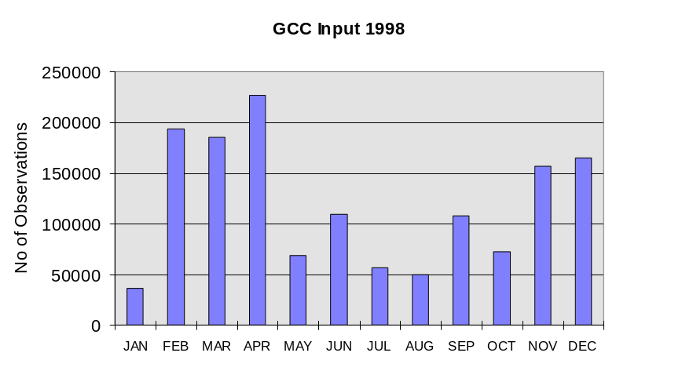

Fig. 3: GCC Input 1998

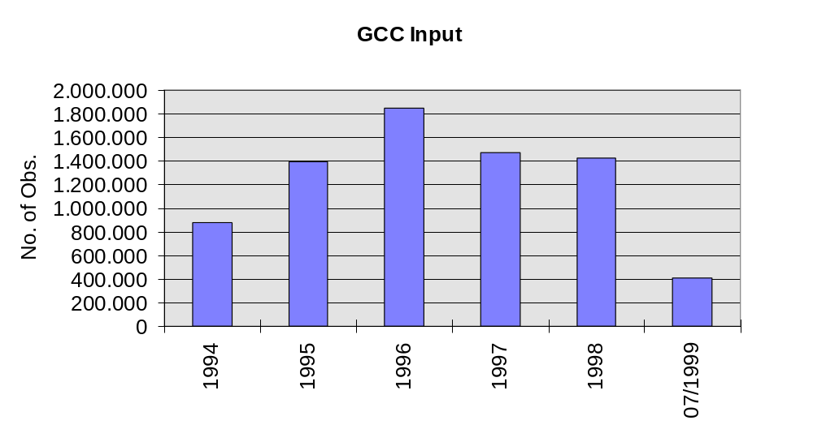

Fig. 4: GCC Input 1994 - 07/ 1999

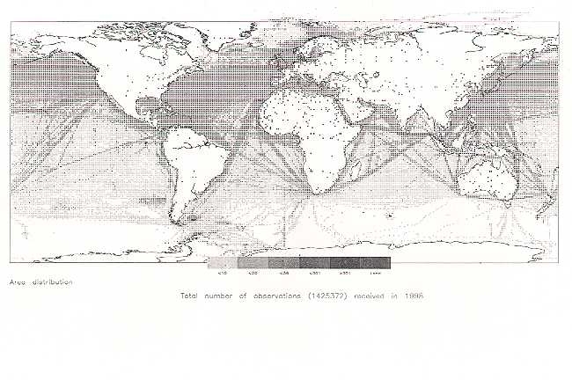
Fig. 5: Spatial distribution of Data Contributions

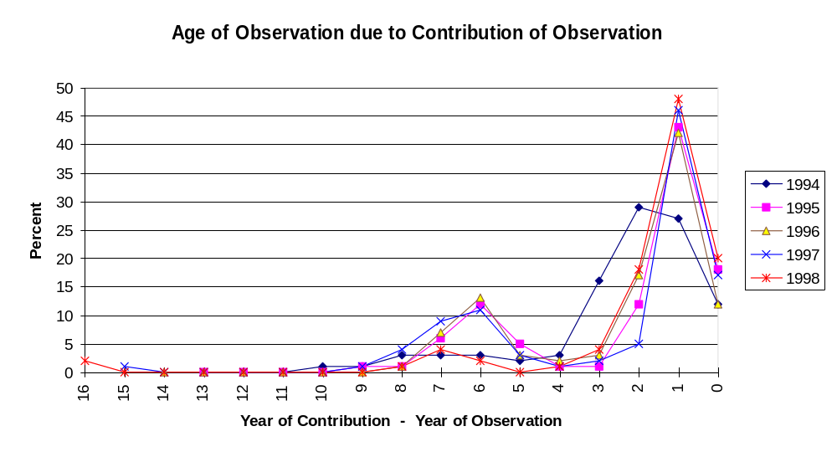

Fig. 6: Age of Observation due to Contribution of Observation

