A MEDIA TO IMPROVE SAFETY NAVIGATION AT THE RIO DE LA PLATA

S. Barreira, C. Rössler, and S. Alonso

Argentine Navy Meteorological Service
Buenos Aires, Argentina

- INTRODUCTION

One of the responsibilities of the SIHN (Servicio de Hidrografía Naval, Argentine Navy Hydrographical Service) is to provide navigation safety in the Río de la Plata region. SMARA (Servicio Meteorologico de la Armada, Argentine Navy Meteorological Service), as part of SIHN, is in charge of meteorological support in the area.

Río de la Plata is one of the natural limits between Uruguay and Argentina (see fig. 1). Its maximum width is of 220 Km. Its south coastal size is 393 km and its north coast extension is of 416 km (Derrotero Argentino,1995). It presents an orientation NW-SE and a marked funnel form. A wide and extensive urban area is located in the southern coast of Río de la Plata. We are interested in this area because it is densely populated and is one of the largest economical and industrial regions in Argentina. Two harbors, great quantity of marinas, several domestic airports and an international airport are located along 120km of the south river coast.

One of the meteorology main interests is to predict the development of weather systems with enough anticipation. Two factors hinder forecaster's task in our country: the lack of basic information in ocean vast areas and La Cordillera de Los Andes, a step orographic barrier, which strongly modifies synoptic systems motions and characteristics. Argentina’s meteorological services main responsibility is the prediction of meteorological phenomena as well as the investigation of methods to improve it.

The central-northeast region of Argentina is affected by the passage of different weather systems like blocking situations, cold fronts, warm fronts, instability lines and diverse mesoscale convective systems, during summer period.

SMARA received buoy data from a fixed location at river outlet during four months (December 1998 - April 1999). This buoy was installed by OCEANOR (a Norwegian company) as a demo for the Comisión Mixta del Frente Marítimo del Río de la Plata. The buoy measured wind (intensity and direction) pressure, air temperature, water temperature, currents and wave data among other variables.

Three storm cases that occur during the period of observation were studied. This unique Río de la Plata time series of buoy data demonstrate the helpful of this kind of data to predict severe weather over the area.

- Location of the buoy and measurements

A buoy weather station was anchored at the outlet of the Río de la Plata (35º 52’S, 55º 57’W) (see fig. 1), in the beginning of December of 1998, which operational period lasted 4 months. Information provided by the fixed buoy comprised air temperature, pressure, wind (direction and intensity), water temperature in several levels, currents, waves (direction and intensity) and salinity. Data were transmitted directly via INMARSAT to a SMARA PC computer. They were not included onto the GTS due to the experimental character of measurements. Buoy – SMARA data delay was 20 minutes. Information was stored in SMARA and they have already been used by several institutions of Argentina and Uruguay.

- Methodology

Pressure, temperature, and wind direction and intensity coming from buoy data and stations at both shores of the river (Carrasco, Uruguay and Punta Indio, Argentina) were plotted. The influence of coastal breeze phenomena over both station data was taking into account during the development of the work.

Argentine Navy Weather Assimilation and Prediction System (ANWAPS) (Barreira, 1996, a,b) was used to obtain the Regional Analysis presented here without Río de la Plata buoy data. During storm periods temperature, dew point and pressure was analyzed with Argentine Navy Mesoscale Analysis System (ANMAS) (Rössler, 1999).

- Cases of study

Numerous cases of precipitation at Río de la Plata region were recorded during the four-month of buoy operation. We selected three cases of heavy precipitation, which were originated by different meteorological situations.

We take into account the precipitation data measured at Aeroparque Jorge Newbery (34º 34’S, 58º 25’W), Ezeiza (34º 49’S, 58º 32’W), Punta Indio (35º 22’S, 57º 17’W) and Carrasco (34º 50’S, 56º 00’W) meteorological stations (see fig. 1). Finally, we chose three cases with precipitation over 60 mm/day recorded in few hours.

4.1. Case 12/13/98

Thunderstorms amount of accumulated precipitation of 108 mm/day at Aeroparque Jorge Newbery, 48.4 mm/day at Ezeiza and 32.4 mm/day at Carrasco were recorded the 13/12/98 between 0400 GMT and 1430 GMT. The 0000 GMT meteorological chart show a high pressure region of 1017 hPa SE of the Prov. of Buenos Aires with center in 57º W, 40º S and a thermal depression at the NW of Argentina of 1008 hPa (see fig. 2).

A storms line developed SW of Río de la Plata coast at 0000 GMT due to temperature differences temperature between warm and wet air coming from the NE and cold and dry air from anticyclone (fig. 3, 4 and 5) At 0600 GMT, hour of beginning Aeroparque thunderstorms, an isotherm packing over the region (fig.6) and a low pressure could be seen at fig. 7 coming from NW were presented.

At 1200 GMT Río de la Plata region was under the influence of depression with warm and wet flow from NE into the river (fig. 8). At 1200 GMT mesoscale chart shows the influence of low pressure at buoy latitude (fig.9). Fig. 10 shows the storm occurrence at 1300 GMT at buoy position. Fig.11 shows the decrease of temperature and pressure.

Wind from East (~90º in fig. 12) previously to storm time, switched to NE (~50º in same figure) during strengthen of the low-pressure system at Río de la Plata. Wind intensity increased during that period (fig.13).

4.2. Case day 1/4/99

Storms amount of accumulated precipitation of 16,2 mm/day at Ezeiza, and at Aeroparque Jorge Newbery of 47,5 mm/day. There is no data at Carrasco and Punta Indio stations. Thunderstorms were presented at Aeroparque and Ezeiza between 0000 GMT and 0900 GMT.

Previously to storm hour, the 1/4/99 0000 GMT pressure chart shows the South Atlantic semipermanent anticyclone, which introduces warm and wet air into Río de la Plata area (Fig. 14). A trough with a low pressure centered at 53ºS, 57º W brings cold and dry air with convective activity ahead at the central-west portion of Buenos Aires province.

0200 GMT dew point mesoscale analysis (fig.15) and air temperature mesoscale analysis (fig 16), show that the wet and warm air from NE is displaced by the cold air from the trough, coming from the south.

At 0300 GMT the surface trough is at buoy position (fig. 17). Temperature decreases four Celsius degrees in two hours, as low-pressure system arrives to Río de la Plata area (fig. 18).

4.3. Case day 1/28/99

Showers and thunderstorms precipitation beginning at 0300 GMT 1/28/99 at Ezeiza were presented during the whole day. 71,3 mm/day were measured. Aeroparque storms began at 0100 GMT 1/28/99 with a total precipitation amount of 48,5 mm/day.

0000 GMT 1/28/99 pressure chart shows a 1020 hPa anticyclone centered at 47º S 63º W which extends its ridge to the Río de la Plata (fig. 19). A 1002 hPa depression dominates the north and central portions of the country and influences upon Río de la Plata area.

1/28/99 0000 GMT 1000/500 hPa thickness chart (fig. 20) shows a cold air drop close to Río de la Plata. It produces air mass instability (fig. 20) in the central portion of Buenos Aires Province.

Buoy temperature and pressure data versus time graphics (fig. 21 and 22) shows no significant differences the 24 hours period of study. This is due to the fact that during that period, precipitation is falling continuously. Systems affecting the region move very little westward (fig. 23) during precipitation period. The 1200 GMT thickness chart shows that the cold drop is still southwestward of Río de la Plata (fig. 24). In spite of system apparent stability, 0300 GMT mesoscale chart (fig.25) shows two storms front, one located at Buenos Aires coastal line and the other in the middle of the river at buoy position.

- Discussion of the results

Although the short term period reviewed is short and that this is not the first experience with fixed buoy data at the Río de La Plata (Anchütz, et. al, 1998), we developed a different sort of analysis for our data. Anchütz, G. et al was a statistical wave analysis paper and ours is focused on the study of severe weather systems.

Buoy data resulted useful for mesoscale and storm track analysis, especially over Río de la Plata estuary, where data are sparse as long as we see in section 4. As storms came from NW or SW to Río de la Plata the fixed buoy weather station was unable to detect storms earlier than Ezeiza or Aeroparque stations. The location of this buoy, from our point of view, resulted more helpful to Uruguay Forecast Service.

Buenos Aires province is a region with a high frequency of convective activity and it is a dense populated area affected by the consequences of the severe weather. From the discussion above, we recommend the anchoring of a fixed buoy network along Buenos Aires Province South Atlantic Ocean coastline to detect systems moving SW-NE, which are the most common systems at Río de La Plata basin.

The buoy will result useful in spring and winter periods when blocking situations generated by strong low-pressure systems come from the NW into Río de la Plata area are more frequently. These systems move southwestward and finally situate SW of the river outlet. During the development of these events Río de la Plata area is affected by long persistent precipitation and wet weather, and the strong wind coming from SE, helps to rise Río de la Plata level and flood the shore areas. Because of buoy location, it could be of a great aid to count with his unique data, especially on winter and spring periods.

ACKNOWLEDGEMENTS

We would like to express our gratitude to E. A. Collini for their helpful comments on the manuscript, to L. Bergmann for preprocessing buoy data, and to D. Souto for her assistance in preparing the figures. Appreciation must also be expressed to Argentine Navy Computer Center where ANWAPS was run.

REFERENCES

Anchütz, A. and R. Escalante, 1998: Measurements of wave action in the oceanic limit of Río de la Plata estuary. Marine meteorology and related oceanographic activities. WMO Report Nº 42, 107-116.

Barreira, S., 1996, a: The effect of the parameterization of physical processes in the Argentine Naval Meteorological Service five-level Model. Atmospheric Research 43, 47-75.

Barreira, S., 1996, c. Argentine Navy Meteorological Service Weather Assimilation and Prediction System. Proceedings of the VII Argentine Conference on Meteorology, Bs. As., Argentina, September 1996, 213-214.(in Spanish).

Derrotero Argentino, 1995: Parte I, Río de la Plata. Servicio de Hidrografía Naval, Armada Argentina, 300 pages.

Rössler, C., 1999: Mesoscale Analysis System. Argentine Navy Meteorological Service Technical Memorandum SMARA-MT 9/99, 8 pages (in Spanish).

Figure 1. Río de la Plata area. Meteorological stations location. AER: Aeroparque Jorge Newbery. EZE: Ezeiza. CAUR: Carrasco. BAPI: Punta Indio. BUOY: Buoy Location
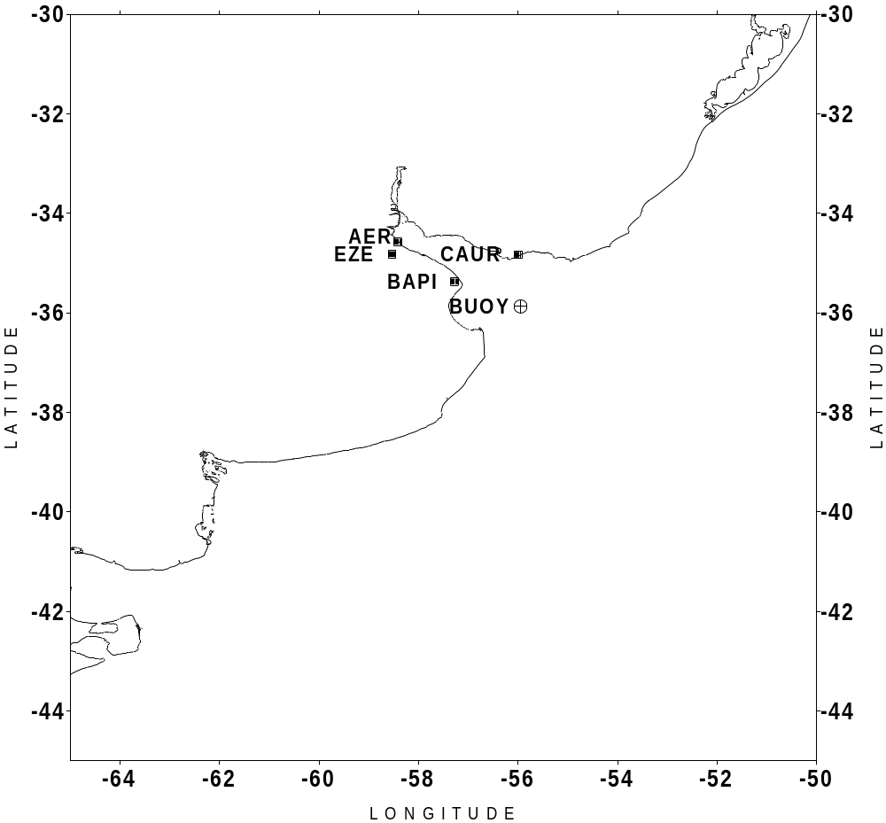
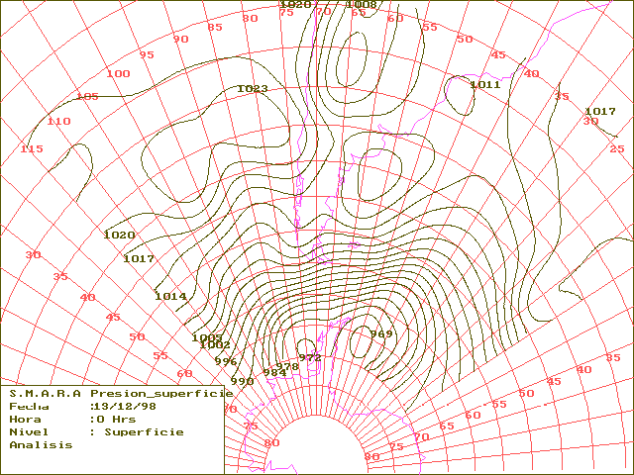
Figure 2. 12/13/98 0000GMT surface pressure analysis
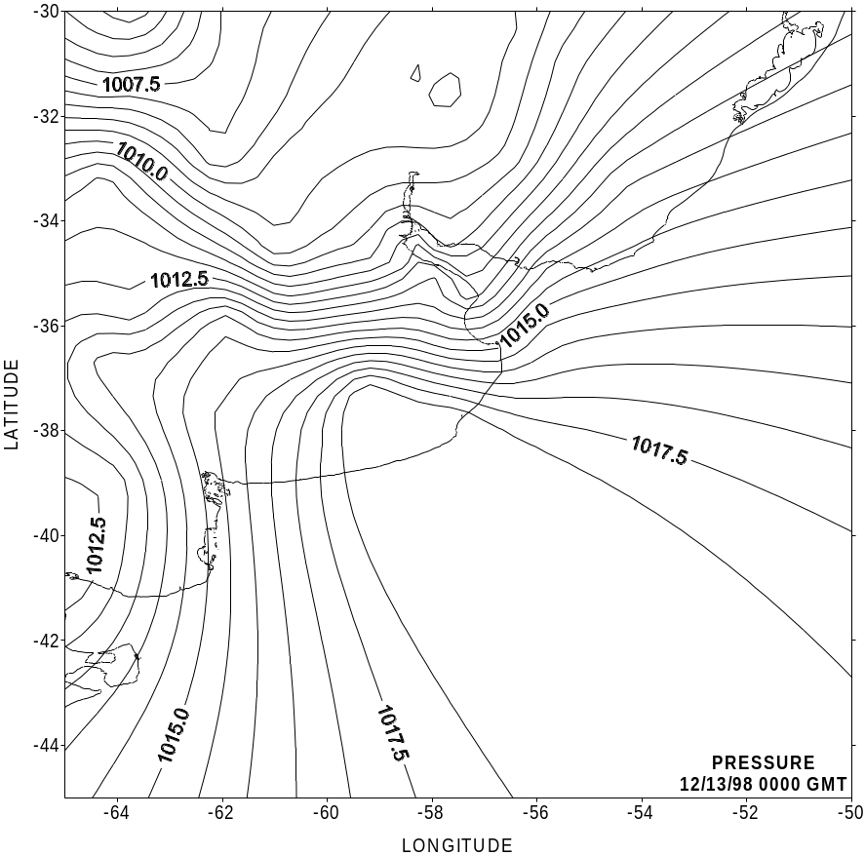
Figure 3. 12/13/98 0000GMT surface pressure mesoscale analysis.
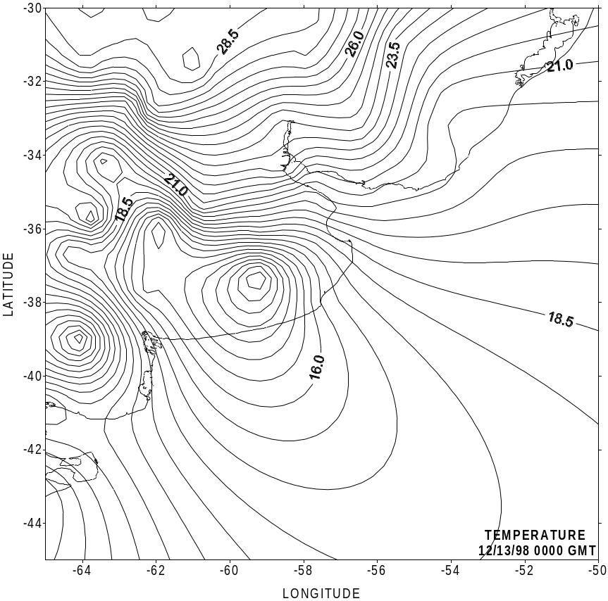
Figure 4. 12/13/98 0000GMT air temperature mesoscale an
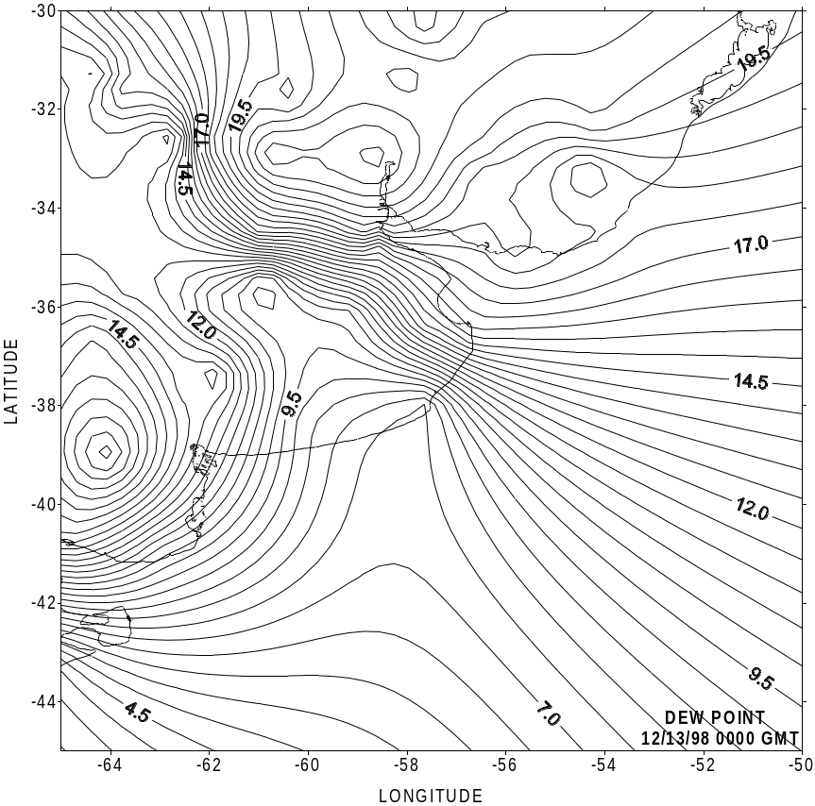
Figure 5. 12/13/98 0000GMT dew point mesoscale analysis.
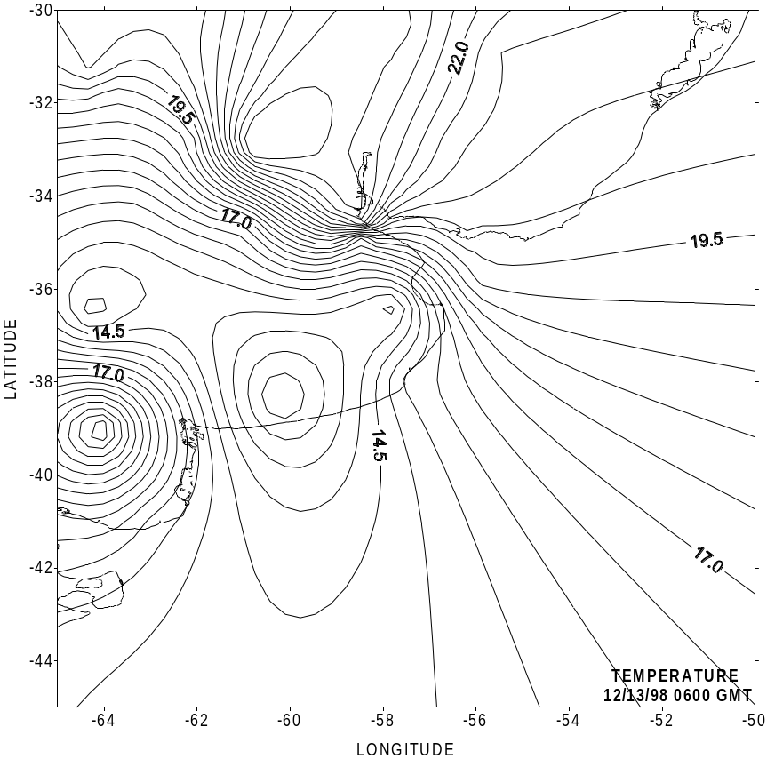
Figure 6. 12/13/98 0600GMT air temperature mesoscale analysis.
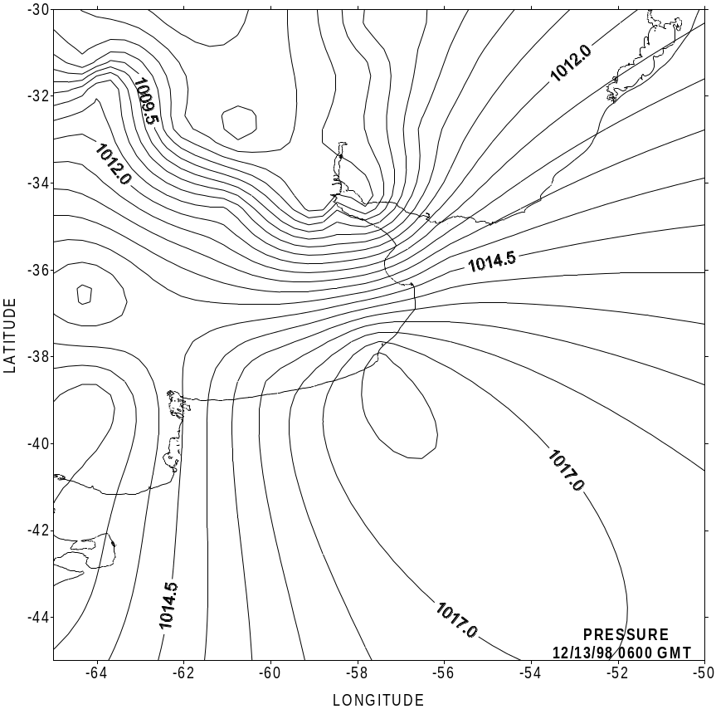
Figure 7. 12/13/98 0600GMT surface pressure mesoscale analysis.
Figure 8. 12/13/98 1200GMT Surface pressure analysis.

Figure 9. 12/13/98 1200GMT surface pressure mesoscale analysis.
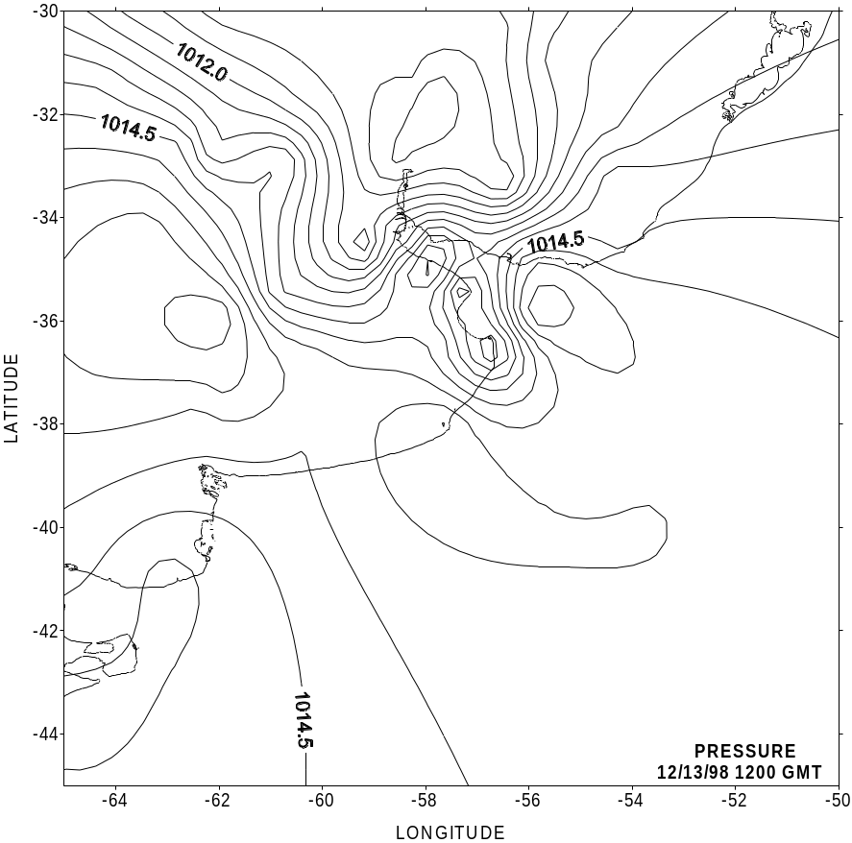
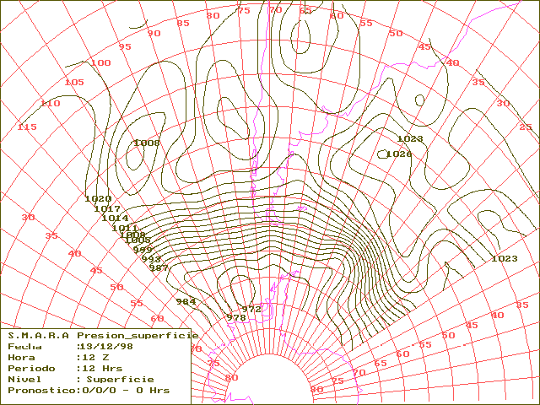
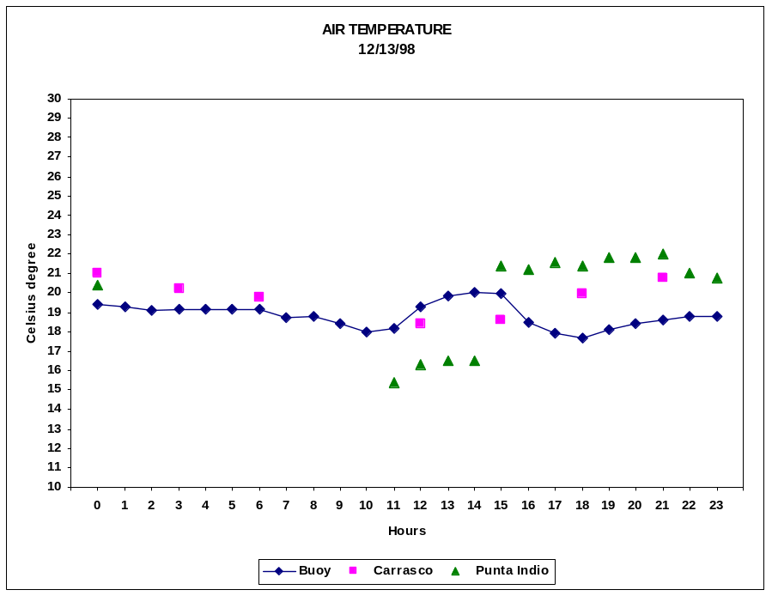

Figure 10. 12/13/98 Buoy, Carrasco and Punta Indio air temperature versus time (local time= GMT-3).

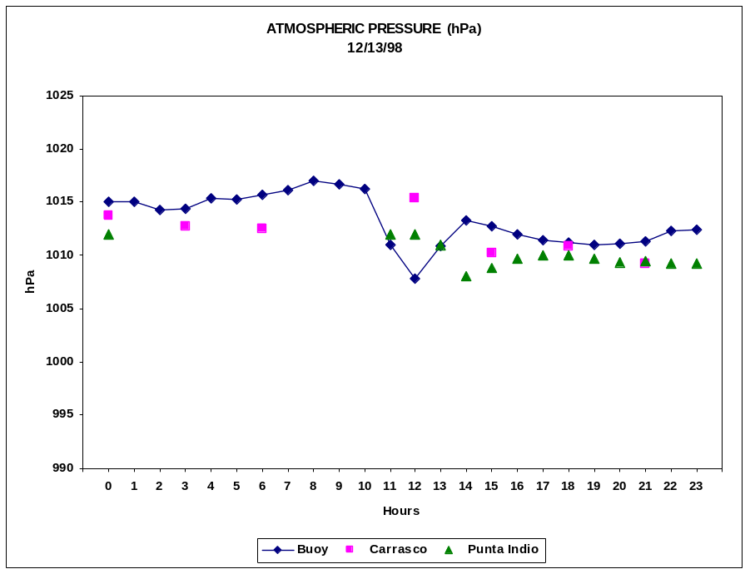

Figure 11. 12/13/98 Buoy, Carrasco and Punta Indio atmospheric pressure versus time (local time=GMT-3).

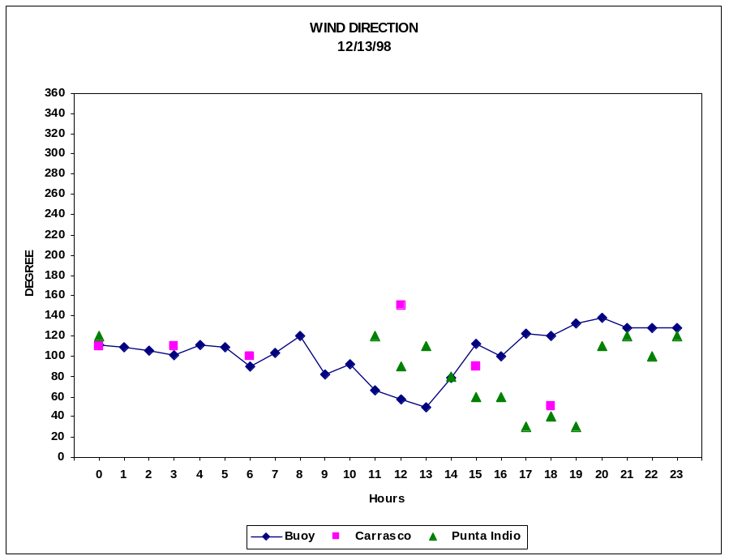

Figure 12. 12/13/98 Buoy, Carrasco and Punta Indio wind direction versus time (local time=GMT-3).

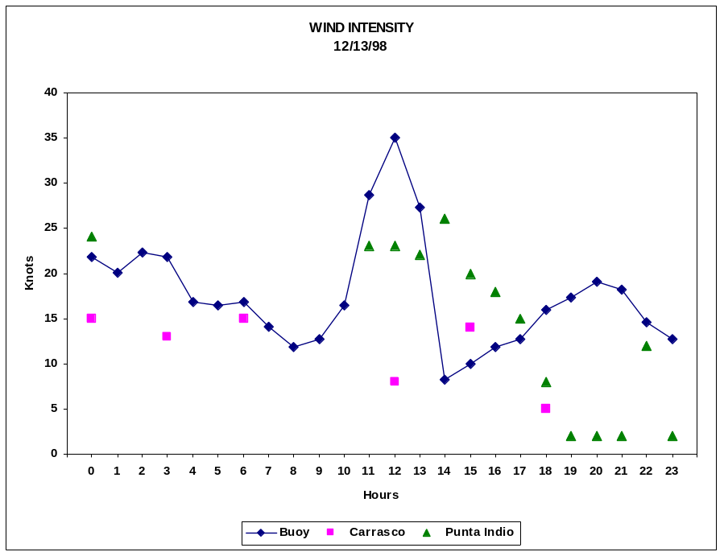

Figure 13. 12/13/98 Buoy, Carrasco and Punta Indio wind intensity versus time (local time=GMT-3).

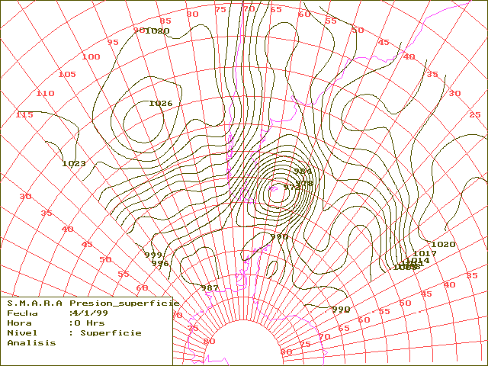
Figure 14. 1/4/99 0000GMT Surface pressure analysis
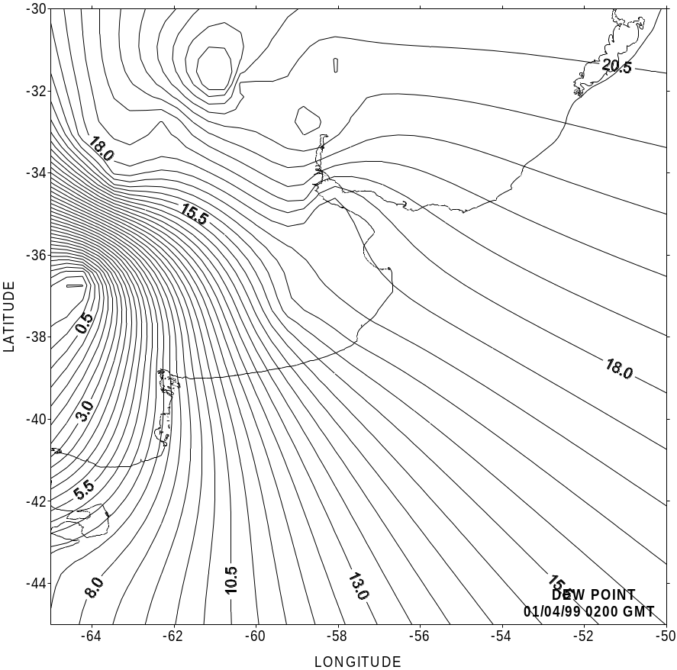
Figure 15. 4/1/99 0300GMT dew point mesoscale analysis.

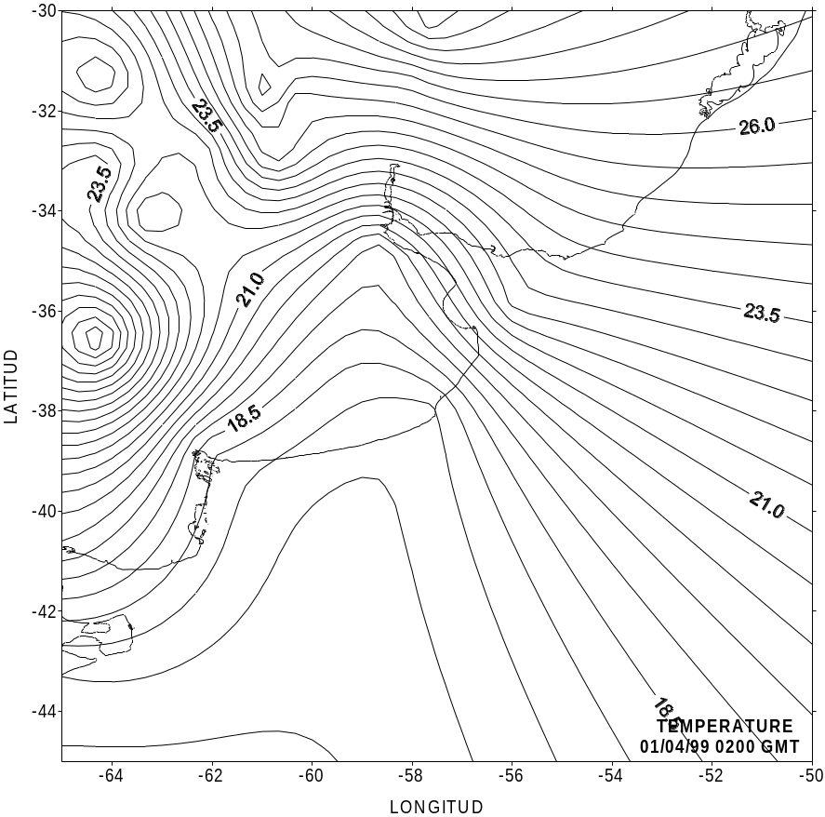
Figure 16. 1/4/99 0200GMT air temperature mesoscale analysis.

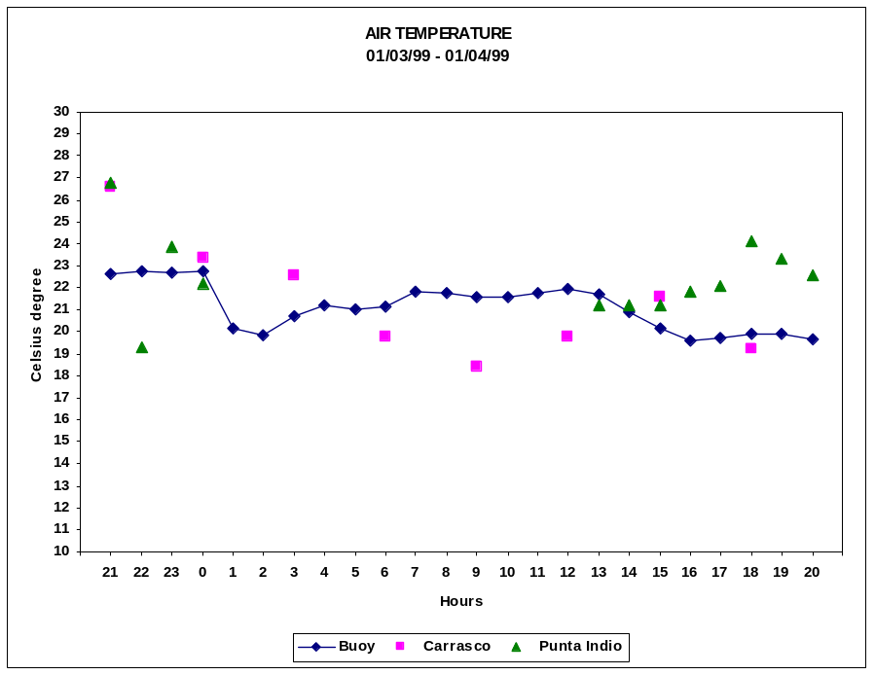

Figure 17. 1/4/99 Buoy, Carrasco and Punta Indio air temperature versus time (local time=GMT-3).

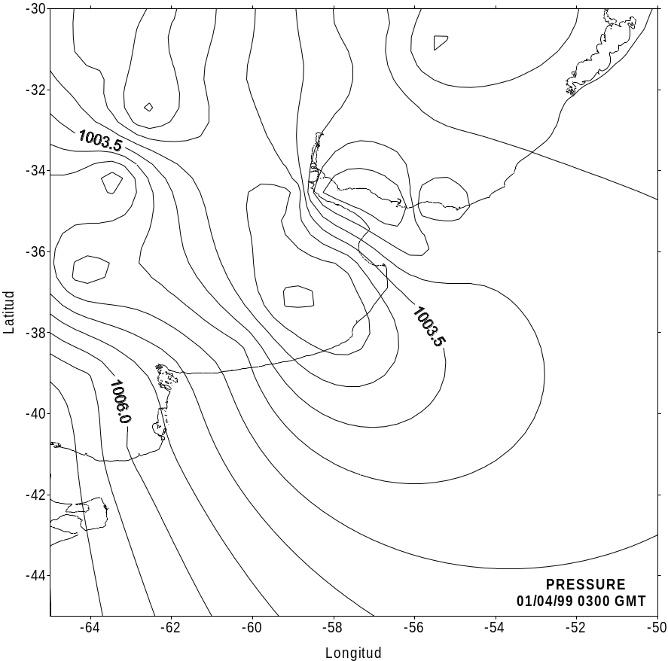
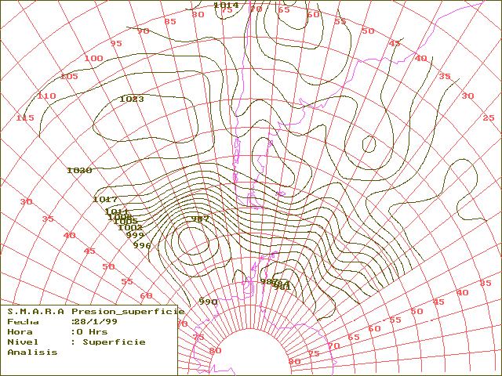Figure 18. 1/4/99 0300GMT surface pressure mesoscale analysis.

Figure 19. 1/28/99 0000GMT Surface pressure analysis

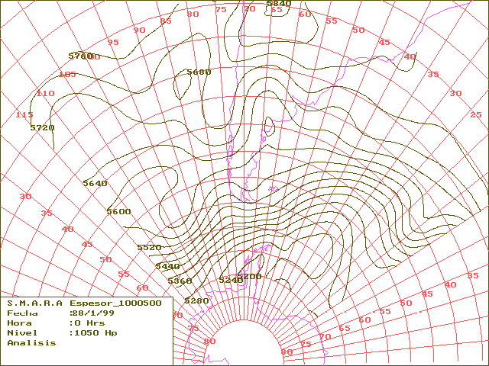Figure 20. 1/28/99 0000 GMT 1000/500 hPa thickness analysis

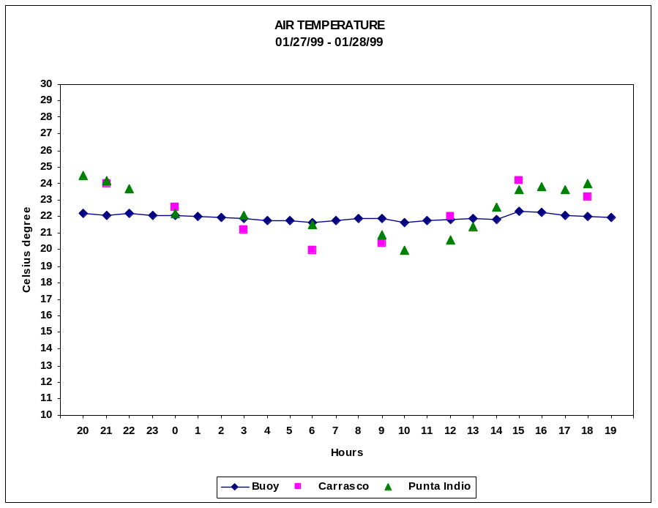

Figure 21. 1/28/99 Buoy, Carrasco and Punta Indio air temperature versus time (local time=GMT-3).

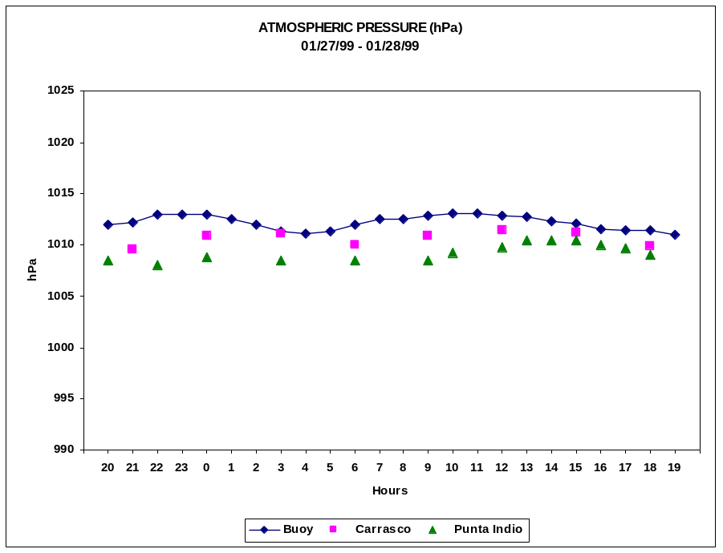

Figure 22. 1/28/99 Buoy, Carrasco and Punta Indio surface pressure versus time (local time=GMT-3).

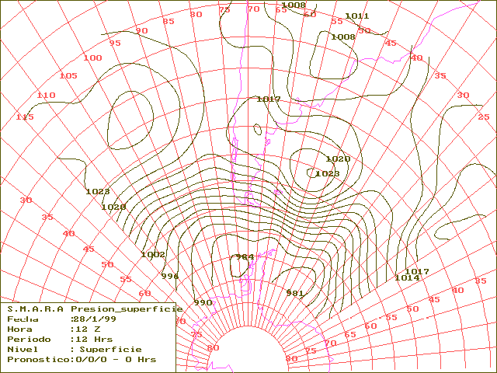

Figure 23. 1/28/99 1200GMT Surface pressure analysis

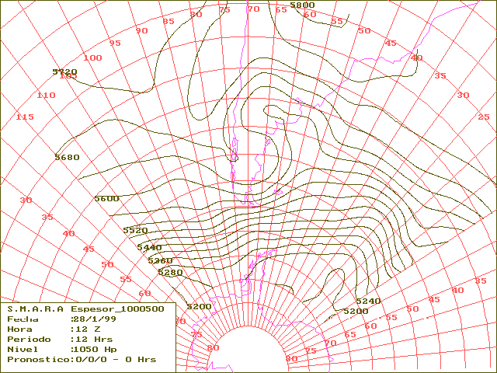
Figure 24. 1/28/99 1200 GMT 1000/500 hPa thickness analysis.
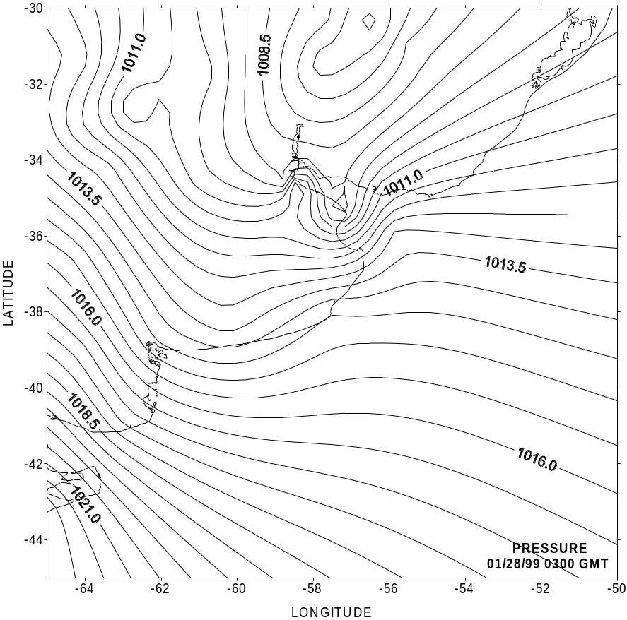
Figure 25. 1/28/99 0300GMT surface pressure mesoscale analysis.

