DATA BUOY COOPERATION PANEL
SEVENTEENTH SESSION

Perth, Australia, 22-26 October 2001

FINAL REPORT

JCOMM Meeting Report No. 8
WORLD METEOROLOGICAL ORGANIZATION  _____________ |  | INTERGOVERNMENTAL OCEANOGRAPHIC COMMISSION (OF UNESCO)  ___________

DATA BUOY COOPERATION PANEL
SEVENTEENTH SESSION

Perth, Australia, 22-26 October 2001

FINAL REPORT

JCOMM Meeting Report No. 8

N O T E

The designations employed and the presentation of material in this publication do not imply the expression of any opinion whatsoever on the part of the Secretariats of the Intergovernmental Oceanographic Commission (of UNESCO), and the World Meteorological Organization concerning the legal status of any country, territory, city or area, or of its authorities, or concerning the delimitation of its frontiers or boundaries.
C O N T E N T S

Report 1

Annex I - List of Participants 25

Annex II - Agenda 31

Annex III - Report of the Technical Coordinator 33

Annex IV - Action Group Report Summaries 60

Annex V - Terms of Reference for the DBCP Evaluation Subgroup 64

Annex VI - Summary of Reports by Data Management Centres 65

Annex VII - Argos System Status and Development 66

Annex VIII - Developments in Satellite Communications Systems 85

Annex IX - Data from Commerical Satellite Systems via the Argos GTS Sub-system 96

Annex X - Financial Situation 100

Annex XI - Expenditures and Income for 1998-2003 103

Annex XII - Contributions 104

Annex XIII - DBCP Implementation & Technical Workplan for the 17th Year 106

A. ORGANIZATIONAL COMPONENT

1. ORGANIZATION OF THE SESSION

1.1. OPENING OF THE SCIENTIFIC AND TECHNICAL WORKSHOP

1.1.1 The Scientific and Technical Workshop with DBCP-XVII was opened by the chairman of the panel, Mr Graeme Brough, at 09.00 hours on Monday, 22 October 2001, in the conference room of Rydges Hotel in Perth, Australia. In doing so, he welcomed all participants to the session, to Australia and to Perth. He expressed gratification at the large number of participants, and offered his thanks to the workshop convener, Mr Ron McLaren, for putting together such an interesting and challenging programme. Mr Brough then invited the Regional Director for Western Australia of the Bureau of Meteorology, Mr Len Broadbridge, to address the session.

1.1.2 Mr Broadbridge also welcomed participants to the meeting and to Perth. In providing an outline of the geography of Western Australia and of the weather and climate of the region, he recognized that the location of the state, bordering both the Indian and Southern Oceans, meant that its meteorology was very dependent on the surrounding oceans. Similarly, weather and climate forecasts for the region were critically dependent on extensive and reliable data from these oceans. In this context, the work of the DBCP was of great importance to both operational meteorology and regional climate studies, and it was thus very appropriate for the panel to be meeting in Perth at this time. Mr Broadbridge expressed his thanks to the IOC Regional Office in Perth, and especially its Director, Mr Bill Erb, for their assistance in preparing for the present session. He concluded by wishing all participants a successful meeting and enjoyable stay in Western Australia.

1.1.3 On behalf of the Executive Secretary IOC, Dr Patricio Bernal, the Director of the IOC Regional Office in Perth, Mr Bill Erb also welcomed participants to the meeting and to Perth. He noted that the Regional Office had been set up with sponsorship from the IOC, the Government of Western Australia and the Bureau of Meteorology, to serve the needs of the Indian Ocean and South West Pacific regions, in particular in the development of the Global Ocean Observing System (GOOS). He outlined some of the current activities of the office in the further development and implementation of GOOS in the region, to which the DBCP was making a significant contribution. In addition, there was a large and diverse marine science community in the Perth area, which was itself contributing to an embryo WAGOOS. Mr Erb concluded by assuring the meeting of the full support of his office and by wishing all participants an enjoyable stay in Perth.

1.1.4 On behalf of the Secretary-General of WMO, Professor G.O.P. Obasi, the representative of the WMO Secretariat also welcomed participants to the meeting, to Australia and to Perth. In doing so, he thanked the Australian Bureau of Meteorology, and in particular Mr Broadbridge and his staff of the Western Australian Regional Office, and the IOC Regional Office in Perth, for organizing the session and for providing such excellent facilities and generous hospitality. He recalled that the DBCP had already enjoyed extraordinary success in the sixteen years of its existence to date, in coordinating buoy programmes worldwide and in enhancing both the quality and availability of buoy data in support of many of the major programmes of WMO and IOC. This success had been due to both the hard work and spirit of cooperation of all panel members, as well as to the effectiveness of its technical coordinators. In recent years it had also encompassed the very popular technical workshops. At the same time, the panel was likely to be called upon to do even more in the future, within the overall marine programme coordination process under the Joint WMO/IOC Technical Commission for Oceanography and Marine Meteorology (JCOMM), in support in particular of global climate studies and marine research. The representative of WMO concluded by assuring the panel of the continuing full support of both Secretariats, and wishing participants a successful meeting and enjoyable stay in Perth.

1.1.5 The list of participants in the workshop is given in an appendix to the workshop proceedings, which are published as a separate DBCP Technical Document.

1.2. OPENING OF THE SESSION

1.2.1 The seventeenth session of the DBCP itself was opened by the panel chairman, Mr Graeme Brough, at 14.30 hours on Tuesday, 23 October, at the same location as the workshop. The list of participants in the session is given in Annex I.

1.3. ADOPTION OF THE AGENDA

1.3.1 The panel adopted its agenda for the session, which is given in Annex II.

1.4. WORKING ARRANGEMENTS

1.4.1 Under this agenda item, the panel decided on its working hours and other arrangements for the conduct of the session. The Secretariats introduced the documentation.

B. IMPLEMENTATION COMPONENT

2. IMPLEMENTATION REPORTS

2.1 TECHNICAL COORDINATOR

2.1.1 The technical coordinator, Mr. Etienne Charpentier, reported on his activities during the intersessional period. He was based in Toulouse, at CLS/Service Argos, and employed by UNESCO. As agreed at previous DBCP sessions, he spent a percentage of his time (about 28% this year) on Ship-of-Opportunity Programme (SOOP) issues. Some assistance on routine tasks, at a level of about 25% of a person's time, was also provided by CLS/Service Argos. The technical coordinator in return from time to time provided some expertise to CLS. About 11% of the technical coordinator's time was also spent on Argo before the Argo coordinator was hired in February 2001 to run the Argo Information Centre (AIC). He provided assistance in the recruitment process. The Argo coordinator who is also based at CLS in Toulouse, and hired under similar contractual conditions, is now placed under the technical coordinator's supervision within the new JCOMMOPS structure, which was established by JCOMM at its first meeting in Akureyri, Iceland, in June 2001.

2.1.2 About 30% of the technical coordinator's time was spent on missions, including preparation. He attended the following meetings:

- Argo data management meeting, IFREMER, Brest, 4 Oct. 2000,
- DBCP-16, Victoria, 16-20 Oct. 2000,
- JTA-20, Victoria, 23-35 Oct. 2000,
- NOAA visit (basically for SOOP), Washington-DC, 27 Oct. – 3 Nov. 2000,
- Discuss Argo with Norwegian institutes, Oslo, 11 December 2000,
- Discuss SeaWatch moored buoy programmes with OCEANOR, Bergen, 12 December 2000
- Preparing JCOMM-1, WMO, Geneva, 5-7 February 2001,
- Working on CEOS/WMO database, SOC, Southampton, 1-2 March 2001,
- Argo Science Team, IOS, Sydney, Canada, 20-22 March 2001,
- CBS Expert Team on Data Representation & Codes, Météo France, Toulouse, 24-25 April 2001,
- CBS Expert Team on Migration to Table Driven Codes, WMO, Geneva, 9-10 May 2001
- IABP meeting, JAMSTEC, Yokohama, 30 May – 1 June 2001,
- Visit JMA, Coast Guards, JAMSTEC, Yokohama, 4-5 June 2001,
- JCOMM-1 meeting, Akureyri, Iceland, 22-22 June 2001,
- I-GOOS meeting, IOC, Paris, 28-30 June 2001,
- Argo Indian Ocean Implementation meeting, Hyderabad, 26-27 July 2001.

2.1.3 A substantial amount of time was spent on user assistance. This included assisting users in inserting their buoy data onto the GTS, providing them with monitoring data, investigating technical problems with particular buoys (why the data are not on GTS? why specific data are wrong?), answering technical questions, providing users with information and/or documentation, etc.

2.1.4 A wide variety of other tasks were performed which included for example: (i) writing technical specifications for encoding buoy data in BUFR using the Argos GTS sub-system, (ii) identifying the buoy programmes whose data are not distributed on the GTS and seeking authorization, (iii) assisting CLS, Service Argos in upgrading the Argos GTS sub-system for resolving specific problems (e.g. new geo-magnetic variation model, processing profile data, encoding housekeeping parameter data in the BUOY code, encoding location time on BUOY reports), (iv) operating the DBCP quality control guidelines, (v) adding new pages onto the DBCP and JCOMMOPS web sites and updating existing pages, (vi) establishing electronic mailing lists for the DBCP and buoy operators, (vii) producing specific reports and statistics, (viii) working on JCOMMOPS database developments in conjunction with the Argo Coordinator, (ix) discussing Argos message format issues with the SVPB evaluation group, etc.

2.1.5 The technical coordinator presented the status of buoy programmes. He reported that in July 2001, about 800 buoys reported on the GTS in BUOY code (nearly all of them reporting SST, about 250 reporting air pressure (representing about 50% of the total BUOY reports), 150 reporting air temperature, 100 reporting wind and 100 reporting sub-surface temperature profiles) and more than 200 moored buoys in SHIP code (mostly meteorological buoys). All buoys reporting in BUOY code are either drifting buoys or moored buoys on the high seas (e.g. TAO). Some of the buoys reporting in SHIP are actually deployed on the high seas (e.g. UKMO moorings). The total number of drifting buoys deployed worldwide seems to have stabilized in the last couple of years at a level of about 1300 drifting buoys. About 57% of these buoys are reporting their data on the GTS.

2.1.6 The full report of the technical coordinator is given in Annex III. The panel expressed its considerable appreciation to Mr Charpentier for the substantial amount of work he had accomplished in support of the DBCP in the past year, especially taking into account the additional support he had provided for Argo and JCOMM.

2.2 ACTION GROUPS AND RELATED PROGRAMMES

2.2.1 Under this agenda item, the panel was presented with reports by its action groups, viz:

- the European Group on Ocean Stations (EGOS) (verbal presentation by Mr Pierre Blouch, EGOS technical coordinator);
- the International Arctic Buoy Programme (IABP) (verbal presentation by Ms Estelle Couture, on behalf of the IABP officers);
- the International Programme for Antarctic Buoys (IPAB) (verbal presentation by Dr Enrico Zambianchi, IPAB chairperson);
- the International South Atlantic Buoy Programme (ISABP) (verbal presentation by Mr Alaor Moacyr dall’Antonia, ISABP chairperson);
- the International Buoy Programme for the Indian Ocean (IBPIO) (verbal presentation by Mr Graham Jones, IBPIO chairperson);
- the Global Drifter Programme (GDP) (verbal presentation by Mr Craig Engler, GDP representatative); and
- the Tropical Moored Buoys Implementation Panel (TIP) (written presentation by Mr Paul Freitag, representing the TIP).

A summary of the presentations is reproduced as Annex IV. As usual, the full reports of the action groups will be reproduced in the panel’s annual report.

2.2.2 A few questions and/or comments were raised concerning those presentations:

- the possibility of the Black Sea buoy programme becoming part of EGOS should be solved through the issuing of a “letter of intent”, addressed by the Black Sea programme chair to the EGOS chair;

- MEDS discovered a problem of bad positions for some of the data put onto the GTS by the Edmonton LUT and the Oslo LUT. Only a small number of LUTs were examined and therefore, it is possible that others may experience similar problems. The panel recognized that since the Edmonton LUT was connected to Service Argos, the users from other countries did not experience this problem. The Meteorological Service of Canada is currently taking steps to correct position accuracy problems for Canadian users and the Norwegian Meteorological Institute will soon connect the Oslo LUT to Service Argos making the position problems disappear for EGOS buoys. Other problems of suspicious locations are dealt with in more detail under agenda item 6.1;

- the panel expressed satisfaction at the reinvigoration of the IPAB after a long transition period;

- the view was expressed that some contacts might be established between ISABP and EGOS, since the former was interested in oceanic zones very close to the so-called “EGOS-South”.

2.3 NATIONAL REPORTS

2.3.1 The panel had received written reports on current and planned buoy programmes from Australia, Brazil, Canada, France, India, Ireland, Japan, Netherlands, New Zealand, Republic of Korea, South Africa, USA. As usual, these reports, as well as others submitted to the Secretariats before 30 November 2001, would be published in the panel’s annual report.

2.4 ARGO

2.4.1 The technical coordinator presented the paper prepared by the Argo technical coordinator regarding the latest developments in the Argo Programme. He recalled that Argo was a pilot project of GODAE and CLIVAR. Argo consists of a broad-scale global array of temperature/salinity profiling floats. It plans to develop a global array of about 3000 floats by 2005, at a horizontal resolution of about 3°x3°. The floats measure water temperature and salinity profiles in the upper 2000 meters of the water column. Access to Argo float data is free and unrestricted with no period of exclusive use. Argo data are distributed globally in real-time over the Global Telecommunication System (GTS) of WMO within 24 hours of the pop-up time. Simple automatic quality control checks are applied before GTS distribution of the data. Scientifically quality controlled data will be available within 3 months via the Internet.

2.4.2 Argo, which is managed by the Argo Science Team, is entering its implementation phase, with more than 200 floats operational in August 2001 and over 400 by late 2001 (including deployments in the Atlantic Ocean, Pacfic Ocean, and Indian Ocean). The number of deployments should sharply increase in the following years. Participating in Argo are the European Union (Gyroscope project), Australia, Canada, France, Denmark, Germany, Japan, Republic of Korea, UK, and USA. Future partners interested to participate in Argo include the People’s Republic of China, New Zealand, India, and the Russian Federation.

2.4.3 A total of 310 floats were funded by six nations through the end of 2000. An additional 325 floats were funded by ten nations and the European Commission in 2001. There are 683 floats per year proposed for funding from 2002 through 2004 by eleven nations. Assuming that 90% of the floats live four years (the other 10% fail early), it will be necessary to provide floats at a sustained rate of 825 per year to maintain a global array. Several nations are seeking additional support for float procurement and several nations are looking at entering into the Argo programme and providing floats. The number of floats available after 2001 continues to vary with funding cycles and programmes, however, given the above information it is quite feasible that a global array of approximately 3,000 floats could be achieved in the 2005-2006 period. Deployments planned through 2001 are focusing on the North, subtropical, and tropical Atlantic; North Pacific; tropical and subtropical Western Pacific; and equatorial Indian Ocean. These areas will continue to receive floats in 2002 along with float deployments planned for the South Atlantic and Southern Ocean.

2.4.4 Data management is done through the Argo Data Management Team (DMT). There are two Argo global data centres, the US GODAE server in Monterey, and the Coriolis data centre in Brest, and several regional or specialized Argo data centres. Argo data are exchanged between those centres in NetCDF format. GTS distribution is presently realized in TESAC format but it is planned to switch to BUFR. The US NODC is acting as the long-term repository for Argo data. The next meeting of the Argo DMT will take place in Brest in November 2001.

2.4.5 The panel was also informed of the establishment in February 2001 of the Argo Information Centre (AIC) in Toulouse, France, which is part of JCOMMOPS. Mathieu Belbeoch, the Argo technical coordinator, was hired at that time to run the AIC and is placed under the supervision of the DBCP technical coordinator. The tasks of the Argo Technical Coordinator are similar to those of the DBCP Technical Coordinator and include (i) fulfilling the requirements of IOC Resolution XX-6 which requires, inter alia, that Member States be informed in advance of the deployment of floats which might drift into their EEZ, (ii) assisting with the implementation and operations of the Argo programme, (iii) providing information, including status of Argo, etc. A JCOMMOPS database and related web based information system is being developed in cooperation between the DBCP, SOOP, and Argo technical coordinators, to serve the needs of these three programmes.

2.5 EVALUATION SUBGROUP

2.5.1 The panel noted with interest and appreciation that the year 2001 was an active year for the SVP drifter community. Meteo-France conducted an analysis of the SVP drifters deployed and found that the total number of SVP-B drifters has decreased since 1996, that performance is independent of deployment method, that early failures have decreased since 1998, that average life expectancy is about 350 days, and that the SVP-B system is valuable for collecting AP data. However, there is still some room for improvement. The TC also found that average life expectancy for SVP-B drifters is about 12 months, while about 38% operate properly for 2 years or more. RMS errors for these drifters remained low, at about 1 hPa.

2.5.2 The SAWS had suffered a grave loss of operational meteorological data for their forecast models as a result of early barometer failures, but at the same time MetService NZ realized good results with their deployments of SVP-B drifters, so will participate more actively in the SVP drifter programme. This includes 6 barometer upgrades for the Southern Ocean. Environment Canada also operationally deployed SVP-B drifters with good results. Several agencies reported on a serious drogue detachment problem, which has since been corrected by the manufacturer. The subgroup chairman urged that manufacturers focus on their quality assurance programmes to prevent serious data losses.

2.5.3 Although data format issues were outside the scope of the subgroup, there is an on-going and fruitful discussion with regard to the change from 20-bit to 28-bit Argos ID’s. Participants in these discussions provided valuable insight into the issue. As a result of recent discussions, the subgroup recommended the deletion of the DBCP01, DBCP02, and M1 formats, while keeping the M2 format, and introducing a DBCP03 format to replace the obsolete DBCP01 format and a DBCO04 format for oceanographic and development/evaluation applications. The subgroup recommends that the obsolete formats be deleted from the DBCP recommended format list, with the two new ones added.

2.5.4 A suggestion was made that some terms used to report drifter status be clearly defined by the subgroup (e.g. “buoy failure”) as these terms may be different for meteorologists and oceanographers. The subgroup is working on this issue and will report to the TC during the intersessional period.

2.5.5 The panel reviewed a proposal by the Technical Coordinator to extend the terms of reference, and possibly membership, of the SVPB/SVPBW evaluation group to become a DBCP evaluation group. The panel recalled that the SVPB/SVPBW evaluation group was created in May 1999 by the DBCP to deploy and test SVPB drifters and variants (e.g. SVPBW, Minimet) in various sea conditions, evaluate the data, suggest hardware/software design changes, share experience, etc. The subgroup is chaired by Elizabeth Horton, primarily works via email, meets annually in conjunction with DBCP workshops, and reports to the DBCP at panel sessions. The panel agreed that the subgroup had proved successful and had led to significant improvements in the quality of the data produced by these instruments. At the same time, the panel agreed that there was a need (i) to evaluate other types of buoys or instruments (e.g. moorings, thermistor strings) but also (ii) to routinely discuss other technical issues such as DBCP recommended Argos message formats, or to define specific DBCP criteria regarding life-times, early failures, ocean areas, etc.

2.5.6 The panel therefore decided to extend the terms of references of the subgroup accordingly and renamed it as “DBCP Evaluation Group”. New terms of reference as well as present group membership are given in Annex V.

2.5.7 The panel discussed a proposal by Dr Sergey Motyzhev to establish a dedicated budget line within the DBCP trust fund for permitting DBCP members to support specific data buoy evaluation studies within an agency in another country. The panel agreed that this would be useful and decided to establish such a fund. It invited interested Member States to make commitments to the proposed dedicated fund. It also requested the chairman to write formally to WMO to request establishment of this budget line.

3. REVIEW OF THE DBCP IMPLEMENTATION STRATEGY

3.1 The panel recalled that it had reviewed its Implementation Strategy in detail at its previous session and agreed that this review process should continue at each annual meeting, in view of ongoing developments in requirements for buoy data, as well as advances in buoy technology. In this context, it undertook a thorough review of the latest version of the strategy. This review included, inter alia, modifications to global requirements for buoy data in support, in particular, of operational meteorology and oceanography, major research programmes including the World Climate Research Programme (WCRP), and the Global Ocean Observing System (GOOS) and Global Climate Observing System (GCOS). The review also encompassed implementation aspects such as the deployment strategy for Southern Hemisphere barometer drifters. The panel agreed that, in view of its highly dynamic nature, the Implementation Strategy should in future be published and made available only through the DBCP web site.

3.2 The panel discussed the Southern Ocean Buoy Programme (SOBP), which is part of its implementation strategy. It recalled that at its last session, it asked the technical coordinator to compile the list of proposed Member States’ commitments for 2002 in the Southern Ocean (i.e. south of 40S to the sea ice zone). The technical coordinator reported figures provided by Member States so far. These can be summarized as follows:

Country | Buoys purchased  SO | Additional upgrades  SO | Total
Australia | 13 | 12 | 25
France | 3 | 5 | 8
Germany | 1 | 0 | 1
New Zealand | 5 | 6 | 11
South Africa | 10 | 8 | 18
UK | 3 | 0 | 3
USA | 15* | 0 | 15
Total | 50 | 31 | 81

3.3 The panel was pleased to hear that the total number of buoys committed for 2002 reached the proposed level of deployments for that region according to the DBCP Implementation Strategy, i.e. about 80 units. It thanked Member States for their continuing support to make air pressure measurements using data buoys in this data sparse area and asked the technical coordinator to coordinate this exercise again for the next panel session.

4. SCIENTIFIC AND TECHNICAL WORKSHOP

4.1 Under this agenda item, the panel reviewed briefly the results of the preceding workshop. The panel expressed its appreciation to Mr Ron McLaren for his excellent work in organizing and chairing the workshop. It agreed that, as before, the proceedings should be published in the DBCP Technical Document series, this time on CD-ROM only, and also made available via the DBCP web site. To this end, all presenters were requested to make the full versions of their papers available to Mr McLaren, in electronic form (MS Office compatible format only), by 31 December 2001 at the latest. The panel further agreed that the 2002 workshop should focus again on applications of buoy data, and should include three main sections, with if possible a particular focus on the meteorology and oceanography of tropical ocean regions:

- research applications
- operational applications
- buoy technology and communications

The panel accepted the kind offer of Mr Eric Meindl to undertake the organization of this workshop.

5. DATA AND INFORMATION EXCHANGE

5.1 REPORTS BY BUOY DATA MANAGEMENT CENTRES

5.1.1 Under this agenda item, the panel reviewed the reports of the IOC International Oceanographic Data and Information Exchange (IODE) Responsible National Oceanographic Data Centre (RNODC) for drifting buoys, operated by the Marine Environmental Data Service (MEDS) of Canada; and of the JCOMM Specialized Oceanographic Centre (SOC) for drifting buoys, operated by Météo-France. A summary of the reports is reproduced as Annex VI. As usual, the full reports of the data management centres will be published in the panel’s annual report.

5.1.2 At its first session (Akureyri, Iceland, June 2001), JCOMM had requested that a study be made on the necessity, or otherwise, of having two different centres dealing with the same kind of data, as is the case for the RNODC and the SOC for drifting buoys. The panel noted that the two centres had different purposes – the RNODC being more oriented towards oceanography and science, and the SOC towards meteorology and operational activities. In addition, they were presently issuing different kinds of products. It nevertheless considered that such a study should be undertaken, involving a complete picture of the activities of both centres in the field of drifting buoys. It agreed that JCOMM might wish, if necessary, to re-focus the work of the centres so as to avoid any duplication of efforts and ensure their full complementarity.

5.2 INFORMATION EXCHANGE

5.2.1 The Panel reviewed the different media it is using for exchange of information. These include the DBCP web site (http://dbcp.nos.noaa.gov/dbcp/) which is hosted by NOAA in Silver Spring, USA, the electronic mailing lists, an Internet technical forum hosted by CLS/Service Argos, DBCP publications and a brochure.

Web site

5.2.2 Pages from the web site have regularly been updated by the technical coordinator and a few new pages added. The web site now includes a wide variety of information such as current DBCP activities, current status of buoy programmes, the list of DBCP recommended Argos message formats, the list of GTS bulletin headers used for GTS distribution of buoy data, links to other pages such as the various panel Action Groups web pages or data monitoring tools (e.g. buoy monitoring statistics), information on data telecommunication systems, deployment opportunities, etc. The web site also includes practical information on how to insert buoy data onto the GTS and to obtain WMO numbers. The panel agreed that the web site was an excellent tool for delivering useful information to panel members, buoy operators, and data users. However, the panel reiterated that in order to keep the web site up to date, panel members are invited to regularly provide the technical coordinator with the latest information on deployment opportunities and deployment plans. The panel also invited the panel members and the Action Groups to provide national and Action Group annual reports respectively in electronic form to the Secretariats and the technical coordinator for inclusion in relevant DBCP web site web pages.

5.2.3 The technical coordinator also informed the panel that DBCP related information was available via the JCOMMOPS web site. This included information on deployment opportunities, status of buoy programmes, WWW, GOOS/GCOS requirements, links to the DBCP web site as well as Action Group web sites, list of meetings, points of contact, etc.

Internet technical forum

5.2.4 The technical coordinator informed the panel that the existing DBCP Internet Technical forum had been renamed (the new address is now http://forum.jcommops.org/) and integrated into a JCOMMOPS forum to deal with other types of platforms as well (i.e. XBTs and profiling floats). This facilitates utilization by users (e.g. one single username/password). The Internet forum is a means of debating technical issues, answering technical questions, and exchanging information among buoy operators or users. Users can easily upload documents, graphics, and web pages into the forum. The panel agreed that the forum was a good complement to the DBCP web site and recommended that panel members should use it.

Electronic mailing lists

5.2.5 As recommended at the panel’s 16th session, two electronic mailing lists have been established by the technical coordinator. One mailing list is basically for panel members to exchange general information regarding the panel's activities (dbcp@jcommops.org presently including about 91 names) and the other one is for a wider community to exchange technical information (e.g. buoy technology, data telecommunication) among buoy operators (buoys@jcommops.org presently including 133 names). In addition, during the intersessional period, a mailing list was established for the SVPB/SVPBW evaluation group (dbcpeval@jcommops.org).

5.2.6 The panel agreed that these mailing lists were an excellent way for exchanging information among interested members and parties. It recommended that they should check with the technical coordinator whether their names actually appeared on the mailing lists and to contact him if they were interested in being added.

Publications

5.2.7 During the intersessional period, the DBCP published its Annual Report for 2000 as Technical Document No. 18, and the proceedings of the October 2000 Workshop in Victoria as Technical Document No. 19. The DBCP documents No. 15 (DBCP implementation strategy) and No. 2 (GTS sub-system guide) were also updated and are about to be published by WMO.

5.2.8 The panel agreed that since the Implementation Strategy document needed to be regularly updated it would be preferable to publish it in electronic form on the web only. This would also permit to save costs on DBCP publications. A new version of publication No. 3 (guide to data collection and location services using Service Argos) is also in the process of being updated. The panel asked the technical coordinator to coordinate this with CLS during the next intersessional period and to submit the updated version to WMO before April 2002 for publication.

5.2.9 As agreed at its 16th session, a draft version of the SVPB design manual was available at the session and will be reviewed by the panel’s evaluation group. The panel agreed that the design manual should be available in electronic form through the DBCP web site.

Brochure

5.2.10 The brochure was reviewed at the Panel's 16th session. This new version will soon be published by the Australian Bureau of Meteorology, as proposed at DBCP-16. At its 15th session in Wellington, the panel decided that the DBCP brochure should be updated every other year. There was therefore no need to update the brochure at this 17th DBCP session.

6. TECHNICAL ISSUES

6.1. QUALITY CONTROL

6.1.1 The technical coordinator reported that a substantial decrease in activity of the DBCP QC guidelines was noticed in the period December 2000 to March 2001. The TC therefore conducted a survey among PMOCs (i.e. the monitoring centres) in early March to investigate the causes of this situation. From the replies received it appeared that (i) the QC Guidelines are useful to fix identified problems relatively rapidly, (ii) that the quality of buoy data is considered as good, and that (iii) the decrease in the guidelines activity during the period could be explained by a busy schedule for QC operators and a higher confidence in the data. Since April 2001 the activity resumed to a level of about 10 QC messages per month.

6.1.2 The technical coordinator reported that during the period August 2000 to July 2001, 1641 buoys reported on the GTS, and that 107 status change proposals regarding 88 buoys had been received from the participating PMOCs. 71 buoys had their status consequently changed (e.g. data removed from GTS).

6.1.3 The technical coordinator recalled that a number of tools are now available to obtain information regarding the quality of buoy data. These included the UK Met. Office quality reports (i.e. semestrial report on the quality of marine data, and the quarterly report on DB in the North Atlantic), the NOAA/NCEP Quality Assessment Project (see the website at http://www.ncep.noaa.gov/NCO/DMQAB/QAP/qcflags/), Météo France Graphical tools (e.g. time series, monitoring statistics, list of buoys with high RMS, see http://www.shom.fr/meteo/qctools/), MEDS archived QC messages:

(http://www.meds-sdmm.dfo-mpo.gc.ca/alphapro/RNODC/buoyqc/search_e.asp)

and QC graphics from the DBCP web site (http://dbcp.nos.noaa.gov/dbcp/0qc.html). Recent data and particularly the buoy monitoring statistics show that the quality of buoy data is excellent (air pressure: RMS=1hPa, SST: RMS=0.7C), including air pressure from SVP barometer drifters (SVPB) since RMS (Obs.-FG) is now in the order of 1hPa. Average lifetime for SVPB air pressure is of the same magnitude as for global drifting buoys, i.e. about 12 months. In addition, MEDS has agreed to participate in the QC guidelines as PMOC for location.

6.1.4 Considering the efficiency of the DBCP QC guidelines, the panel noted a proposal by the technical coordinator to establish similar procedures for XBT data and Argo profiling float data and to integrate these along with the DBCP QC guidelines into a more general scheme within JCOMM. The panel recalled that the DBCP QC guidelines were based upon the following principles which are also valid for XBT and profiling float data if considered in JCOMMOPS context: (i) meteorological and oceanographic centres are in the best position to operate quality control procedures, (ii) the technical coordinator is in the best position to identify platform operators (e.g. based upon WMO number), (iii) principal GTS coordinators must be designated by programme managers as being responsible to actually change platform status. The technical coordinator reported that JCOMMOPS could provide tools to facilitate relay of QC information back to programme managers regarding data buoys (existing DBCP PMOCs), XBTs (as is presently done by MEDS), and profiling floats (e.g. UK met. Office to control the quality of profiling floats). Considering that such formal relay mechanisms do not presently exist for XBTs and profiling floats, the panel agreed that such an integration could be valuable for these observing systems, including of course data buoys, and therefore asked the technical coordinator to make a specific proposal which would eventually be submitted to the JCOMM Observations Programme Area Coordination Group meeting in early 2002.

6.1.5 The panel also discussed the flagging of location data by RNODC/DB, with the difference between observation time and location time exceeding 30 minutes approximately 55% of the time (although at least in the meteorological community these are considered as valuable data). This particularly leads to removal of a substantial number of buoys from the status maps provided by RNODC/DB through its web site and can potentially send misleading messages to the user communities regarding the level of activity of the DBCP Action Groups. This issue was raised at the last IABP meeting in Yokohama, May 2001, where the meeting asked the technical coordinator to bring this issue to the DBCP and the other Action Groups. This was done and the technical coordinator wrote to MEDS, which is operating RNODC/DB. Ms. Estelle Couture explained that RNDOC/DB understood concerns expressed by the DBCP and the Action Groups and consequently proposed to implement the following changes in its quality control procedures for buoy data:

- Implement new QC flags (1:good; 2: good but time of location and time of observation differ by more than 30 minutes and less than 12 hours; 3: doubtful; 4: bad).

- Re-QC all the location data in its archives over the next year.

- Re-generate the RNODC/DB web site over the next month to include all data.

6.1.6 RNODC/DB also informed the panel that it was planning a full review of the processing/QC system and will most likely seek scientific advice from the meteorological and oceanographic community. The panel asked the technical coordinator to act as a focal point in case MEDS needed specific advice from the community.

6.2. CODES

BUOY

6.2.1 The panel recalled that the new version of the FM-18-XII-BUOYcode was due for implementation on 7 November 2001. Only Section 4 was changed, and included new fields to encode for thermistor string (i) the length of the cable (ZcZcZcZc), the hydrostatic pressure at lower end of the cable (ZhZhZhZh), and an indication whether depths are corrected to take inclination of string into account (Qz). Section 4 also included new fields to indicate the buoy type (BtBt), the drogue type (XtXt), the anemometer height (AhAhAh), and the anemometer type (AN). The panel encouraged its members to provide related information in their technical files when asking Service Argos to insert buoy data on the GTS.

6.2.2 The panel recalled that at its 16th session it had agreed that it would no longer request any additional modification to the BUOY code.

BUFR

6.2.3 The panel recalled that at its 16th session it had agreed (i) to take steps for developing table driven encoding capability within the Argos GTS sub-system, (ii) that BUFR was preferable to CREX, (iii) to make a recommendation to the JTA to include in the Argos development programme developments required to ensure BUFR encoding capability, and (iv) that early 2003 should be regarded as a target for implementation and actual distribution of buoy data in BUFR.

6.2.4 The panel had agreed that once BUFR was implemented, buoy data should continue to be distributed in BUOY/SHIP code in parallel to BUFR distribution and recommended that this should be the case for the foreseeable future after implementation of BUFR.

6.2.5 At the following JTA session, the meeting agreed with the DBCP recommendation and included required developments in the Argos development programme. During the intersessional period, the technical coordinator wrote technical specifications for encoding buoy data in BUFR using the Argos GTS sub-system. The specifications were submitted by CLS to a private company for cost evaluation in June 2001. At the time of the meeting no cost evaluation figure was available. Developments should begin in early 2002 for an operational implementation in early 2003.

6.2.6 Also during the intersessional period, the technical coordinator reported that he attended the meeting of the CBS Expert Team on Data Representation and Codes, Toulouse, 23-27 April 2001. The ET discussed the need for new BUFR descriptors and new entries in BUFR table B as well as the need for templates for each type of report. Regarding buoy data, it recommended to create a few entries in BUFR tables (i.e. last know position, buoy type, battery voltage, submergence, originating centre for Argos data). These additions will hopefully be adopted by CBS at its November 2001 meeting (fast track) for implementation in November 2002. The Expert Team also proposed a specific template for encoding buoy data in BUFR (see Annex xxx). DBCP members are encouraged to make further suggestions regarding this template and to inform the technical coordinator.

6.3. ARGOS SYSTEM

Operations

6.3.1 The panel noted with interest a presentation by CLS and Service Argos Inc on the present status and future enhancements of the Argos system. Argos systems operated aboard 5 NOAA satellites in 2001. Two of these are second generation systems (Argos 2) on board NOAA 15(K) and NOAA 16(L), the two satellites currently designated as operational by NOAA. Thus, expanded receiver bandwidth is available operationally and all Argos users are urged to take advantage of the improved performance possible by transmitting outside the Argos 1 band. Some delays are occurring in the receipt of the Argos global data due to the termination of Stored Tiros Information Processing (STIP) data receipt by the antenna at Lannion. The real-time (bent pipe) data receipt performance continues to improve with the addition of 7 new regional stations during the last 12 months: Aussaguel, Buenos Aires, Cayenne, Helsinki, Las Palmas, Noumea, Réunion #2. Unfortunately, the HRPT imager failed in Oct. 2000 and real-time data are no longer available from NOAA 11.

6.3.2 The global processing centers at Largo and Toulouse continued to operate without a problem with an operational reliability of 99.9%. The Internet is now the primary communication link to receive and distribute data and the dedicated 64K transatlantic line between Largo and Toulouse was replaced in 2001 by an Internet link and a 128K ISDN backup. Data availability continued to improve with 87% of the real-time data being available within 30 minutes and 2/3 of the Argos data being retrieved in real-time.

Enhancements

6.3.3 In addition to the upgrades of computers and software detailed in Annex VII, most of the work has been dedicated to the Argos 2001 project and the preparation of the Argos Downlink. As per Argos 2001, the Argos new user interface on the web has been completed and the data access module will be open shortly to some beta testing users. It will be available to all users at the beginning of year 2002. In parallel, the step 2 development, involving automatic distribution and added value services such as moored buoy monitoring and sensor detection is underway and is to be completed at the end of Y2002.

6.3.4 The ADEOS-II launch is scheduled for February 2002 and all preparatory tasks for the Argos Downlink, such as the Downlink Message Monitoring Center (DMMC), User Interface, Master Platform network implementation are being completed at CLS/SAI. Downlink receivers will be available by the end of the years. In the meantime, simulator devices are ready to help manufacturers integrate the receivers in their platforms.

6.3.5 In order to enhance the timeliness of Argos data, especially in tropical areas, cooperation with the Brazilian space agency, INPE, is ongoing. INPE has 3 satellites in orbit and plans to launch 5 more within the next 4 years, all compatible with Argos-2. Preliminary tests show that these satellites provide 30% to 40% of additional data in tropical regions around Brazil. The panel encouraged CLS/SAI to progress this cooperation.

6.3.6 CLS/SAI are continuing their transmission performance tests in the Argos-2 extended frequency bandwidth. These show that the number of messages and their quality significantly increases when other channels outside the Argos-1 bandwidth are used. Users are hence strongly advised to take benefit of to these channels to enhance the performance of their platforms.

6.3.7 The panel was informed that STIP downloaded from the satellites at the Lannion Global Receiving station were not available anymore and that this could potentially have adversely effects on the timeliness of the data eventually distributed to the users (e.g. via GTS). Considering that the impact of possibly restoring the collection and processing of STIP data was not well estimated at the moment, it agreed that there was a need to investigate the issue further. The panel requested Mr David Meldrum and the technical coordinator to conduct a study to document the impact of data timeliness on programme performance and to provide the relevant material to OpsCom.

6.3.8 The panel suggested that it would be useful for those in charge of buoy programmes as well as for manufacturers if Service Argos could regularly make available, via the web, up to date diagrams showing the distribution of the Argos frequency spectrum utilization. The panel agreed that this would indeed be useful information to eventually spread utilization of Argos frequencies within the authorized spectrum and therefore potentially lower the transmission bit error rates for all users. It therefore requested Service Argos to make such products routinely available.

Argos GTS sub-system

6.3.9 The technical coordinator reported on the latest developments with regard to the Argos GTS sub-system. These included (i) systematically including location time in BUOY reports (useful for computing surface velocity based upon drifter tracks), (ii) consistent numbering for every buoy of housekeeping parameter data in Section 4 of BUOY reports, (iii) implementation of a new version of the geo-magnetic variation model to deduce wind direction with regard to the geographical North from direction measured with regard to magnetic North using a compass onboard a drifting buoy (new IGRF 2000 model is valid for the period 2000 to 2005), and (iv) removal of ambiguous duplicates 12 hours apart for Argos XBT data.

Quality Control for profile data

6.3.10 The technical coordinator informed the panel that the Argo data management team was in the process of recommending the implementation of specific quality control checks for profile data at all centres responsible for inserting such data on the GTS. These tests will particularly be implemented at the various Argo data centres. However, these were not implemented within the Argos GTS sub-system although Argo profiling float data are actually being processed by this system. To avoid inconsistencies in the real-time data flow originating from various data centres, recommended automatic real-time QC checks should be implemented within the Argos GTS sub-system as well. After discussion, the panel agreed that such tests might also be useful for thermistor string data (e.g. TAO) and for Argos XBT data as well. It therefore recommended that the Argos JTA includes required developments in the Argos development programme, on the basis of agreed specifications provided by the appropriate management bodies for the programmes concerned. Future proposed enhancements to the Argos GTS subsystem should be handled in the same way.

6.4. NEW COMMUNICATION TECHNIQUES AND FACILITIES

6.4.1 Under this agenda item, the panel vice-chairman, Mr David Meldrum, presented a review of those commercial satellite communication systems which might ultimately be of use to buoy operators. Although most systems under review offered attractive facilities, such as two-way communications, reliable high data throughput rates and near real-time coverage, the panel was concerned that in many cases the future of the systems was uncertain. This concern was compounded by the lack of influence that the panel considered it would have with the satellite operators. The panel therefore recommended that members should be cautious before committing to a new communication system.

6.4.2 The panel, in recognizing its duty to remain abreast of developments in communications technology, thanked Mr Meldrum for his report (see Annex VIII), and asked that he present a similar review at its next session. The panel further requested the 2002 workshop organizer to ask the satcomms operators to make presentations to the workshop.

  - JCOMMOPS

Establishment of JCOMMOPS

6.5.1 The panel recalled that the JCOMMOPS concept is based upon services provided by the DBCP and SOOP Technical Coordinator as well as the Argo Technical Coordinator. It therefore provides integrated support at the international level for implementation and operations of In situ meteorological and oceanographic observing systems such as buoys on the high seas, ships of opportunity (e.g. XBTs), and Argo profiling floats.

6.5.2 The panel also recalled that the JCOMMOPS concept had been discussed and approved at its 16th session in Victoria, October 2000. SOOPIP later approved the concept as well. At its first session in Akureyri, Iceland, June 2001, JCOMM strongly endorsed the JCOMMOPS concept and therefore formally established it. JCOMMOPS is placed under the JCOMM Observations Programme Area and under the direction of the DBCP, SOOP, and Argo.

6.5.3 Services provided by JCOMMOPS include providing information on (i) operational status of relevant observing systems, (ii) requirements expressed by GOOS, GCOS, and the WWW, (iii) available deployment opportunities, (iv) satellite data telecommunication systems (e.g. survey, data formats). Information is provided either directly by the coordinators or via the JCOMMOPS web site, or specific electronic mailing lists. JCOMMOPS also (i) relays quality information from data users to data producers, (ii) promotes GTS distribution of the data, (iii) encourages archival of the data by appropriate data centres, and (iv) monitors the data when required by users.

JCOMMOPS database

6.5.4 JCOMMOPS is building a database which will include GTS related information regarding WMO codes, WMO number allocations, as well as sample GTS data as provided on a monthly basis by the JCOMM Specialized Oceanographic Centre for Drifting Buoys (at Météo France). The database will also include information on XBTs (as provided by SOOP operators), Argo, some metadata, and quality information as produced by major GTS users.

Deployment opportunities

6.5.5 The technical coordinator recalled that information on deployment opportunities for drifting buoys, servicing of moored buoys on the high seas, XBTs, and Argo profiling floats will be integrated within JCOMMOPS. Dedicated web pages on the JCOMMOPS web site include the list of National Focal Points for logistical facilities, information on ship of opportunity lines, research ship schedules, and air deployments (presently offered by Navoceano). Information is organized by ocean basin and by country and for ship deployments indicates contact points, potential deployment area, time period, type of ship, availability of crew, whether ship riders can embark to assist in the deployments, whether the ship can stop etc. Panel members are also invited to regularly provide the technical coordinator with information on deployment opportunities they are aware of as well as their deployment plans so that the information can be made available through the relevant web page and be useful for others.

6.5.6 The activities of JCOMMOPS are eventually expected to facilitate (i) decision making by programme managers, (ii) programme implementation, and (iii) programme operations. Private companies can also expect a better visibility as well as quality evaluation feedback.

6.5.7 The panel once again endorsed the implementation of JCOMMOPS and congratulated the two technical coordinators for the excellent and valuable work they had undertaken in developing the centre and its database. It encouraged other groups concerned with operational in situ ocean observing systems to contribute to and benefit from the work of JCOMMOPS.

  - GTS DISTRIBUTION OF BUOY DATA COLLECTED THROUGH COMMERCIAL SATELLITE SYSTEMS

6.6.1 In response to a DBCP-XVI requirement, CLS/SAI presented a study on the integration in the current Argos GTS subsystem and the distribution onto the GTS of data collected by commercial satellite systems, see Annex IX. The work involved is fairly dependent on a certain number of options such as how the data are accessed, their nature – i.e. raw data bit stream, observations- and the associated formats. Complexity clearly increases with the number of operators likely to supply the data. The easiest solutions are related to ftp file transfer from the operator to CLS/SAI of raw data bit streams, but other options could be implemented. To proceed with the matter, the DBCP agreed to undertake a feasibility study relating to Argos acting as a gateway for insertion of already formatted buoy data onto the GTS. The panel recommended the inclusion of an appropriate action in the Argos development programme if and when the feasibility study shows that it is practicable.

6.7 OTHER TECHNICAL ISSUES

Safety

6.7.1 The panel noted with concern an incident report by Mr K. Premkumar of the National Institute of Ocean Technology (NIOT), India, regarding the explosion of one of their moored buoys aboard ship around 1000 hours on 10 August 2001, resulting in the death of a crew member. It expressed its sincere condolences to Mr Premkumar and to NIOT for this tragic event.

6.7.2 Mr Svein Hansen, representing the buoy manufacturer, OCEANOR, made a presentation on the features of the buoy, as well as a technical analysis of the likely causes of the explosion, which were:

- the release of hydrogen gas from the batteries inside the instrument cylinder, resulting from their overcharging;
- a temperature rise of the batteries resulting from the buoy being kept on deck for 1.5 hours, leading to the generation of hydrogen beyond an acceptable limit;
- a spark generated in the electrical circuit.

Mr Hansen noted that this was a particularly unfortunate incident, which OCEANOR had not encountered previously in the operation of more than 500 of their buoys of various types over more than 10 years.

6.7.3 Mr Premkumar reported that NIOT had constituted an expert committee to examine the incident, including distinguished scientists in mechanical and electrical engineering, battery development and manufacture, forensic science and pressure vessels. This committee had also concluded that the explosion was due to the emission of hydrogen and oxygen from overcharged batteries, ignited by an electrical spark. The recommendations of the expert committee were then placed before the panel.

6.7.4 After discussion, the panel recommended that manufacturers should enhance buoy safety through improved design in the following areas:

- Batteries are to be placed in a vented compartment, eliminating voids as far as possible, with a double venting arrangement;
- Incorporation of an overcharge controller and temperature controlled switch, to disconnect the batteries from the solar panels when required;
- Incorporation of an explosive gas sensor and temperature sensor inside the battery compartment and instrument cylinder, with the data to be transmitted once a day, to allow corrective action, or suitable explosive gas testing procedures, to be undertaken on buoy retrieval or servicing;
- Incorporation of continuous monitoring of battery charge current and voltage, to be transmitted with the buoy data;
- Incorporation of a suitable purging system and procedures.

6.7.5 The panel requested both manufacturers and buoy operators to keep it informed of the improvements being carried out towards buoy safety, so that it in turn can inform all other operators of these as a part of its technical information exchange function, in the interests of the whole community.

Recycling of WMO buoy ID numbers

6.7.6 The panel recalled that buoy operators were encouraged to recycle (re-use) allocated WMO buoy ID numbers at a certain time after the death of the platform to which they were originally assigned, as a way of ensuring that the available pool of such numbers did not become exhausted. At the same time, it was necessary, for both operational and archival purposes, to ensure that a certain time period elapsed before such recycling. After some discussion, the panel agreed that such a time delay should be a minimum of six months, and requested the technical coordinator and the Secretariats to promulgate this recommendation widely in the user community.

7. NEW ACTION GROUPS

7.1 The panel noted with interest a presentation by Brian O’Donnell and Ron McLaren of the Canadian Meteorological Service of their work, on behalf of the DBCP, to investigate the possible establishment of an action group for the North Pacific Ocean. Over the past year, meetings were held with PICES (the North Pacific Marine Science Organization) towards the establishment of a subgroup (called an Advisory Panel) to their Physical Oceanography and Climate Committee (POC). PICES accepted the concept of this new group.

7.2 The panel endorsed the proposal to establish a North Pacific action group, with participation from the PICES Advisory Panel. It requested Canada to work with the Secretariats to organize a preparatory meeting for such a group in the first half of 2002. DBCP members with interests in this ocean basin were encouraged to join this new action group.

8. COORDINATION AND REPORTING PROCEDURES

JCOMM

8.1 The panel recalled that the Joint WMO/IOC Technical Commission for Oceanography and Marine Meteorology was now the primary reporting and coordination mechanism for the DBCP. It noted with interest a report on the status of implementation of JCOMM, and in particular on the results of the first session of the Commission, (Akureyri, Iceland, 19 to 29 June 2001), at which the panel was represented by the Technical Coordinator and the vice-chairman for Europe.

8.2 The panel noted that there had been full agreement at JCOMM-I that a major priority for the coming intersessional period would be the implementation and maintenance of an operational ocean observing system to provide the data required to support global climate studies. Detailed requirements for these data have been developed and will be maintained by the Ocean Observations Panel for Climate of GOOS, GCOS and the WCRP, which thus becomes one of the primary scientific advisory bodies for JCOMM. In reviewing the report of the OOPC to the session, the Commission recognized a number of priority requirements, including the implementation and long-term maintenance of Argo and its integration with the SOOP; operational implementation of VOSClim; long-term resources for system maintenance; and integrated data management.

8.3 JCOMM-I had recognized that existing and future operational ocean observing networks involve a complementary mix of in situ and remote sensing technologies and platforms. These include ship-based systems (the traditional VOS, the XBT ship-of-opportunity programme, ASAP and future non-physical measurements), autonomous unmanned devices (drifting and moored buoys, floats, other sub-surface vehicles), tide gauges and coastal stations, satellites, aircraft and ground-based radars. The increasing requirement of all users for the delivery of fully integrated data and product streams is, in turn, increasing pressure for a more integrated approach to the observing systems themselves. As a first step towards such enhanced integration, the Commission agreed to establish a Ship Observations Team, grouping the existing ship-based observing panels (VOS, SOOP and ASAP), and creating a mechanism to deal more easily with new observation requirements and technologies.

8.4 Of particular interest to the panel, the Commission recognized that both drifting and moored ocean data buoys now constitute a major component of the integrated ocean observing system, and that the DBCP had been instrumental both in enhancing the coordination of national and regional buoy programmes, and also in improving the quantity and quality of buoy data available on the GTS. At the same time, the Commission noted the substantial ongoing problem caused through the vandalism of data buoys, and adopted a recommendation designed to address this problem. The Commission further recognized that the Argo project represents a significant development in large-scale oceanography, and agreed that it should eventually become a part of the overall operational ocean observing system coordinated through JCOMM.

8.5 The Commission strongly supported the proposal to establish a JCOMM in situ Observing Platform Support Centre (JCOMMOPS), based initially on the existing DBCP/SOOP and Argo coordination mechanisms. It recognized that the centre is already operational, and a review is to be undertaken to assess the benefits and efficiency that might be achieved by extending the terms of reference of JCOMMOPS to include also support for VOS and ASAP. This review will begin at the first session of the SOT (Goa, February 2002), with the results to be passed through the Observations Coordination Group (on which the panel is represented by its chairman) to the JCOMM Management Committee at its second session in early 2003.

8.6 The panel requested that the results and recommendations of this review of JCOMMOPS should be made available for discussion at its 18th session in 2002, so that its own views and recommendations on the matter could also be passed to the Management Committee. At the same time, the panel reiterated its strong support for JCOMM, and requested its chairman and the Secretariats to ensure that the DBCP was fully represented in and contributed to the appropriate JCOMM activities.

Indian Ocean Observing System

8.7 The panel noted with interest a presentation by Mr Bill Erb, Director of the IOC Perth Regional Office, on plans and actions directed to developing the Indian Ocean Observing System. These included in particular a proposal for a major conference on the system towards the end of 2002. The panel recognized the importance, both of the Indian Ocean itself as a component of the global ocean, and of this developing initiative. It agreed that the DBCP Strategy should cover involvement of the panel with the initiative, and requested the IBPIO to take the lead in implementing support for the system in terms of data from both drifting and moored buoys. It also requested the chairman and technical coordinator to consider the possibilities for submitting a paper from the panel to the proposed conference.

C. ADMINISTRATIVE COMPONENT

9. REPORTS

9.1 CHAIRMAN AND VICE-CHAIRMEN

Chairman

9.1.1 The chairman reported that his sixth year of chairmanship of the DBCP had continued to be most interesting and challenging - the main activities during the year are summarized in the following paragraphs.

9.1.2 The chairman noted that progress had been made on most items in the intersessional work plan and action is in hand on all the remaining matters. The chairman wished to record his appreciation for the work of panel members and especially the efforts of the two vice chairmen, the technical coordinator, and the Secretariats of WMO and IOC in advancing the workplan.

9.1.3 During the intersessional period the chairman noted that his activities had been varied this year, but nonetheless there were a number of important issues that required attention throughout this period. The chairman reported that he attended the meeting of the TIP action group, which was held in Perth, WA, last November. Amongst other things this meeting was the last meeting of the TAO Implementation Panel, which has now been reformed as the Tropical Moored Buoy Implementation Panel (taking over the TIP acronym). The chairman also reported that he represented the panel at the CLIVAR Ocean Observations Panel (COOP) meeting in Hobart, Tasmania, in March, where he presented the panel’s activities and it’s methods of operation. The chairman was ably assisted by the vice-chairmen and technical coordinator in handling a number of other current issues.

9.1.4 The chairman brought members attention to the first meeting of the Joint WMO/IOC Technical Commission for Oceanography and Marine Meteorology (JCOMM) which was held in Akureyri, Iceland, in June this year. This Commission replaces WMO’s former Commission for Marine Meteorology (CMM) and the joint WMO/IOC Committee for the Integrated Global Ocean Services System (IGOSS). He noted that the DBCP is now part of the JCOMM structure, in the Observations Programme Area (OPA), and formally reports via the Observations Coordination Group (OCG). The OCG also includes the Ship Observations Team (ASAP, SOOPIP, & VOS), the Sea Level Observations Team, and is also linked to the Argo Team. The panel was represented at JCOMM by one of the vice-chairmen, Mr David Meldrum, and the technical coordinator, Mr Etienne Charpentier. Peter Dexter from the WMO Secretariat and Yves Treglos from the IOC Secretariat were also present.

9.1.5 The chairman also noted that the cooperation between marine programmes is continuing, and there is now a firm commitment arising from the JCOMM meeting to create a JCOMM in-situ Observing Platform Support centre (JCOMMOPS) to provide support to all marine programmes across the Commission. The support provided by the technical coordinator has been broadening over the last few years, to include firstly the Ship of Opportunity Programme Implementation Panel (SOOPIP), and more recently the Argo Project. In fact during the year, there was a new person recruited to assist Mr Charpentier on Argo matters, Mr Mathieu Belbeoch. Details of these arrangements are presented under another agenda item.

9.1.6 The chairman reported that there had been a range of very important issues involving the DBCP’s Action Groups over the year. These groups had enjoyed another successful and productive year, and continued to contribute to the on-going success of the panel in their respective advancement of buoy matters. While there has been an amount of movement in group membership during this year, the overall progress has been unaffected. One item of interest to the panel was that Mr Graham Jones, chairman of the IBPIO, represented his Action Group at the recent meeting of the Indian Ocean Argo Implementation meeting held in Hyderabad in July. This item was mentioned, because there appears to be an amount of expertise that the DBCP, as a whole, could offer to colleagues in the Argo Project. In addition, the chairman noted with interest the success of the SVPB Evaluation Group, convened by Ms E Horton from NAVOCEANO, which operated during the year.

9.1.7 The chairman highlighted the continuing production of technical documents in the DBCP series - covering the Annual Report for 2000 and the Technical Presentations made at the Sixteenth Session.

9.1.8 The chairman expressed his appreciation for the assistance of the two vice-chairmen during the intersessional period, particularly with respect to representing the panel at various international meetings. He also expressed his thanks to the technical coordinator and the two Secretariats.

Vice-chairmen

9.1.9 During the past 12 months, Mr E. Meindl, vice-chairman for North America, represented the DBCP at the 8th session of the International South Atlantic Buoy Programme (ISABP) which was held in Mar del Plata, Argentina. Mr Meindl made three presentations, including a formal summary report of DBCP-XVII using material supplied by Mr E. Charpentier, Technical Coordinator of the DBCP; an overview of moored buoy systems; and description of the US National Data Buoy Center (NDBC) data quality control programme and possible application to drifting buoy systems. In addition, he communicated with several panel members by telephone and e-mail regarding miscellaneous buoy matters.

9.1.10 During the intersessional period, the main DBCP-related activities in which Mr D. Meldrum, vice-chairman for Europe, was involved were as follows:

- JCOMM. A presentation about the work of the DBCP was given to the first session of the Joint WMO/IOC Technical Commission for Oceanography and Marine Meteorology (JCOMM) in Akureyri, Iceland. Topics covered included the rationale behind the creation of the panel in 1985, the appointment of the technical coordinator, the modes by which the technical coordinator implements the panel's work plan, the formation of action groups, other practical achievements and future plans. The opportunity was also grasped to interact closely with other delegates in devising new plans for the implementation of operational oceanographic monitoring networks.

- Mobile satellite systems. A close watch was kept on developments in this area, and an updated information paper produced for DBCP-XVII. As noted on previous occasions, many of the new systems are unlikely to offer satisfactory oceanic coverage. Several are also experiencing severe financial difficulties, forcing a number of regroupings and closures. On the positive side, most systems have now recognized the importance of offering a data service, with some having released modem products on to the market.

- DBCP Implementation Plan. This was updated to reflect the consensus that is developing regarding the requirements for marine observations in support of climate modeling and operational marine forecasting, as stated at the 1st International Conference of the Ocean Observing System for Climate (OceanObs 99), and at JCOMM-I in Iceland. Other aspects of the plan, which is to be reviewed by the panel at this session, were updated by the technical coordinator, Mr Etienne Charpentier.

9.1.11 The panel expressed its considerable appreciation to the chairman and vice-chairmen for the very valuable work which they had undertaken on behalf of the DBCP during the past 12 intersessional period.

9.2 SECRETARIATS

Report by the WMO Secretariat

9.2.1 The panel noted with appreciation that the WMO Secretariat had continued to undertake a number of activities on behalf or in support of the DBCP during the past intersessional period. These included publication and distribution of the Annual Report for 2000 and the proceedings of the 2000 Technical Workshop; continued management of the panel's funds; preparation of various letters and documentation; follow-up on decisions of DBCP-XVI and preparation for DBCP-XVII; liaison with CBS on codes and other matters; with other WMO technical commissions and regional associations on relevant issues; and with CLIVAR, GCOS, SCOR and WOCE; preparation of material for the WWW Operational Newsletter, the WMO Bulletin and other publications; presentations on the DBCP and other in situ marine observing activities to various fora; maintenance of the WMO buoy ID number register.

9.2.2 The panel carefully reviewed the list of National Focal Points for the DBCP and the register of WMO buoy ID numbers, which were presented by the Secretariat. It noted that this ID register had been simplified and rationalized during the past year, and also now included float number allocations in the new numbering scheme for Argo floats, proposed at DBCP-XIV and introduced formally on 1 June 2001. As agreed at DBCP-XVI, a new list of national focal points for logistic support for JCOMM observing systems in general had also been compiled and was maintained on the JCOMM web site.

Report by the IOC Secretariat

9.2.3 The IOC Secretariat representative reported to the session that, since the sixteenth sessin of the panel, the IOC Assembly has held its twenty-first session (Paris, 3-13 July 2001). The Assembly did not refer in any significant way to the panel.

9.2.4 Regarding the work undertaken within IOC to try and define an IOC data policy, the Assembly stressed the importance of ensuring that a new IOC policy on the exchange of oceanographic data should not result in a reduction of data flow. It also urged its Member States to develop national positions on oceanographic data exchange policy issues during the intersessional period and to grant their national representatives the mandate to negotiate within that position.
9.2.5 As usual, the IOC Secretariat had also managed the position of the technical coordinator from the administrative standpoint. These issues are dealt with under other agenda items. The panel expressed its appreciation to the IOC Secretariat for its ongoing support.

10. FINANCIAL AND ADMINISTRATIVE MATTERS

10.1. FINANCIAL SITUATION

10.1.1 The panel considered the financial statements provided by IOC and WMO as follows:

- Finalized IOC account 1 June 2000 - 31 May 2001;
- Interim WMO account 1 January 2000- 30 September 2001;
- Provisional WMO statement of estimated income and expenditure to 31 May 2002.

These statements are reproduced in Annex X. The panel approved and accepted these various statements as appropriate.

10.1.2 In doing so, the panel noted that increasing panel activity and associated costs had placed severe strain on the panel’s budget. Furthermore in 2001, the WMO Secretariat had charged the panel with the full cost of the panel’s publications, resulting in a significant overspend in this area. It was pointed out that individual national contributions to the budget had not risen (and in some cases had decreased) during the past 10 years or more, despite increasing costs. These latter had until 2001 been covered by attracting new contributors.

10.1.3 Actions taken both to address the budget deficit and also to deal with the debt incurred in 2001 are discussed under agenda item 10.3.

10.2. CONTRACTS

10.2.1 The contracts established by IOC/UNESCO for the employment and logistic support for the position of the technical coordinator were considered and approved by the panel.

10.3. FUTURE COMMITMENTS

10.3.1 The panel recalled that, at its tenth session (La Jolla, November 1994), it had highlighted the long lead-time required to recruit a new Technical Coordinator. It therefore requested Mr. Charpentier to kindly inform the Chairman, every year by the month of December, whether or not he was wishing to continue as technical coordinator for one additional year after the previously agreed minimum term of his employment as such. In the event of a decision to continue on the part of Mr. Charpentier, it was agreed by the panel that it would retain him as technical coordinator, subject to the availability of funds. This procedure had been followed in all subsequent years. By December 2000, the additional year in question was made up of the period 1 June 2002 to 31 May 2003.

10.3.2 Nevertheless, the panel considered that the situation had evolved since its tenth session and therefore reviewed the conditions of a possible agreement between itself and Mr Charpentier regarding the expected duration of the latter's employment as technical coordinator. It understood that the panel has become a well-known body and is recognized for its achievements, at least within the community concerned by its work. It was clear that any possible successor to Mr Charpentier would most likely come from that community, within which a call for candidatures could be issued very quickly by electronic means. The lead-time required to recruit a new technical coordinator would therefore be much shorter than it used to be in the past, when the panel had yet to demonstrate its possibilities and its value, and when the communication means did not included e-mail and electronic address lists.

10.3.3 On this basis the panel agreed that a new arrangement between itself and Mr Charpentier would therefore include the following:

- Mr Charpentier would be requested to inform the chairman, every year "Y" by the 1st of October, of his wish, or otherwise, to continue to work as technical coordinator of the panel for the period 1 June "Y+1" to 31 May "Y+2". Should that information be a wish to continue, the panel in turn would agree to retain him as technical coordinator, subject to the availability of funds;

- At any time, should Mr Charpentier decide to give up the position, he would be required to inform the panel as soon as possible, and in any case preferably six months in advance, of his decision, as well as to assist in the recruitment and training of his successor, in order to ensure as full continuity as possible in the work of the panel's technical coordinator.

10.3.4 Before addressing the question of a budget for 2002/3, the panel first considered in detail the problem posed by the operating deficit (estimated at approximately $18,000) for 2001/02. It recognized that the primary factors contributing to this were:

- Some additional travel costs specific to this year only;

- A one-off funding for the new JCOMMOPS data base

- Additional publication costs in WMO.

Apart from the publication costs, these were essentially one-off expenses, which would not recur in later years. As far as the costs of publications was concerned, the panel agreed that these could be substantially reduced through: maintaining some publications only on the web; publishing other documents only on CD-ROM; printing externally to WMO, perhaps in some Member States as in-kind contributions to the panel. Further savings could be made in future if the contract and travel of the JTA chairman could be funded from other sources.

10.3.5 Provided that the existing deficit could be removed, the panel therefore agreed that it should maintain the same budget structure and scale of contributions for 2002 as it had in 2001. Before agreeing such a budget, the panel decided:

- That the DBCP should make a formal request to JTA 21 that full funding for the JTA Chairman be provided annually by the JTA beginning in year 2002;

- That the DBCP should seek additional one-time contributions from the DBCP members for year 2002, to eliminate the current deficit.

In this context, the panel noted with appreciation the kind offers from the UK and the USA to cover part of this deficit, on the understanding that these contributions were matched by similar one-off contributions from other panel Members. The panel requested the chairman and Secretariats to develop a specific plan to fully cover the deficit, taking into account these offers, and to write to the panel Members concerned accordingly.

10.3.6 On this basis, and assuming that the 2001 deficit is indeed cleared, the panel adopted a budget for 2002/03, which is given in Annex XI. The scale of provisional contributions required to balance expenditures under this budget is given in Annex XII, on the assumption that contributions will again be received from SOOP participants similar to those in the current year.

10.3.7 The panel recalled that JCOMM-I had requested that consideration be given to implementing a mechanism for ensuring some long-term continuity and stability in funding for JCOMMOPS, given the present and future importance of this facility. In this context, the panel studied a proposal offered by David Meldrum, which involved a formula for funding the DBCP/SOOP coordinator position through the JTA, essentially on the basis of operational usage of the system. The panel concluded that, while the proposal had some merit in principle, it was unlikely that it would receive a favourable response from the JTA and that it should be deferred at this time, with possible additional review and analysis at a later date. The panel further agreed:

- That the JTA body should not be used as a source of revenue or a mechanism to generate revenue that would support special interest groups;

- An alternate mechanism, such as the DBCP approaching the ROC’s directly (without passing through the JTA) and asking them for DBCP funding by applying a levy on their JTA usage, would also not be practicable. This is because many of the ROC’s are neither DBCP members, nor are they normally represented at the DBCP meetings.

10.3.8 The panel nevertheless agreed that a mechanism for the long-term funding of the coordinator should eventually be implemented. It therefore agreed to address this question again at DBCP-XVIII, and in the meantime requested its chairman and the Secretariats to prepare some possible scenarios, including a levy system of some type, if possible for consideration in advance of the session.

10.4. REVIEW OF THE TASKS OF THE TECHNICAL COORDINATOR

10.4.1 Under this agenda item, the panel reviewed the existing arrangements for the employment of the technical coordinator, as well as the sharing of his activities between the panel and the Ship-of-Opportunity Programme. The panel decided that these arrangements were suitable for the foreseeable future, subject to review at each panel session. In addition, as discussed in detail under items 6.5 and 8 above, the technical coordinator was now an integral component, along with the Argo technical coordinator, of the new JCOMMOPS centre.

D. CONCLUDING COMPONENT

11. RECOMMENDATIONS TO THE ARGOS JTA

11.1 The panel agreed the following recommendations regarding Argos System developments, which it requested its chairman to bring to the attention of JTA-XXI:

- Recalling the discussion on Argos GTS processing of Argo float data (paragraph 6.3.10) the panel concluded that the Argos GTS sub-system should be enhanced with an optional Q/C module for Argo profiling data and that the chairman should bring a request to the JTA to include this enhancement in the Argos development programme.

- The meeting had noted that some platform data, suitable for insertion into the GTS, but processed outside the Argos system could be accepted by the Argos GTS sub-system at little additional effort. It therefore asked the chairman to request the JTA to approve an appropriate enhancement to the GTS processing sub-system, subject a detailed examination of its feasibility and cost (see paragraph 6.6.1).

- The panel recalled the discussion under item 10.3 on funding for the next biennium in which it had noted it would be no longer possible to fund the position of the JTA chairman. The meeting therefore requested its chairman to propose to the JTA that the JTA should take on this responsibility, should it agree that an independent chairman be funded in the future.

- Recalling previous general recommendations on this subject, the panel recommends that the JTA include in the Argos development programme any CLS/SAI technical developments associated with the emerging Brazilian satellite cooperative effort.

12. WORKPLAN

12.1 As in previous years, the panel reviewed and updated its operating procedures, as well as the overall work plan for itself and the technical coordinator for the coming intersessional period. These work plans are given in Annex XIII.

13. ELECTION OF THE CHAIRMAN AND THE VICE-CHAIRMEN OF THE PANEL

13.1 The panel re-elected Mr Graeme Brough as its chairman, to serve until the end of the next panel session. It also re-elected Mr Eric Meindl and Mr David Meldrum as its vice-chairmen for the same period.

14. DATE AND PLACE OF THE NEXT SESSION

14.1 The panel recalled its agreement at DBCP-XVI that, in principle, the session in 2002 would be hosted by France. It was therefore pleased to accept the confirmation from Météo France to host DBCP-XVIII in Martinique, subject as always to a similar agreement by JTA-XXI. Tentative dates for the session were agreed as 14-18 October 2002. In accepting this invitation, the panel recognized that such a location would have the added advantage of minimising overall travel costs for the majority of participants (those from North and South America and Europe). The panel further recognized that, as in many other past locations for its annual meetings, having this meeting in Martinique would provide an opportunity to introduce the DBCP and its work to a wider community in the Caribbean than would otherwise be involved. It therefore requested the Secretariats to make efforts to encourage and assist the participation of experts from other Caribbean countries, to the extent possible.

14.2 Bearing in mind its general policy to, as much as possible, alternate the annual meetings between hemispheres, the panel also noted with appreciation the tentative offer from Brazil to host the 2003 session, as usual towards the end of October. It further noted with appreciation the tentative offer from NIOT, India, to host the 2004 session in Chennai, India.

15. CLOSURE OF THE SESSION

15.1 In closing the session, the chairman, Mr Graeme Brough, thanked all participants for their active and constructive input to what had been a very successful session. Participants in turn offered their thanks to the chairman for his wise guidance during the session and throughout the intersessional period. They also once again expressed their appreciation to the Australian Bureau of Meteorology for hosting the session, and to the Western Australian Regional Office of the Bureau and the IOC Perth Regional Office, for their support and hospitality.

15.2 The seventeenth session of the Data Buoy Cooperation Panel closed at 1200 hours on Friday, 26 October 2001.

Annex I
LIST OF PARTICIPANTS

AUSTRALIA

Mr Rick Bailey
Chair JCOMM Ship Observations Team
CSIRO/BMRC JAFOOS
Bureau of Meteorology
150 Lonsdale Street
Melbourne VIC 3001
Australia
Tel: + 613 9669 4170
Fax: + 613 9669 4660
Email: rick.bailey@csiro.au

Mr Graeme Ball
Manager, Marine Observations Unit
Bureau of Meteorology
GPO Box 1289K
MELBOURNE, Vic. 3001
Australia
Telephone: +61-3 9669 4203
Telefax: +61-3 9669 4168
E-mail: g.ball@bom.gov.au

Mr Graeme Brough
Chairman, DBCP
Bureau of Meteorology
G.P.O. Box 1289 K
MELBOURNE, Vic. 3001
Australia
Telephone: +61-3 9669 4163
Telefax: +61-3 9669 4168
E-mail: g.brough@bom.gov.au

Mr David K. Evans
Bureau of Meteorology
150 Lonsdale Street
MELBOURNE, Vic. 3000
Australia
Telephone: +61-3 9669 4205
Telefax: +61-3 9669 4168
E-mail: d.evans@bom.gov.au

Mr Graham Jones
Chairman, IBPIO
Bureau of Meteorology
G.P.O. Box 1289 K
MELBOURNE, Vic. 3001
Australia
Telephone: +61-3 9669 4167
Telefax: +61-3 9669 4168
E-mail: g.jones@bom.gov.au

Mr Walter McLean
Bureau of Meteorology
GPO Box 1289K
Melbourne VIC 3001
Australia
Tel: + 613 9669 4735
Fax: + 613 9669 4168
Email: w.mclean@bom.gov.au

Mr Phil Parker
National Programme Manager, Marine Services
Bureau of Meteorology
150 Lonsdale Street
Melbourne VIC 3001
Australia
Tel: + 613 9669 4510
Fax: + 613 9669 4695
Email: p.parker@bom.gov.au

BRAZIL

Mr Alaor Moacyr Dall'Antonia Jr
Chairman, ISABP
Head, Meteorological and
Agrometeorological General Coordination
Instituto Nacional de Meteorologia-Inmet
Eixo Monumental - Via S1
70670-400 BRASILIA, DF
Brazil
Telephone: +55-61 344 9955
Telefax: +55-61 343 1487
E-mail: alaor@inmet.gov.br

CANADA

Mr Ronald G. Perkin
Institute of Ocean Sciences
9860 West Saanich Road
SIDNEY, BC V8L 4B2
Canada
Telephone: +1-250 363 6584
Telefax: +1-250 363 6746
E-mail: perkinr@pac.dfo-mpo.gc.ca

Mr Brian O'Donnell
Regional Director
Meteorological Service of Canada
Pacific and Yukon Region
Environment Canada
Suite 200, 1200 West 73rd Avenue
VANCOUVER, British Columbia
Canada V6P 6H9
Telephone: +1-604 664 9090
Telefax: +1-604 664 9004
E-mail: Brian.O'Donnell@ec.gc.ca

Ms Estelle Couture
Marine Environmental Data Service (MEDS)
12W082 - 200 Kent Street
OTTAWA, ON K1A 0E6
Canada
Telephone: +1-613 990 0259
Telefax: +1-616 993 4856
E-mail: couture@meds-sdmm.dfo-mpo.gc.ca

Mr Ron McLaren
Head, Marine Services
Meteorological Service of Canada
Pacific and Yukon Region
Environment Canada
Suite 700-1200 West 73rd Avenue
VANCOUVER, B.C., V6P 6H9
Canada
Telephone: +1-604 664 9188
Telefax: +1-604 664 9195
E-mail: Ron.McLaren@ec.gc.ca

FRANCE

Mr Pierre Blouch
Programme coordinator, EGOS and IBPIO
Météo-France
Centre de météorologie marine/Brest
13, rue du Chatellier
BP 90411
F-29604 BREST Cédex
France
Telephone: +33-2 98 22 18 52
Telefax: +33-2 98 22 18 49
E-mail: pierre.bloch@meteo.fr

Dr Gerard Loaec
Chef du service
Mésures in situ et electronique
IFREMER
Centre de Brest
BP 70
29280 Plouzané
France
Tel: + 332 9822 4099
Fax: + 332 9822 4135
Email: gerard.loaec@ifremer.fr

INDIA

Dr K. Premkumar
Programme Director, National Data Buoy Programme
National Institute of Ocean Technology
NIOT Campus
Tambaram Main Road
Pallikkaranai, Chennai 601 302
India
Tel: + 9144 246 0678
Fax: + 9144 246 0661
Email: prem@niot.ernet.in

Dr Satheesh Chandra Shenoi
National Institute of Oceanography
Dona-Paula
GOA-403 004
India
Telephone: +91-832 221322, 226253
Telefax: +91-832 223340, 221360, 229102
E-mail: shenoi@darya.nio.org

ITALY

Dr Enrico Zambianchi
Chairman, IPAB
Instituto di Meteorologia e Oceanografia
Universita Parthenope
Via Acton 38
80133 NAPOLI
Italy
Telephone: +39-81 5475583
Telefax: +39-81 5513679
E-mail: enrico.zambianchi@uninav.it

JAPAN

Professor Yutaka Michida
Ocean Research Institute
University of Tokyo
Minamidai 1-15-1 Nakano-ku
Tokyo 164-8639
Japan
Tel/Fax: + 813 5351 6532
Email: ymichida@ori.u-tokyo.ac.jp

KOREA, REPUBLIC OF

Mr Jae-Cheol Nam
Director
Marine Meteorology and Earthquake
Research Laboratory
Meteorological Research Institute, KMA
460-18 Shindaebang-dong
Dongjak-gu
SEOUL, 156-720
Republic of Korea
Telephone: +82-2 847 2495
Telefax: +82-2 847 2496
E-mail: jcnam@metri.re.kr

Mr Tae-Hee Kim
Scientific Researcher
Marine Meteorology and Earthquake
Research Laboratory
Meteorological Research Institute, KMA
460-18 Shindaebang-dong
Dongjak-gu
SEOUL, 156-720
Republic of Korea
Tel: + 822 847 2495
Telefax: +82-2 847 2496
Email: kth@metri.re.kr

NETHERLANDS

Mr A.T. Frank Grooters
Observations and Modeling Department
Royal Netherlands Meteorological Institute
P.O. Box 201
3730 AE DE BILT
The Netherlands
Telephone: +31-30 220 6691
Telefax: +31-30 221 0407
E-mail: frank.grooters@knmi.nl

NEW ZEALAND

Ms Julie Fletcher
Marine Meteorological Officer
Meteorological Service of NZ Ltd.
P.O. Box 722
WELLINGTON
New Zealand
Telephone: +64-4 4700 789
Telefax: +64-4 4700 772
E-mail: fletcher@met.co.nz

Mr John Burman
Measurements Standards Engineer
Meteorological Service of NZ Ltd
P.O. Box 1515
Paraparaumu Beach
PARAPARAUMU
New Zealand
Telephone: +64-4 297 0129
Telefax: +64-4 297 3213
E-mail: burman@met.co.nz

SOUTH AFRICA

Mr Carlton Fillis
South African Weather Service
Private Bag X097
Pretoria 0001
South Africa
Tel: + 2712 309 3009
Fax: + 2712 309 3020
Email: carlton@weathersa.co.za

Mr Louis Vermaak
Technical Coordinator, ISABP
South African Weather Service
Private Bag X97
PRETORIA 0001
South Africa
Telephone: +27-12 309 3834
Telefax: +27-12 309 3020
E-mail: vermaak@weathersa.co.za

UKRAINE

Professor Sergey Motyzhev
Marine Hydrophysical Institute NASU
2, Kapitanskaya Street
SEVASTOPOL 99011
Ukraine
Telephone: 380-692 540450
Telefax: +380-692 540450
E-mail: marlin@stel.sebastopol.ua

UNITED KINGDOM

Mr David Meldrum
Vice-chairman, DBCP
Programme Leader, Technology Development
Scottish Association for Marine Science
Dunbeg
OBAN PA37 1QA
Scotland
United Kingdom
Telephone: +44-1631 559 273
Telefax: +44-1631 565 518
E-mail: dtm@dml.ac.uk

USA

Mr Stephen J. Auer
NOAA Office of Global Programs (R/OGP)
Office of Oceanic and Atmospheric Research (NOAA)
1100 Wayne Avenue, Suite 1201G
SILVER SPRING, MD 20910
USA
Telephone: +1-301 427 2089
Telefax: +1-301 427 2222
E-mail: auer@ogp.noaa.gov

Mr Robert Bassett
National Environmental Satellite, Data,
and Information Service (NESDIS/NOAA)
Route: E/SP3, BLDG FB4, RM 3320
5200 Auth Road
SUITLAND, MD 20746-4304
USA
Telephone: +1-301 457 5681
Telefax: +1-301 457 5620
E-mail: Robert.Bassett@noaa.gov

Mr Steven K. Cook
Atlantic Oceanographic and Meteorological
Laboratories (R/AOML)
Office of Oceanic and Atmospheric Research (NOAA)
8604 La Jolla Shores Drive
LA JOLLA, CA 92038
USA
Telephone: +1-858 546 7103
Telefax: +1-858 546 7185
E-mail: skcook@ucsd.edu

Mr Craig Engler
Atlantic Oceanographic and Meteorological
Laboratories (AOML/OAR/NOAA)
4301 Rickenbacher Causeway
MIAMI, FL 33149-1026
USA
Telephone: +1-305 361 4439
Telefax: +1-305 361 4366
E-mail: Craig.Engler@noaa.gov

Ms Elizabeth Horton
Naval Oceanographic Office, 110 (NAVOCEANO)
Stennis Space Center, MS 39529
USA
Telephone: +1-228 688 5725
Telefax: +1-228 688 5514
E-mail: hortone@navo.navy.mil

Mr Eric A. Meindl
Vice-chairman, DBCP
Chief, Operations Branch
National Data Buoy Center (W/OPS52)
(NDBC/NWS/NOAA)
Stennis Space Center, MS 39529
USA
Telephone: +1-228 688 1717
Telefax: +1-228 688 2869
E-mail: Eric.Meindl@noaa.gov

Prof. Peter Niiler
Scripps Institution of Oceanography
La Jolla CA 92093-0213
USA
Tel: + 1858 534 4100
Fax: + 1858 534 7931
Email: pniiler@uscd.edu

Dr Stephen R. Piotrowicz
Deputy Director
The National Office for Integrated Sustained Ocean Observations
2300 Clarendon Bvd.
Suite 1350
Arlington, VA 22201-3367
USA
Telephone: +1703 588 0850
Telefax: +1703 588 0872
E-mail: S.Piotrowicz@ocean.us.net

Dr Sidney W. Thurston
Associate Programme Director Austral-Asia Region
NOAA Office of Global Programs
Office of Oceanic and Atmospheric Research (NOAA)
1100 Wayne Avenue, Suite 1210
SILVER SPRING, MD 20910
USA
Tel: + 1301 427 2089 Ext. 154
Telefax: +1-301 427 2073
E-mail: thurston@ogp.noaa.gov

CLS/ARGOS

Mr Christian Ortega
CLS/Service Argos
8-10 rue Hermès
Parc technologique du canal
31526 RAMONVILLE ST AGNE
France
Telephone: +33-5 61 39 47 29
Telefax: +33-5 61 39 47 97
E-mail: christian.ortega@cls.fr

DBCP

Mr Etienne Charpentier
Technical Coordinator, DBCP and SOOP
JCOMMOPS
Parc Technologique du Canal
8-10 rue Hermes
F-31526 RAMONVILLE SAINT-AGNE
France
Telephone: +33-5 61 39 47 82
Telefax: +33-5 61 75 10 14
E-mail: charpentier@jcommops.org

JTA CHAIRMAN

Mr Derek J. Painting
Chairman, Argos JTA
5 The Sycamores
Darby Green
Blackwater
CAMBERLEY GU17 0EE
United Kingdom
Telephone: +44-1252 876804
Telefax: +44-1252 654612
E-mail: djpainting@compuserve.com

SERVICE ARGOS INC.

Mr William E. Woodward
Service Argos Inc.
1801 McCormick Drive, Suite 10
LARGO, MD 20774
USA
Telephone: +1-301 925 4411
Telefax: +1-301 925 8995
E-mail: woodward@argosinc.com

OBSERVERS

AXYS

Mr Mark Blaseckie
Technical Services
AXYS Environmental Systems
PO Box 2219
Sidney BC
Canada V8L 3S8
Tel: + 1250 655 5850
Fax: + 1250 655 5810
Email: mblaseckie@axys.com

Dr Tom Vandall
Director of Sales and Marketing
AXYS Environmental Systems
PO Box 2219
Sidney BC V8L 3S8
Canada
Tel: + 1250 655 5850
Fax: + 1250 655 5856
Email: tvandall@axys.com

OCEANOR

Mr Svein Hansen
OCEANOR
Pir-Senteret
N-7005 Trondheim
Norway
Tel: + 4773 54 52 00
Fax: + 4773 54 52 01
Email: svein.hansen@oceanor.no

PACIFIC GYRE

Mr Andy Sybrandy
President
Pacific Gyre
Carlsbad CA
USA
Tel: + 1760 918 9798
Fax: + 1413 375 0914
Email: asybrandy@pacificgyre.com

TECHNOCEAN

Mr Jeff Wingenroth
General Manager
Technocean Inc.
820 NE 24th Lane
Unit 112
Cape Coral, FL 33909
USA
Tel: + 1941 772 9067
Fax: + 1941 574 5613
Email: jw@technocean.com

VAISALA

Mr Robert Caplikas
Managing Director
Vaisala Pty Ltd
PO Box 619
3 Guest St.
Hawthorn VIC 3122
Australia
Tel: + 613 9818 4220
Fax: + 613 9818 4522
Email: robert.caplikas@vaisala.com

SECRETARIATS

IOC

Mr Yves Tréglos
GOOS Project Office
UNESCO/Intergovernmental
Oceanographic Commission
1, rue Miollis
75732 PARIS Cédex 15
France
Telephone: +33-1 45 68 39 76
Telefax: +33-1 45 68 58 12
E-mail: y.treglos@unesco.org

WMO

Dr Peter Dexter
Ocean Affairs Division
World Meteorological Organization
7 bis, Avenue de la Paix
Case Postale No 2300
CH-1211 GENEVE 2
Switzerland
Telephone: +41-22 730 82 37
Telefax: +41-22 730 80 21
E-mail: dexter@www.wmo.ch

Annex II

AGENDA

A. ORGANIZATIONAL COMPONENT

1. ORGANIZATION OF THE SESSION

1.1 OPENING OF THE SCIENTIFIC AND TECHNICAL WORKSHOP
1.2 OPENING OF THE SESSION
1.3 ADOPTION OF THE AGENDA
1.4 WORKING ARRANGEMENTS

B. IMPLEMENTATION COMPONENT

2. IMPLEMENTATION REPORTS

2.1 TECHNICAL COORDINATOR
2.2 ACTION GROUPS AND RELATED PROGRAMMES
  - NATIONAL REPORTS
  - REPORT BY THE ARGO SCIENCE TEAM
2.5 EVALUATION SUBGROUP

3. REVIEW OF THE DBCP IMPLEMENTATION STRATEGY

4. SCIENTIFIC AND TECHNICAL WORKSHOP

5. DATA AND INFORMATION EXCHANGE

5.1 REPORTS BY BUOY DATA MANAGEMENT CENTRES
5.2 INFORMATION EXCHANGE

6. TECHNICAL ISSUES

6.1 QUALITY CONTROL
6.2 CODES
6.3 ARGOS SYSTEM
6.4 NEW COMMUNICATION TECHNIQUES AND FACILITIES
  - JCOMMOPS
  - GTS DISTRIBUTION OF BUOY DATA COLLECTED THROUGH COMMERCIAL SATELLITE SYSTEMS
  - OTHER TECHNICAL ISSUES

7. NEW ACTION GROUPS

8. COORDINATION AND REPORTING PROCEDURES

C. ADMINISTRATIVE COMPONENT

9. REPORTS

9.1 CHAIRMAN AND VICE-CHAIRMEN
9.2 SECRETARIATS

10. FINANCIAL AND ADMINISTRATIVE MATTERS

10.1 FINANCIAL SITUATION
10.2 CONTRACTS
10.3 FUTURE COMMITMENTS
10.4 REVIEW OF THE TASKS OF THE TECHNICAL COORDINATOR

D. CONCLUDING COMPONENT

11. RECOMMENDATIONS TO THE ARGOS JTA

12. WORKPLAN

13. ELECTION OF THE CHAIRMAN AND THE VICE-CHAIRMEN OF THE PANEL

14. DATE AND PLACE OF THE NEXT SESSION

15. CLOSURE OF THE SESSION
Annex III

REPORT OF THE TECHNICAL COORDINATOR

Introduction

This report covers the period 1 October 2000 to 30 September 2001. During this period the Technical Coordinator (TC) of the Data Buoy Cooperation Panel (DBCP) was based in Toulouse at CLS, Service Argos, and was employed by the United Nations Educational, Scientific and Cultural Organisation (UNESCO). The time spent on TC DBCP tasks could be estimated as following:
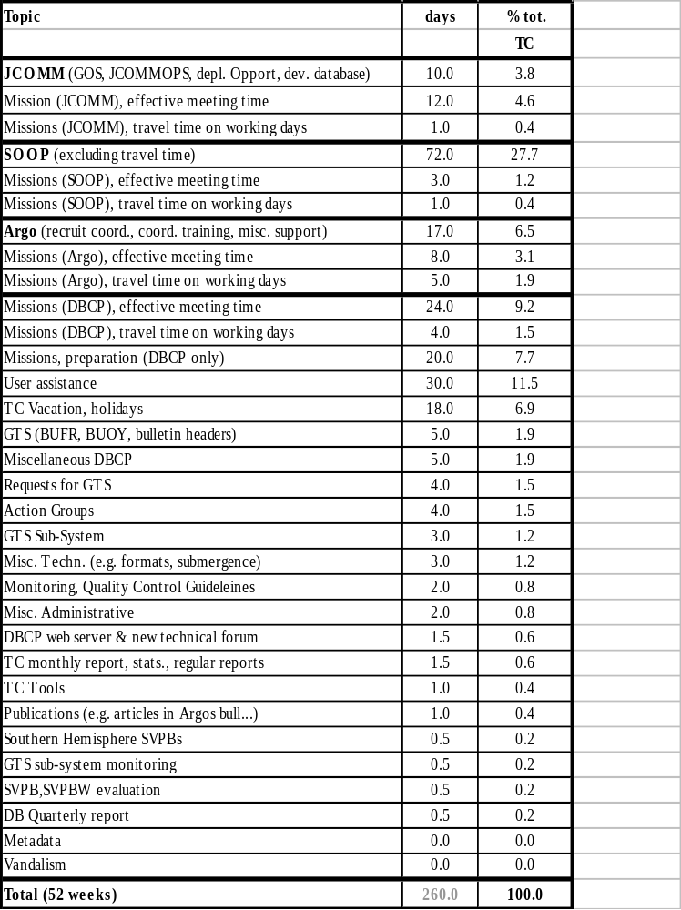

During the period, I also worked for SOOPIP part time (about 30%) and spent some time on Argo (about 11.5%) and JCOMM (about 9%). Work spent on JCOMM was directly related to DBCP and SOOP activities. Work spent on Argo included attending Argo Science Team meeting, Argo data management meeting, and the Indian Ocean Argo Implementation planning meeting plus work related to the recruitment of a an Argo coordinator, preparation of the coordinator's work plan, supervising and training. During the period CLS provided some staff support for routine tasks on DBCP related issues:
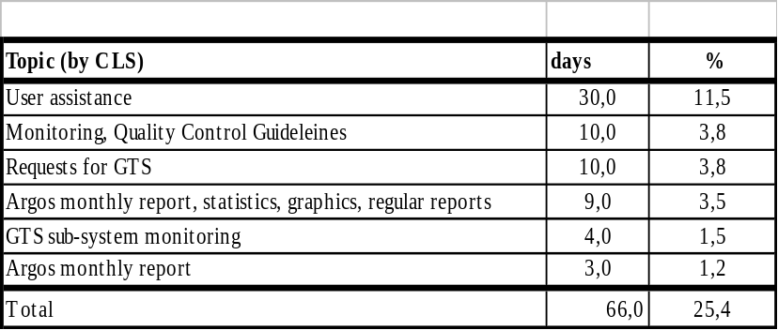

The following paragraphs describe in detail the various activities of the TC DBCP during the period. Paragraph 2 highlights recent DBCP activities. Paragraph 3 describes specific non regular tasks undertaken by the TC DBCP during the considered period while paragraph 4 describes regular tasks normally undertaken during any intersessional period.

DBCP highlights (As of August 2001)

2.1) Present status of buoy programmes
See graphics in Appendix B:
- Graph-1: Buoys reporting via Argos and those on GTS by country also available at http://dbcp.nos.noaa.gov/dbcp/statact.gif
- Graph-2: Number of drifting buoy data on GTS in BUOY code by country and sensor also available at http://dbcp.nos.noaa.gov/dbcp/status.gif

Among the drifting and moored buoys which are reporting on GTS in BUOY format, the following variables are being measured (valid for drifting and moored buoy data received from GTS at Météo France during the period 25-31 July 2001):

Variable | Buoys | Reports/day | Average  Delay (min.) | Remark
Any variable | 812 | 10230 | 178
Air pressure | 253 | 5115 | 195
Sea Surface temperature | 714 | 7226 | 151
Air temperature | 154 | 1747 | 147
Wind | 104 | 848 | 218 | Mainly moored buoys
Air pressure tendency | 152 | 2830 | 153
Air relative humidity or dew point temperature | 71 | 309 | 196
Sub-surface temperatures | 100 | 552 | 334 | Mainly TIP moored buoys; small number of drifting buoys with thermistor strings
Waves | 17 | 112 | 182 | Small number of buoys

Remark: There are more than 200 moored buoys which transmit in SHIP format (e.g. USA, Canada). Most of these moored buoys are coastal buoys which measure basic meteorological variables such as air pressure, air temperature, and wind. Statistics for such buoys are not included above because the DBCP deals with drifting buoys and moored buoys in the high seas. Only a very small number of moored buoys in the high seas actually transmit in SHIP format.

2.2) DBCP session and workshop

16th DBCP session and Scientific&Technical workshop were held in Victoria, BC, Canada, 1620 October 2000.

24 presentations were made at the Scientific and Technical workshop. These covered subjects such as (i) developments in moored and drifting buoy design, sub-surface floats, sensors, communications, and operational programmes, (ii) data requirements relating to operational oceanography and meteorology, including case studies related to weather forecasting, and (iii) buoy data applications in oceanographic and meteorological modelling, global climate studies.

The Technical Coordinator of the DBCP reported on his activities for the Panel during the last intersessional period. DBCP Action Groups reported on their specific activities. National reports were presented and we had a report by Howard Freeland regarding the Argo Science Team. Elizabeth Horton reported on the SVPB evaluation sub-group and was pleased to report that there have been improvements with regard to the quality of SVPBs during the intersessional period, especially regarding infant mortality and air deployment success rates.

DBCP implementation strategy was reviewed in line with emerging consensus on the requirements for marine observations to support global climate studies and operational marine forecast, as well as latest developments with JCOMM, data telecommunication systems, and emerging regional programmes (e.g. Black Sea, Southern Ocean).

The Panel discussed information exchange and technical issues (QC, GTS codes, Argos system, new communication techniques, meta data, GTS distribution of buoy data collected through commercial satellite systems, SVPB upgrade), and particularly, the Panel:

- Recommended that Australian Bureau of Meteorology (BOM), Environment Canada (EC), the Icelandic Meteorological Office (IMO), and the South African Weather Bureau (SAWB) resume their activities as PMOCs in the DBCP QC guidelines.
- Decided to update DBCP publications No. 3 (Argo guide), 2 (GTS sub-system guide), and 15 (implementation strategy). A new document (SVPB design manual) will replace DBCP publication No. 4 (SVPB construction manual).
- Decided to update its brochure. Australia offered to publish the new version of the brochure.
- Decided to establish two DBCP electronic mailing lists, one for DBCP members to exchange information on general DBCP matters, and one for buoy operators to exchange information on technical details.
- Recommended to the JTA that the developments needed to distribute buoy data in BUFR code should be included within the Argo development programme for implementation in early 2001.
- Decided to continue evaluation of the SVPB, and SVPBW/Minimet drifters.
- Recommend that buoy operators deploying Lagrangian drifters with drogues at 15 meters should report submergence data on GTS as well (as a way to derive drogue status in quasi real time) as second housekeeping parameter of BUOY reports. AOML accepted to monitor drogue status in deferred-time and to request Service Argos to change drogue status in GTS BUOY report for all Lagrangian drifters reporting on GTS.

Regarding the SVPB drifters in the Southern Ocean, the Panel was pleased to hear that the USA resumed deployment of barometer drifters in the region and that a few countries accepted to purchase barometer upgrades to AOML for eventually reaching a level of about 80 units in the SO. Many countries also offered deployment opportunities. The Panel decided to include a Southern Ocean Buoy Programme (SOBP) directly as a component of its implementation strategy, not as a new Action Group.

The Panel discussed on the opportunity to establish a Black Sea Buoy Programme and a North Pacific Buoy Programme (as a new Action Group). Member states with interests in these regions were invited to investigate feasibility and develop specific proposals. Results will be discussed at the next Panel session.

With regard to JCOMM, the Panel recognize the importance of JCOMM integration process. The Panel supported the concept of JCOMMOPS and agreed that it should be formally presented at JCOMM-I for adoption. DBCP deployment opportunities will now be documented via JCOMMOPS.

17th DBCP session will be held in Perth, Australia, 22-26 October 2001.
2.3) Global Implementation
2.3.1) JCOMM
Since the DBCP is now reporting to JCOMM, it changed its terms of reference consequently.
The DBCP agreed to regularly update its own implementation strategy to be consistent with the GOOS/GCOS Action Plan. The strategy was updated by DBCP-XVI.
First JCOMM meeting was held in Akureyri, Iceland, 19-29 June 2001. JCOMM praised the work of the Panel for implementation of buoy programmes, and approved the designation of the Panel as the JCOMM Data Buoy Team. JCOMM also passed a number of recommendations related to format for metadata, establishment of JCOMMOPS, and vandalism on data buoys (see below for details).
Establishment of a JCOMM Observing Platform Support Center (JCOMMOPS)
In the same spirit which lead to the merging of CMM and IGOSS into JCOMM, it was proposed to integrate DBCP, SOOP, and Argo International Coordination activities or services into one entity called the JCOMM Observing Platform Support Centre (JCOMMOPS).

Centre is located in Toulouse using DBCP, SOOP, and Argo facilities, and managed by the Technical Coordinator of the DBCP. JCOMMOPS basically includes services which (i) relate to in-situ physical oceanography and/or meteorological marine observations, (ii) can be integrated, (iii) require coordination at the international level in an implementation and operational perspective, and (iv) are presently provided by the Technical Coordinator of the DBCP and SOOP, plus those provided by the Argo Technical Coordinator through the activities of the Argo Information Centre (AIC).

JCOMMOPS runs a web site (http://www.jcommops.org/) specific services plus links to important JCOMM facilities such as the JCOMM Electronic Products Bulletin. New activities or services will gradually be proposed using existing resources from the DBCP, SOOP, and Argo. In case other JCOMM operational products which can assist in the implementation of considered observing systems are offered by Member States, links to those products will be added.

Following support by the DBCP (DBCP-XVI) and by SOOP which provide most of JCOMMOPS resources, JCOMMOPS concept was recently discussed and strongly endorsed at the first JCOMM meeting, Akureyri, Iceland, 19-29 June 2001. See description of JCOMMOPS at http://www.jcommops.org/doc/jcommops/jcommops.htm.

From the activities of JCOMMOPS, it is expected to achieve the following goals:

- Facilitating decision making by programme managers
- Facilitating programme implementation
- Enhancing operational and monitoring aspects

2.3.2) Deployment opportunities
With the advent of the Argo programme (sub-surface floats, http://www-argo.ucsd.edu/, http://argo.jcommops.org/), it becomes rational, and cost-effective to integrate within JCOMM information on deployment opportunities for drifting buoy and float deployments, servicing of moored buoys, and ship of opportunity cruises (SOOP may assist for deployments of buoys and floats, and may require using "DBCP" deployment ships for XBT drops). Such information is useful for DBCP, SOOP, Argo, TAO, TRITON, PIRATA, and possibly for national programmes dealing with such platforms. This new web page is a start in this regard but it will be very valuable to develop information on the subject with more precise information and to establish it as a new JCOMM integrated product. A JCOMM circular letter was sent to seek information on deployment opportunities from member states. A JCOMMOPS related web page was established (http://www.jcommops.org/depl_opport.html). This page is consistent with the replies received and will be kept up to date according to new information received. It includes information such as:
      - Ship lines or deployment plans, and contact points for
      - IABP, IBPIO, Australia, New Zealand, South Africa, and USA.
      - List of DBCP National focal points for logistic support
      - Air deployments
      - Ship Of Opportunity Lines (SOOP)
      - Port Meteorological Officers
      - Research ship schedules
Meanwhile, TC DBCP encourages buoy operators to use the information among other things to plan deployments.
Particularly, for buoy operators involved with buoy deployments, it would be useful to know whether they would be in a position to provide the TC regularly with detailed information regarding the following topics:
- Buoy deployment plans (point of contact, area of deployment, maps, periods of deployment)
- Possibility to use deployment opportunities you are currently using for sub-surface Argo float deployments.
For SOOP operators, although we know about recent cruises, it would be useful to have more detail about planned cruises (point of contact, frequency, periods, SOOP lines covered by cruise), and whether specific cruises might be used for buoy or float deployments. Indication whether a SOOP operator is on board would be useful.
DBCP participants are invited to check the information on deployment web page and report on any discrepancy or new information they think would be useful to appear on it.
Detailed information on air deployments (http://www.jcoomops.org/air_depl.html) is available thanks to information recently provided by Elizabeth Horton of the US Naval Oceanographic Office.
A page on buoy deployment methods and recovery is also available from the DBCP web site at http://dbcp.nos.noaa.gov/dbcp/1bdr.html.
2.3.3) Southern Hemisphere barometers
A Southern Ocean Buoy Programme (SOBP) is now part of the DBCP Implementation Strategy.
Commitments for 2001 are:

Country | Actual SH  (07/2001) | Actual SO  (07/2001) | Upgrades  SO | Main players
Australia | 15 | 11 | 10 | BOM,  Ant. Div.
Brazil | 13 | 0 | 0 | INPE
France | 3 | 3 | 0 | Météo France
Germany | 1 | 1 | 0 | AWI
Japan | 2 | 0 | 0 | JAMSTEC
New Zealand | 5 | 1 | 1 | MSNZ
South Africa | 6 | 3 | 8 | SAWB
UK | 2 | 2 | 0 | UKMO
USA | 47 | 12 | 12 | GDC,  Navoceano
Total | 94 | 33 | 31
Proposed commitments for 2002 are:
Country | Buoys purchased SO | Additional upgrades SO | Total
Australia | 13 | 12 | 25
Brazil | 0 | 0 | 0
France | 3 | 5 | 8
Germany | 1 | 0 | 1
Japan | 0 | 0 | 0
New Zealand | 5 | 6 | 11
South Africa | 10 | 8 | 18
UK | ? | ? | ?
USA | 15* | 0 | 15*
Total | 47 | 31 | 78
*: USA defines Southern Ocean as 20S-55S and plans to deploy 40 barometer drifters in this region. Figures indicated above are about 37% of figures provided by USA, i.e. percentage of earth area between 40S and 55S as compared to earth area between 22S and 55S (i.e. 100*[sin(55)-sin(40)]/[sin(55)-sin(20)] %).
AOML also offers to upgrade standard drifters (SST only) with barometers for $US 1000 per unit (see http://dbcp.nos.noaa.gov/dbcp/svpb_upgrade.html)
2.3.4) Vandalism on data buoys
Vandalism issue was discussed at the meeting of the IHO Commission on the Promulgation of Radio Navigational Warnings (CPRNW), Monaco, 29-19 June 2000. IHO agreed to promulgate navigational warning messages on the presence of data buoys in the seas and the necessity of their safety for assistance to mariners, in particular during bad weather times. Such messages are based upon information provided by the Technical Coordinator of the DBCP (see documents on the DBCP web site which are available for DBCP members to use as needed at http://dbcp.nos.noaa.gov/dbcp/vandalism.html and http://dbcp.nos.noaa.gov/dbcp/vandalism.pdf).
This issue was discussed at the first meeting of JCOMM, Akureyri, Iceland, 19-29 June 2001. JCOMM recommended Member States (i) to contact their respective Hydrographic Services to reinforce the message in the "Hydrogram" and to ensure that it is reissued as often as possible; (ii) to develop, if possible, tamper proof designs for buoy systems; (iii) to design a warning system in the event any data buoys were intentionally damaged; and (iv) to take legal steps nationally to limit acts of vandalism within their territorial seas and Exclusive Economic Zones.
2.3.5) DBCP Action Groups
2.3.5.1) EGOS
Chairman: Volker Wagner, DWD, Germany
Vice-Chairman: Wil Van Dijk, the Netherlands
Technical Secretary: Torleif Lothe, Christian Michelsen Institute, Norway
Technical Coordinator: Pierre Blouch (deployment coordination and GTS matters), Meteo France
Last Meeting: 5-6 June 2001, Dublin, Ireland
Next meeting: Paris, 4-5 December 2001.
Status: EGOS activity is high with a well spread network of 41 operational EGOS buoys in the North Atlantic Ocean (status as of June 2001 with 8 FGGE type buoys and 33 SVPB). Average life-time of EGOS buoys excluding early failures is 439 days (mid-2001, 424 for FGGE buoys, 447 days for SVPBs). Life-time of SVPB buoys improved substancially. In order to reduce data availability delays (GTS), EGOS operates two LUTs, one in Sondre Stromfjord, Greenland, and one in Oslo, Norway. 13 moored buoys (12 UK, 1 France) are operated by EGOS in the North Atlantic Ocean. Ireland is also developing a moored buoy programme. EGOS area of interest covers the sea area from the European coastline out to 50 °W, between 30°and 65°N, including adjacent seas, such as the Baltic and Mediterranean Seas.
2.3.5.2) IABP
Chairman: Tim Goos, Environment Canada
Coordinator: Ignatius Rigor, University of Washington
11th IABP meeting was held at JAMSTEC, Yokohama, 40 IABP buoys were operational in the Arctic basin in May 2001. Plans for next intersessional period will permit to main an array of about the same size (planned deployments are USA: 13 to 15 buoys, Canada: 2 buoys, Norway: 2 buoys, Germany: 4 buoys, Japan: 2 buoys, UK: 1 buoy). MEDS published an IABP CD-Rom. The key re-seeding of the buoy array across the Arctic Basin occurred annually, courtesy of the Naval Oceanographic Office (NAVOCEANO) under the WHITE TRIDENT exercise.

Next IABP meeting: Ottawa, Canada, 22-24 May 2002.
2.3.5.3) ISABP
Chairman: Alaor Moacyr Dall’Antonia Jr. , MHS, Brazil
Vice Chairman: Javier Valladares, Argentina
Coordinator: Louis Vermaak, SAWB, South Africa
Last ISABP meeting: Mar del Plata, Argentina, 30 July - 3 August 2001.
Next ISABP meeting: Cape Town, July or August 2002.
In July 2001, 47 buoys were reporting on GTS in BUOY code in the South Atlantic Ocean (i.e. between 55S and Tropic of Capricorn). These included 15 buoys measuring air pressure. As of next ISABP meeting in 2002, ISABP will meet every other year.
2.3.5.4) IBPIO
Chairman: Graham Jones, BOM, Australia
Coordinator: Pierre Blouch, Météo France
Meeting: Perth, Australia, October 2001
In July 2001, 127 buoys were reporting on GTS in BUOY code in the Indian Ocean (i.e. North of 55S). These included 67 buoys measuring air pressure. Most of these buoys are Lagrangian drifters (standard SST and SVPBs).

The Department of Ocean Development (DoD), Government of India, through the National Institute of Ocean Technology (NIOT), operates a network of 12 moored buoys. Data are distributed on GTS in BUOY format.

IBPIO information was available on the World Wide Web at: http://www.shom.fr/meteo/ibpio, and a promotional leaflet had been published.
2.3.5.5) IPAB
Chairman: Enrico Zambianchi, Istituto Universitario Navale, Italy
Coordinator: Peter Wadhams, SPRI, UK
Last IPAB meeting (IPAB-III), Fairbanks, Alaska, 26-28 June 2000.
The IPAB was launched in 1995 for a period of 5 years, to coordinate drifter deployments in the Antarctic sea ice zone, to optimize buoy distribution and create a central data archive. The programme was reviewed at the third biennial meeting in Fairbanks, Alaska, in June this year. It was resolved to continue the programme indefinitely, and as of September 2000, 14 participants had reconfirmed their commitment to the IPAB action group.

Deployments during 2000 were less than during earlier years, and in October there were only 10 active buoys contributing to IPAB. Although the exact situation was as yet uncertain, it would appear that deployments next year would be much improved. At least 10 to 12 high latitude deployments were expected, with the possibility that more than 20 buoys might be ultimately deployed.

In July 2001, 14 buoys were reporting on GTS in BUOY code from the Antarctic region (i.e. South of 55S). 9 of these buoys were reporting air pressure.

Next meeting: Cape Town, July or August 2002.
2.3.5.6) GDP
Chairman: Pierre Poulain
Manager, GDC: Craig Engler, AOML, USA
The Global Drifter Center (GDC) has now been fully integrated into NOAA's Global Ocean Observing System (GOOS) Center in Miami, Florida. GDP deploys about 420 drifters per year in the world oceans, including 200 into the tropical Pacific, 90 into the tropical Atlantic, 50 into the tropical Indian and more than 12 into the southern ocean.

The GDC supports the upgrading of SVPs to SVPBs by any country which desires to do so and it is working closely with those countries in coordinating the shipping and deployment of those upgraded drifters.

The GDC and its related Data Assembly Center (DAC) provides products through the following web site: http://www.aoml.noaa.gov/phod/dac

The GDC encourages other drifter programmes to contribute their data to the DAC if those data are collected by the SVP WOCE type drifter with drogues set between 10 and 15 meters.

Distributing submergence data on GTS:

The DBCP agreed that submergence data of Lagrangian drifters should be distributed on GTS so that sea surface velocity can be derived in quasi real-time by GTS users based upon drogue status (drogue status is derived from submergence). Since there is no provision for coding submergence in BUOY reports and since modification of the BUOY code is not possible anymore (at last CBS, DBCP agreed via its ET/DR&C that it would not require any additional BUOY code modification and tentatively eventually switch to table driven codes), the DBCP agreed to adopt the following practice: Submergence data from Lagrangian drifters should be coded in % (percentage of time the drifter is being submerged) as housekeeping parameter number 2 of BUOY reports. Most of the Lagrangian drifters which report on GTS now comply with this recommended practice.
2.3.5.7) TAO
Chairman: Mike McPhaden, PMEL, USA
Coordinator: Paul Freitag, PMEL, USA
In January 2000 the TAO Array was renamed TAO/TRITON reflecting the transition of sites west of 165°E longitude from ATLAS moorings, designed and built by PMEL, to TRITON moorings, designed and built by JAMSTEC. The transition to TAO/TRITON required the assembly of data processed by both PMEL and JAMSTEC into a unified data set available on the World Wide Web from both PMEL and JAMSTEC. Data from all sites continued to be disseminated on the GTS. A new data distribution page provided a wider range of data types, more varied temporal sampling and options on formats. Data return remained good. The overall value for real-time data availability from ATLAS moorings was 89% for the past year (Oct 1999 to Oct 2000). Damage to moorings and sensors due to fishing activity continued to be of concern. This damage accounted for a significant amount of data loss, especially in the far eastern and far western portions of the Pacific basin. The array was expanded for NOAA's EPIC (Eastern Pacific Investigation of Climate Processes) Programme (http://www.pmel.noaa.gov/tao/epic/) with 3 additional moorings along 95°W in the eastern Pacific. Moreover, all moorings along this line were enhanced with additional sensors to provide real-time telemetry of long- and short-wave radiation, rainfall, barometric pressure, salinity, and ocean currents. A two-month long, land-based intercomparison of TAO, TRITON and WHOI-IMET surface instrumentation was conducted this summer. Initial examination indicated that data from the three systems compared well. A detailed description of the intercomparison and analysis of the data would be published as a technical report.

PIRATA (Pilot Research Moored Array in the Tropical Atlantic) was completing its pilot phase and was about to enter a 5-year (2001-2006) consolidation phase during which data from the array would be evaluated for its utility in support of research and operational forecasting. The number of moorings in the array would be reduced from 12 to 10, due to larger than expected losses due to vandalism.

TIP changed its terms of reference and name to include mooring in tropical area of the Pacific, Atlantic, and Indian Oceans. It's now called the Tropical Moored Buoy Implementation Panel (TIP). This was in part in response to the fact that TAO was now fully implemented and in an operational phase. TIP now functions as a technical advisory committee for existing or future mooring programmes in any of the tropical oceans. The scientific design and scope of future moored arrays will be addressed by the sponsors of TIP, the COOP (CLIVAR Ocean Observation Panel) and OOPC (Ocean Observations Panel for Climate).
2.4) Information exchange
2.4.1) DBCP Web server (http://dbcp.nos.noaa.gov/dbcp)
Latest or modified pages:
- List of DBCP recommended Argos message formats (DBCP-M2 format introduced, http://dbcp.nos.noaa.gov/dbcp/1ramf.html)
- Deployment opportunities (via JCOMMOPS web site at http://www.jcommops.org/depl_opport.html)
- Data collection and location systems (by David Meldrum, http://dbcp.nos.noaa.gov/dbcp/1smms.html)
- DBCP efficiency and achievement (http://dbcp.nos.noaa.gov/dbcp/achieved.html)
The panel is reminding interested members and Action Groups (AG) to provide the technical coordinator with their annual reports (i.e. national reports and AG reports respectively) and deployment opportunity information in electronic form for inclusion in the DBCP web site.
2.4.2) DBCP Internet technical forum
The DBCP Internet technical forum which was established in May 1999 was renamed and move to the JCOMMOPS forum in early 2001. JCOMMOPS forum includes DBCP, SOOP, and Argo technical sub-forums. Having one single forum for the three programmes permits to facilitate utilization by users (e.g. one single username/password). Address of JCOMMOPS forum is http://forum.jcommops.org/ .The DBCP forum is a mean of debating on technical issues, answering technical questions, and exchanging information among buoy operators or actors. The forum is a good complement to the DBCP web site and is directly linked to it. Documents, questions and answers can be exchanged over the forum while being accessible to anybody in the buoy community.
If desired, new teams dedicated to DBCP Action Groups can be created on the forum with privileged access for AG Participants and administration privileges for the AG Coordinator (please contact the Technical Coordinator of the DBCP in that case). An EGOS team has been created which is managed by Pierre Blouch.

2.4.3) DBCP mailing lists
2 DBCP mailing lists have been created:
- dbcp@jcommops.org is a mailing list for exchange of general information on DBCP activities. List presently includes 86 names (Jan. 2001).
- buoys@jcommops.org is a mailing list for exchange of technical information among buoy operators. Lists presently includes 131 names (Jan 2001).
Details at: http://www.jcommops.org/mailing_lists.html#DBCP.
2.4.5) New DBCP publications:
The DBCP recently published the following documents within its Technical Document series:
- No. 11: DBCP annual report for 1997
- No. 12: October 1997 DBCP Workshop's report (La Réunion)
- No. 13: DBCP annual report for 1998
- No. 14: October 1998 DBCP Workshop's report (Marathon)
- No. 15: DBCP implementation strategy
- No. 16: DBCP annual report for 1999
- No. 17: October 1999 DBCP Workshop's report (Wellington)
- No. 18: DBCP annual report for 2000
- No. 19: October 2000 DBCP Workshop's report (Victoria)
- The following documents still have to be published:
- update DBCP publications No. 3 (Argos guide)
- update DBCP publications No. 2 (GTS sub-system guide)
- update DBCP publications No. 15 (implementation strategy).
- A new document (SVPB design manual) will replace DBCP publication No. 4 (SVPB construction manual).
2.5) Buoy monitoring statistics
A comprehensive report describing algorithms and remaining discrepancies among statistics produced by UKMO, NCEP, Météo France, and ECMWF is available via the DBCP web site at http://dbcp.nos.noaa.gov/dbcp/monstats.html.
2.6) SVPBW evaluation group
A DBCP sub-group on SVPBW/Minimet has been created by the DBCP. Purpose of the sub-group is to deploy test drifters in all sorts of sea conditions, evaluate data, suggest hardware/software design changes, share experience, etc...
Sub-group works mainly through mail exchange and use the DBCP technical forum (http://forum.jcommops.org/) for basic open discussion, record of those discussions and publication of intermediary or final results.
A "SVPB/SVPBW evaluation" sub-forum has been created in the DBCP technical forum where only sub-group participants can upload discussion topics and documents while all documents posted are available to everybody.
Sub-group presently includes the following people:
  - Elizabeth Horton, Navoceano (Chairperson)
  - Pierre Blouch, Météo France
  - Sarah North, UKMO
  - Graeme Brough, BOM
  - Peter Niiler, SIO
  - Etienne Charpentier, DBCP
  - Ray Mahr, Metocean
  - Jeff Wingenroth, Technocean
  - Gary Williams, Clearwater Instrumentation
  - Sergey Mothyzev, MARLIN
  - Louis Vermaak, SAWB
The group is open to anybody who can provide something for the evaluation, namely:
  - Drifters to deploy
  - Deployment opportunities
  - Archived data
  - Expertise
  - Software development (e.g. by buoy manufacturer)
  - Design suggestions according to evaluation
Any other person interested in participating in the evaluation group should contact Elizabeth Horton.
At the 16th DBCP session, Victoria, October 2000, it was reported that Météo-France set up a metadata base containing information on approximately 800 SVPB drifters and their variants to study drifter mortality rates. A number of factors influenced life expectancy, including message length, transmission repeat period, battery capacities, type of barometer and manufacturer. There had been improvements, including greatly reduced infant mortality, 100% air deployment success rate, decrease in Argos message length, elimination of gross errors and increase of data available onto the GTS. Several specific areas were investigated, including tests of different types of barometers (Météo-France), analysis of barometer ports (Marlin) and continuous development of a digital WOTAN drifter (Pacific Gyre). Several recommendations were suggested: that QC tools had been made available on the DBCP web page and buoy operators should take advantage of those tools to check their data onto the GTS; that manufacturers should be careful with drogue attachments, construction of barometer ports and electrical connections between the hydrophone and the hull on WOTAN drifters.
Reports from the evaluation sub-group can be found on the DBCP technical forum at http://forum.jcommops.org/ under "DBCP forum" then under "SVPB/SVPBW evaluation sub-group".
At its June 2001 meeting, EGOS showed that average life-time of SVPB drifters in the North Atlantic was now in the order of 418 days (447 days when excluding early failures) for a total of 15 SVPB buoys.
2.7) Impact studies regarding data buoys:
List of impact studies regarding data buoys is available through the DBCP web site (http://dbcp.nos.noaa.gov/dbcp/impact.html). Anybody with information on past, present or future studies which are not listed in the web page is invited to submit details to the Technical Coordinator.
2.8) GTS
2.8.1) BUOY code, BUFR
At its 16th session, the Panel agreed that BUFR encoding capability should be included in the Argos GTS sub-system. It recommended that the JTA includes related developments in the Argos development programme for implementation of BUFR in early 2003. This was agreed by the JTA. As of early 2003, all buoy data processed via Argos will be distributed on GTS in BUFR and in BUOY formats. Period during which BUOY reports will continue to be produced is not defined yet. However, the Panel agreed that the transition period where both BUFR and BUOY will be used will last for several years. The Technical Coordinator wrote technical specifications for implementation of BUFR within the Argos GTS sub-system. The specifications were submitted by CLS, Service Argos to a private company for cost evaluation in June 2001. At the time of writing this report no cost evaluation figure is available. Developments should begin in early 2002.
Regarding BUOY, CBS agreed with the following modification of the BUOY code basically to with with metadata. New fields in Section 4 will be implemented on 8 November 2001, and are indicated in red below:
SECTION 4 444 (1Q_{p}Q₂Q_{TW}Q₄) (2Q_{N}Q_{L}Q_{a}Q_{z})
{(Q_{c}L_{a}L_{a}L_{a}L_{a}L_{a}) (L_{o}L_{o}L_{o}L_{o}L_{o}L_{o}) or (YYMMJ Gggg/)}
(3Z_{h}Z_{h}Z_{h}Z_{h} 4Z_{c}Z_{c}Z_{c}Z_{c}) (5B_{t}B_{t}Z_{t}Z_{t})
(6A_{h}A_{h}A_{h}A_{t}) (7V_{B}V_{B}d_{B}d_{B}) (8V_{i}V_{i}V_{i}V_{i}) (9i_{d}Z_{d}Z_{d}Z_{d})

Existing i_{d} field (drogue type) will be coded “/” because a new 2 character field (Z_{t}Z_{t}) was proposed for drogue type.
2.8.2) GTS bulletin headers
List of GTS bulletin headers is available at http://dbcp.nos.noaa.gov/dbcp/1gbh.html.
2.8.3) GTS Sub-system
2.8.3.1) Recent improvements that have been realised with the Argos GTS sub-system:
  - Location time always included in BUOY reports
  - Housekeeping parameter numbering is consistent for all BUOY reports produced by a single buoy.
  - New version of geo-magnetic variation model (IGRF 2000)
  - Removal of ambiguous duplicates 12 hour-apart (Argos XBT data).
2.8.3.2) Planned or needed developments:
  - Encoding of data in BUFR format to start in early 2002.
  - Standard quality control procedures for Argo data.
2.9) Meta-data
A synthesis of DBCP members comments regarding the metadata issue was submitted to the JCOMM Sub-group on Marine Climatology in January 2000 (see http://dbcp.nos.noaa.gov/dbcp/metadata.html). The sub-group met in early 2000 and took the DBCP recommendations into account. At its first session in Akureyri, Iceland, 19-29 June 2001, JCOMM recommended that the format agreed upon by its sub-group on Marine Climatology be used as the global format for the assembly, exchange and archival of metadata from all types of ODAS, including, in particular, drifting and moored buoys and fixed platforms.

To assist in preparing the compilation of the final catalogue, DBCP members and the Action Groups must compile their own metadata catalogues, with a view to submitting them when required in a format as close as possible to the one that proposed by JCOMM.
For drifting buoys, the panel, at its 16th session in Victoria, October 2000, noted that a good way to collect most of the metadata was to ask buoy manufacturers to fill out a standardized sheet each time a new drifting buoy was being delivered. This will be discussed with the TC and the GDC in order to suggest a standard form as well as how and to whom it should be submitted. The JCOMM Sub-group on Marine Climatology would be the overall repository of metadata for all ocean observing systems.
Regarding inclusion of metadata in GTS reports, the meeting of the CBS Implementation Coordination Team on Data Representation and Codes, Geneva, 10-14 April 2000, finally accepted to recommend inclusion of certain metadata (e.g. anemometer height, buoy type, drogue type) in the BUOY code for implementation on 8 November 2001 (see BUOY code issue above). This was accepted by CBS in November 2000.

Calibration procedures for buoys should be adequately documented and archived. Panel members are urged to provide the JCOMM Sub-group on Marine Climatology with related calibration information as well.
2.10) Data collection and location systems
2.10.1) Argos
2.10.1.1) Argos message formats
The DBCP decided to publish a list of recommended Argos message formats via its web server (see (http://dbcp.nos.noaa.gov/dbcp/1ramf.html), and encouraged new buoy operators looking for advice or expertise to use one of those. Advantages of listed formats are detailed. Although buoy operators are free to develop and use their own formats, usage of existing formats permits to substantially speed up insertion of buoy data onto the GTS through the Argos users' guidance offices.
Present list is available on the DBCP web site and includes the following formats:
- DBCP-M1: Format proposed by Météo France
- DBCP-M2: New format discussed in the context SVPB evaluation group for 28 bit Argos Ids. This format was adopted in July 2001.
- DBCP-O2: SVPB so called 2-page format
- DBCP-O1: SVP standard drifter (SST only)
2.10.1.2) Argos Joint Tariff Agreement
The 20th session of the Argos Joint Tariff Agreement meeting was held in Victoria, BC, Canada, 23-35 October 2000.
DBCP recommendation with regard to the development of the BUFR were accepted (implementation in early 2003). 1123.5 PTT*years were committed by participants in the JTA for 2001, including additional commitments from USA. Tariff for 2001 was fixed to FF 26400 plus a monthly FF 20 active platform fee according to the plan decided at the previous JTA meeting. Subject to agreement by the Argos Operations Committee, the meeting agreed in principle to phase-in the inclusion of class a/B locations as part of the basic JTA over a 3-year period, beginning with a one-third reduction of the charges for this service in 2001. In order to encourage manufacturers and users to split frequency usage, a 10% discount will be provided to those PTTs transmitting outside of the 401.648-401.652 MHz frequency band.

Bonus system continues with an upper limit of 82% for those countries already benefiting from the bonus. The meeting also agreed to make a bonus available also to those ROCs whose signed PTT-years in 2001 were at least as great as those signed in 2000 and bid at JTA-20.
2.10.2) Other telecommunication systems
The Panel is continuing to review and report on new developments in telecommunication systems potentially useful for buoy programmes.
A paper outlining these developments is available on the DBCP web site at http://dbcp.nos.noaa.gov/dbcp/1smms.html.

Specific TC DBCP non regular tasks undertaken during the intersessional period

October 2000

- Argo data management meeting, Brest, 4 October 2000
- DBCP-XVI meeting, Victoria, 16-20 October 2000
- JTA-20 meeting, Victoria, 23-25 October 2000
- Washington-DC mission (SOOP, Argo), 27 Oct-3 Nov.

November 2000

- Establish DBCP general interest mailing list (dbcp@jcommops.org)
- Establish buoy operators' mailing list (buoys@jcommops.org)
- SOOPIP mailing list renamed to soopip@jcommops.org
- "Test GTS bulletin header issue" (checking buoy data before GTS distribution)
- Update deployment opportunities on JCOMMOPS web site (http://www.jcommops.org/depl_opport.html) according to information provided by NFPs.
- Collect/compile SOOP operators metadata. Produce SOOP semestrial survey, Jan-June 2000. Notice discrepancy between GTS reports received at Météo France and reports transmitted on GTS as indicated by SOOP operators.
- WMO ID issue for Argo (A9xxxxx). Argo needs unique WMO Ids for every float (i.e. no reallocation) => numbers extended from A9xxx to A9xxxxx.
- Argo coordinator's position, new announcement & review/call candidates
- Test new version of Argos GTS sub-system implemented (floats: PRESDEDUC module, housekeeping parameters, location date). Implemented 20 Nov.
- Reformat SOOP monthly report to include Argos Ids and counts. Discussion regarding format with Meteo France and BSH.
- Météo France provided me with list of BATHY reports received Jan-June 2000
- Météo France now providing me (JCOMMOPS) with list of GTS reports on a monthly basis (BATHY, TESAC, TRACKOB). BUOY, SHIP, and TEMP-SHIP reports will be provided later.
- Write simplified WAVEOB format documentation and provide it to the Italian Sea Wave Monitoring Network. Suggest contact point for GTS insertion of the data.

December 2000

- "Test GTS bulletin header issue" (continue). Idea finally abandoned. Tests can be conducted through direct distribution of BUOY reports from the Argos GTS sub-system to the buoy operator.
- Mission to Norway, 11-12 December. Discuss Norwegian Argo initiative in Bergen with MRI, DNMI, NERSC, Aanderaa, Oceanor. Discuss Oceanor moored buoy programmes and GTS distribution of the data.
- Argo coordinator's position, review/call candidates with selection committee. Mathieu Belbéoch finally selected by committee.
- SOOP database: fix inconsistencies between SOOP metadata as provided by operators and GTS reports received by Meteo France.
- EGOS meeting, 5-6 Dec. 2000, Geneva. DBCP represented by Peter Dexter.
- Vacation: 25 Dec 2000 - 5 Jan 2001
- Update SOOP semestrial report for jan-june 2000 based upon new input/information

January 2001

- Vacation: 25 Dec. 2000 - 5 Jan 2001
- SOOP monthly GTS report. Reformat report, make suggestions to SOOP operators.
- Submergence of standard SVP drifters on GTS as housekeeping parameter #2. All standard US drifters now report information on GTS. I assisted AOML and SAI in this regard.
- Prepare Argo coordinator's mission to USA and Canada
- Revamp SOOP web site and navigation
- Update JCOMMOPS, DBCP, SOOP, AIC web sites
- Update SOOP semestrial report for jan-june 2000 based upon new input/information
- IRD/Nouméa CD-Rom on SSS available on-line
- Draft DBCP and SOOP input for GOOS 2000 status report
- Work on SOOP database (review data model, scripts). Make suggestions to SOOP operators. Importance to update the list of SOOP ships on a monthly basis.
- Problem with GTS distribution of large TESAC reports (UK floats) from Service Argos (problem with X25 connection between Service Argos and Meteo France)
- GTS bulletin headers for Argo floats. More generally, GTS bulletin headers for buoys and XBTs.

February 2001

- Compile list of Argo floats
- Mission to Geneva, 5-7 February 2001 to write JCOMM-I preparatory documents on DBCP and SOOP.
- Amend JCOMMOPS proposal document according to Rick Bailey’s comments
- Prepare arrival Mathieu Belbéoch (workplan, meetings, missions, CLS logistics)
- SOOP database, "Programme ships" table
- Reformat SOOP monthly report
- Ask SOOP operators to provide information monthly regarding the ships they operate
- GOS database update, prepare Southampton meeting
- 19 February: Mathieu Belbéoch, new Argo Coordinator starts work.
- Mathieu Belbeoch’s training
- Work with Mathieu Belbeoch on a paper for 1st meeting of the Advisory Body of Experts on the Law of the Sea (ABE-LOS), Paris, 11-13 June 2001
- Indonesian Agency for the Assessment and Application of Technology (BPPT) is looking for cooperation with DBCP for re-deploying moored buoys in Malacca Strait, Jakarta Bay, Java Sea and Batam Waters
- Clarify situation regarding funding for the Argo Coordinator’s position. Negotiate with USA for 2001 contribution.
- Problem of Indian ocean SOOP sampling. USA to continue supporting lines IX06, IX07, and IX21. Australia is endeavouring to maintain its previously operated lines. Japan had temporary problems but will resume usual contribution. NIO, India, looking for ship opportunities along line Bombay-Mauritius
- Provide Louis Vermaak with formula used by Argos GTS sub-system to reduce air pressure to sea level.
- Assist in fixing problem regarding GTS distribution of UK float data.
- Discuss proposal for a specific GTS bulletin header for float data (i.e. in general form TTAAii, letters “FX” used for AA, e.g. “SOFX01”)
- Make some comments to Steve Cook regarding the draft SOOP Best Guide and Principles manual.

March 2001

- Prepare CEOS/WMO database update meeting by compiling list of ocean/marine variables observed through JCOMM.
- CEOS/WMO database update meeting, Southampton, 1-2 March
- Prepare AST-3 meeting stressing on integration issues.
- AST-3 meeting, Sidney, Canada, 20-22 March
- Mathieu Belbeoch’s training
- Decrease in DBCP QC guidelines activity. Make survey. Study how this could be integrated within JCOMM with DBCP, SOOP, and Argo (JCOMMOPS)
- Prepare graphs for updated DBCP brochure.
- Contact various web site webmasters in the metocean community (GOOS, GCOS, GTSPP, IODE, CLIVAR, etc.) and make sure that DBCP, SOOP, Argo, and JCOMMOPS web sites are referenced on those sites.
- Contact SOOP operators to get data and metadata for the SOOP semestrial survey, Jan-Dec. 2000. Start compiling received data.
- According to Steve Piotrowicz, USA will probably provide 11000 XBT probes next year (as this year).
- Assist GDC in rapidly inserting submergence and battery voltage data on GTS for some 100 buoys (write SQL script to automatically insert required sensors in Argos GTS sub-system database).
- Prepare CBS ET/DRC meeting, 23-27 April 2001, Toulouse. BUFR common sequences used for buoy data.
- TAO IP (TIP) changed its terms of references. It’s now the Tropical Moored Buoy Implementation Panel (TIP) and now covers all equatorial ocean regions, i.e. Atlantic, Indian, and Pacific oceans.

April 2001

- SOOP Semestrial report
- SOOP Best guide and principles
- JCOMMOPS web development project with Mathieu Belbeoch and myself including Geographical Information System, Oracle database, dynamic pages, etc. Tools will be used for Argo primarily but developments will be done so that the tools can be used for the DBCP and SOOP. This is therefore a joint project with DBCP, SOOP, and Argo Information Centre. CLS is providing computers, software, maintenance, and some computer technical support. DBCP is participating for $5000 this year and hopefully for another $5000 next year.
- Continue investigation of deferred-time QC feedback needs (DBCP) and how the DBCP QC guidelines could evolve. Integrated tools (JCOMMOPS) could eventually be proposed for the DBCP, SOOP, and Argo.
- Work on SVPB design manual.
- Prepare list of required BUFR descriptors for DBCP, SOOP, Argo (in preparation to ET/DRC meeting).
- 24-25 April: Meeting of CBS Expert Team on Data representation and Codes, Toulouse.

May 2001

- Work with Mathieu Belbeoch on design of JCOMMOPS database
- 7 May: Vacation
- 9-10 May: Meeting of CBS Expert Team on Migration to Table driven code forms, representing IOC. Coordinating with Bob Keeley in this regard.
- Write technical specifications for BUFR encoder to be implemented with the Argos GTS sub-system.
- Continue investigating integrated QC feedback mechanism for DBCP, SOOP, and Argo.
- SOOP Forum established under JCOMMOPS forum (http://forum.jcommops.org ). DBCP and Argo forums moved to JCOMMOPS forum. There is therefore now only one forum for the three Panel, making things more simple for forum users (e.g. only one username/password and address to remember).
- Update SOOP semestrial survey for 2000 based upon data submitted by IRD, Nouméa, and NIO, India. BOM data missing at this point.
- Update list of SOOP ships in my database.
- Prepare document for I-GOOS-V meeting
- Prepare documents for IABP and EGOS meetings.
- 25 May: Vacation
- 12. 30 May-1 June: IABP meeting in Yokohama. Some 40 buoys maintained in the Arctic Ocean by IABP. Question of quality of location data raised (e.g. Edmonton LUT). Flagging of location data by MEDS (55% of reports flagged). Environment Canada to investigate participating in the DBCP QC guidelines for Arctic boy data. MEDS to investigate participating in the guidelines for location data. Deployment opportunities to be provided to me by IABP Coordinator.

June 2001

- 4-5 June: Visit JMA, Japan Coast guards, JAMSTEC in Tokyo and Yokohama. Successful meetings. I made a presentation on DBCP, SOOP, AIC, and JCOMMOPS at JMA. Coast guards agreed to distribute their data on GTS (30 drifters).
- Prepare slides for JCOMM-I meeting.
- 21-22 June: Attend JCOMM-I meeting in Akureyri, Iceland. Represent DBCP, SOOP. Present proposal on JCOMMOPS.
- 28-30 June: I-GOOS meeting, Paris. Make presentation on AIC and results from ABE-LOS meetings (Mathieu Belbeoch attended the meeting).
- Flagging of location data by MEDS when difference between observation time and location time exceeds 30 minutes. Address issue with DBCP AG and DBCP Chairman. Write letter to MEDS.
- Finalize specifications for BUFR and submit to CLS. CLS is sub-contracting the work.
- Continue JCOMMOPS database and web developments with Mathieu Belbeoch
- Write prospectus on JCOMMOPS for investigating JCOMMOPS development funding by European Union.
- Get IGRF2000 coefficients for geo-magnetic variation model implemented in the Argos GTS sub-system for correcting wind data from buoys. Make software modification to implement the coefficients in the application.
- Prepare slides on DBCP and IBPIO activities for presentation at the Argo Implementation planning meeting in Hyderabad, India, 26-27 July 2001.

July 2001

- Discussion on recommended Argos message formats
- Prepare document and slides for Eric Meindl for presentation at the ISABP meeting, Mar del Plata, Argentina.
- Problem with BOM XBTs, duplicates 12 hours apart (observation time) being distributed on GTS.
- Edit SOOP Best Guides and Principles to reduce size of the electronic version in order to place it on the web site.
- 9-20 July 2001: Vacation
- 26-27 July 2001: Argo Indian Ocean Implementation meeting, Hyderabad, India.

August 2001

- Preparation of DBCP session (preparatory documents: TC report, Information exchange, QC, Codes, Argos GTS sub-system, JCOMMOPS)
- Work on JCOMMOPS database with Mathieu Belbeoch
- SOOP Semestrial report for January-June 2001.
- UKMO SST monitoring restored
- Explosion of a moored buoy in Bay of Bengal. Collect information from DBCP members on similar accidents.
- Update and test Argos GTS sub-system in conjunction with CLS, Service Argos for (i) new IGRF2000 geo-magnetic variation model, (ii) Argos message signature and associated QC test to eliminate duplicates (12 hours appart) in Argos XBT data, and (iii) GTS insertion from Argos US centre to NWS Gateway via FTP.

September 2001

- Preparation of DBCP session (presentations, slides)
- Work on JCOMMOPS database with Mathieu Belbeoch. Prepare dynamic web tools for DBCP and SOOP.
- SOOP Semestrial report for January-June 2001.

Regular or normal tasks

  - Monitoring

Below are detailed the different monitoring activities that the TC DBCP undertook during this intersessional period:

    - Quality Control Guidelines

      - Reading QC messages

To read the QC messages from the BUOY-QC Internet mailing list as posted by the Principal Meteorological or Oceanographic Centres responsible for GTS buoy data quality control (PMOC). For rationalisation purposes, all the proposals are stored and archived in a data base.

      - Contacting PGCs

To contact the PGCs: The QC guidelines have been automated, so most of the time status change proposals are automatically forwarded to the Principal GTS Coordinator (PGC) provided that he has an email address. In case the PGC has no email address, the TC DBCP contacts the PGC directly, and suggests him to implement the proposed change. The PGC should normally contact Service Argos and/or Local User Terminal (LUT) operators and request implementation of the proposed change. In case the PGC disagrees, the TC DBCP immediately deposits a denial message on the bulletin board.

      - Checking Argos files

To check Argos files and/or GTS data in order to ascertain whether suggested modifications have actually been implemented or not.

      - Feed back.

Possibly to deposit feed back information on the bulletin board on behalf of Service Argos for sensors actually recalibrated.

    - Specific problems.

To resolve specific problems related to GTS for given buoys, such as looking carefully at the data and the transfer functions. For example, I could be investigating why no or only a few messages are received at Meteorological Centres...

    - TC DBCP files.

To update TC files: list of the operational platforms and programmes (on GTS or not), new programmes, WMO numbers, monitoring statistics...

  - User assistance

As usual, I answered specific questions and resolved specific problems as needed or requested by users.

    - Principal Investigators (PI) or buoy programme managers:

PIs regularly request the TC DBCP to look at specific problems regarding their buoy data or request assistance for GTS distribution of the data. For example, I could be studying in detail Argos message formats and sensor transfer functions or I could obtain WMO numbers on their behalf. I could also simulate satellite orbits in order to estimate orbital delays.

    - Local User Terminals (LUT):

From time to time, LUT operators ask me to provide them with the transfer functions used with specific platforms so that they can also report to the GTS via their LUT.

    - Meteorological Centres

Meteorological Centres may contact me when they need information on given platforms drifting in an area of interest.

    - Secretariats:

Upon request, I provided WMO or IOC secretariats with graphs and documentation.

    - Buoy manufacturers.

Buoy manufacturers regularly contact me to be included in the DBCP list of drifting buoy manufacturers (http://dbcp.nos.noaa.gov/dbcp/1lobm.html). I may also discuss technical issues with them.

    - Individual users

Individual users contact me to obtain buoy information and/or seek information on how to obtain buoy data. I usually redirect them to adequate institution(s) (e.g. RNODC/DB).

    - Acting as a Principal GTS Coordinator

e.g. When the regular PGC is in vacation, I can replace hem/her and act as a PGC.

    - Focal point.

Directly or through the BUOY-QC Internet mailing list, I am acting as a focal point between the Meteorological Centres and the Principal Investigators when a specific action is required for a buoy reporting onto the GTS (e.g. remove the data from the GTS, recalibrate a sensor...).

    - Investigate various data loss problems.

  - Drifting Buoy Quarterly Report

The Drifting Buoy Quarterly Report was issued , and distributed widely by CLS, Service Argos.

  - Global Telecommunication System (GTS)

    - Status for drifting buoys reporting onto the GTS:

Year | Operational drifting buoys | On GTS | % on GTS
July 1991 | 718 | 264 | 36.8%
July 1992 | 1162 | 474 | 40.8%
August 1993 | 1269 | 548 | 43.2%
September 1994 | 1246 | 587 | 47.1%
September 1995 | 1429 | 631 | 44.2 %
September 1996 | 1180 | 638 | 54.1%
September 1997 | 1159 | 581 | 50.1%
August 1998 | 1230 | 543 | 44.1%
July 1999 | 1270 | 728 | 57.3%
July 2000 | 1385 | 807 | 58.3%
July 2001 | 1338 | 763 | 57%

See also graphs, tables, and maps in Appendix B
Météo-France provided me with Data Availability Index Maps on a monthly basis. The maps are useful to identify the data sparse ocean area for each kind of geo-physical variable and therefore to assist the various data buoy programmes in adjusting deployment strategies. The maps show clearly the impact of the TAO array ATLAS moored buoys (wind), of DBCP regional action groups such as the ISABP (air pressure), or of specific national programmes such as MSNZ (air pressure).

    - GTS bulletin headers:

All Local User Terminal sources comply with WMO regulations regarding GTS bulletin headers.

See Appendix A for a complete list of GTS bulletin headers used to date.

    - Quality Control.

The work of the TC DBCP concerning Buoy data Quality Control was related to the following topics:

- Actually monitor the Internet Mailing List, and contact PGCs accordingly when those cannot be reached automatically.
- Act as a PGC upon request.

Refer to related DBCP session agenda item (Quality Control of buoy data) for details.

    - Non-standard wind sensor heights:

I keep up to date the list of drifting buoys making wing measurements and reporting on GTS using the BUOY code (updated on a semestrial basis). The list includes the WMO and Argos ID numbers, the height of the anemometers and whether or not a correction to 10 meters is applied. List is available via the DBCP web site at http://dbcp.nos.noaa.gov/dbcp/1wb.html.

    - Non-standard air pressure measurements for stations in altitude.

A few land stations reporting via Argos continue to report on GTS in BUOY code instead of SYNOP. I am therefore keeping up to date the list of such stations. This list includes the WMO, and Argos ID numbers, the Position and Altitude of the stations and whether or not Air Pressure is reduced to sea level. List is available via the DBCP web site at http://dbcp.nos.noaa.gov/dbcp/1lsribc.html (updated on a semestrial basis).

    - New buoys on GTS

I am regularly contacting buoy programme managers of new programmes in order (i) to convince them to authorize GTS distribution of their buoy data, and (ii) to offer assistance for that purpose. Programme managers who spontaneously authorize GTS distribution of their buoy data, may regularly contact me for assistance.

The new GTS sub-system permits to process the data provided that adequate information is precisely implemented in the system. I am therefore studying in details technical files of buoys with complicated Argos message formats. In some instances I obtain WMO numbers from National Focal Points or WMO secretariat on behalf of the programme managers.

  - Argos GTS Sub-System

The regular work of the Technical Coordinator concerning the Argos GTS Sub-System is mostly related to the following topics:

- Monitor the system and look for possible problems.

- Make sure the problems are corrected.

- Training of the Argos Users' Guidance Office and work in conjunction with it regarding complex problems.

Refer to related DBCP session agenda item (Argos) for details.

  - DBCP World Wide Web Internet server

The regular work of the Technical Coordinator concerning the DBCP web site is mostly related to the following topics:

- Keep regular files on the Web. Server up to date (transfer files).

- Tentatively keep links to other servers up to date.

- Refer to related DBCP session agenda item (Information exchange) for details.

  - TC statistics and graphs.

    - Active drifting buoys.

Using Argos files and data provided by LUT operators, I computed on a monthly basis, by country and by organisation, graphs showing the distribution of active GTS and non-GTS drifting buoys. It is particularly useful to see the evolution of the total number of drifting buoys deployed by the various countries involved, and the percentage of these reporting to the GTS. See graph-1 in Appendix B (distribution of active buoys by country), graph-2 (distribution of GTS buoy data by country and variable), and graph-3 (Evolution of number of air pressure observations distributed on GTS per month since 1991 (from ECMWF monitoring statistics)).

    - Quality of air pressure.

I Computed on a monthly basis, the graph showing the distribution of the RMS (of Observation minus First Guess Field) of Air Pressure data according to ECMWF monthly monitoring statistics. This graph, which uses 6 months of data, gives a good estimate of the quality of the drifting buoy Air Pressure data. See graph-4 in Appendix B (evolution of mean RMS (Obs.-First guess) per month since 1991 for global GTS air pressure data (from ECMWF monitoring statistics)), and graph-5 (histogram of distribution of RMS (Obs. - First Guess) for the period 02/2001 to 07/2001).

    - Air pressure from drifting buoy life time.

I Computed the graphs showing the distribution of life times of Air Pressure measurements, using the ECMWF monitoring statistics.

  - Action Groups, Regional actions.

    - Action Groups.

I liaise with DBCP Action Group coordinators and reply questions from them, prepare DBCP reports for AG meetings (to be presented by the DBCP representative at the meeting), and possibly attend those meetings on behalf of the DBCP.

  - Miscellaneous

    - Drifting Buoy Quarterly Report.

I checked the Quarterly Report on Drifting Buoy and gave approval before CLS could send it to WMO and IOC.

    - Argos monthly status report.

I checked the Argos monthly status report to WMO which was prepared by CLS, Service Argos.

    - TC DBCP files.

I updated my files on a PC, using a data base management system (Paradox) and getting the data from Argos files and various status reports.

    - WMO/Argos number cross reference list and PGC list.

I issued, on a monthly basis, the WMO/Argos number cross reference list, and sent it via the BUOY-QC mailing list to various Meteorological Centres and interested individuals. The list also includes the WMO numbers managed by the Oslo and Edmonton Local User Terminals (LUT) and indicates for each WMO number, the Argos number, the drifting buoy owner, and the dates the WMO numbers have been introduced and removed from the system (Argos or LUT). Attached to it is also included the list of Principal GTS Coordinators (PGC) designated by Principal Investigators for asking Service Argos to implement status changes on buoys reporting onto the GTS.

    - TC DBCP bimonthly report.

I provided the Chairman of the DBCP as well as the WMO and IOC Secretariats with my bimonthly report.

    - List of buoy user requirements.

I am keeping this list up to date according to comments or information from buoy users.

    - Documentation, assistance.

I provided users with documentation or status reports concerning specific programmes or experiments; I answered specific questions regarding the Argos System.

    - TC DBCP missions.

I prepared the various missions or meetings I had to attend.

    - Preparation of the DBCP session.

I prepared specific documents and the TC report for the DBCP annual session:
Annex IV
ACTION GROUP REPORT SUMMARIES
The European Group on Ocean Stations (EGOS)
Mr P. Blouch, Technical coordinator of the EGOS programme, reported on EGOS activities for the intersessional period. Dr V. Wagner, Deutscher Wetterdienst and Mr W. van Dijk were elected by the Management Committee as Chairman and Vice Chairman on December 2000, in Geneva.

In 2000, the average number of drifting buoys reporting at least air pressure and operating in EGOS programme was 49. This number is the highest number ever reached in the history of EGOS. The activity level has decreased in 2001, with an average of 43 for the 9 first months. Mr Blouch informed the panel that the number of SVP-B drifters operating in EGOS regularly increases to the detriment of FGGE buoys which are less and less used by participants. The latest represents no more than one fourth of all the operating drifting buoys.

During the intersessional period a total number of 40 drifting buoys were deployed. This number is fewer than the total number of buoys deployed in 1999 (71) and in 2000 (57). The average lifetime of buoys operated in EGOS programme is regularly computed. After a decline between 1996 (340 days) and 2000 (205 days) due to bad results obtained from SVP-B drifters more and more used at this time, the mean lifetime reached 250 days in 2000 then 380 days for the 9 first months of 2001.

Mr Blouch also reported on the EGOS moored buoy programme. A total of 15 stations are operated by EGOS members. Out of the nine stations normally operated by the UK Met. Office, seven was in activity at October 1st, 2001. The 2 remaining, K3 and K7, should be replaced soon. The Irish Marine institute operates two stations in cooperation with 4 other institutions including Met Eireann and the UK Met. Office. Two buoys, Brittany and Gascogne, are jointly operated by Meteo-France and the UK Met. Office. Meteo-France operates the “Cote d’Azur Buoy”. Lastly, the buoy temporarily moored during the POMME experiment off Portugal will serve to initiate a new station in the Mediterranean Sea.

Information on EGOS, including buoy trajectories and reports, is available on the Internet through http://www.meteo.shom.fr/egos/ Web site.

The International Arctic Buoy Programme (IABP)
This year’s business meeting (IABP-11) was hosted by JAMSTEC and was held in Yokosuka, Japan from May 30 to June 1 2001. IABP’s activities during the last intersessional period included the deployment of 12 new buoys over the Arctic Ocean. Seven of these buoys were deployed during the White Trident exercise in August 2001, courtesy of the US Naval Meteorology and Oceanographic Command. As of September 4 2001, IABP’s buoy network included 32 buoys all reporting on GTS. Also, a CD of 20 years of IABP data, products and documents was produced and distributed by MEDS.

Ongoing activities included the operation of a LUT in Edmonton by the Meteorological Services of Environment Canada, data management and the maintenance of the IABP web page by the Polar Science Center: http://iabp.apl.washington.edu.

The International Programme for Antarctic Buoys (IPAB)
The International Programme for Antarctic Buoys (IPAB) was launched in 1995 to establish, coordinate and maintain a network of drifting buoys in the Antarctic sea-ice zone in order to monitor and to support research on atmospheric and oceanic climate in the Antarctic sea-ice zone. The operational area of the Programme is south of 55 degrees South latitude, and includes that region of the Southern Ocean and Antarctic marginal seas within the maximum seasonal sea-ice extent.
More than 140 buoys providing data to the programme were deployed south of 55 °S in the seven-year period between 1995 and 2001. Most IPAB data buoys report through System Argos and the programme encourages buoy operators to equip platforms with basic pressure and temperature sensors and to contribute real-time operational meteorological data via the GTS. At October 2001, the total number of active IPAB buoys in 2001 amounted to 25, 21 of which were equipped with an atmospheric pressure sensor, and 19 of which were reporting their data via the GTS, with a sensible increment with respect to year 2000.
Chairman: Enrico Zambianchi, Universita’ di Napoli “Parthenope”, Italy
Coordinator: Peter Wadhams, Scott Polar Research Institute, UK
Last IPAB meeting (IPAB-III): Fairbanks, Alaska (USA), June 2000
Next meeting: Cape Town (South Africa), July or August 2001

The International South Atlantic Buoy Programme (ISABP)
The Programme Committee reported that the International South Atlantic Buoy Programme (ISABP) experienced another successful year. Data coverage is the South Atlantic is good but are constantly coming under threat. In the mid-Atlantic there are still big gaps in drifting buoys but the area around the equator is covered by the PIRATA array.

Global Drifter Centre deployed 148 drifters, consisting of 119 SVP, 10 SVP-G(GPS), 17 SVPB and 2 SVP-BWD drifters. The South African Weather Service deployed 41 drifters of which 26 were in the South Atlantic. Although the South African Weather Service experienced some failures with 10 SVPB drifters, which was deployed during September and December 2000, they continue to have a good life span from drifters averaging at 450 days. 4 SVPB drifters are still operating on average between 1300 and 1400 days. Brazil deployed 9 drifters and 2 fixed stations. One of the moored buoys sensors was damaged during a storm. They also continue to experience problems with fishermen tampering with the drifters. Most of these deployments were done from ships of opportunity except for 18 drifters that was air-deployed by the USA navy.

Although the LUT’s on Gough, Marion and Falklands/Malvinas are still not providing data directly to the GTS, the LUT in Argentina is now providing data to Argos for distribution on the GTS.

ISABP held a successful eight programme meeting in Mar del Plata, Argentina from 30 July to 3 August 2001. The meeting was preceded by a technical and scientific workshop. During the meeting Alaor Dall’ Antonia was re-elected as chairman and Louis Vermaak as Programme Coordinator. The ISABP is planning a joint meeting with IPAB in Cape Town during 2002.

The International Buoy Programme for the Indian Ocean (IBPIO)
The Chairman of the International Buoy Programme for the Indian Ocean (IBPIO) Mr. G. Jones reported on its fifth meeting held on 18-19 October 2001 at Perth, Western Australia, in conjunction with DBCP-XVII. Participants representing seven countries in the Indian Ocean region attended the meeting. He noted that the number of countries formally participating in the IBPIO remains at five:

- Bureau of Meteorology (BOM), Australia
- Global Drifter Center (GDC) of NOAA/AOML, USA
- Meteo-France
- National Institute of Oceanography (NIO), and National Institute of Ocean Technology (NIOT), India
- South African Weather Service (SAWS) (formerly South African Weather Bureau)

He welcomed with pleasure the very recent addition of the NIOT of the Department of Ocean Development (DoD), India to the list.

The programme Coordinator Mr. P. Blouch reported on the status of the programme, noting in particular that although the rate of deployment of drifters in the Indian Ocean has declined, the number actually operating remains stable, mainly due to increased drifter lifetimes and fewer premature failures. He also noted that the number of drifters reporting barometric pressure had significantly increased, brought about by the provision of barometer upgrades to AOML/GDC drifters funded by NOAA and various other IBPIO participating agencies. The next meeting of the IBPIO will be held in 2002 in Capetown in conjunction with a joint ISABP/IPAB, and will include a technical workshop.

The Global Drifter Programme (GDP)
The NOAA Global Drifter Program (GDP) is a branch of the Global Ocean Observing System (GOOS) Center at NOAA’s Atlantic Oceanographic and Meteorological Laboratory (AOML). The GDP objective is to maintain a global array of ARGOS tracked Lagrangian Drifters to meet the need for an accurate and globally dense set of in-situ observations of Sea-surface temperature (SST) and surface circulation. The ideal resolution for SST is 5 degree by 5 degree. This data from the drifter array supports short-term (seasonal-to-interannual) climate predictions as well as climate research and monitoring.

A total of 402 buoys were deployed between October 2000 and September 2001. 39 of the SVP buoys had been upgraded with a barometer sensor. The barometer upgrades were funded by the Australian Bureau of Meteorology, Meteo-France, New Zealand Met Service and NOAA/SIO. 10 were specialized BP/WSD buoys that report barometric pressure, wind speed and wind direction in addition to sea surface temperature and position. This information is transmitted on the GTS to support hurricane forecasting. Naval Aircraft, Research Vessel, and Voluntary Observation Ships were utilized to deploy the drift buoys.

Plans are for the deployment of 446 drifters between October 2001 and September 2002. A number of SVP buoys are being upgraded with barometers. 10 SVP buoys will be upgraded with Barometers by Meteo-France, 40 SVP buoys upgraded with Barometers by NOAA/SIO, 10 SVP upgraded with Barometers by Australian Bureau of Meteorology, 8 SVP upgraded with Barometers by South African Weather Service and 10 SVP upgraded with Barometers by Zealand Met Service. 10 BP/WSD buoys will be deployed at the beginning of the 2002 hurricane season. Efforts will be made to deploy SVP and SVP-B buoys in data sparse regions by working with the other organizations in DBCP.

The GDP provides an opportunity for Meteorological agencies to add Barometers to SVP drifters deployed in the Southern Ocean. More information can be found on the DBCP website under SVPB Upgrade Opportunity link http://dbcp.nos.noaa.gov/dbcp/

The Tropical Moored Buoys Implementation Panel (TIP)

The TAO/TRITON (Tropical Atmosphere Ocean/Triangle Trans-Ocean Buoy Network) moored buoy array is a central component of the ENSO Observing System, deployed specifically for research and forecasting of El Nino and La Nina. The present composition of TAO/TRITON consists of 55 ATLAS moorings maintained by PMEL (Pacific Marine Environmental Laboratory), 10 TRITON moorings maintained by JAMSTEC (Japan Marine Science and Technology Centre), and 5 subsurface ADCP (Acoustic Doppler Profiler) moorings (4 maintained by PMEL and 1 by JAMSTEC). Two additional sites of the TAO/TRITON array at 8N and 5N, 137E will be occupied by TRITON moorings in October 2001.

In addition to the core moorings of the area, there are several moorings deployed or planned as enhancements. Among those presently deployed are 3 ATLAS moorings along 95W (at 12N, 10N and 3.5N) for the Eastern Pacific Investigation of Climate Processes (EPIC) and a TRITON mooring at 0° 138°. TRITON moorings will be deployed along 130E in October 2001 (2N) and in 2002 (5N, and 8N). Two TRITON moorings will also be deployed in the Indian Ocean in October 2001.

PIRATA (Pilot Research Moored Array in the Tropical Atlantic) is beginning a 5-year (2001-2006) consolidation phase during which the pilot array will be continued in a 10-mooring configuration and evaluated for its utility in support of research and operational forecasting. Vandalism continues to be of concern, especially in the Gulf of Guinea. PIRATA data return is lower than for TAO, mainly because of vandalism and maintenance cruises; TAO moorings are routinely serviced on a semi-annual schedule, while PIRATA moorings are limited to annual maintenance.

In the past year, the TIP was re-organized and reconstituted as the Tropical Moored Buoy Implementation Panel. The panel is now responsible for coordination and implementation of moored buoy programmes in all three tropical ocean regions as part of an integrated approach to observing the climate system. The new TIP, like the old, is sponsored by CLIVAR, GOOS, and GCOS, and will address both research and operational objectives; it likewise remains an action group of the DBCP.

Annex V

Terms of reference for the DBCP Evaluation Subgroup:

The DBCP evaluation subgroup shall:

- When required by the DBCP, evaluate quality of buoy data produced by specific types of buoys, as well as functioning, efficiency, and possibly suggest design changes for improvement (sensors, hardware, software, data formats).

- Suggest specific tests and/or evaluation deployments in different sea conditions to DBCP members in order to evaluate buoy quality as described in (1) above.

- Share experience and results of evaluation with the DBCP and other interested parties.

- Work on specific technical issues in order to facilitate standardization (e.g. DBCP recommended Argos message formats).

- Define specific criteria for evaluation purposes (e.g. ocean areas, definition of acceptable quality data, e.g. early failures, life-times, delays, accuracies, resolutions, etc.)

- Meet annually in conjunction with the DBCP Technical Workshop.

- Report on its activities and results at DBCP sessions.
Annex VI
SUMMARY OF REPORTS BY DATA MANAGEMENT CENTRES

Responsible National Oceanographic Data Centre (RNODC) for Drifting Buoys

This year, the RNODC for drifting buoys operated by MEDS in Canada archived an average of 232 000 BUOY reports per month originating from an average of 860 buoys per month. MEDS drifting buoy archives currently hold 21 million records ranging from 1978 to the present.

MEDS maintains and updates a website where information such as status maps, inventories and statistics are updated on a monthly basis. The information may be viewed globally or by action group at:

http://meds-sdmm.dfo-mpo.gc.ca/meds/prog_int/rnodc/rnodc_e.html.

As a participant of the IABP, MEDS contributed to the Programme by producing and distributing a CD of 20 years of data and related information.

QC issues pertaining to the flagging of location data are discussed under agenda item 6.1.

Specialized Oceanographic Centre (SOC) for drifting buoys
Mr P. Blouch presented the report of the SOC, operated by Meteo-France in Toulouse. As at MEDS, buoy data collection and archiving are performed on a regular basis. Mr Blouch emphasized the fact that this work is mainly carried out for operational purposes. He described two particularities of the centre:

Firstly, the SOC should become a part of the contribution of Meteo-France to the Coriolis project in the near future. Coriolis, initiated by IFREMER and Meteo-France is specialized in archiving, quality control and distribution of in-situ data including Argo, XBT, buoy data and so one. Coriolis already works closely with MEDS for data exchange and acts as mirror centre of GODAE for Argo data.

Secondly, the French SOC supports JCOMMOPS by providing to the DBCP Technical Coordinator GTS data which are used to carry out statistics on GTS data reception sensor per sensor for individual buoys.

Mr Blouch presented a series of monthly graphic products produced by the SOC for drifting buoys, moored buoys and ships. Data are delivered on request or on a regular basis. In his presentation, Mr Blouch highlighted the value of Data Availability Index Maps in identifying the areas where a lack of data exists.

Annex VII

ARGOS SYSTEM STATUS AND DEVELOPMENT

- Argos system operation

  - Ground receiving stations

    - Global stations

The impact of the stopping in delivery of STIP data sets to Lannion station in 2000 was an event of outstanding importance. Even though previously this station only received two data sets per day from each satellite (corresponding to two “blind” orbits), it nevertheless helped us to deliver data faster to users. More, let us remember that, since 1978, Lannion station was used to acquire the blind orbits.

An important and positive development was the resumption in STIP data reception from the NOAA-12 satellite. Previously, we were only receiving two orbits daily in all. From July 27, 2000, we again started receiving all orbits via the Wallops and Fairbanks stations. Unfortunately, since March 20 last, we have been receiving only two orbits per day (without being advised).

We continued to receive STIP data sets from NOAA-11, especially since the HRPT channel was shut down last October. This is an essential factor for the Argos system (see figure 2). However, data throughput times are still long and any improvement we can achieve here would obviously be very welcome.

As regards the two operational satellites, NOAA-15 and NOAA-14, the latter now having been replaced by NOAA-16, we find ourselves in a similar situation to last year. Overall performance is good, but we are systematically experiencing delays with NOAA-15 between 7:00 and 12:00 UTC. For NOAA-16, delays are between 2:00 and 6:00 UTC. Could we reduce these delays by using Lannion station?

Figure 1 shows STIP data set arrival times at the Toulouse and Largo processing centres. Ideally, one data set should be received every 100 minutes.

Figure 2 shows the satellite orbit plans in April 2001. See how NOAA-11 is important to keep good performances!

    - Regional stations

CLS and Service Argos Inc. pursued their efforts in 2000 to increase the number of receiving stations able to provide TIP data sets from the NOAA satellites. Three new stations thus joined the Argos network during the year. They are in Cayenne (French Guyana, IRD), Hawaii (USA, NOAA/NWS), and Toulouse (France, CLS). The latter, which is running alongside the existing station at CLS, is dedicated above all to studies, testing and other activities not compatible with operational requirements.

There are currently 23 stations delivering TIP data sets to CLS and Service Argos Inc. See list of stations in Table 1.

Unfortunately, these regional stations no longer process data from NOAA-11 since the HRPT channel was shut down on October 17, 2000. However, most of them process data from NOAA-16, NOAA-15, NOAA-14 and NOAA-12, so we have been able to maintain good throughput times for delivery of results.

  - Processing centres

Each of the five Argos processing centres—in Toulouse, Largo, Melbourne, Tokyo, and Lima—operated without a major hitch in 2000.

The two global processing centres in Toulouse and Largo continue to process data sets from all receiving stations, handling over 380 data sets per day (see Figure 4). The regional processing centres in Melbourne, Tokyo, and Lima only process data sets from stations covering their region. Supplementary data providing global coverage are supplied by the Toulouse centre.

The number of Argos platforms operating continues to increase. In December 2000, about 4400 platforms were active on average per day. However, each of the two global centres processed data from 8000 individual platforms during this month.

Figures 6 and 7 show the number of locations and messages received every day by the Largo and Toulouse centres.

  - Communication links

The Internet is the main communication link used to distribute processed data to users and to retrieve data sets from receiving stations. Each global centre has a 512 kbps link.

The X25 protocol is now used only by the Toulouse centre to send weather bulletins to the Météo France weather service. Some users, for security reasons, still prefer to receive their data using this communications protocol via our Automatic Distribution Service (ADS).

The transatlantic link between Toulouse and Largo still exists but its days are numbered and it will be phased out in July this year.

  - Throughput time for delivery of results

CLS throughput times for delivery of results should be calculated in terms of the time taken to make available the data for end users. For each message received by the satellite, we compute the data availability, which is the time elapsed between the recording of the message on board the satellite and processing of the same message by the global centre.

Figure 8 shows the throughput time for delivery of results for stored data from NOAA-16 and NOAA-15, the two operational satellites. 40% of the data are available within two hours, while 65% of the data are available within three hours. This is quite the same situation as the last year.

We can correlate these statistics with those produced by NOAA, which computes data set delivery times to Argos global processing centres, while CLS computes result delivery times to Argos users. These result delivery times include the orbital delay, the time taken by NOAA to deliver data sets, and the time taken to process them by Argos global centres.

Figure 9 shows the throughput time for delivery of results for stored data from NOAA-11 and NOAA-14, the two backup satellites (we no longer receive stored data from NOAA-12). Only 30% of the data are available within three hours as opposed to 65% for the two operational satellites. This delay is due to NOAA-11 data set delivery times.

Figure 10 shows the throughput time for delivery of results for real-time data from NOAA-16, NOAA-15, NOAA-14 and NOAA-12, and data acquired by the 23 HRPT receiving stations. Note that about 2/3 of the Argos data are now available in near real time.

87% of these real-time data are available within 30 minutes.

The throughput time for delivery of results for real-time data includes three main delays:

- satellite pass duration, because we have to wait for the end of the pass to transfer and process the data set. It means an average of 5 minutes.
- time taken to transfer the data set to the global processing centres. Most transfers go over the Internet and the transfer rate is getting better and better.
- time taken to process the data set by the global processing centres, which is not significant (less than 30 seconds).

Argos system Enhancements

  - Hardware configuration (see figure 11)

After making a successful year 2000 transition, which took up a lot of our time in 1999 and somewhat held back investments due to the perceived risks involved, we resumed work in 2000 on upgrading our computer systems architecture.

This task consisted in preparing for the arrival of the first elements of the Argos 2001 project to upgrade the Argos processing system. The new system will be built around an Oracle database, which will now support all modules. The first module of the system is the User Office, comprising all software required to declare technical and commercial data regarding users, programmes, transmitters and sensors.

The main changes in our computer systems architecture involved:

- integrating a third computer with enough processing power to support the new database;
- upgrading the two other computers so that they can back up the new one if needed;
- increasing disk storage capacity by about 70 gigabytes to accommodate the new database.

Basically, our computer systems architecture is the one presented in the next page.

Another key investment in 2000 was the acquisition of a reliable, efficient, centralized data backup system. Our processing centre environment is becoming increasingly heterogeneous, with a Sun Solaris firewall, Argos data processing and distribution under OpenVms, and desktop office systems under Windows. Using dedicated resources to back up data from each element at the processing centre was becoming complex and virtually unmanageable. For this reason we opted for a centralized solution able to back up any kind of data from any system.

We pushed back our project to increase the bandwidth on our Internet connection to 1 Mbit until 2001. We are currently operating at 512 kbits. However, we pursued and nearly completed the migration of our LAN from 10 to 100 Mbits.

  - Ground segment architecture (see figure 12)

Three new HRPT stations joined our network in 2000, thus helping to improve data throughput times to users. They are in Cayenne (French Guyana), operated by the French development agency IRD; Hawaii (USA), operated by NOAA/NWS; and Toulouse (France), where CLS is running a station dedicated to operations only.

By the end of 2000, most of the 23 stations in our network had acquired the capability to process data from the new NOAA-16 satellite.

  - Software configuration

Although CLS is now focusing most of its software development efforts on the Argos 2001 and Argos/Next projects, a team is still working on corrective software maintenance and upgrades that are vital to continue meeting user requirements.

The major tasks in 2000 consisted in:

- increasing the reliability of ADS software;
- providing support for new data formats used by transmitters on fishing vessels;
- migrating all data transfers between global and regional processing systems to IP;
- providing support for transmitters with 28-bit ID numbers.

    - Argos 2001

The purpose of the Argos 2001 project is to upgrade the entire Argos processing system. This ambitious project is vital for the long-term continuity of the Argos system and to better serve users. This project is scheduled in three phases:

Phase I: development and implementation of a new user interface allowing users to access data and view and update technical files via a Web server. The System Use Agreements database will also be implemented during this phase. Data will be stored and managed by a database management system designed to be responsive to users' needs. Our objective is to give users more versatility if they require. Consequently, we will be expected to offer them quick and efficient support.

Phase II: Improvement and development of value-added services.

Phase III: Redesign of the Argos processing system.

Current status:
Phase I began end 1998 and is being pursued.
The user management application is operational.
The User Office application is operational since end of 2000.
The Web interface will be opened to beta testing users in September and for all users at the end of the year.
The SUA web interface for NOAA and CNES will be operational in September.
The phase II is started yet.
The operating interface specifications are completed.
The specifications for value-added services will be completed for September.
The end of this phase is scheduled for the end of next year.

    - Argos/Next

The downlink messaging capabilities provided by the ADEOS II/Argos DCS equipment will require the addition of two new components to the current Argos ground segment:

A Downlink Message Management Centre (DMMC) located at CLS premises in Toulouse, France.

The DMMC's role is to centralize, validate, and schedule downlink message requests from users before transmitting downlink messages to the satellite (via a Master Beacon).

DMMC development was completed by the end of the second quarter of 2000. DMMC Acceptance tests took place during the third quarter of 2000.

Note : a symmetrical DMMC will be installed at SAI Largo - USA ( after ARGOS 2001 phase I development will be completed).

The Argos/Next Web server developed within the scope of the Argos 2001 project will allow users to:

- enter requests and compile downlink messages for platforms carrying an Argos Next/Argos 3 receiver;
- monitor request status until completion.

The Argos Web server - Argos-Next part development is underway: completion is scheduled for next autumn 2001.

A network of four master beacons located at strategic points around the globe, acting as the link between satellites and the DMMC.

The four locations foreseen for these beacons are: Toulouse, Hatoyama, Fairbanks, and Spitsberg (TBC).

After completing the development of the prototype, the first two master beacons were installed in Toulouse (France) and Hatoyama (Japan) respectively in September and December 2000.

The Fairbanks Master Beacon installation is scheduled for next September.

This project is also managing the current Argos software upgrade to support:

- file exchanges with the ADEOS II ground segment;
- ADEOS II spacecraft maneuvers;
- ADEOS II/Argos DCS Level-0 data and HK telemetry processing;
- processing of Argos messages related to the downlink messaging service;
- 28-bit ID numbers.

All these modifications have now been completed.

Fully detailed interface tests between NASDA/ADEOS II ground segment and CLS/APC were conducted since mid-2000 and will last till the ADEOS-II launch (called Mission Simulation test - MST).

The goal of these tests is to confirm both mission data and mission operation interface compatibility between NASDA/ground segment and CLS/APC.

The launch of ADEOS-II, previously scheduled for November 2000, has now been pushed back to February 2002.

    - Regional processing centres

The three regional processing centres—in Melbourne, Tokyo, and Lima—operated without a major hitch in 2000.
The main work at these centres involved upgrading versions of basic software and installing new software (ADS, Internet Protocol, new data formats for fishing vessels) already in use at global processing centres to ensure uniformity.

Argos GTS sub-system developments

  - Small improvements

The following developments have been conducted during the intersessional period with regard to the GTS sub-system:

- Location time always included in BUOY reports: Location time was only included when the difference between the observation time and the location time exceeded 30 minutes. With this modification location time is always included in BUOY reports. This permits to precisely obtain drifter tracks from GTS reports and to deduce surface velocity for these meteorological centres willing to do so.
- Housekeeping parameter numbering is consistent for all BUOY reports produced by a single buoy. This was required by the DBCP at its last session to transmit submergence data as housekeeping parameter number 2 for Lagrangian drifters (since no BUOY code modification was possible anymore). BUOY code permits encoding of 3 housekeeping parameters in its section 4. Housekeeping parameters appear in a row in Section 4 (i.e. groups 8ViViViVi). In order to deduce the housekeeping parameter's number, and to avoid ambiguities, all 3 housekeeping parameters have to be present. For example, in case there is no housekeeping parameter number 1 transmitted, it would be transmitted anyway with value "////" (i.e. missing) so that housekeeping parameter number 2 always appears in the second position.
- New version of geo-magnetic variation model: Old version of the geo-magnetic variation model implemented within the Argos GTS sub-system was valid for the period 1995-2000. New version (IGRF 2000) is valid for the period 2000-2005. This is the the International Association of Geomagnetism and Aeronomy (IAGA) International Geomagnetic Reference Field (IGRF) model which is distributed by the NOAA National Geophysical Data Centre. Details about this model can be found at http://www.ngdc.noaa.gov/seg/potfld/geomag.html. Geo-magnetic variation model is used for correcting wind direction data measured from data buoys using a compass. The wind direction therefore transmitted through Argos is relative to the magnetic North. The correct applied at Service Argos using the IGRF model permits to distribute wind directions on GTS relatively to the geographic North.
- Removal of ambiguous duplicates 12 hour-apart (Argos XBT data). Time of observation for XBT data transmitted via Argos is encoded modulo 12 hours: only a number of minutes in the range 0 to 720 minutes is transmitted in Argos messages; using Argos message transmission time permits to calculate the exact time of observation (e.g. 12UTC + encoded value if Argos message was transmitted between 12 UTC and 23h59 UTC). However, this leads to ambiguities in obtained observation time in case the same Argos message is transmitted for more than 12 hours. In practice, same Argos message can be transmitted for up to 14 hours when no other profile has been made during the period. The only way to filter out ambiguous times is to check whether the same profile was transmitted with an observation time 12 hours older. This could be achieved by computing a signature of the Argos message which contains the whole profile. Signature is a 32 bit number which has high probability of being different for two different Argos messages (therefore two different profiles). The system removes all observations for which an observation 12 hours older was transmitted with the same signature.

  - GTS distribution of sub-surface floats

This issue was discussed at the 16th DBCP session where it was reported that developments required for processing and distributing on GTS sub-surface float data had been completed. This followed requirements expressed by Australia, UK, France, and Japan (refer to DBCP15 final report for details). Basically, the new system is profile oriented and permits: (i) to process a large number of profile points (presently up to 120), (ii) delayed mode GTS distribution to ensure that all the profile data received through several satellite passes were collected before a GTS report was actually generated, and (iii) new specific transfer functions (data processing modules). The new system is capable of processing sub-surface float data provided the data are encoded in Argos messages according to specific formats. Older generation floats are not compatible with the system.

However, specific automatic Quality Control checks as recommended by the Argo data management team were not implemented within the Argos GTS sub-system. Argo data processed for GTS purposes through other centres (e.g. NOAA/NCEP, CORIOLIS) do comply with the Argo data management team recommendation. To avoid inconsistencies in the real-time data flow originating from various data centres, recommended automatic real-time QC checks should be implemented within the Argos GTS sub-system as well. The Panel is invited to make such a recommendation to the Argos JTA for inclusion of relevant developments in the Argos development programme.

  - Future developments

    - BUFR

At its 16th session, the DBCP recommended to the Argos JTA to include development of BUFR encoding capabilities into the Argos GTS sub-system for implementation in early 2003. At its 20th session, the JTA accepted the DBCP recommendation. During the intersessional period the Technical Coordinator wrote technical specifications which had been submitted by CLS, Service Argos to a private company for cost evaluation. No figures had been provided yet but developments should start in early 2002.

Annex (figures)

Figure 1: STIP data set arrival times at the Toulouse and Largo processing centres. Ideally, one data set should be received every 100 minutes.

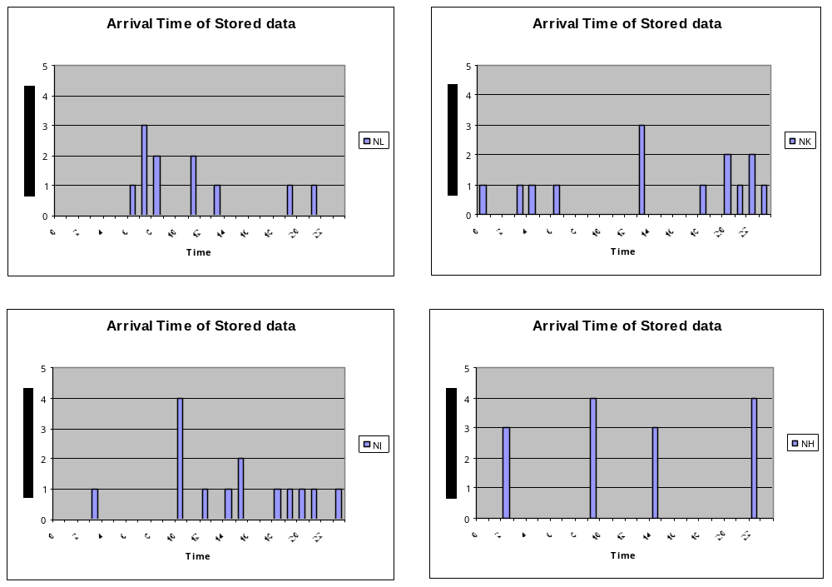
Figure 2: the satellite orbit plans in April 2001. See how NOAA-11 is important to keep good performances !

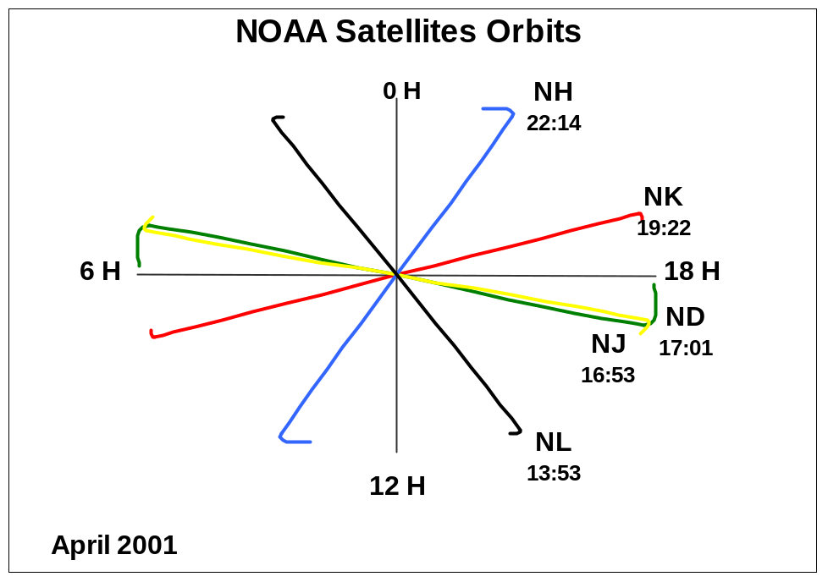
Table 1:

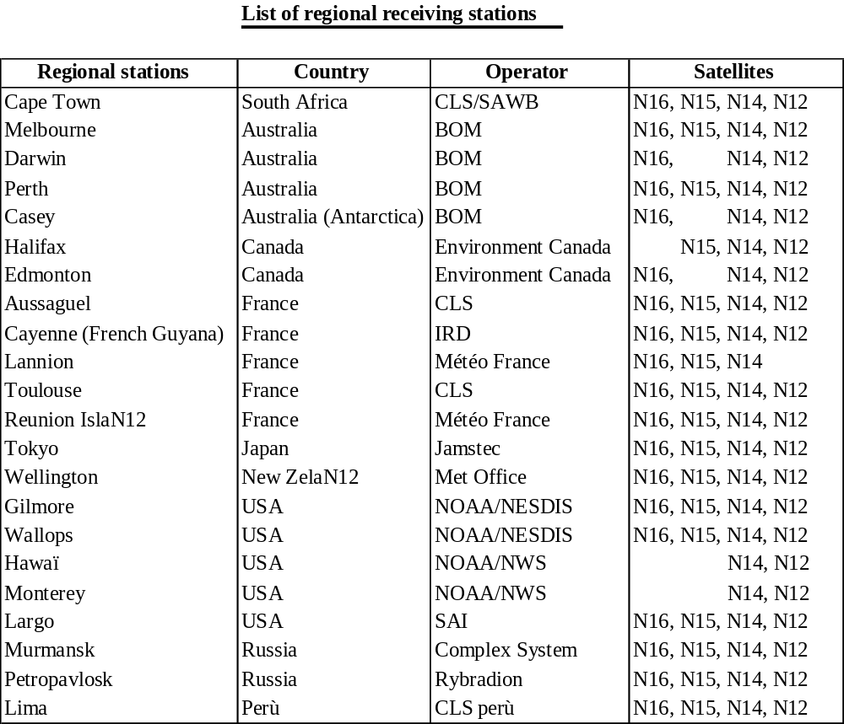
Figure 3: Regional receiving Stations
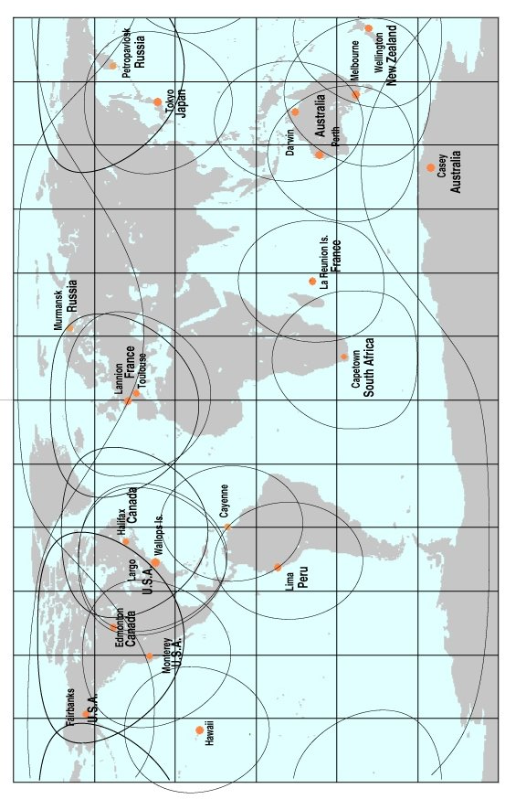

Figure 4: Number of processed data-sets, April 2001
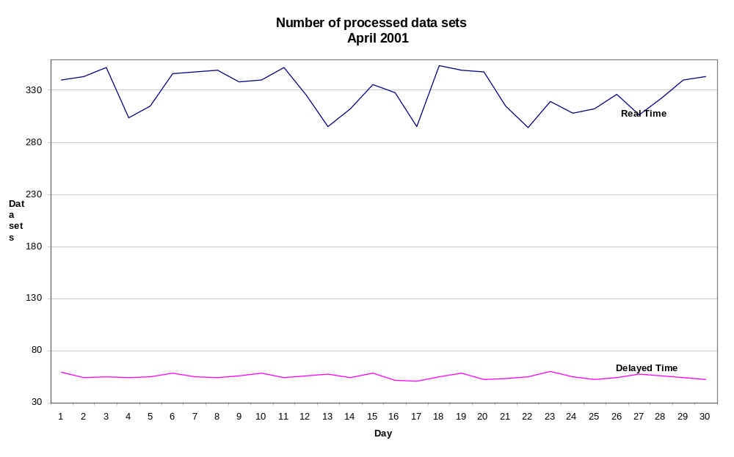
Figure 5:

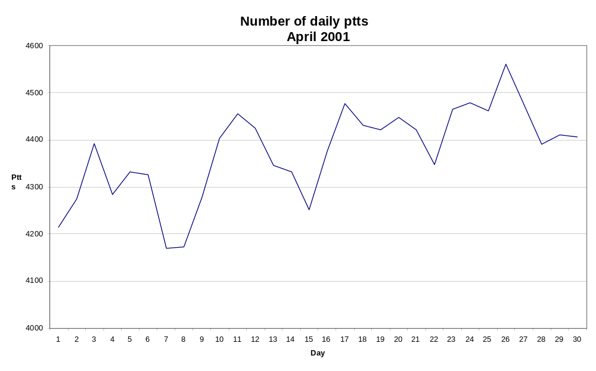
Figures 6: Number of locations and messages received every day by the Largo centre
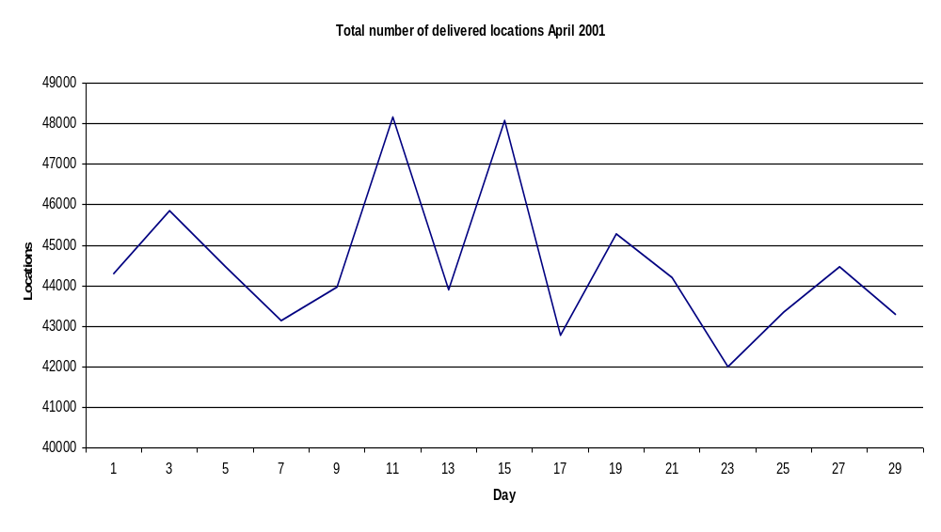

Figures 7: Number of locations and messages received every day by the Toulouse centre:

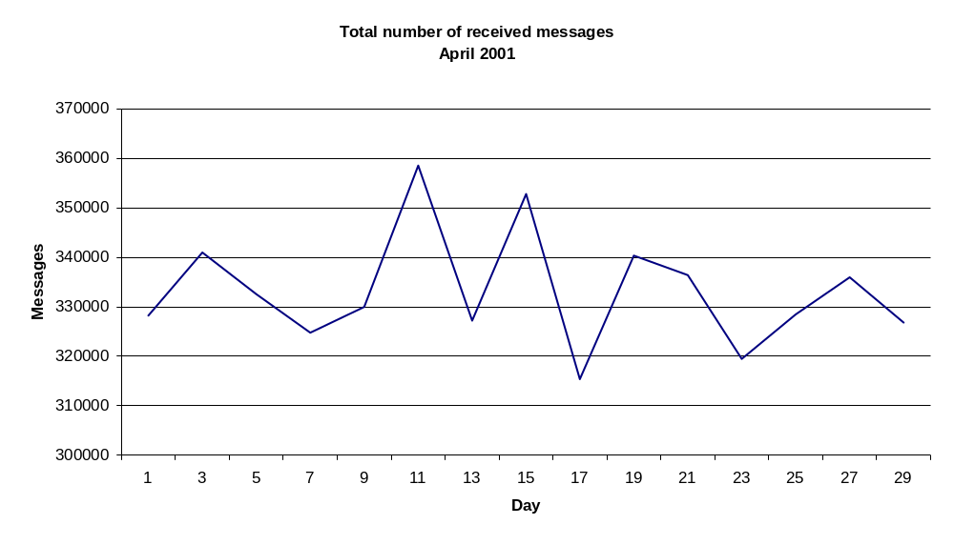
Figure 8:
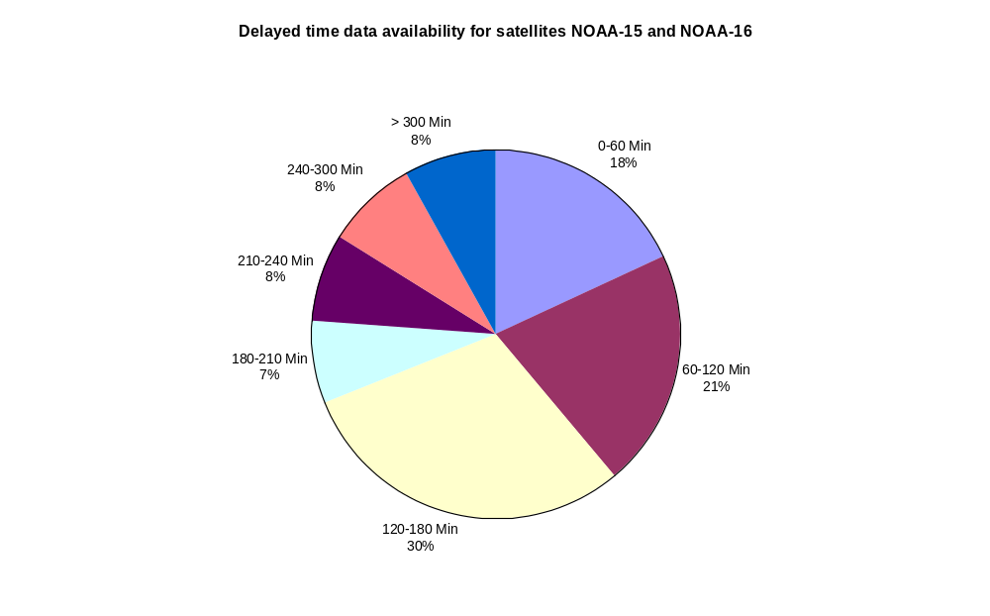

Figure 9:

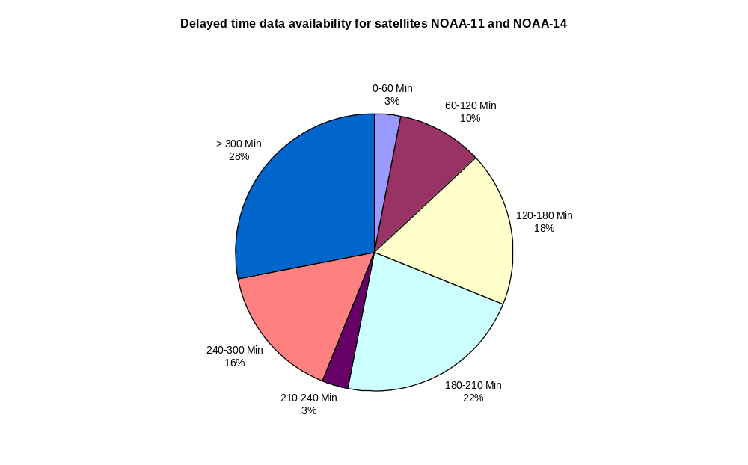

Figure 10: Throughput time for delivery of results for real-time data from NOAA-16, NOAA-15, NOAA-14 and NOAA-12, and data acquired by the 23 HRPT receiving stations.

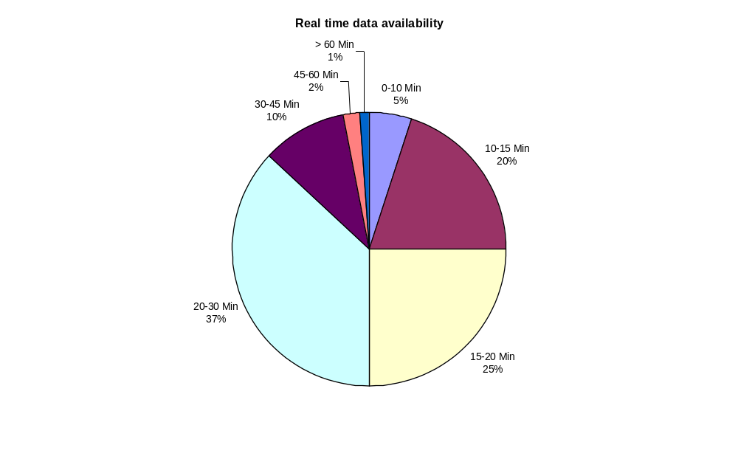

Figure 11: Argos system Enhancements, hardware configuration

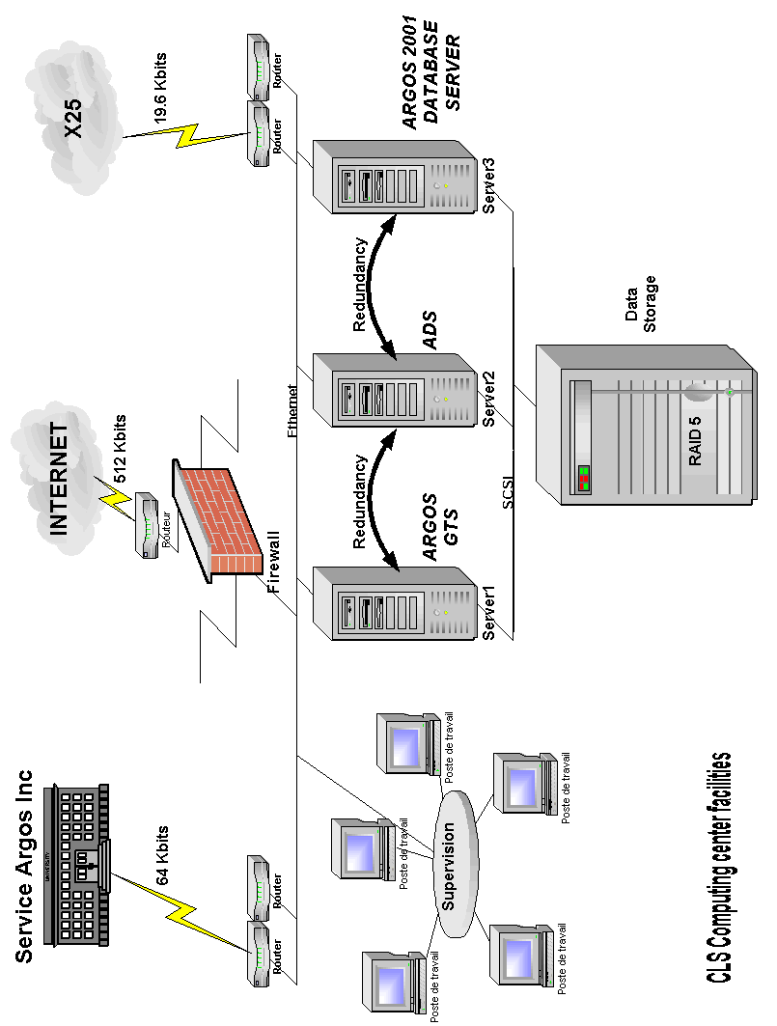

Figure 12: Argos system Enhancements, Ground Segment architecture

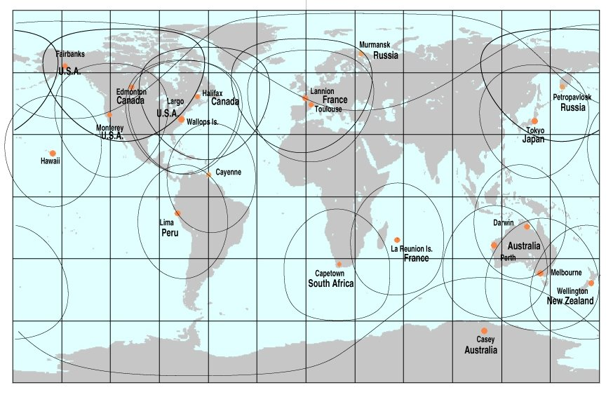

Annex VIII

DEVELOPMENTS IN SATELLITE COMMUNICATIONS SYSTEMS

1. INTRODUCTION

Mobile satellite systems (MSS) may be classified according to orbit altitude as follows:

• GEO - geostationary earth orbit, approx. altitude: 35 000 km
• MEO - mid-altitude earth orbit, approx. altitude: 10 000 km
• LEO - low earth orbit, approx. altitude: <1 000 km

LEOs can be further sub-divided into Big LEO and Little LEO categories. Big LEOs will offer voice, fax, telex, paging and data capability, whereas little LEOs will offer data capability only, either on a real-time direct readout ('bent pipe') basis, or as a store-and-forward service.

Since the satellite footprint decreases in size as the orbit gets lower, LEO and MEO systems require larger constellations than GEO satellites in order to achieve global coverage and avoid data delays. Less energy is, however, generally required for LEO and MEO satellite communication because of the shorter average distance between transmitter and satellite. Some systems implement several high-gain antennas to generate ‘spot beams’ and so reduce the requirement of the mobile to have a complex antenna and/or high output power. A key feature of several MSS currently under development will be their inter-operability with existing public switched telephone and cellular networks, using a dual-mode handset, for example.

Because of the commercial forces which are driving the implementation of the new systems, many will primarily focus on land masses and centres of population, and will not offer truly global or polar coverage. These systems will not in general be acceptable for global ocean monitoring. Furthermore, while the technical capabilities for the new MSS do currently exist, delays are inevitable due to problems with spectrum allocation, licensing (in each country where the service will be offered), company financing, and availability of launch vehicles and ground stations.

It is unlikely that all of the planned systems will overcome all of these hurdles. Indeed, major financial difficulties have hit a number of systems, with Starsys having been cancelled, Iridium having collapsed (and been relaunched), and both Orbcomm and New ICO having been in and out of Chapter 11 bankruptcy protection in the US. Mergers are becoming increasingly common, as market reality forces system planners to cut their losses and pool resources: CCI, Teledesic, Ellipso and New ICO have all recently signed buy-out or collaboration agreements with cellphone entrepreneur Craig McCaw.

From a technical point of view, some systems do offer significantly enhanced capabilities compared with existing methods. Potential advantages include two-way communication, more timely observations, and greater data rates and volumes. Some systems may also prove to be considerably less expensive than existing channels, although this is as yet unclear. However, dangers will exist for data buoy users of most MSS, in that they will generally be small minority users of the system, with consequent lack of influence in regard to pricing. The arrangements for data distribution are also unlikely to be tailored towards data buoy applications, in particular those that require data insertion on the GTS.

2. DESCRIPTION OF CANDIDATE SATELLITE SYSTEMS

The following paragraphs describe the salient features of those systems that might have a data buoy application. In many cases systems are at an early planning stage, and reliable technical information on which to base an evaluation is unavailable. This section is summarized in tabular form in at the end of the document.

2.1 Little LEOs

2.1.1 Argos

Argos has been used by the oceanographic community for more than two decades, and is a dependable, true polar, operational data collection and platform location system. Communication is one-way only, at 400 baud, with practicable data rates of the order of 1 kbyte per day. Transmissions by the mobile are unacknowledged by the system and therefore have to incorporate some form of redundancy if data transfer is to be assured. The system enjoys a particularly clean part of the spectrum (401.65 MHz), with minimal interference from other users. Traditionally, Argos has flown as an attached payload on the NOAA ‘TIROS’ weather satellites, but future launches will also use the Japanese ADEOS and European METOPS platforms.

Enhancements to the Argos on board equipment (‘Argos-2’) include increased receiver bandwidth and sensitivity, with two-way communication (‘downlink messaging’) to be piloted aboard ADEOS-II in 2002. Next generation Argos equipment (‘Argos 3’) will fly from 2004 onwards, and will offer order of magnitude increases in data rates, as well as two-way communications. The system is one of the few that offers true global coverage, and currently has no commercial requirement to recover the cost of the launch or space segment equipment. Proposed changes to the rules within the US regarding fair competition by fully commercial satellite systems may impact the service that Argos will ultimately be able to offer.

The first of the Argos-2 satellites, NOAA-K (NOAA-15) was launched in May 1998 and is now operational, replacing NOAA-D (NOAA-12) as the morning satellite. This was followed in September 2000 by NOAA-L (NOAA-16). The launch of NOAA-M (NOAA-17) is scheduled for March 2002. Several new direct readout stations have been commissioned recently, including Murmansk, Petropavlosk, Halifax, Edmonton, Monterey, Réunion, Cape Town, Lima, Tokyo, Largo, Cayenne, Hawaii and Toulouse. This continues the programme of improving data timeliness by exploiting use of Argos in 'bent-pipe' mode. Further enhancements to the on board equipment (Argos-3), to the ground processing centres and software are at the planning stage.

2.1.2 Orbcomm

This company was awarded the first FCC Little-LEO licence in late 1994. Satellites consist of discs about one metre in diameter prior to deployment of solar panels and antenna. Two satellites were launched into polar orbit during 1995, using a Pegasus rocket piggy-backed on to a Lockheed L-1011 aircraft. After a prolonged period of launcher problems, 35 satellites are now in orbit, making up the complete constellation – although Orbcomm have been awarded a licence for an expansion to a 48 satellite constellation. Of these satellites, 30 are currently operational. The A, B, C and D planes are at 45° inclination and therefore have poor coverage at high latitudes: only two satellites, in the F and G planes (70°), offer a near-polar service. No further launches have been announced.

The system offers both bent-pipe and store-and-forward two-way messaging capabilities, operating in the VHF (138-148 MHz) band. User terminals are known as ‘Subscriber Communicators’ (SCs). Although there have been significant problems with interference close to urban areas, this is not expected to impact offshore operations, and trials of the system have been encouraging. Operational experience of the system is growing rapidly, although it remains difficult to obtain detailed technical information from Orbcomm.

The message structure currently consists of packets transmitted at 2400 bps (scheduled to rise to 4800 bps), and coverage is now global and near-continuous between the polar circles. Messages are acknowledged by the system when correctly received and delivered to a user-nominated mailbox. The platform position is determined, if required, using propagation delay data and doppler shift, or by an on-board GPS receiver. Position accuracy without GPS is similar to that offered by Argos, i.e. km-scale.

The limitations on the store-and-forward mode messages (known as globalgrams) have become apparent, with SC originated messages limited to 229 bytes and SC terminated messages limited to 182 bytes. Each SC can theoretically have a maximum of 16 globalgrams stored on each satellite. Currently, satellites will not accept or process globalgrams when in view of a ground (‘gateway’) station. As messages have to be designated as globalgrams or bent-pipe by the SC at the moment of origination, this presently limits the flexibility of the system to adapt to different coverage situations. Work-arounds do, however, exist, and it is expected that the next generation of SCs will be able to adapt more readily to changes in satellite communications mode.

Authorized transceiver manufacturers include Panasonic, Elisra (Stellar), Torrey Science, Magellan and Scientific Atlanta. Elisra were the first to offer a transceiver with a fully integrated GPS engine, although Panasonic now also have one available. Scientific Atlanta have made a chip-set available to third-party integrators. Prices of most units are between $600 - $1000.

The ground segment has started to expand, and there are now active stations in Italy, Argentina, Brazil, Japan and Korea in addition to the four in the US. However the Japanese and Korean stations are not available for international registrations. Further stations are under construction in Malaysia, Morocco, and Brazil, and potential sites have been identified in Russia, Ukraine, Philippines, Botswana, Australia and Oman. 16 international service distribution partners have been licensed. Non-US customers have faced considerable difficulties because of the absence of ground stations, lack of spectrum licensing and the presence of other in-band users. However the situation is improving rapidly. Currently subscription costs within Europe are on a fixed cost per unit with two bands of usage (above and below 4kbytes per month with a typical monthly rate for the higher band being $70). A fully metered billing system based on users’ actual data throughput was to be implemented in July 2000 but was postponed, officially due to technical problems. If this billing system is implemented with the planned charges ($6/kbyte) then it will result in a massive increase in airtime costs for any user with data rates over 0.5 kbytes/day. Metered billing is apparently implemented outside Europe.

Orbcomm have been suffering financial difficulties, and filed for ‘Chapter 11’ bankruptcy protection in September 2000. The outstanding debts are believed to stem largely from the system rollout phase, with net running costs being of much smaller concern. Industry opinion is that Orbcomm will prevail, largely because of the commitment of many third-party equipment and system manufacturers to the success of the system, and evidence of increasing service take-up by a diverse range of customers.

2.1.3 Starsys

This system was to have been broadly similar to Orbcomm, except that it offered bent pipe mode only, thus limiting its usefulness to coastal areas. Further work on the system, in which the operators of the Argos system were closely involved, has been suspended because of difficulties in securing financial backing. The FCC licence was returned in late 1997.

2.1.4 Iris/LLMS

This European-led system appears to be similar to Argos, using two polar-orbiting satellites with store-and-forward capability. However, terminals are alerted by the satellite downlink signal, and two-way communications and message acknowledgement are supported. Location is by doppler and ranging, and message lengths of up to a few kilobytes are permitted. Some provision is planned for terminal-terminal communication within the satellite footprint. A single satellite was in orbit for system tests, but nothing further has been heard, and the parent company’s website (www.saitrh.com) no longer makes any mention of the system.

2.1.5 Vitasat/Gemnet

This was a 36 + 2 satellite constellation proposed by CTA Commercial systems. Their experimental satellite was the failed Vitasat launch in 1995. CTA is reported to have been taken over by Orbital Science Corporation, the parent organization of Orbcomm, and the 36-satellite Gemnet component has been cancelled. However, the volunteer VITA organization still exists and currently has one satellite in orbit, with plans to rent bandwidth on two other existing satellites, HealthSat-2 and UoSat-12. This proposal received FCC clearance in December 2000, and the company has now brought HealthSat-2 on line. The main mission is to offer low-cost messaging services to developing countries.

2.1.6 Faisat

The Final Analysis company have planned this 32 (+ 6 spare) satellite constellation to provide data messaging services, principally aimed at small messages (~ 100 bytes), but with support for larger messages as well. It will operate in both bent-pipe and store-and-forward modes. The first satellite launch, on the Russian Cosmos vehicle, was scheduled for early 2000, but nothing has been reported. Further launches are expected to occur roughly twice a year. The system received FCC authorisation in April 1998. A test satellite (also part of the Vitasat system) was launched in 1997.

2.1.7 Leo One

This US-designed system consists of a planned 48-satellite constellation offering store-and-forward two-way messaging at up to 9600 bps. An FCC license was granted in February 1998, and a spectrum sharing agreement signed with the operators of the Russian maritime satellite system, TSYKADA. Commercial operation is expected to start in 2003, although no details are known regarding the launch schedule. Orbit inclination will be 50°, giving useful coverage up to latitudes of about 65°.

2.1.8 Gonets

Two GONETS LEO messaging systems have been proposed by the former Soviet Union, using both UHF and L/S-band communications channels. Both will offer true global coverage from high inclination 1400 km orbits. One system, GONETS-D already has 8 satellites in orbit with a further 36 planned. No operational experience has been reported to date.

2.1.9 Other Systems

Six E-Sat satellites are planned. Launches were to have started in 2001, but nothing has so far been announced. The system is aimed principally at the US utility industry for remote metering. The Italian based Temisat is another planned system which is intended to offer global coverage. Little further has been heard of the European SAFIR store-and-forward messaging system, which has two satellites in orbit, but has yet to relaunch a service after major technical problems with its first satellite.

2.2 Big and Broadband LEOs

2.2.1 Iridium

Iridium filed for Chapter 11 bankruptcy protection in August 1999, and underwent financial restructuring. Financial difficulties continued and the system ceased operation in April 2000. At that time, Iridium had its complete constellation of 66 satellites plus spares in orbit, and offered a true global service through a network of ground stations backed up by inter-satellite links. The system has since been resurrected by the US Department of Defense, and a commercial service has been relaunched. Of particular interest to data buoy operators was the Motorola L-band transceiver module, which was designed to be easily integrated with sensor electronics via a standard serial interface, but this product is not likely to appear. Most Iridium phones are, however, data capable and will interface with a standard modem. Throughput is claimed to be 2400bps.

2.2.2 Teledesic

This ‘Internet in the Sky’ system plans a 288 (originally 840) LEO constellation to carry global broadband services such as video conferencing, the Internet, etc. It recently merged with Celestri, another proposed broadband LEO system. Since then there has been some doubt over the actual makeup of the combined constellation. Teledesic has suffered because of the financial difficulties of Iridium, as Motorola, one of Teledesic’s primary investors and head of the industrial partnership developing the system, transferred engineering effort and funding to prop up Iridium. Teledesic has received FCC licensing for operations in the USA. Teledesic, which has now joined forces with Craig McCaw’s New ICO, recently announced that it is ‘nearly ready’ to name its prime contractor for system build.

2.2.3 Globalstar

Globalstar was Iridium’s main competitor in the mobile satellite telephony market. After a bad start in September 1998 when 12 satellites were lost in a single launch failure, Globalstar now has its complete 48-satellite constellation in space, and commenced a limited commercial service in the US in October 1999. Service has since been expanding to other regions and was available in the UK in mid 2000. Globalstar differs significantly from Iridium in that for a call to be made the user must be in the same satellite footprint as a gateway station. There is no inter-satellite relay capability as in Iridium. This means that coverage will not be truly global, especially in the short term as far fewer gateways have been built than originally planned. Although Globalstar was currently in a much stronger financial position than any of its competitors, only 55,000 subscribers have been signed and the company laid off half of its work force in August 2001.

Data services at 9600 bps are planned to be commercially available sometime in the near future. As with Iridium this is likely to be very dependent on the initial success of the basic voice service. Globalstar also has a second generation system planned, said to involve 64 LEO satellites and 4 GEO satellites. Little else is known about the planned enhancements of this system.

2.2.4 Other Systems

Other planned big LEOs include Ecco (by the owners of Orbcomm), Ellipso (a hybrid elliptical LEO/MEO system, now merged with Teledesic and New ICO), LEO SAT Courier (a German led system which was originally a much smaller little LEO system), Signal and SkyBridge.

2.3 MEOs

2.3.1 New ICO

New ICO (formerly ICO Global Communications) is the third of the three main players in the global satellite telephony market. However it also has suffered severe financial difficulties and filed for Chapter 11 bankruptcy protection in August 1999, just two weeks after Iridium. The system, formerly known as Inmarsat-P but now fully autonomous, will use a constellation of 12 MEO satellites backed by a 12-station ground segment to provide a truly global voice, fax, data and messaging service. The aim is to complement and be inter-operable with existing digital cellular telephone networks. Prior to filing for bankruptcy protection, the first launch was planned for late 1999 with commercial service roll out scheduled for the third quarter of 2000. The company emerged from Chapter 11 protection in May 2000, and the first satellite was launched in June 2001, with service scheduled to start in 2003.

When the complete constellation is in service two satellites will always be visible from any point on the earth's surface. The space segment is being built by Boeing Satellite Systems. Data rate will be 9600 bps. Many large manufacturers are engaged in developing dual mode ICO/cellphone handsets. An ICO ‘engine’, is to be defined for the benefit of third-party equipment manufacturers (OEMs).

New ICO have joined forces with Teledesic (both owned by ICO-Teledesic Global), with major revisions to the scope of both systems. In particular New ICO is now putting a far greater emphasis on data services, rather than voice services, which are now widely recognized as holding smaller potential.

2.3.2 West

Little is known about this system, being designed by Matra Marconi Space, except that 9 MEO and GEO satellites were planned, with multimedia-like services scheduled to begin in Europe via West early Bird in 2003. A follow-on vehicle supporting a fully-fledged ATM switch is planned for 2004.

2.4 GEOS

2.4.1 Inmarsat D+

This is an extension of the Inmarsat D service using the new (spot-beam) Inmarsat Phase 3 satellites and small, low-power user terminals. The system was initially designed as a global pager or data broadcast service, with the return path from the mobile used only as an acknowledgement. D+ permits greater flexibility, but the uplink packets are still limited to 128 bits. The first ground station has been implemented in the Netherlands by the existing Inmarsat service provider (Station 12), but useful technical information has been difficult to obtain.

D+ transceiver manufacturers include JRC, Calian, STK-Atlas and Skywave. The JRC unit features an integral GPS receiver and combined GPS/Inmarsat antenna, and is the first to receive type approval. The Skywave unit includes an integral antenna and is specifically designed for low power applications.

The service may prove particularly attractive to national meteorological services as protocols already exist with Inmarsat service providers for the free transmission of observational data to meteorological centres for quality control and insertion on to the GTS. Inmarsat, given its assured multinational backing and established infrastructure, is also extremely unlikely to disappear.

2.4.2 ODL

Oceanographic DataLink (ODL)³ is a US Office of Naval Research sponsored demonstrator system that uses Intelsat C-band transponders to communicate with small oceanographic packages at rates of up to 10 kbps. New signal processing techniques allow such transponders to be used in low energy applications. Both antenna and transceiver size are small (the complete package is expected to be video cassette size), and data costs are expected to be low. Successful bench trials have been completed, and the results of field evaluations are now awaited with interest, but no information has been forthcoming.

2.4.3 Thuraya

This advanced GEO offers voice-band communications with compact cellphone-sized handsets by using steerable spot beams to achieve sufficient link margin. Data services are available using a modem connection on the handset. Coverage is not advertized for oceanic areas, but may be available on request.

3. REFERENCES

1. Hanlon, J (1996). Emerging LEOs telemetry options for use in scientific data buoys - a marine instrument manufacturer's perspective. In: Proceedings of the DBCP Technical Workshop, Henley on Thames, October 1996. DBCP Technical Document No 10, WMO, Geneva.

2. Hoang, N (1999). Data relay systems for drifting buoys utilizing low-earth orbit satellites. In: Proceedings of the DBCP Technical Workshop, Hawk’s Cay, October 1998. DBCP Technical Document No 14, WMO, Geneva.

3. Gamache, K A and Fogel, P E (2000). Oceanographic DataLink. Sea Technology, May 2000, pp 23-31.

Many interesting articles and status reports may be found in: International Space Industry Report, Launchspace Publications, Washington (see below).

4. USEFUL WEB SITES

4.1 General information

Little LEO status, launch dates http://www.ee.surrey.ac.uk/SSC/SSHP/const_list.html
Constellation overview http://www.ee.surrey.ac.uk/Personal/L.Wood/constellations/
The Satellite Encyclopaedia http://www.tbs-satellite.com/tse/online/
General satellite news/gossip http://www.hearsat.org/
Satellite news http://www.spacedaily.com/
General space news http://www.space.com/spacenews/

4.2 Specific operators

Argos http://www.cls.fr/
http://www.argosinc.com/
Ellipso http://www.ellipso.com/
E-SAT http://www.dbsindustries.com/
Final Analysis http://www.finalanalysis.com/
Globalstar http://www.globalstar.com/
GOES http://www.goes.noaa.gov/
Inmarsat http://www.inmarsat.org/
Iridium http://www.iridium.com/
LEO One http://www.leoone.com/
LEO SAT Courier http://www.satcon-de.com/
METEOSAT http://www.esoc.esa.de/external/mso/meteosat.html
New ICO http://www.ico.com/
Orbcomm http://www.orbcomm.com/
Ocean DataLink (ODL) http://www.viasat.com/government/globalcontrol/index.htm
SAFIR http://www.fuchs-gruppe.com/ohb-system/
Skybridge http://www.skybridgesatellite.com
Teledesic http://www.teledesic.com/
Thuraya http://www.thuraya.com/
VITA http://www.vita.org/
West http://www.matra-marconi-space.com/

_____________

Appendix: 1

Overview of Mobile Satellite Systems with Possible Data Buoy Applications

System | Status* | Date (if known) | Orbit type | Buoy position | Message type | Terminal size | Power (watts) | Comments
ARGOS | Operational |  | Little  LEO | Doppler  Shift | data: 32 bytes | Handheld | 1 | Various enhancements, incl 2-way messaging, are scheduled
ECCO (CCI Global) | Planned | 2003+ | LEO | GPS  Required | voice/data | Handheld | TBD | 12 equatorial satellites planned by 2003. Status questionable – merged withICO-Teledesic Global
ELLIPSO | Licensed | Service 2003+ | Big  LEO | GPS required | voice/data | Handheld | TBD | 17 satellites in highly elliptical orbits,  serving major land masses. Status questionable – merged withICO-Teledesic Global
EYESAT | Experimental |  | Little  LEO | GPS  Required | data: 60 bytes | Handheld | 5 | 1 satellite 1995, principally for radio amateurs
E-SAT | Licensed | Launch 2001+ | Little  LEO | GPS  Required | data: TBD | TBD |  | 6 satellites for utility metering (aimed at Continental US only initially)
FAISAT | Licensed | Service 2002+ | Little  LEO | GPS  Required | data: 128 bytes | Handheld | 10 | 38 satellites 2000+ Test satellite launched 1997
GEMNET | Cancelled (pre-op) |  | Little  LEO | GPS  Required | data: no maximum | 'laptop' | 10 | 1st satellite 1995 - launch failure  36 satellites by ???
Globalstar | Operational | 1999 | Big  LEO | GPS  Required | voice/data:  no maximum | Handheld | 1 | 48 satellites + spares (constellation complete) Limited coverage due to lack of ground stations. Financial difficulties.
GOES, Meteosat, GMS | Operational |  | GEO | GPS required | data: various options | laptop | 10 | 4 satellites; directional antenna desirable NOAA / ESA / Japanese met satellites.
GONETS-D | Pre-operational |  | Little  LEO | GPS/  Glonass | Data | Handheld | TBD | 8 satellites in orbit, 36 more planned
GONETS-R | Planned |  | Little  LEO | GPS/  Glonass | Data | Handheld | TBD | 48 satellites planned
INMARSAT-C | Operational |  | GEO | GPS  required | data: no maximum | 5.5 kg | 15 | Steered antenna not required
INMARSAT-D+ | Operational |  | GEO | GPS required | data: 128bytes uplink, 8 bytes downlink | Handheld | 1 | Global pager using existing Inmarsat-3 satellites Note very oriented to downlink
ICO (New ICO) | Licensed | Service 2003 | MEO | GPS  required | voice/data:  no maximum | Handheld | 1 | Global voice and packet data services. Recently merged with Teledesic to form ICO Teledesic Global. 12 satellites planned – 1 launched
Iridium | Revived | Service resumed 2001 | Big  LEO | GPS  required | voice/data:  no maximum | Handheld | 1 | 72 satellites in orbit
IRIS/LLMS | Experimental |  | Little  LEO | Doppler +  ranging | data: up to few  kbytes | Handheld | 1 | 1 satellite in orbit. Belgian messaging system part of an ESA research prog.
LEO One | Licensed | Service mid 2003 | Little  LEO | GPS  required | data uplink 9600bps, downlink 24000bps | Handheld | Max 7 | 48 satellite constellation, store and forward + 8 spares. No polar sats
LEO SAT Courier | Planned | Service 2003+ | Big  LEO | GPS required | Data / voice | Handheld | 1-5 | 72 satellites
OCEAN-NET | Experimental |  | GEO | Moored | no maximum | Large |  | uses moored buoys + Intelsat
Ocean DataLink (ODL) | Experimental |  | GEO | GPS | no maximum | Handheld | TBD | uses Intelsat
Odyssey | Cancelled (pre-op) |  | MEO | GPS  required | voice/data:  no maximum | Handheld | 1 | 12 satellites were planned
Orbcomm | Operational | 1998 | Little  LEO | Doppler  or GPS | data: no maximum | Handheld | 5 | 35 satellites in orbit, 30 operational, expansion to 48 sats licensed
SAFIR | Pre-operational |  | Little  LEO | Doppler  or GPS | data: no maximum | laptop | 5 | 2 satellites in orbit
Signal | Planned |  | Big  LEO |  | voice/data |  |  | 48 satellites planned
SkyBridge | Licensed | Service 2002+ | Big  LEO | GPS  Required | Broadband | Larger than handheld |  | 80 satellites planned. Re-utilising GEO spectrum allocations
Starsys | Cancelled (pre-op) |  | Little  LEO | Doppler +  Ranging | data: 27 bytes multiple msgs | Handheld | 2 | 12 satellites 1998+  24 satellites 2000+
Teledesic | Licensed | Service Late 2004 | Big  LEO | GPS required | Broadband |  |  | 288 satellites planned  FCC licence granted  Merged with new ICO
Temisat | Experimental |  | Little  LEO |  | Data |  |  | 7 satellites planned for environmental data relay. 1 satellite launched 1993.
Thuraya | Operational |  | GEO | Integral GPS | Voice/data |  |  | 1 multiple spot beam satellite in orbit (over Middle East), 1 planned
Vitasat | Pre-operational |  | Little  LEO | GPS  Required | Data |  |  | 2 satellites in orbit,  2 more planned
WEST | Planned | Service 2003+ | MEO | GPS  Required | Broadband |  |  | 9 satellites planned

* Status of systems is categorized into one of six groups:

Planned: Little is known about the system except a name, notional type, and services to be offered. Mostly not licensed, although some may be.

Licensed: System has been licensed by a national or international regulatory agency (in most cases the FCC), but no satellites have been launched.

Experimental: System has one or more satellites in orbit for experimental purposes (not usually part of the final constellation). Includes new systems planning to use existing satellites.

Pre-operational: System is in process of launching, or has launched, its constellation but is not yet offering full services. Some limited evaluation service may be available.

Operational: System has full or nearly full constellation in place and is offering readily available service to external users (not necessarily commercial).

Cancelled: System has been cancelled, either before satellites launched (pre-op) or after (post-op).

Annex IX

DATA FROM COMMERCIAL SATELLITE SYSTEMS VIA THE ARGOS GTS SUB-SYSTEM

Overview and suggested actions

The document below initiates the discussion on GTS distribution for data collected by commercial systems. The DBCP action item is recalled as a start, tasks and options to be considered are reviewed afterwards. A qualitative summary of the situation is provided as a conclusion.

As the options have a major impact on the amount of work and associated investment, the panel is invited to review them and take some decisions to facilitate next steps of the study.

Recall of the action from DBCP XVI

At its 16th session, the panel discussed the issue of GTS distribution of buoy data for data collected via commercial satellite systems. While noticing that a few buoy operators were already using systems other than Argos to collect the data, the Panel agreed that there was presently no recommended solution and buoy operators had to process the data themselves, do the quality control and encoding, and routinely submit the data in real time to their national meteorological services for insertion onto the GTS.

The panel agreed that there were existing and likely future requirements for the GTS distribution of data collected through such commercial satellite systems, as well as on the potential value to all concerned of using the existing data processing facilities of the Argos GTS Sub-system to effect such distribution. The panel therefore requested CLS/Service Argos to undertake a feasibility study of the main issues involved. Such a study should involve also the technical coordinator, the chairman of the JTA and Mr Rob Bassett, representing the Argos Operations Committee, and should have three distinct components:

- The extent and possible complexity of the present and likely future requirements for such a facility;
- Technical aspects of the question, including possible procedures for transferring data to the Argos GTS Sub-system as well as any necessary modifications required to the system;
- Policy issues involved, including possible impacts on the JTA and Argos operating agreement, a new Argos service category to accommodate such processing, and an estimate of eventual end-user charges for this service.

The panel agreed that the study should be limited to existing satellite systems known to be used already by buoy operators (Orbcomm, Inmarsat, Globalstar), and that it would not necessarily involve any interaction by CLS/Argos with the satellite operators themselves. It requested that the study should be available in time for review and further discussion at DBCP-XVII. At the same time, the panel decided that the issue should be brought to the attention of the forthcoming JTA, but with no action to be proposed.

Initial study

Introduction

Assessing the extent and possible complexity of the work, requires an overview of the mechanism needed to achieve GTS distribution of buoy data collected via commercial satellite systems.

The tasks to be considered are:

- Task 1 - Access to data : retrieving or receiving data files from the operators
- Task 2 - Data integration in Argos GTS sub-system, depends on data type and format
- Task 3 - Adaptations to the Argos GTS sub-system, this is a direct consequence of tasks 1/2.

For each task, there’s a need to review the options which have a direct impact on complexity.

Access to data

Access to data can be many. The key question is whether the data files are « pushed » – i.e. sent automatically by the operator - or « pulled » – i.e. accessible on a server and dedicated commands are needed to retrieve the data.

As general rule, complexity is lower when data files are « pushed ». Yet the « pull » option can be implemented without much trouble when it is an ftp access to the operator disk. Complexity would be related in such case to number of different operators from which data would be accessed.

The easiest solution is to ftp data files on a dedicated disk in Argos processing centre.

The other important aspect to take into consideration is whether the data are provided by the satellite operators or the buoy operators. Complexity of the « pull data» options clearly increases with the number of operators.

In all cases, developments might be required on the buoy or satellite operators side.

Data integration in GTS sub-system

The format and the type of data has a significant impact on data integration in the Argos GTS subsystem. Data files can be:

- bit stream data, observation are embedded in bit stream
- observation data file: data are provided as observations with platform ID, time values, locations, sensor data…
- GTS code: data are already coded in GTS format, the sub-system is just used to relay the observations to the GTS network.

For all options above, especially the first two, reducing complexity requires an agreement on limited number of formats and format standardization.

When data files are provided by satellite operators, the format is usually fixed. There are one, sometimes more, formats by satellite operator.

If distribution from buoy operators is selected, formats could be standardized.

The bit stream data file option will provide the higher flexibility in formats since the GTS subsystem is built to accommodate a large number of formats.

The table below describes the tasks needed for each of above data file options.

Tasks  Data file options | Bit stream decoding and sensor data processing | Quality controls | GTS coding (WMO) | GTS distribution
Bit stream | * | * | * | *
Observations |  | * | * | *
GTS code |  |  |  | *

GTS sub-system adaptation

This task is much dependent on the options above. Bit stream data file should be rather easily be input in the GTS sub-system. There are some considerations to be paid to the dimensioning of the data set, the number of sensors etc. to facilitate compatibility or reduce modifications on the GTS sub-system.

The integration of observation data files requires consequent work as those files will need to be integrated somewhere in the « middle » of the GTS sub-system process and that there’s no structure in existing software to facilitate this operation. If required, this should be considered together with the complete upgrade of the GTS sub-system.

The GTS code data files, as they would be integrated at the « end » of the entire GTS sub-system process, would require some work with a low level of complexity.

Satellite operators versus buoy operators

The table below summarizes the characteristic features of data distribution by satellite or buoy operators.

Option  Tasks | Satellite operators | Buoy operators
Data access | Inmarsat C : pull server and email, ftp (depends on station)  Inmarsat D+ : push, ftp  Orbcomm : push email (may depend on station) | Pull data : usually no data server except in data management centres, some operators provide ftp access to files stored in a disk  Push data : increase used of ftp forwarding,  some are to be developped, ftp  Simple procedure may be imp
Bit stream or dated observations | Bit stream or dated observations, according to what is transmitted | Bit stream or dated observations
Formats | Inmarsat C : any format  Inmarsat D+ : hexadecimal (binary), decoded GPS fixes  Orbcomm : binary or ASCII, decoded GPS fixes, depends on what is transmitted  Formats are fixed by the operators | Various formats but possibility to standardize
Bit stream or dated observations | Bit stream or dated observations, depends on what is transmitted | Bit stream or dated observations

Pull data option usually requires developing more sophisticated routine to access the operator server. For some system or stations (Land Earth Station), data can only be retrieved once from the operator mail box, thus inhibiting the access by another user. There might be a confidentiality consideration too with this option, if the buoy operator doesn’t wish to provide full access to all data stored in the LES. if only a part

Push data access will limit the developments. The easiest solution would be ftp transfer to a disk at the Argos processing centres. This can only be done by satellite operators already offering this capability, or the buoy operator, subject to their developing the task. Format standardization cannot be achieve with satellite operators but can be worked out with buoy operator.

Policy issues

According to the status of he technical issues, it seems premature to discuss policy issues. Yet, what needs to be considered is the impact of data access on costs. For satellite operators there are usually extra charges to push data to several addresses. Question to be considered is whether investments and operating costs for CLS/SAI should be integrated in the JTA policy or dealt separately with CLS/SAI.

Summary

The table below gives qualitative information on the impact of options on level of work and complexity

* high
** rather high
*** medium
no « * » means no significant impact on the task

Options  Impact on tasks | Pull data | Push data | Bit stream file | Dated observations | GTS code | Fixed formats (few) | Various formats
Data access | * | ***
Data integration |  |  | *** | * | ** | *** | *
Sub-system adaptation |  | *** | *** | * | ** | *** | *

As a consequence, the solution requiring less work is when stream bit files are pushed to our computer and that standard formats are defined. It is to be noted that the bit stream offers higher flexibility in formats since the GTS sub-system is built to accommodate a large number of formats.

The panel is invited to review the options and make decisions.

Annex X

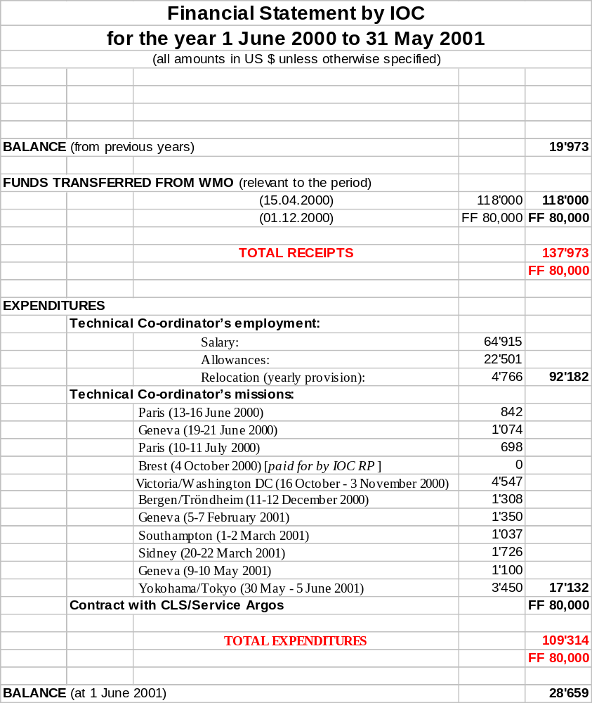

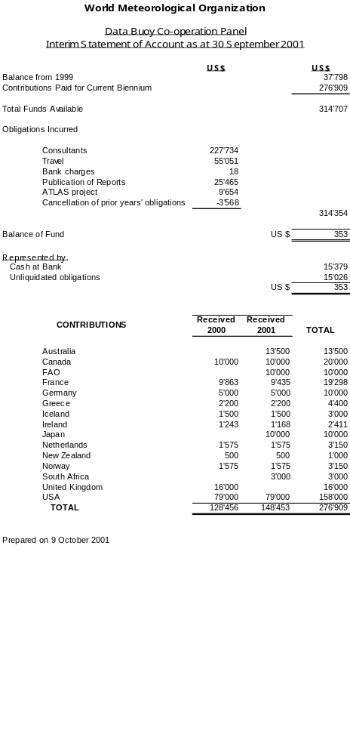
PROVISIONAL ESTIMATE OF INCOME AND EXPENDITURE
UNTIL 31 MAY 2002

Income |  |  |  |  | USD
 | Balance of fund from interim account |  |  | 353
 | Sale of DBCP ties and scarves |  |  | 1,000
Expenditure
 | Publications | New publications (GTS Guide) | 6,000
 | Unseen Obligations |  |  | 7,353
 | Data base development |  |  | 5,000
 | Travel of chairman/vice-chairmen/JTA chairman |  |  | 1,000
 | Total |  |  | 19,353
 | Anticipated balance to transfer to 2001/2002 account |  |  | -18,000

Annex XI

EXPENDITURES AND INCOME FOR 1998-2003

 | Actual 1998 and 1999  (2 years) |  |  | Estimated 2000/01  (2 years) |  |  | Estimated 2002/03  (1 year)
 | USD
Expenditures
Technical Coordinator (Salary, Travel and Logistics) | 249,211 |  | 252,000 |  | 126,000
Travel  (chair, vice-chairs and JTA chair) | 16,559 |  | 35,327 |  | 19,000
Experts | 3,845
JTA chairman | 5,490 |  | 15,000 |  | 7,000
Publications | 12,194 |  | 30,000 |  | 10,000
DBCP ties |  |  | 1,350
WMO | 8,620 |  | 30 |  | 50
Contingencies |  |  |  |  | 1,200
TOTAL | 295,919 |  | 327,707 |  | 163,150
Income achieved/required to balance expenditures
Contributions | 300,072 |  | 276,909 |  | 162,650
DBCP ties |  |  | 1000 |  | 500
Carry forward from  Previous biennium | 33,645 |  | 37,798
Carry over to (or back from) next biennium | -37,798 |  | 18,000
TOTAL | 295,919 |  | 327,707 |  | 163,150

Annex XII

DRAFT TABLE OF PROVISIONAL CONTRIBUTIONS

DBCP
 | 2000-2001 |  |  | 2001-2002 |  |  | 2002-2003
AUSTRALIA (including JTA chair support 2000-02) | 13,500 |  | 13,500 |  | 12,500
CANADA | 10,000 |  | 10,000 |  | 10,000
FRANCE | 9,863  (FRF 70,000) |  | 9,435  (FRF 70,000) |  | 10,000  (FRF 70,000)
GREECE | 2,200 |  | 2,200 |  | 2,200
ICELAND | 1,500 |  | 1,500 |  | 1,500
IRELAND | 1,243  (IR£ 1,000) |  | 1,168  (IR£ 1,000) |  | 1,300  (IR£ 1,000)
JAPAN |  |  | 5,000 |  | 5,000
NETHERLANDS | 1,575 |  | 1,575 |  | 1,575
NEW ZEALAND | 500 |  | 500 |  | 1,000
NORWAY | 1,575 |  | 1,575 |  | 1,575
SOUTH AFRICA | 3,000 |  | 3,000 |  | 3,000
UNITED KINGDOM (including JTA chair support 2000-02) | 16,000 |  | 16,000 |  | 15,000
USA (including JTA chair support 2000-02) | 69,000 |  | 69,000 |  | 68,000
JTA (for JTA chair support) |  |  |  |  | 10,000
TOTAL | 129,956 |  | 134,453 |  | 142,650

SOOPIP

 | 2000-2001 |  | 2001-2002 |  | 2002-2003
Germany | 5,000 |  | 5,000 |  | 5,000
Japan | 5,000 |  | 5,000 |  | 5,000
USA | 10,000 |  | 10,000 |  | 10,000
TOTAL | 20,000 |  | 20,000 |  | 20,000

TOTAL INCOME FROM CONTRIBUTIONS

 | 2000-2001 |  | 2001-2001 |  | 2002-2003
TOTAL | 149,956 |  | 154,453 |  | 162,650

Annex XIII

DBCP IMPLEMENTATION & TECHNICAL WORKPLAN FOR THE 17th YEAR

PART A - Summary of tasks

1. Analyse programme information & other data as appropriate & in particular in accordance with DBCP global programme implementation strategy.

2. Assist in the planning & implementation, as appropriate, of the ocean data buoy component of GOOS, GCOS & CLIVAR.

3. Implement database of buoy programme information on JCOMMOPS web server.

4. Update & amend, as necessary, the DBCP World Wide Web server, including up to date information on existing & planned data telecommunication systems.

5. Continue investigation regarding developments in communication technologies & facilities, relevant to the collection of sensor &/or location data from buoys.

6. Update & publish new versions of DBCP publications No. 2 (Argos GTS sub-system), 3 (Argos guide) & 15 (Implementation strategy, web only). Produce new publications: 2001 Annual Report, Workshop Proceedings (CD-Rom and web only), and SVPB Design Manual (CD-Rom and web only).

7. Develop & implement cooperative buoy deployment strategies, in particular with the GDP, to provide buoy networks which serve both research & operational applications.

8. Organize scientific & technical workshop at DBCP-XVIII

9. Publish new version of DBCP brochure

10. Monitor & evaluate quality of pressure & wind data from SVPB & SVPBW drifters.

11. Assist in implementing new buoy programmes as required.

12. Encourage other centres to act as PMOC

13. Begin implementation of BUFR within Argos GTS sub-system.

14. Check out list of variables & templates for encoding of buoy data in BUFR.

15. Document calibration procedures

16. Provide the Technical Coordinator with deployment opportunities (maps & point of contact) for inclusion on the JCOMMOPS web server.

17. Produce table of national commitments in the Southern Ocean (by next Panel’s session).

18. Buoy operators to develop their metadata catalogues & submit information to the JCOMM sub-group on Marine Climatology

19. Finalize standard format for manufacturers to provide metadata when delivering buoys.

20. Recommends that JTA includes the following feature in the Argos development programme as soon as requirements are expressed by relevant Panels: Implementation of Quality Control procedures for profile data according to requirements expressed by relevant Panels (AST, TIP, SOOP).

21. Make proposal to the JCOMM OPA for integration of DBCP QC guidelines into a wider scheme to include also float and XBT data

22. MEDS to implement new QC flagging system for location data and to reprocess its archives accordingly over the next year. RNDOC/DB maps to be updated during the next month to show all data. MEDS also to review its QC system.

23. David Meldrum and the Technical Coordinator to study impact of data timeliness on programme performance and provide materials to the Argos OpsCom

24. Brazil to provide the Technical Coordinator with survey paper on the impact of delayed data on NWP

25. Put a link on DBCP web site news page to the NOAA Argos web site

26. To undertake a feasibility study for Service Argos acting as a gateway for insertion of already formatted buoy data onto the GTS. DBCP to recommend the includsion of related developments in the Argos development programme if/when the feasibility study shows it’s practicable.

27. Relevant panel members to routinely (e.g. monthly) provide the Technical Coordinator with the list of moored buoys they operate and which are reporting in SHIP format. This list must be provided in an electronic form in a format suitable for automatic data processing. Format to be defined with TC.

28. Enhance buoy safety through improved design (refer recommendations) and keep the Panel informed about related changes.

29. The Evaluation Group to suggest definitions for early failures, useful data, lifetime, ocean areas, etc., to be used by the panel in its activities.

DBCP IMPLEMENTATION & TECHNICAL WORKPLAN FOR THE 17th YEAR

PART B

TASK | CARRIED OUT BY* | SUPPORTED/  ASSISTED BY | REPORTED TO/  ACTION BY
1 | TC | Vice-chairmen | Chairman for presentation to the panel
2 | DBCP | Panel members | Panel
3 | TC |  | Panel
4 | NOAA/AOML & TC | Vice Chairman (Meldrum) | Panel
5 | Vice-chairman (Meldrum) & TC | Chairman & Panel members | Panel
6 | TC, Secr. | Service Argos (No. 3 by April 2002), Scripps Institution of Oceanography (No. 4), Panel Members (No.15) | Panel
7 | Regional action groups, GDC | Panel members, TC | Panel, GDP
8 | Mr. Eric Meindl | Secr. | Panel
9 | Australia |  | Panel
10 | DBCP evaluation group |  | Panel
11 | Support team (USA, UK, Brazil, Canada) | TC, Secr. | Panel
12 | Panel Members | TC | Panel
13 | CLS, Service Argos | TC | Panel, JTA
14 | Panel Members | TC | CBS ET/DRC, Panel
15 | Panel Members |  | JCOMM sub-group on MC
16 | Members |  | Panel
17 | TC | Panel Members | Panel
18 | Buoy operators |  | JCOMM –MC
19 | GDC & TC |  | Panel, JCOMM SG-MC
20 | TC | CLS, AST, TIP, SOOP | JTA-XXI, Panel
21 | TC | Secr., JCOMM OPA, JCOMM DMA | JCOMM OPACG, Panel
22 | MEDS | Panel | DBCP-XVIII
23 | David Meldrum | TC | OpsCom
24 | Brazil |  | TC
25 | TC |  | Panel
26 | TC | Service Argos | JTA-XXI, Panel
27 | Panel Members | TC | Panel
28 | Manufacturers | Panel Members | Panel
29 | Evaluation Group |  | Panel

DBCP ADMINISTRATIVE WORKPLAN FOR THE 17TH YEAR

PART A - Summary of tasks

1. Maintain summary of requirements for buoy data to meet expressed needs of the international meteorological & oceanographic communities.

2. Maintain a catalogue of existing ongoing ocean data buoy programmes

3. Maintain a list of national contact points for the DBCP & within other relevant bodies with potential for involvement in DBCP activities.

4. Identify sources of buoy data not currently reported on the GTS & determine the reason for their non-availability.

5. If deemed necessary, make proposals for coordination activity as a result of the above actions to address items 2 to 6 in the terms of reference of the DBCP.

6. Arrange for the circulation of information on the Panel's activities, current & planned buoy programmes & related technical development/evaluations, including via distribution of existing DBCP publications to potential Argos GTS users.

7. Monitor the operation of the Argos GTS processing sub-system & arrange for modifications as necessary.

8. Continue the arrangements (including finance) to secure the services of a technical coordinator.

9. Review programme & establish working priorities of the technical coordinator.

10. Prepare annual report of the DBCP.

11. Support, as required, existing DBCP action groups (EGOS, IABP, IPAB, ISABP, IBPIO, GDP, TIP), and provide assistance on request to other internationally coordinated buoy programme developments.

12. Investigate requirements for initiating new coordinated buoy deployments in other ocean areas such as the Black Sea.

13. Tentatively establish a North Pacific Buoy Programme within PICES (possibly as a new Action Group) and organize preparatory meeting.

14. Make every effort to recruit new contributors to the trust fund.

15. Keep up-to-date with the latest buoy technical developments.

16. Coordinate operation of DBCP QC guidelines.

17. Follow up & possibly assist in implementing requirements expressed by the buoy users within the Argos system.

18. Provide technical workshop papers to WMO Secretariat (end December) & publish proceedings (mid 2002).

19. Submit national reports & Action Group reports in electronic form to the technical coordinator for inclusion in the DBCP server.

20. Prepare & distribute revised budget estimates for 2002-2003

21. Secr. & members to identify necessary funding to allow for expansion of JCOMMOPS & AIC staffing & resources.

22. Interested Member states to make commitments to the DBCP newly established budget line of the DBCP trust fund dedicated to instrument evaluation. Chairman to write formally to WMO to establish the budget line.

23. Continue development of JCOMMOPS.

24. Possibility of Black Sea buoy programme to become part of EGOS by issuing a letter of intent from Black Sea Programme Chair to the EGOS Chair

25. Make a study on the necessity, or otherwise, of having two different centres in JCOMM dealing with the same kind of data, as is the case for the RNDOC/DB and SOC/DB.

26. Review to assess the benefits and efficiency that might be achieved by extending the TOR of JCOMMOPS to include also support for VOS and ASAP.

27. IBPIO to take the lead in implementing support for an Indian Ocean Observing System as far as data buoys are concerned. Chairman and TC to consider submitting papers from the Panel to the conference on the system (end of 2002).

28. Promulgate DBCP policy regarding the reallocation of WMO ID numbers to the user community.

DBCP ADMINISTRATIVE WORKPLAN FOR THE 17TH YEAR

PART B

TASK | CARRIED OUT BY* | SUPPORTED/  ASSISTED BY | REPORTED TO/  ACTION BY
1 | TC | Panel members & Secr. | Chairman for presentation to the panel
2 | TC | Panel members & Secr. | Chairman & panel for information
3 | Secr. | Panel members | Chairman & panel for information
4 | TC, CLS | Panel members & Secr. | Chairman & panel for information
5 | Chairman & TC | Secr. & others as appropriate | To Panel for consideration & appropriate action or for direct action by chairman
6 | TC | Chairman, Secr. & CLS | Wide circulation by Secr. & CLS
7 | TC | CLS | Panel & users
8 | Chairman & sub-committee | Secr. | Secr.
9 | Panel/chairman |  | Panel (at next session)
10 | Chairman & Secr. | TC | Executive Councils of WMO & IOC
11 | Chairman & Secr. | TC | Panel
12 | Ukraine, Chairman & Secr. | EGOS, Panel members | Panel
13 | Canada | Secr., Panel Members | Panel
14 | Chairman | Panel members | Panel
15 | Operational services, chairman, vice-chairmen & TC | Panel members | Panel
16 | TC | Panel members & operational services | Panel
17 | CLS | TC | Panel, meeting on JTA
18 | Panel members, WMO Secr. |  | Panel
19 | Panel members, AG, TC |  | Panel
20 | Secr. |  | Panel
21 | Secr. & panel members
22 | Panel members, Chairman |  | WMO, Panel
23 | DBCP TC & Argo TC | Panel Members, Secr., CLS | Panel
24 | Black Sea BP | Secr., EGOS | Panel
25 | RNODC/DB, SOC/DB | JCOMM | Panel
26 | JCOMM SOT | VOS, ASAPP, SOOP | First session of SOT, DBCP-XVIII, JCOMM MS-2
27 | IBPIO | DBCP Chair, TC, Secr. | Panel
28 | TC/WMO Secr. |  | User community

