GPS-BASED RADIOSONDE SYSTEM
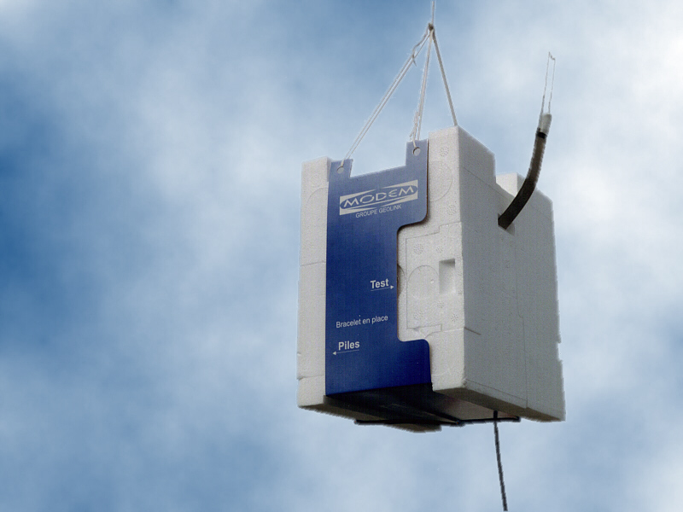 | GPSonde GL98  (WMO code 77)  SR2K  Ground station

Main Features
GPSonde GL98 | SR2K Ground station
FULLY-CODED GPS RADIOSONDE  PRESSURE DERIVED FROM GPS ALTITUDE  SENSORS CALIBRATION STORED ON EEPROM  GROUND CHECK FACILITY  400 TO 406 MHz DIGITAL SYNTHESISER  200 KHz STEP FREQUENCY SETTING  DIGITAL TRANSMISSION IN 1 SEC CYCLES  NARROW BANDWIDTH  POWER SUPPLY WITH DRY CELL BATTERIES  BATTERIES LIFE > 3HOURS  NO SUSPENSION LENGTH LIMITATION | 19 Inch RACK FITTED  12-CHANNEL GPS RECEIVER  REAL TIME DIFFERENTIAL GPS (DGPS)  BOTH RAW AND PROCESSED DATA AVAILABLE  EDITION OF WMO CODE MSG  STANDARD COMPUTER ABILITIES  FRIENDLY USE SOFTWARE WORKING ON  NT4 & NT5 OPERATING SYSTEM  REAL TIME GRAPHICAL VISUALIZATION  BUILT-IN FREQUENCY SCANNER  OMNIDIRECTIONAL AERIALS  EASY TO INSTALL  SONDE PROGRAMMING INTERFACE

SUMMARY OF TECHNICAL SPECIFICATIONS

GPSonde GL98 RADIOSONDE:

GENERAL |  |  | BATTERIES
Dimensions | : 113 x 155 x 146 mm |  | Technology | : 1.5V Alkaline
Weight | 405 g (including batteries) |  | Autonomy | : >3 h
 |  |  | Package | : 8-battery pack

TEMPERATURE |  |  | HUMIDITY
Sensor type | : Thermistor |  | Sensor type | : Capacitor
Measurement range | : +50° to –90° |  | Measurement range | : 0% to 100%
Resolution | : 0.1°C |  | Resolution | : 0.1%
Absolute accuracy | : +/- 0.5°C |  | Absolute accuracy | : +/-5%
Response time | : <2s |  | Response time | : <2s
Measurement rate | : 1 Hz |  | Measurement rate | : 1 Hz
Calibration adjustment | : Calibration prior launch |  | Calibration adjustment | : Calibration prior launch
Factory calibration | : Stored in EPROM |  | Factory calibration | : Stored in EPROM

WIND MEASUREMENT |  |  | TRANSMITTER
General | : DGPS with C/A code altitude |  | Frequency range | : 400 to 406 MHz
Altitude Range | : Unlimited with authorisation |  | Frequency step | : 200 KHz
Position accuracy | : 10 m |  | Frequency setting | : Programming interface
Horizontal Wind accuracy | : 0.15 m/s |  | Maximum drift | : +/- 1 KHz
Wind direction accuracy | : 2 ° |  | Output Power | : 300 mW
Position resolution | : 0.01 m |  | Modulation type | : Digital PSK 4800 bauds
Horizontal wind resolution | : 0.01 m/s
Wind direction resolution | : 0.1 ° |  | CALIBRATION
Measurement rate | : 1 Hz |  | Factory calibration | : Stored on EPROM
 |  |  | Ground Check | : Prior launch

SR2K GROUND STATION

GENERAL
Dimensions | : 19’’ rack - Width: 450 mm – Depth: 320 mm – Height: 135 mm
Weight | : 12 kg
Consumption | : 150 W
Output | : Real time data, COM1, COM2, LP1, VGA, USB, PS2, Ethernet
Programming interface | : Front panel connector with cable
GPS | : 12-channel receiver
Computer functions | : Non dedicated PC allowing work on others Windows applications
Accessories | : All standard computer accessories can be connected: Printer, modem, …
TELEMETRY  Built-in receiver  Tracking range  Modulation | : 400 – 406 MHz digital Synthesiser  : 250 Km  : PSK | 



