WORLD METEOROLOGICAL ORGANIZATION  ________________________ | INTERGOVERNMENTAL OCEANOGRAPHIC  COMMISSION (OF UNESCO)  ________________________
JOINT WMO/IOC TECHNICAL COMMISSION FOR OCEANOGRAPHY AND MARINE METEOROLOGY (JCOMM)  SHIP OBSERVATIONS TEAM  FOURTH SESSION  GENEVA, SWITZERLAND, 16 TO 21 APRIL 2007 |  |  | SOT-IV/Doc. VI-3.1.1  (15.II.2007)  __________  ITEM VI-3.1.1  Original: ENGLISH

ASAPP-XVI
Monitoring and Data Management

Monitoring activities of ECMWF in support of ASAP

(Submitted by ECMWF)

Summary and purpose of document

The Appendix to this document contains the report of ECMWF on the monitoring of the quality of ASAP data.

ACTION PROPOSED

The ASAP Panel is invited to:

- Note and comment on the information provided, as appropriate;

- Take action as necessary to correct deficiencies identified from the monitoring.

______________________

Appendix: Summary Report on the Monitoring of ASAP Ship Data, January – December 2006

Appendix

Summary Report on the Monitoring of ASAP Ship Data
January-December 2006



European Centre for Medium-Range Weather Forecasts

1. Summary:

The number of ASAP reports is still on the increase since 2005. In 2006 the percentage of ASAP soundings reaching 100 hPa has dropped to figures between 85 and 90% compared to values between 90 and 95% in 2005. A few problems have been detected mainly related to wrong reported positions. The statistics have continued to be good.

2. Data reception:

Figures 1 to 5 show a number of time series with the monthly counts of ASAP reports received at ECMWF from January 1994 onwards. In these plots on top of the monthly values a moving average curve is shown in order to assess the temporal trends. So in figure 1 such a time series is shown for temperature data at the level of 500 hPa. Most of the reports include this mid tropospheric level however this plot is representative of the number of received reports at ECMWF. The positive trend seen in 2005 is still going on during 2006. This positive trend can be found also in the time series for wind data at the level of 250 hPa (figure 2). A standard evaluation for the radiosondes performance is the assessment of the percentage of launches reaching the level of 100 hPa.

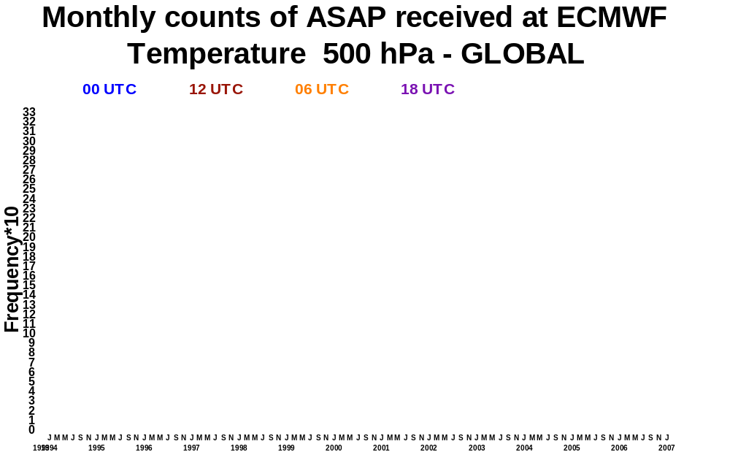

Figure 1
ASAP temperature data received at 500 hPa level Jan 1994 to Feb 2007 (00, 06, 12 and 18 UTC)

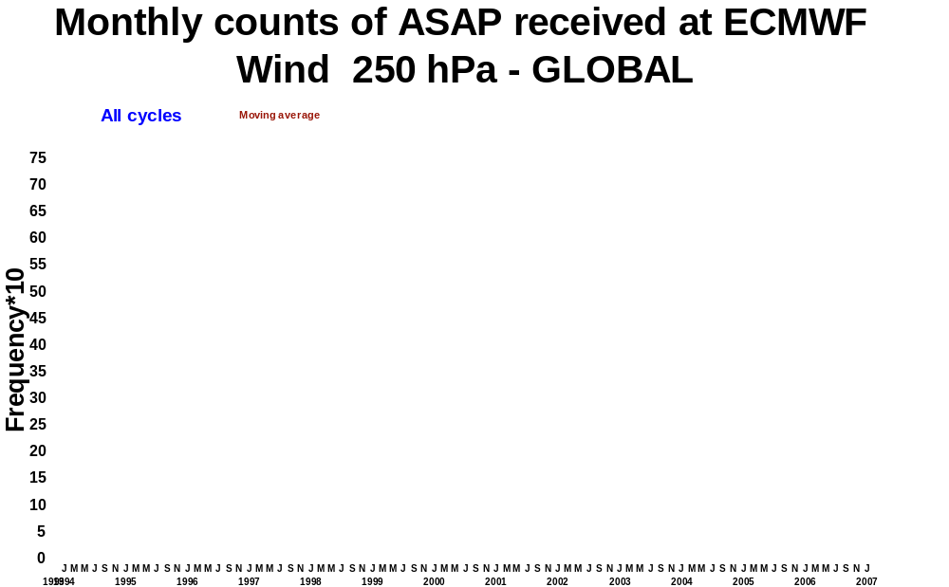

Figure 2
ASAP wind data received at 250 hPa level Jan 1994 to Feb 2007 (all cycles together)

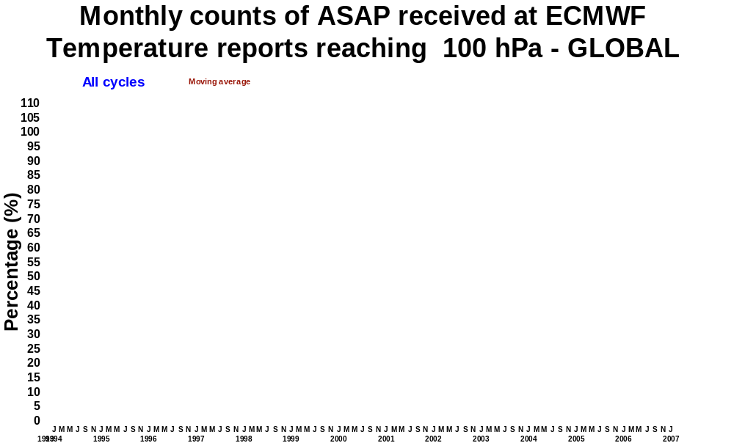

Figure 3
Percentage of ASAP temperature data reaching 100 hPa level Jan 1994 to Feb 2007

This level in the lower stratosphere is representative for a crucial layer in the analysis of the thermal structure of the atmosphere in the NWP models. Figure 3 shows that sort of time series. The percentage of launches in the years 2000 to 2005 have been between 90 to 95% but in 2006 this figures have dropped down to values between 85 to 90%

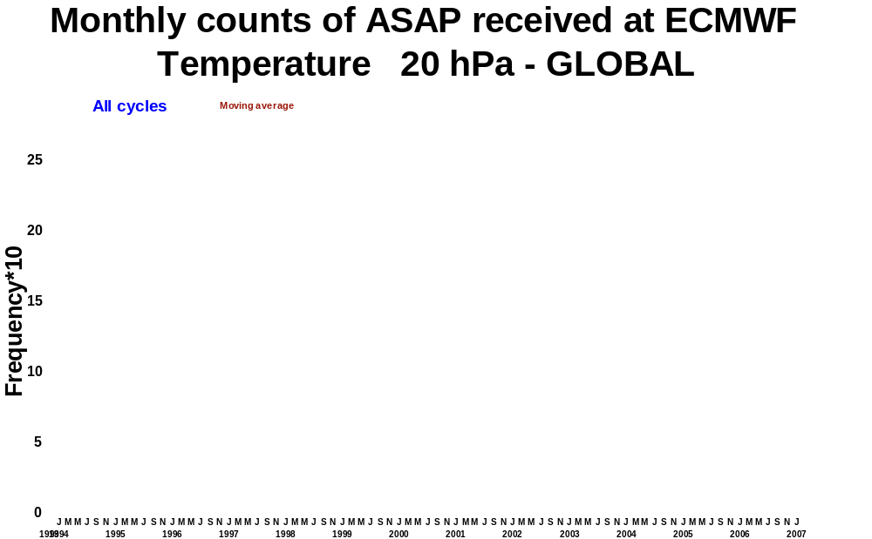

Figure 4
ASAP temperature data received at 20 hPa level Jan 1994 to Feb 2007 (all cycles together)

In the case of upper levels in the stratosphere we see in figure 4 a positive trend in 2005 and 2006 for the level of 20 hPa. Only a reduced number of launches reach levels above 10 hPa.

3. Troubleshooting:

There are no relevant changes related to the geographical distribution of the ASAP reports with most of the ASAP units operating in the North Atlantic and areas close to Japan. A few reports come from the Southern Atlantic and Eastern Pacific and we have also the Spanish ASAP operating close to the Canary Islands.

The problems related to ASAP units in 2006 are similar to the previous years that’s to say the reception of corrupted call-signs from time to time and the wrongly located reports which normally are rejected by the model quality control but in occasions can introduce wrong pieces of information in the model analysis when the departures from the background fields are below the QC thresholds. The problem of the wrongly located reports is in most of the cases due to a change of the longitude from east to west or vice versa and more seldom to a change of hemisphere in the reported latitude. Figure 5 shows the ASAP tracks in November 2006 and in figure 6 the tracks of ASAP unit WPKD in April 2006 showing two wrong positions.

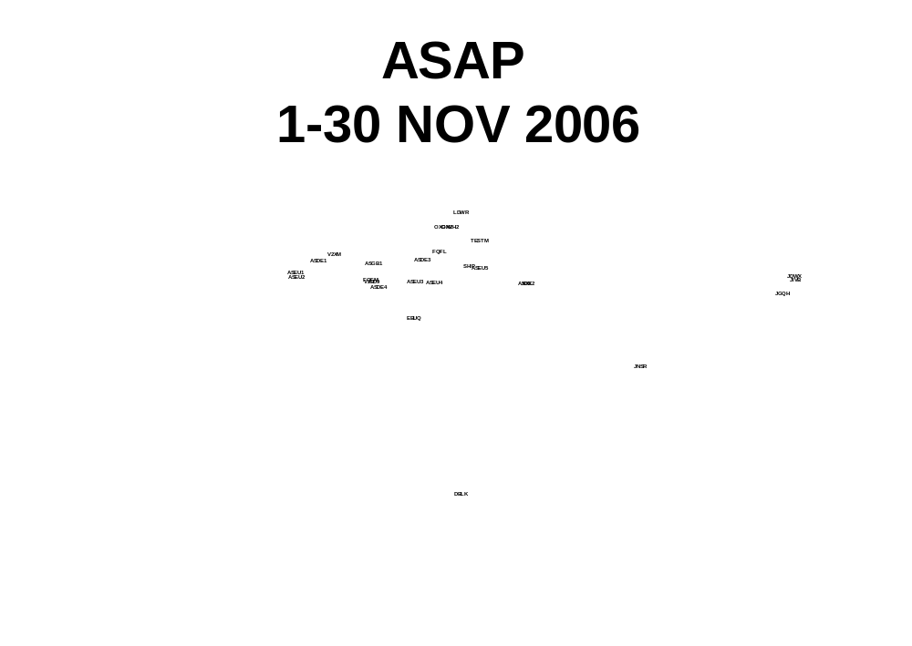

Figure 5
ASAP tracks November 2006

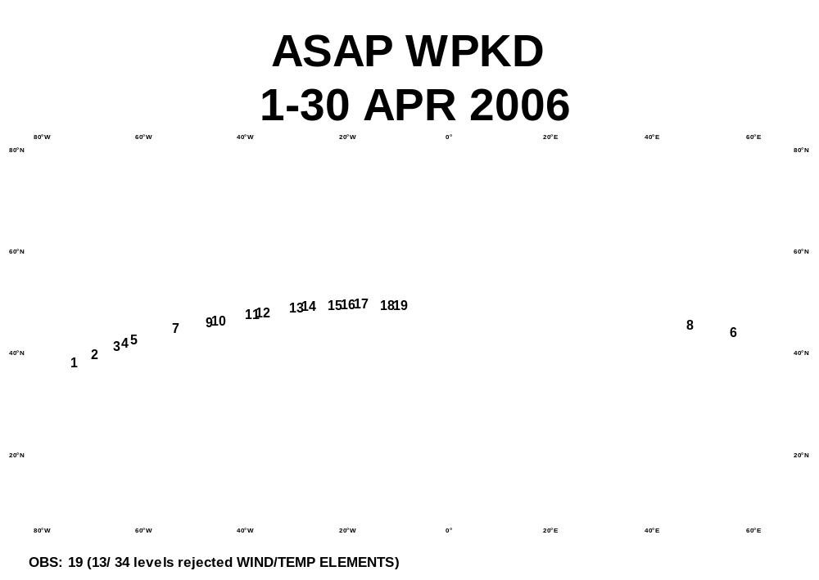

Figure 6
Track for ASAP WPKD in April 2006 showing two erroneous reporting positions
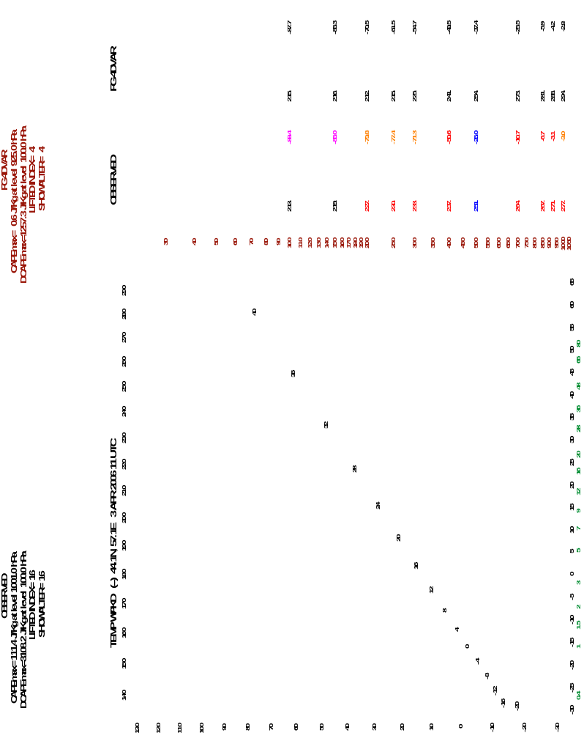

Figure 7
A wrongly located ASAP report rejected by the 4DVAR QC. Full red line is the observed temperature, dotted red is the First Guess temperature, and dashed blue is the observed dew point and dotted blue the First Guess dew point

In figure 7 the tephigram of one of those wrongly located reports can be seen. In this case the differences between the observed profiles and those from the model fields are large and the whole report was rejected by the model quality control. But this is not always the case. On June 15th 2006 the Danish ASAP OXVH2 sailing south of Greenland sent a report with a longitude of 15 degrees East instead of 15 degrees West that’s to say in the middle of Sweden as shown in figure 8. The departures of the temperature profile were not large enough to be rejected by the model except at the PBL and at the Tropopause which was 50 hPa higher in the First Guess (in Sweden) than in the observation (in North Atlantic). So in this particular case wrong data was introduced in the model analysis (see figure 9).

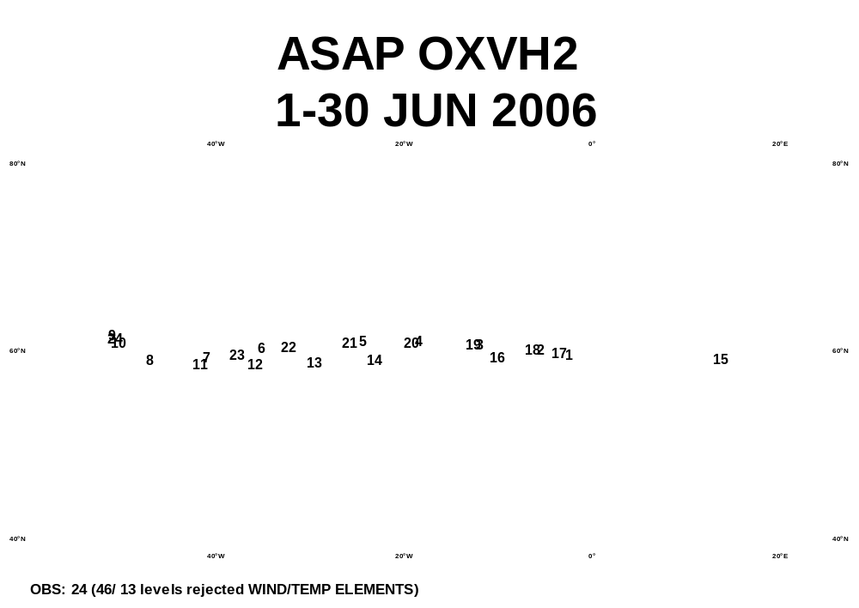
Figure 8
Track for ASAP OXVH2 in June 2006 showing one erroneous reporting position
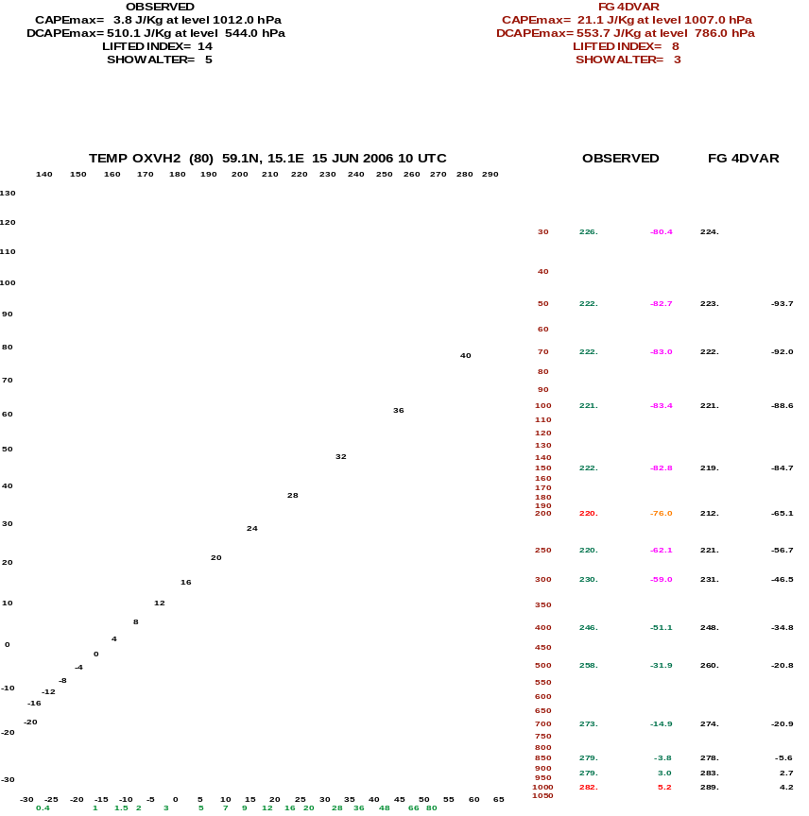

Figure 9
A wrongly located ASAP report accepted by the 4DVAR QC.
The point now is whether to blacklist or not one of these ASAP. The decision making has to rely in the history and long term statistics of individual platforms. This is one of

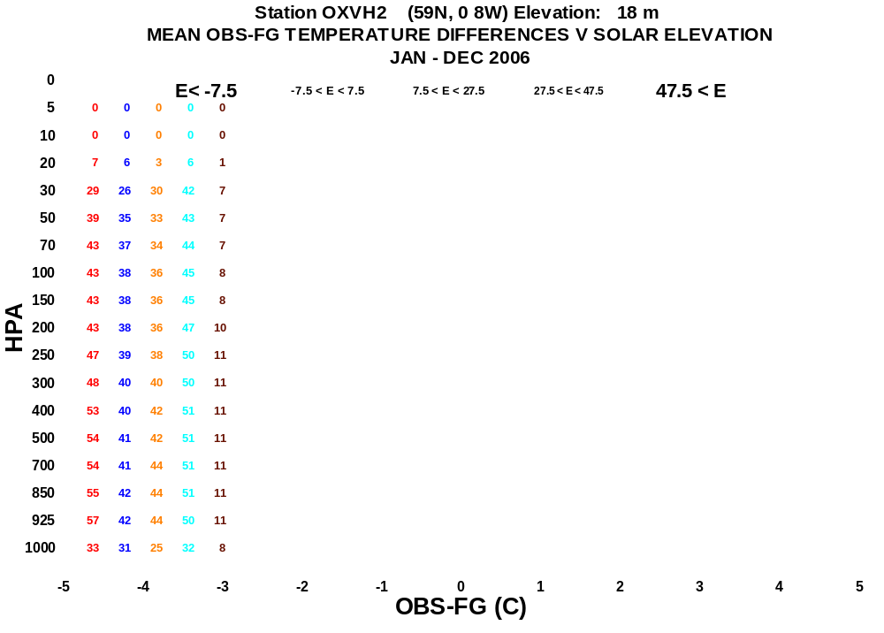
Figure 10
Temperature vertical statistics OB-FG (bias and STD) as a function of the solar elevation at the time of the observation. January to December 2006

The issues we deal with not only for ASAP but also for all radiosondes on a global scale. The vertical statistics shown in figure 10 computed for ASAP OXVH2 from January to December 2006 show a good general performance for this unit so no action was taken to include the ASAP in the blacklist.

4. ASAP data monitoring at ECMWF:

The ASAP data monitoring at ECMWF is carried out at two different levels. First we have the daily monitoring which is done by the Met Analyst on duty in the MetOps room and then we have the monthly and longer term monitoring. A number of tools have been developed to help the Met Analysts to have an easy access to the current status of the observations performance. Once a day a number of products are updated and displayed in the ECMWF web pages. The number of ASAP reports are accessible to everybody in our external web pages as shown in figure 11. The rest of the daily products are in our internal web pages for monitoring purposes as time series also. Two interesting products are the time series for temperature, humidity and wind both for data usage and statistics. The data usage and statistics are offered at three atmospheric layers (below 700 hPa, 700 to 400 hPa and above 400 hPa) both for all data and for used data in the assimilation. In figures 12 and 13 two examples can be found about the data reception and usage. Figure 14 shows an example of a time series with temperature statistics for observed temperature departures from First Guess and Analysis above 400 hPa.

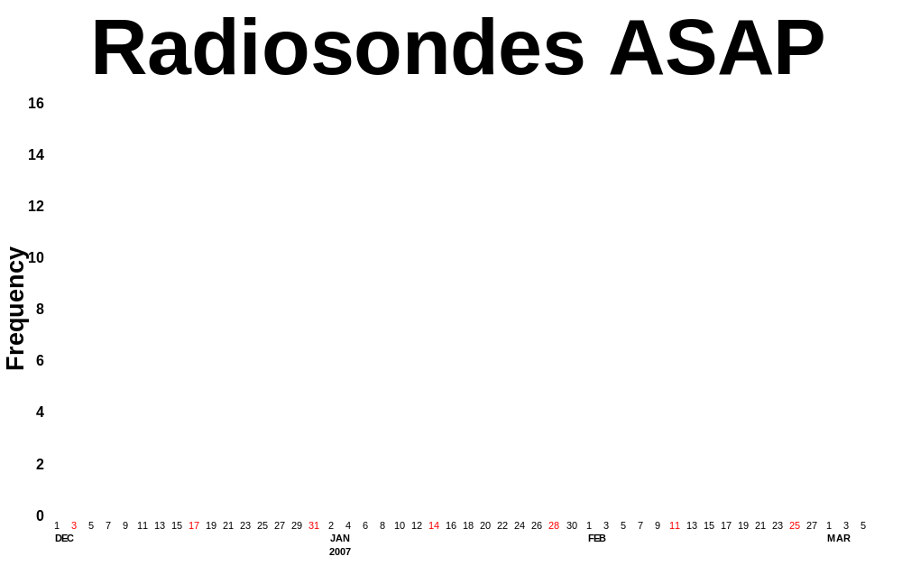
Figure 11

Time series showing the number of ASAP reports received at ECMWF (1st Dec 2006 to 6th March 2007)

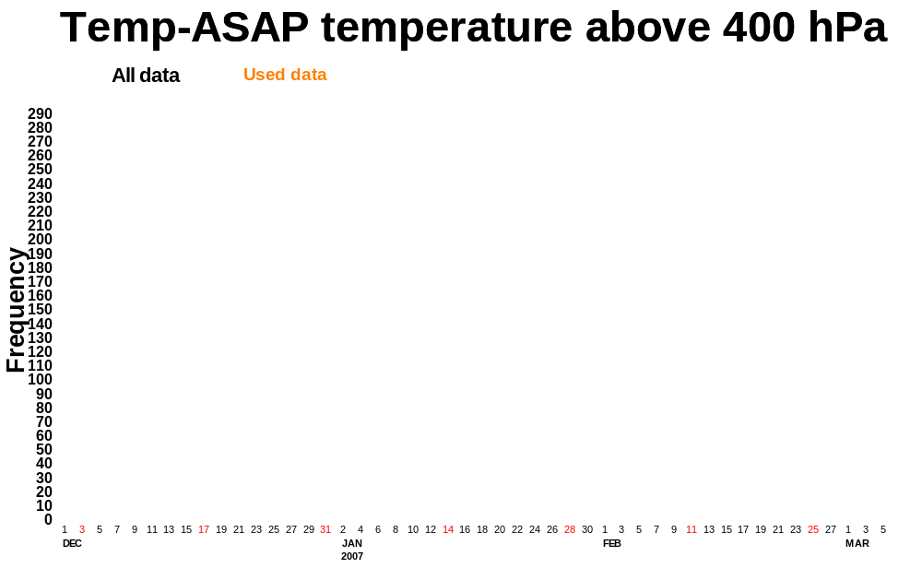

Figure 12

Time series showing the number of temperature data received and used above 400 hPa (1st Dec 2006 to 6th March 2007)
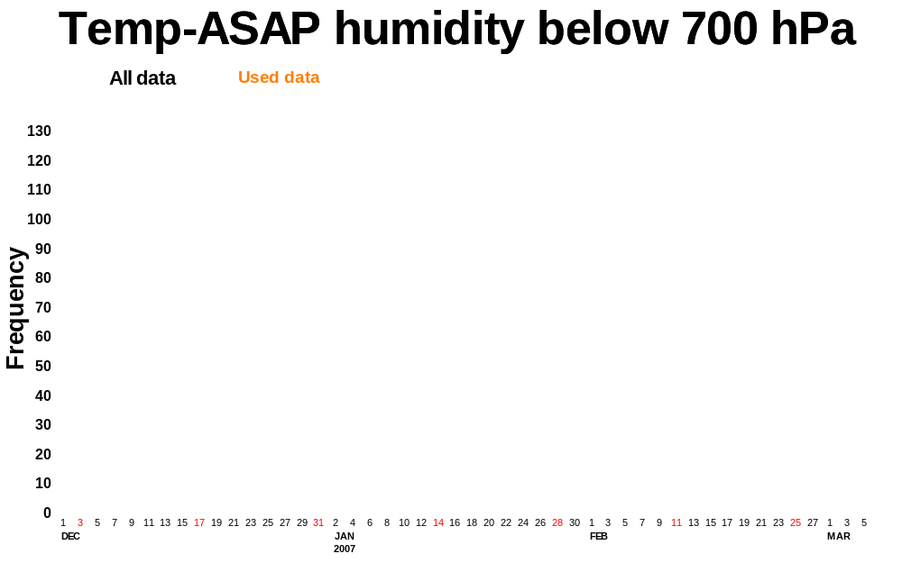
Figure 13
Time series showing the number of humidity data received and used below 700 hPa (1st Dec 2006 to 6th March 2007)
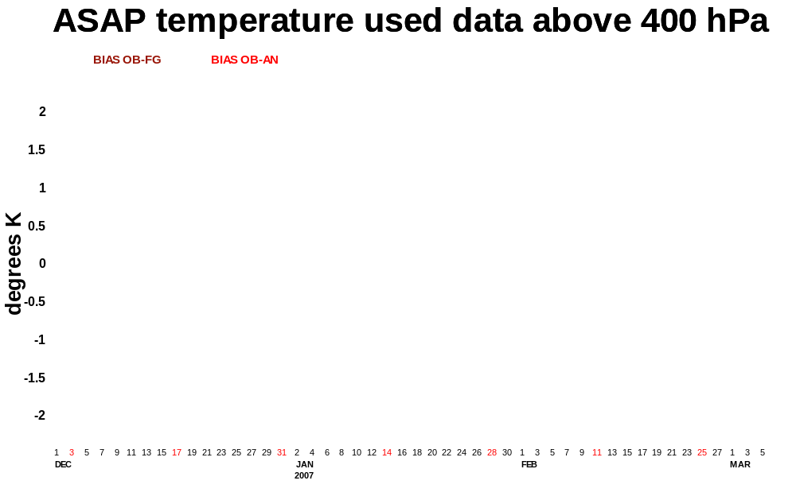
Figure 14
Time series showing the ASAP temperature statistics above 400 hPa OB-FG (bias and STD) and OB-AN (bias) (1st Dec 2006 to 6th March 2007)

Figures 15 and 16 show longer term statistics as vertical profiles for the Japanese ASAP and the rest of units. These composite vertical statistics show a good performance of the ASAP observational system.
As stated in previous years reports the sampling of the North Atlantic area is reasonable but we have a similar lack of information in the Southern Hemisphere. More information in the Southern Hemisphere would be beneficial also for satellite radiances calibration.
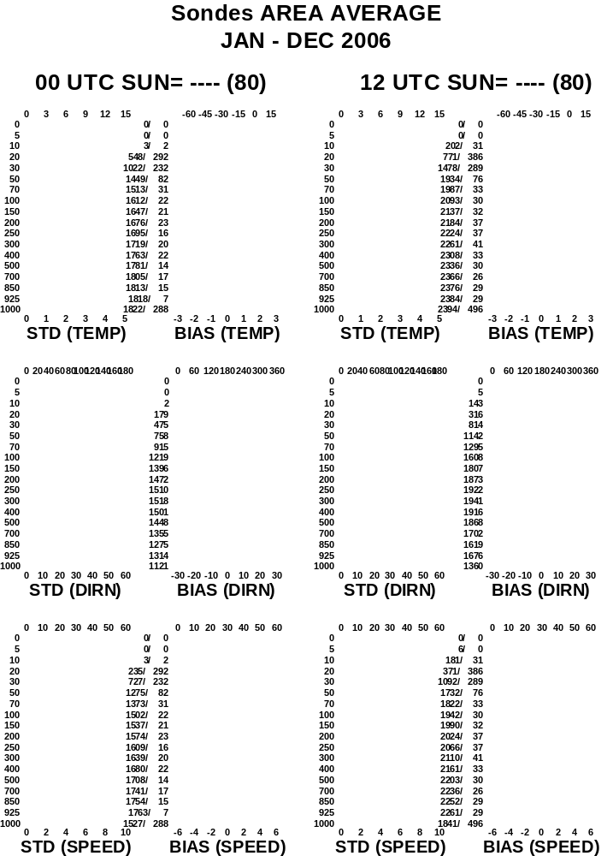

Figure 15

Vertical statistics ASAP except Japanese. January to December 2006
Full red line: OB-FG statistics (BIAS)
Dashed red line: OB-AN statistics (BIAS)
Full blue line: OB-FG statistics (STD)
Dashed blue line: OB-AN statistics (STD)
Dotted black line: Observed mean/variability profile

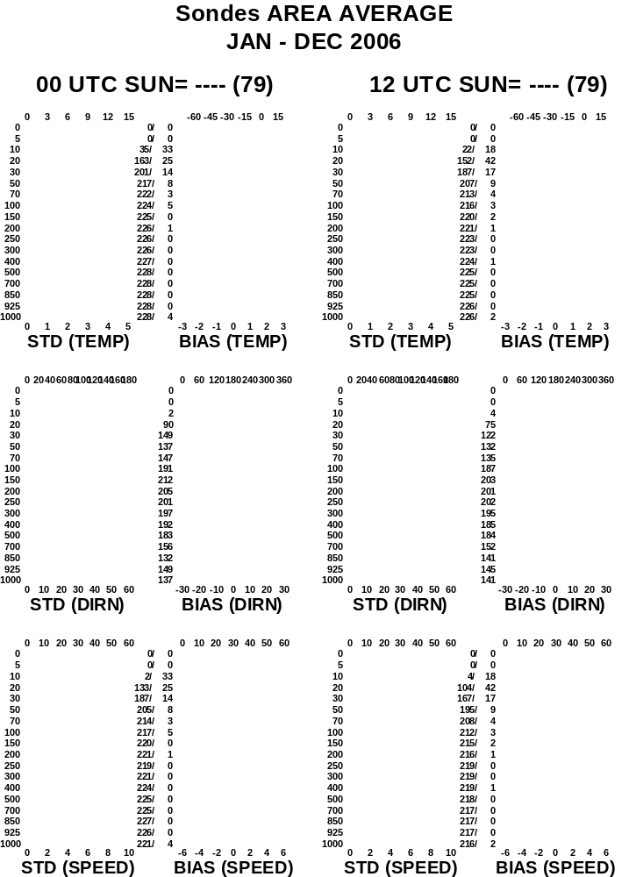

Figure 16
Vertical statistics Japanese ASAP. January to December 2006
Full red line: OB-FG statistics (BIAS)
Dashed red line: OB-AN statistics (BIAS)
Full blue line: OB-FG statistics (STD)
Dashed blue line: OB-AN statistics (STD)
Dotted black line: Observed mean/variability profile
5. Conclusions:

- The number of ASAP reports received at ECMWF show a positive trend since 2005.
- The percentage of launches reaching the level of 100 hPa has dropped to values between 85 to 90% in 2006 compared to figures between 90 and 95% in 2005.
- Corrupted call-signs received from time to time.
- Wrong reported positions received almost every month in 2006. In most of the cases the reports were rejected by the model QC but in a few occasions passed though the model quality control. This problem has not been detected in any of the Japanese ASAP.
- The ASAP data are monitored at ECMWF using a number of products updated on a daily basis in our web site.
- The ASAP statistics have continued to show a good performance.

_____________

