WORLD METEOROLOGICAL ORGANIZATION  ________________________ | INTERGOVERNMENTAL OCEANOGRAPHIC  COMMISSION (OF UNESCO)  ________________________
JOINT WMO/IOC TECHNICAL COMMISSION FOR OCEANOGRAPHY AND MARINE METEOROLOGY (JCOMM)  SHIP OBSERVATIONS TEAM  FOURTH SESSION  GENEVA, SWITZERLAND, 16 TO 21 APRIL 2007 |  |  | SOT-IV/Doc. V-2.4  (15.II.2007)  __________  ITEM V-2.4  Original: ENGLISH

SOOPIP-VII
Programme IMPLEMENTATION

Operational XBT Systems and Development

(Submitted by Gustavo Goni and Derrick Snowden)

Summary and purpose of document

This document reports on the preliminary outcomes of series of intercomparison tests of six different Expendable Bathythemograph (XBT) data acquisition systems and on their performances. This document summarizes the XBT systems performance relative to a Conductivity Temperature Depth (CTD) instrument, which is used as groundtruth, and confirms that all XBT systems perform within manufacturer specifications.

ACTION PROPOSED

The Ship Observations Team is invited to:

- review the information contained in this report and comment as appropriate;

- discuss the results of the XBT acquisition system inter-comparison;

- discuss other equipment-related matters: 1) further development of XBT auto-launchers, 2) review of fall rate equation, 3) strengthen contact with scientific community to evaluate sampling strategies, 4) collaboration with developing countries, 5) strategy to purchase XBTs at a bulk rate, 6) transmission costs, 7) adopting a consistent unique identifier for each XBT profile.

______________________

Appendix: None
DISCUSSION

Introduction

Temperature profile observations from eXpendable BathyThermographs (XBT) have been utilized in observational physical oceanographic studies for more than 40 years. Over the course of these 40 years, the technology on which the XBT data collection system is based has evolved. Recently, the major manufacturer of XBTs and XBT data collection systems (Lockheed Martin-Sippican Inc.) has introduced a new element to the standard XBT data collection system. Specifically, the Analog to Digital (A to D) circuit board has been redesigned to accommodate modern personal computers (PCs). The previous A to D board (model MK-12), in use for more than 15 years, required an ISA port to interface with a PC. While ISA slots were common in PCs in the 1970s and 1980s, they are increasingly less common in modern PCs. To keep pace, Lockheed Martin Sippican has developed a new A to D board (model MK-21) that interfaces to a PC through a Universal Serial Bus (USB) port. In addition to the Lockheed Martin Sippican redesign, another A to D board has recently been developed at Australia’s Commonwealth Scientific and Industrial Research Organisation (CSIRO) (model: Devil). What follows are results from a one day cruise designed to test XBT data acquisition systems using all three A to D boards in six distinct configurations. The primary goal of this cruise was to verify that temperature data collected with the new systems was consistent with temperature data collected from the older well vetted systems and with an independent, high accuracy Conductivity-Temperature-Depth (CTD) system.

Experimental Setup

A complete XBT data recording system is comprised of a launching device, an A to D board through which the launcher interfaces with the computer (also known as a recorder reference Roemmich and Cornuelle) and a personal computer running the controller software. The launching device serves two purposes. One, to complete the electrical circuit between the XBT itself and the recorder. And two, to hold the tube containing the XBT wire. Two types of launchers are commonly in use in observational programs. A hand launcher (Lockheed Martin Sippican model: LM-3A was used for this cruise) is a small, hand held device capable of launching one probe at a time. The hand launcher is easily portable and facilitates launching XBTs from multiple places on a ship. For more intensive observational programs, it is desirable to launch multiple XBTs in close succession and reloading a hand launcher becomes burdensome. For these situations, the National Oceanographic and Atmospheric Administrations Atlantic Oceanographic and Meteorological Laboratory (NOAA/AOML) and the Scripps Institute of Oceanography (SIO) independently developed autolaunchers capable of holding six to eight XBTs and launching successive probes with as little as one minute between casts. Both LM-3A hand launchers and AOML and SIO autolaunchers were utilized during this cruise. The recorders (A to D boards) were described previously. Lockheed Martin Sippican models MK-12 and MK-21 as well as the CSIRO Devil board were used on this cruise. The final component of an XBT data collection system is the PC and the controller software. The two autolauncher systems using the MK-12 recorders are older DOS based PCs running controller software written in house, by AOML and SIO engineers independently. Recently, AOML and SIO have collaborated to create a new version of the Shipboard Environmental data Acquisition System (SEAS) software that has been utilized by NOAA for years on volunteer observing ships. This new version (SEAS 2000) has the capability of using both hand launchers from Lockheed martin Sippican as well as autolaunchers from AOML or SIO. The six XBT systems and the CTD system are described in Table 1.

Table 1: Description of the six XBT data collection systems tested on the cruise.
System Name | Launcher Type | Recorder Type | Controller Software (PC)
seashand | Lockheed Martin Sippican LM-3A | MK-21 | SEAS2000 (Windows XP PC)
devilhand | Lockheed Martin Sippican LM-3A | Devil | Devil Software  (Windows XP PC)
sioauto | SIO Autolauncher | MK-21 | SEAS2000 (Windows XP PC)
seasauto | AOML Autolauncher | MK-21 | SEAS2000 (Windows XP PC)
siok98 | SIO Autolauncher | MK-12 | K98 Software (DOS 386 PC)
aomlauto | AOML Autolauncher | MK-12 | AOML Software (DOS 386 PC)

For comparison with the XBT data, a Seabird 25 internally logging profiling CTD was used. The SBE25 logs samples at 8Hz (the XBT systems sample at a rate of 10Hz). The CTD was lowered and raised at a rate of 50 meters/min. This sensor package was calibrated at the Seabird headquarters in March 2005 and then again in March 2006. During that year the temperature sensor drifted only 0.3 mdeg C. Given the magnitude of the drift error compared with the accuracy of XBT systems, no correction was made for CTD temperature drift.

The drop plan was designed to maximize the number of XBT/CTD pairs available for comparison. The CTD downcast was initiated when the CTD was just below the sea surface (ca. 1 m). The first XBT was dropped approximately 30 seconds after the CTD down cast was initiated. This way, we were able to simultaneously sample the relatively shallow mixed layer with both the CTD and XBT at least one time per cast. XBT casts were repeated continuously during the course of the CTD downcast until the CTD reached the predetermined depth of the down cast (800m). Every effort was made to initiate XBT casts simultaneously but due to subtle differences in the startup procedures of the various systems, this was not always achieved. The time between casts for the four autolaunching systems was much shorter than for the hand launching systems so there were typically two to three more XBT casts per CTD cast for these systems. In total there were seven CTD profiles with both down and up-casts collected during the day.
Sippican Deep Blue probes were used for all casts and are indistinguishable from Sippican T-7 probes discussed in numerous other studies [Hanawa, et al., 1995].
Table 2: Summary of the XBT profiles collected with each system.
Instrument | Total profiles | Trimmed at z < 500m | Trimmed at z < 150m
seasauto | 68 | 5 | 2
sioauto | 63 | 10 | 1
siok98 | 68 | 6 | 4
aomlauto | 65 | 4 | 3
devilhand | 52 | 3 | 3
seashand | 54 | 1 | 0

The initial XBT cast was at 16:57 GMT on June 21 at 33 34.8 N 118 24.0 W and the final cast was at 00:14 GMT on June 22 at 33 32.7 N 118 19.5 W. During the course of the day the ship drifted approximately 8 kilometers toward the east-southeast (Figure 1). The sioauto system was installed closest to the ctd winch. In early afternoon the wind speed increased and the XBT wire interfered with the ctd cable causing a short in the xbt recording system. After several failures, the sioauto system was moved about ten feet aft and wire interference became less of a problem for the remainder of the experiment.

Summary of Results

The errors in an XBT temperature profile can be classified a priori as being due to the temperature sensor error or due to the depth inference based on a fall rate equation. One method of isolating the temperature error is to concentrate the analysis on so called isostads, where the temperature gradients are minimal. Within these isothermal layers the temperature gradients are negligible and the differences between the XBT and CTD temperatures, if the CTD temperature is considered accurate, are entirely due to XBT temperature sensor error. Figure 1 shows a summary of the mean differences between the XBT and CTD temperatures within two relatively isothermal layers, and for the entire profile. Additionally, the standard error of the mean is represented.

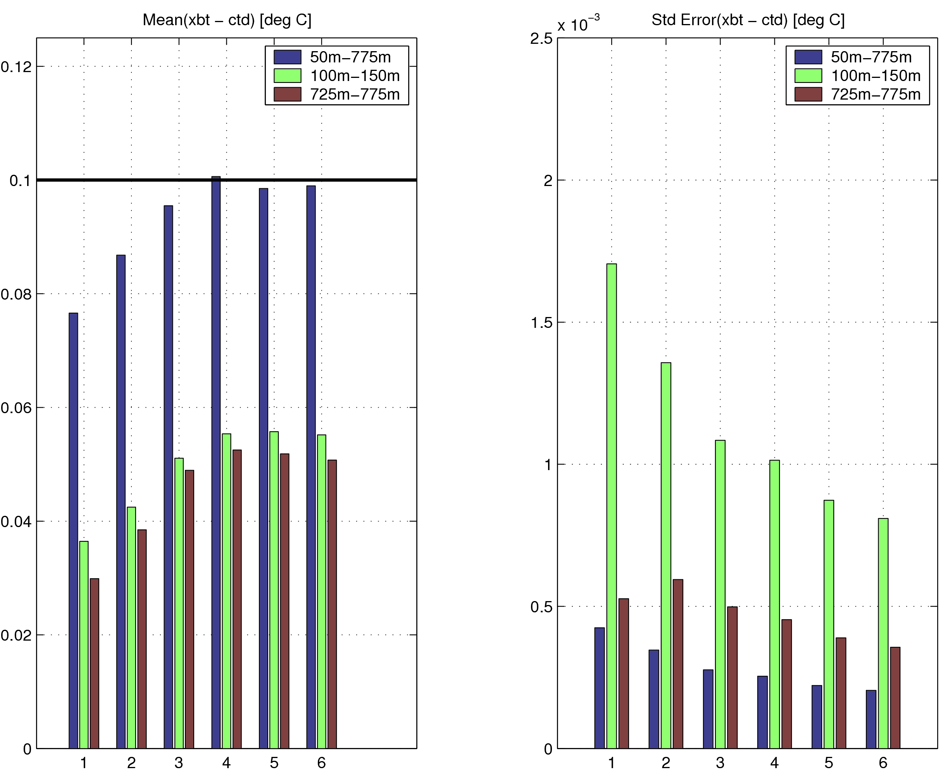
Figure 1: Mean (left) and Standard Error (right) of differences between XBT and CTD temperatures. The three bars in each grouping represent a partitioning of the data into (a) the entire profile below 50m, (b) the approximately isothermal layer between (100m-150m), (c) the approximately isothermal layer between (725m-775m). The manufacturers specified error tolerance (0.1 deg C) is shown as the black line in the left panel. The groupings along the x axis are the instrument types. 1) aomlauto, 2) devilhand, 3) seasauto, 4) seashand, 5) sioauto, 6)siok98.

For the isothermal layers between 100-150m and 725-775m, all six systems show mean differences well below the manufacturer specified error of 0.1 deg C. The aomlauto and devilhand systems show slightly lower mean differences (0.037 and 0.042 respectively) than the remaining four systems that are all near 0.05degC.

The other major source of error in an XBT temperature profile is due to an inaccurate fall rate equation. The XBT depth is not measured, but rather inferred from a model of the rate at which an XBT falls through the water. Fall rate equation error has been studied extensively yet remains the largest source of error in the total XBT error budget [Hanawa, et al., 1995], [Kizu and Hanawa, 2002]. For this experiment, plots (not shown) of the XBT temperatures overlayed on the CTD temperatures show a consistent between the two instruments. The nature of the offset is such that the XBT is either measuring deeper in the water column than the fall rate predicts or has a warm bias. These two effects are difficult to distinguish as they can be interrelated. We further proceed with the Hanawa et al., 1995 method for identifying and correcting fall rate error. Using this technique, which matches features in the temperature gradient curves of the XBT and CTD, it is possible to identify the XBT depth error as a function of depth (Figure 2).

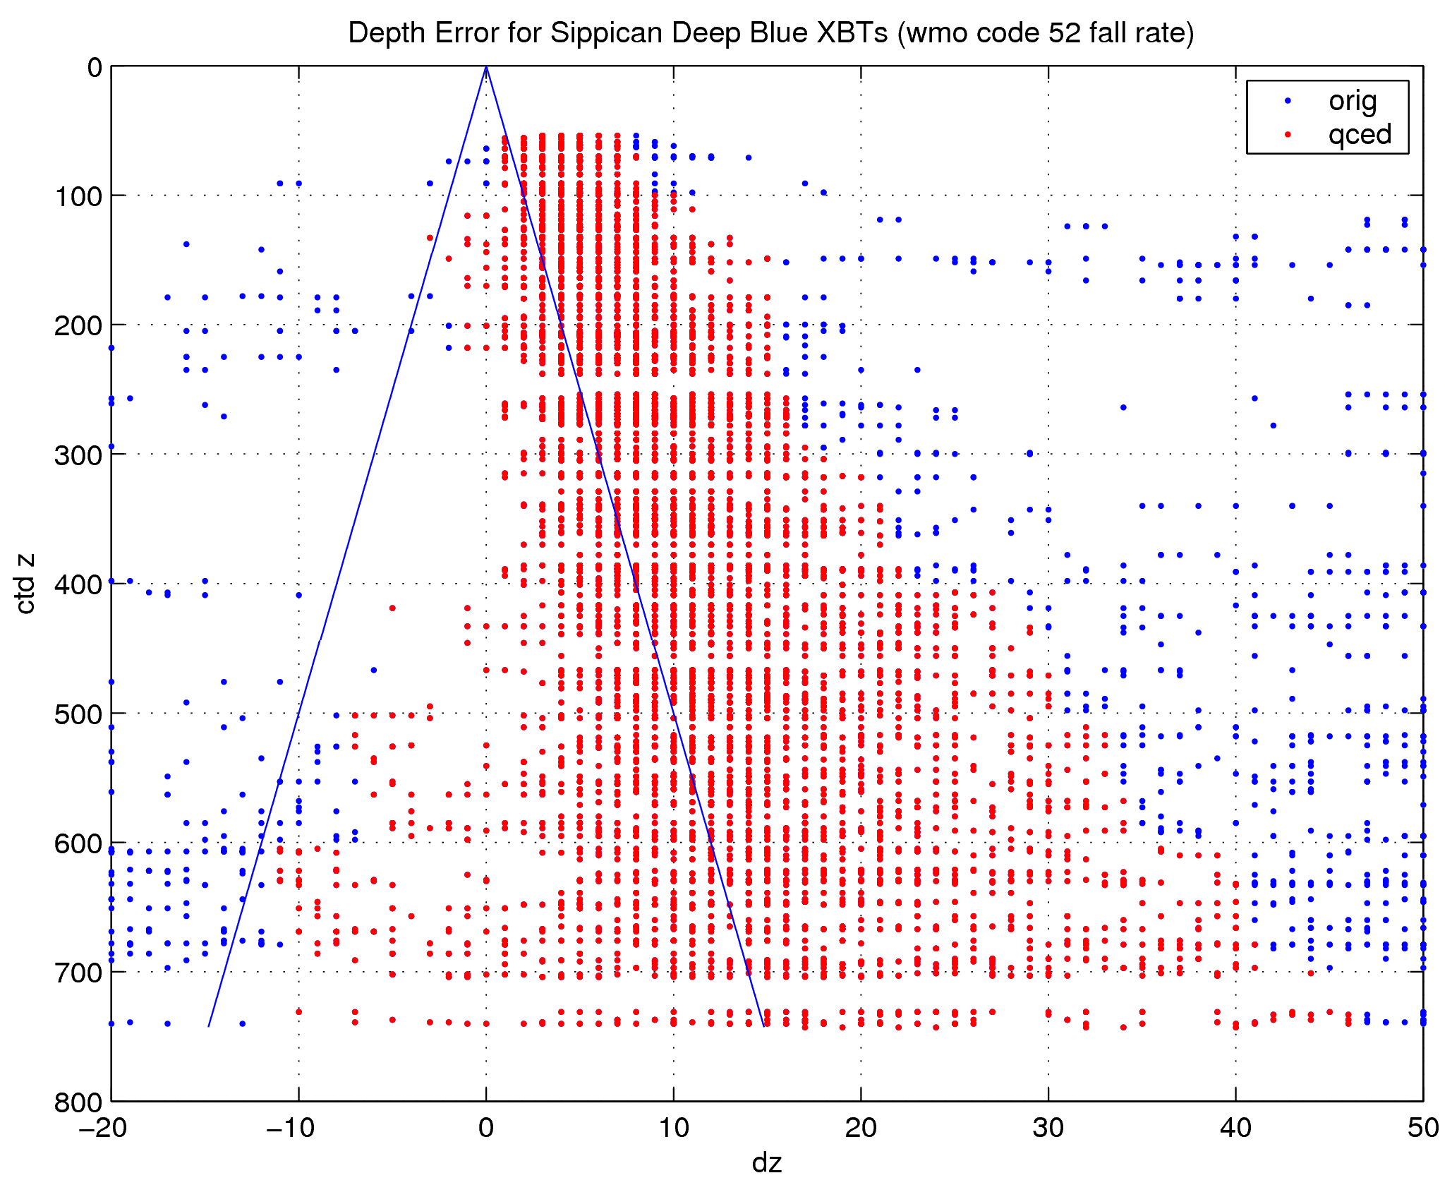
Figure 2: XBT depth error for all profiles collected using all six XBT systems. The positive offset is outside the manufacturer depth error specification (2% of depth shown by the blue lines). The blue vs. red dots show the all the data (blue) and only that data deemed of high enough quality to include in the fall rate estimation procedure.

The XBT depth errors, in many cases, exceed the manufacturers depth error specification (2% of depth). Therefore, we estimated a new fall rate equation to try to eliminate the bias in the XBT depths. The fall rate equation estimated from this data (red dots) differs from the Hanawa et al., 1995 as shown in table 3.

Table 3: Coefficients for the fall rate equation estimated in this study and the fall rate equation typically used (WMO Code 1770: 52) for Sippican Deep Blue XBT probes. The equation is of the form Z= A*T^2 + B * T + C

 | This study | Hanawa et al., 1995
A | -0.00231 | -0.00225
B | 6.364 | 6.691
C | -3.36 | 0

Using the new fall rate equation, we recalculated the summary of the differences between XBT and CTD temperatures (Figure 3). The differences between the corrected XBT curves and the CTD curves are smaller for all instruments.

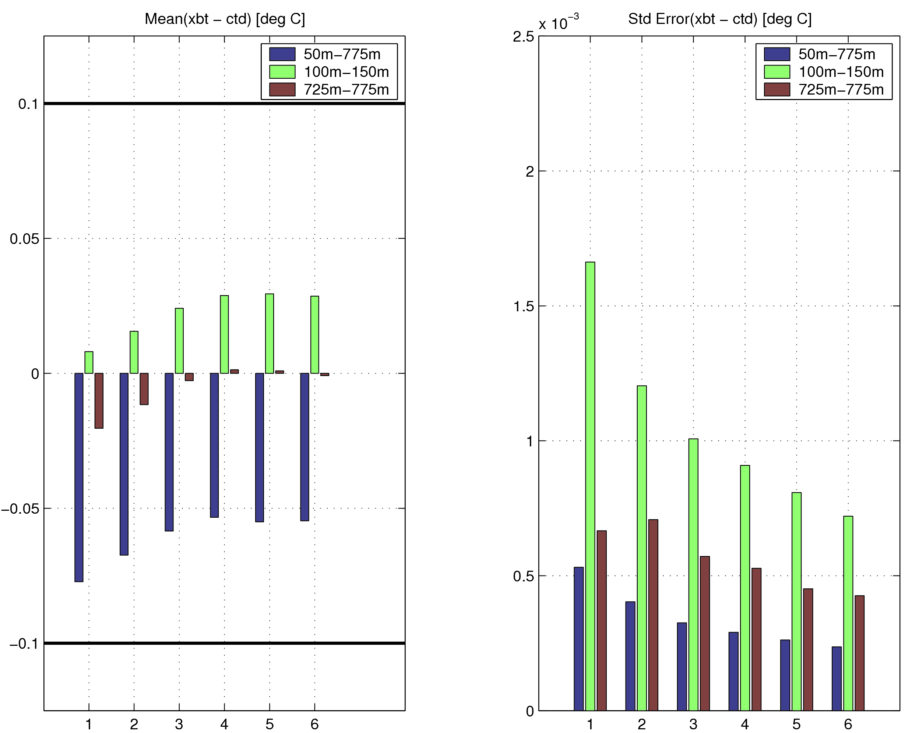
Figure 3: As in figure 1, except using the new fall rate equation from table 3.

Conclusions

This document provides a short summary of a comparison between six XBT data collection systems and one CTD system. The results indicate that for each system the temperature error is well below the manufacturer specified values but that the fall rate error, using standard values for the fall rate equation coefficients, may be slightly larger than the manufacturer specifications. Nevertheless, the sum of these two errors is still below the total error as specified by the manufacturer.

The data in this experiment was used to estimate a new fall rate equation for Sippican Deep Blue probes in an attempt to correct the observed depth errors. This calculation resulted in a new fall rate equation which differs appreciably from the standard fall rate equation for this probe type. This experiment was not designed to identify fall rate errors so these calculations should be considered preliminary analysis. At this time we are not prepared to recommend that the Ship Observations Team consider adopting a new fall rate equations. We have follow experiments designed to identify fall rate errors more accurately planned for Spring 2007.

References

Hanawa, K., et al. (1995), A new depth-time equation for Sippican or TSK T-7, T-6 and T-4 expendable bathythermographs (XBT), Deep-Sea Res. (I Oceanogr. Res. Pap.), 42, 1423-1451.

Kizu, S., and K. Hanawa (2002), Recorder-Dependent Temperature Error of Expendable Bathythermograph, Journal of Oceanography [J. Oceanogr.]. 58, 469-476.

_____________

Appendix: None

