WORLD METEOROLOGICAL ORGANIZATION  ________________________ | INTERGOVERNMENTAL OCEANOGRAPHIC  COMMISSION (OF UNESCO)  ________________________
JOINT WMO/IOC TECHNICAL COMMISSION FOR OCEANOGRAPHY AND MARINE METEOROLOGY (JCOMM)  SHIP OBSERVATIONS TEAM  FOURTH SESSION  GENEVA, SWITZERLAND, 16 TO 21 APRIL 2007 |  |  | SOT-IV/Doc. IV-3.3  (28.II.2007)  __________  ITEM IV-3.3  Original: ENGLISH

VOSP-V
Monitoring and Data MAnagement

GCC report on the VOS and VOSClim

(Submitted by GCC United Kingdom and GCC Germany)

Summary and purpose of document

This document presents the 2006 Global Collecting Centre Annual Report, and possible changes to the GCCs. However, details may be revised after the 2nd Expert Team on Marine Climatology meeting 26-27th March 2007.

ACTION PROPOSED

The Ship Observations Team is invited to:

- review the information gathered so far;

- use this information when discussing relevant agenda items (particularly agenda item IV-3.5,
Review of Marine Climatological Summaries Scheme);

______________________

Appendices: A. Global Collecting Centres for Marine Climatological Data Annual Report 2006 (English)

- Draft IMMT-4 (English)

C. Draft MQCS-VI (English)

DISCUSSION

1. VOS data
The GCCs started their operations in 1994 after the WMO Commission for Marine Meteorology agreed the need to improve quality and flow of global marine data.

The 2006 GCC Report is attached in Appendix A, however the main issues to note from the report are:

Table 1
Country Name | 1st Q | 2nd Q | 3rd Q | 4th Q | Total
Argentina | 192 | 209 |  | 9 | 410
France | 72011 |  | 55274 |  | 127285
Germany | 168124 | 35659 | 29787 | 28143 | 261713
Hong Kong, China | 1221 | 356 | 379 | 733 | 2689
India |  | 2060 | 2509 |  | 4569
Israel |  |  | 9197 |  | 9197
Japan | 5307 | 10909 | 8157 | 8251 | 32624
Malaysia |  |  | 3011 |  | 3011
Netherlands | 14792 | 11875 | 16503 |  | 43170
New Zealand |  |  |  | 14211 | 14211
Norway |  | 8460 |  |  | 8460
Poland |  |  |  | 972 | 972
Russian Federation | 25296 | 25114 | 25812 | 25149 | 101371
Singapore |  |  |  | 831 | 831
South Africa | 762 | 577 |  | 764 | 2103
United Kingdom |  | 307059 | 20672 | 17712 | 345443
16 Countries | 287705 | 402278 | 171301 | 96775 | 958059

- 958,059 observations were received from sixteen CMs (Table 1), with New Zealand contributing for the first time.
- Observations were received from as far back as 1993 but 55% of data was from 2005 & 2006.
- The concentration of data continues to be highest along the main shipping lanes and around coasts and with the most data sparse areas in the Southern Ocean (Figure 1).
Figure 1
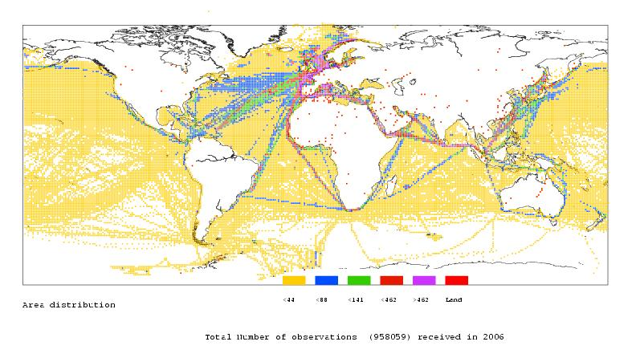
- Data continues to show evidence of improved quality; with the number of on-land positions decreasing (2006: 194), number of duplicated observations decreasing (2006: 282), number of observations without flags decreasing and number of ‘blank elements’ decreasing.
- The MQCSforCMs version III software completed testing in 2006 and is now available for use by CMs. All CMs previously in possession of the software have now received the new version.
- A developing significant issue is the use of masked callsigns by ships in real-time (i.e. id=’SHIP’). When callsigns are masked it is not possible for GCCs and RMs to fully quality control these data; comparisons with real-time prove extremely difficult and identifying whether observations have been duplicated becomes impossible. This issue will be addressed at the 2nd ETMC meeting (March 2007).

2. VOSClim data
The VOSClim Project is an ongoing pilot within JCOMM's Voluntary Observing Ships' Scheme. It aims to provide a high-quality subset of marine meteorological data with detailed information on how the data have been obtained.

In 2006 the GCCs were pleased to see a considerable increase in observations from VOSClim ships with a breakdown of submissions to DAC shown in Table 2 & Table 3.

Table 2

2006 Q | Date of Dispatch | Good | Dregs | Total | Obs from VOSClim Ships | Obs from VOSClim Ships with additionals
1 | 05/04/2006 | 287,495 | 210 | 287,705 | 15,594 | 3,453
2 | 06/07/2006 | 402,254 | 24 | 402,278 | 47,116 | 38,637
3 | 04/10/2006 | 171,263 | 38 | 171,301 | 11,767 | 2,554
4 | 09/01/2007 | 96,765 | 10 | 96,775 | 9,536 | 8,815
TOTALS |  | 957,777 | 282 | 958,059 | 84,013 | 53,459

Table 3

Year | Total VOF Obs | Obs from VOSClim Ships | VOSClim Ships: %age of total VOF Obs received | Obs from VOSClim Ships with additionals | VOSClim Additionals: %age of total VOF Obs received
2003 | 1,078,517 | 9,578 | 0.9% | 5,166 | 0.5%
2004 | 1,114,948 | 44,894 | 4.0% | 5,249 | 0.5%
2005 | 933,398 | 38,890 | 4.2% | 8,276 | 0.9%
2006 | 958,059 | 84,013 | 8.8% | 53,459 | 5.6%

VOSClim data are highlighted in the 2006 GCC Report (Appendix 1) however the key issues to note are:
- 84,013 VOSClim observations were received from five of the nine VOSClim CMs.
- This is more than double the amount received in 2005, making up almost 9% of total VOF submissions.
- The number of obs with VOSClim additional elements reported has also risen significantly however this number (53,459) is still less than two thirds of total submissions from VOSClim ships (64%).
- The GCCs have continued to receive data with VOSClim additional elements from non-VOSClim registered ships. Although this amount has dropped in 2006 it is still an issue that needs to be addressed.
- Quality of VOSClim ship submissions does generally prove to be of better quality than of VOF. In 2006 all VOSClim submissions were reported with flags and only 14 observations were dregs/duplicated data.

3. IMMT
A proposal for IMMT-4 has been made at the 2nd ETMC to include some changes to the format. In the revised IMMT, if the record originated from an electronic logbook with embedded MQCS, the coding number “4” for the source of observation (element 40) is reserved only for this. There are minor proposed changes to element codes and also an adjustment to element numbers due to the proposal to separate element 91 (s_{L}hh) into two elements 91 (s_{L}) and 92 (hh) and remove the QC indicator for s_{L} (element 98).

4. MQCS
In line with the IMMT-4 proposal the MQSC-VI will include element code and number changes. The MQCS-VI will also propose to raise the upper limit of SLL (maximum height of deck cargo above summer load line) to 35m. This will allow for both ship size and cargo deck height increasing.

5. Future of GCCs and Responsible Members
A more streamlined global data process is to be proposed by the GCCs at the 2nd ETMC. The Global Collecting Centres believe there should be a review of the roles and responsibilities of the GCCs and Responsible Members (RM). Each quarter all eight RMs now receive the full global dataset (oppose to just the data within their area of responsibility they received in the past). Due to this, there are quite possibly eight different versions of the same observations (due to individual RM quality control) available that a Contributing Member could request. Additionally, each area does not produce/publish the Marine Climatological Summaries charts, as stated on the WMO marine meteorological programme web site. The end-to-end data management should be more streamlined, with less duplication of data and effort.

The main changes proposed are:
- GCCs to become more pro-active in collecting data and provide CMs with help so countries not submitting can do so.
- GCCs to make data available quarterly via FTP for any CM to access.
- Establish a task team on the definition of the role and functions of RMs, as well as their number, concerning; archival and distribution of marine meteorological data and generation of marine climatological products.
- Consider a ‘Higher Level Quality Control Standards’ (HQCS) for archived data.
- Consider work between ICOADS and the GCCs to create amalgamation of IMMT & IMMA codes, or software to convert from one format to the other.

The outcome of the 2nd ETMC is not known at time of writing.

_____________

Appendices: 3
Appendix A

Global Collecting Centres for Marine Climatological Data

Annual Report 2006

Germany United Kingdom

Deutscher Wetterdienst Met Office
GCC GCC
S9 Saughton House
P.O.-Box 30 11 90 Broomhouse Drive
D-20304 Hamburg Edinburgh, EH11 3XQ
Germany Scotland, UK
email: gcc@dwd.de email: gcc@metoffice.gov.uk
website: www.dwd.de/gcc website: www.metoffice.gov.uk/research/interproj/gcc/

1. Introduction
1.1 Origin of the GCCs
In 1963, the WMO Commission for Marine Meteorology (CMM) established the Marine Climatological Summaries Scheme (MCSS). Their objective was to develop and maintain a joint effort of all maritime nations in the collection of marine data and production of climatological statistics. To achieve this, eight responsible members (RMs) were appointed; Germany, Hong Kong, India, Japan, Russia, The Netherlands, UK and USA. Each of the eight RMs was assigned a specific area of responsibility (see Appendix A) where any queries/data requests regarding these areas should be directed.

In 1993, the WMO CMM agreed there was a need to improve the flow and quality control of global marine data. As a result, two Global Collecting Centres (GCCs) were established; one based at the DWD Germany and the other at the Met Office UK. The GCCs are a collecting, processing and distribution point for all marine Voluntary Observing Fleet (VOF) data (see marine data-flow diagram in Appendix C).

It is the responsibility of each Contributing Member (CM) to collect data from their voluntary observing ships, apply a minimum quality control and regularly submit these to both GCCs. The GCCs ensure these data meet the Minimum Quality Control Standards (MQCS) and, four times a year (at the end of March, June, September and December), re-distribute the data to the eight RMs. It is important that the GCCs work in close co-operation and apply identical procedures. This ensures that, even in the event of failure of one, total data-flow continues.

For further details of the GCCs work see websites above.

1.2 Introduction to GCC 2006
This 2006 report marks the 13th year of GCC operation.

The GCC report highlights the activities, new developments and future plans over the past year. Section 2 details Voluntary Observing Ship data received throughout 2006. This includes the amounts of data received, problems encountered and also details of the quality of these data. The distribution of all data is described in section 3. Then future development within the GCCs and the summary is reported in section 4 & 5. At the end of the report section 6 provides information on contributions to JCOMM’s VOSClim project detailing volumes and quality of data received from VOSClim registered ships.

2. Voluntary Observing Fleet (VOF)
2.1 VOF Data Contributions 2006
In 2006 the total number of observations received by the GCCs was 958,059 (see Table I). This is a 3% increase on 2005 collections. The contributions came from 16 countries (including one country contributing for the first time) and although this is the same number as last year, it still represents less than 50% of the 41 total CMs. A detailed analysis in Table II displays all CMs and their contributions since the GCCs began. Half of countries submitting data in 2006 did so only once or twice throughout the year. The GCCs would ask that CMs send their observations more regularly, preferably on a quarterly basis.

The majority of data received by the GCCs are via email and anonymous FTP transfers. It arrives in IMMT format but submissions are still widely spread between IMMT-1, 2 & 3 (17% IMMT-1, 19% IMMT-2, 64% IMMT-3). IMMT-3, formally ratified at JCOMM-II in September 2005, is preferred. On occasion a CM may submit a data file of varying length and in 2006 this occurred on 5 occasions. This can be problematic for the GCCs as it hinders processing, therefore, submissions are requested to be in one IMMT format only.

The volume of data received over the past thirteen years varies significantly and is observed in blue in figure 1. However, a notably smoother variation can be seen as when considering only unique data (non-duplicate) in purple. This shows that in some years there have been significantly large submissions of duplicated data, however, since 2003 this has been less evident with duplicates making up a very small percentage of the total. For some CMs this is still an issue that should be addressed and by checking the data prior to submission these problems could be dealt with before the GCCs receive the data. [N.B. The new version III consolidated MQC-software, which allows the separation of duplicates, is available free of charge to all CMs through the GCCs.]

Data was received by the GCCs each month during 2006, but it is noted that there was considerably more data received in the first half of the year (figure 2). The distribution of observing periods within 2006 continues to span more than a decade (figure 3 & 4). It can be seen that data has been received from as far back as 1993, and that 55% of observations were from 2005 and 2006 alone. The GCCs appreciate prompt submission of data, however, old data is still important and represents a valuable addition to the global database.

There is an escalating problem with an increased number of ships reporting under the anonymous callsign of ‘SHIP’ or similar. This is often done because of security concerns however this should not be an issue in non-real-time. When callsigns are masked it is not possible for GCCs and RMs to fully quality control these data; comparisons with real-time prove extremely difficult and identifying whether observations have been duplicated becomes impossible. This issue will be discussed at the Joint WMO-IMO Consultative Meeting (February 2007) and at the ETMC meeting (March 2007). In the meantime, the GCCs would ask CMs, where possible, to ensure masked callsigns are converted back to true IDs prior to submission and to inform the GCCs of the real-time callsign for comparison.

  - VOF Data Processing
To ensure that data meet the JCOMM agreed Minimum Quality Control Standards (latest version MQCS-V), they are processed through a series of GCC programs. Processing draws attention to invalid dates & positions, out-of-range values and invalid coding (i.e. ‘/’ instead of blank) etc. At the final stage of processing, elements are given flags related to their quality and these are compared to flags set by the CM.

During processing there are some instances where simple errors within the date, time, position or identifier (elements 2-8, 42) are noted. Although simple, errors of this sort can be detrimental to the validity of the whole observation, but these can normally be corrected after consultation with the CM. Checking of data by the CM before submission would save time and help alleviate this problem. On occasion, however, some errors are not corrected and these data are then rejected from the dataset to a ‘dregs’ file. Occurrences of this sort are mostly due to duplicated data. 0.03% (282) of observations received in 2006 fell into this category.

Correct positioning is an issue still to be considered, with on-land observations being reported. The areal distribution map in figure 5 shows the main shipping lanes between continents with much data concentrated at the coasts. The locations of observations on-land are highlighted in red. There were 194 observations reported on-land in 2006 which is an improvement on 327 in 2005.

2.2.1 VOF Data Processing – Detailed Analysis
A detailed analysis of GCC 2006 processing identified further issues in the reporting of observations. Some data are still submitted with FM13 coding of "/" or "-" instead of a blank as required by IMMT. The use of invalid coding has decreased in 2006 to 0.01% (2005: 0.08%).

In the reporting & coding for precipitation, it is interesting to see that for all VOSClim and ‘automatic’ ships the correct coding for inclusion of precipitation, iR = 3 or 4, is used. However, for 10% of VOS this is left blank. This coding is incorrect even if the element has not been recorded. The GCCs suggest that a change in the compilation of observations at source would be the best way to deal with this type of problem.

The MQC software compares flags already set on the data by CMs to those the MQCS-V would set. This showed that in 2006, 1.8% of observations did not have flags set at all. This figure is five times less than 2005 (9.3%), indicating that the sharp increase the previous year was anomalous. Further analysis identifies 84,020 (0.44%) occasions where flags conflicting with MQCS-V require resetting to a level of 6 or 7 where necessary (see extract from GCC 1994 report in Appendix B for details). This is a large rise in changes compared to 2005 (0.02%)

There is evidence to show that the percentage of elements reported blank has varied frequently over past years. However, it is seen in 2006 that there has been a reduction in reported blanks for all elements (excluding precipitation) and in some cases a decrease of 10-20%. Figure 6a shows the percentage of reported blank elements for 2004 to 2006. Figure 6b details blank elements for VOS, automated stations and VOSClim ships. The most commonly reported blank elements were still precipitation, swell direction and height of lowest cloud, with most frequent ‘blank’ reports submitted from automated stations. This is considerable but as automated stations are accounting for less of the total observations (2006: 3%, 2005: 7%, 2004: 33%) this is not as concerning. To demonstrate the reduction of the blank reported elements, it is interesting to look at figures 6c, 6d and 6e which display VOShips, automated stations and VOSClim-Ships separately for the past two years.

Detailed bilateral correspondence was conducted with some CMs on the improvement of data quality and resolving of problems.

3. Dispatch of Data
During the year four data collectives are dispatched via FTP server to RMs, one at the end of each quarter. The collectives are checked by MQCS-V, meaning the quarterly dispatched data are in IMMT-3 format, even though they were contributed in other versions by the CMs. The original format is coded in element 65 (IMMT version).

The dispatched data comprises of three files; the ‘good’ file holding all reports which passed the MQC successfully, the ‘dregs’ containing data which were rejected due to errors in organisational information and the third ‘msgs’ or ‘warn’ file holding information on the ‘dregs’ observations and other problems arising within the file. It is the responsibility of each RM to decide how to proceed with these data, either omitting or correcting the ‘dregs’.

It has been noted that occasionally CMs have resent data within later datasets. These duplicates cannot be rejected by the GCCs if they are submitted during different quarters and are therefore only noticed by the RMs during further processing. Please can CMs refrain from re-submitting data, however, if it is necessary then please make GCCs aware of this to allow replacement within the database.

RMs not only receive data for their area of responsibility but they all now also receive the full global dataset quarterly. Requests for data/summaries can be made directly to any of the RMs, however, the cost of processing is sometimes charged.

4. Developments
2nd Session of ETMC: ETMC meeting in March 2007 is due to finalise the revised IMMT-4 and MQCS-VI. In the revised IMMT-4, if the record originated from an electronic logbook with embedded MQCS, the coding number “4” for the source of observation (element 40) is reserved only for this. The MQCS-VI will raise the upper limit of SLL (maximum height of deck cargo above summer load line) to allow for increasing ship size and cargo deck height. The IMMT-4 will also propose to separate element 91 (s_{L}hh) into two elements 91 (s_{L}) and 92 (hh) and remove the QC indicator for s_{L} (element 98). Due to these adjustments the element numbers from characters 146 to 155 will be affected and increased by 1.

MQCforCM Software: GCC MQCforCM version III is now available and can be obtained by contacting the GCCs. This new software includes changes to checks according to MQCS-V, checking present weather codes from automatic stations, checking of VOSClim additional elements, the addition of new flags in the IMMT-3 format and also the choice to separate duplicate records. All countries who had the previous version of MQCforCM have now been sent the update.

Recording Observations: The KNMI electronic logbook, TurboWin, is being encouraged on all manual reporting European ships and due to its embedded MQCS software, this should lead to some improvement of data quality.

Quarterly Exchange of data by FTP: The UK GCC has moved over to using FTP for transferring data in line with GCC Germany. Therefore, the quarterly exchange to all RMs will now be carried out in this way.

5. Summary
To summarise, the GCCs continue to receive data from a number of CMs regularly and the quality of this data appears to be improving with reduced dregs, reduced on-land positions, reduced number of blank elements, reduced number of observations with no flags and an increasing number of observations in IMMT-3 format. However, countries having trouble submitting data should contact the GCCs to make them aware of their difficulties and take action in working toward addressing these issues.

There is still a delay between our received and controlled data in the archives of the RMs and those only collected and flagged data in other real-time international datasets. We would like to encourage all countries to submit their observations, and if their ships do not record in a logbook they should submit their MQCS checked GTS data. This will give RMs the opportunity to check data with higher quality control for their archives and further processes.

There are some points from the report that need consideration from CMs.
- Observations should be submitted regularly on a quarterly basis.
- Convert masked callsigns (i.e. ‘SHIP’) back to original prior to submission.
- Data files should be sent in one IMMT format only – IMMT-3 preferably.
- By applying MQCS to data prior to submission CMs can identify and rectify any significant problems, in particular issues within date, time and position.
- With improved compilation of observations, the presence of ‘/’ and incorrect/missing flags could be addressed before submission.
- Any CM not yet received the updated ‘MQCS for CMs’ (version 3) can do so by contacting the GCCs.

With increasing demand from climate research, marine forecasting, satellite calibration, climate modeling and maritime industries, marine data is highly sought after. Therefore, CMs can appreciate the importance of their submissions they make and the value this adds to the global marine database.

The GCCs would like to thank the CMs for their data that was submitted and for their co-operation during 2006. As always, all members are invited to provide further feedback, which may benefit the whole system and integrity of the marine database.

6. VOSClim Data 2006

6.1 VOSClim Project
The VOSClim Project is an ongoing pilot within JCOMM's Voluntary Observing Ships' Scheme. It aims to provide a high-quality subset of marine meteorological data with detailed information on how the data have been obtained. These data are available in delayed mode and are of great value to both operational marine forecasting and global climate studies.

The IMMT-2 format, which allowed delayed mode submission of VOSClim elements (element 87-93), came into effect in January 2003. The more recent IMMT-3 format, which allows flags to be set on these additional elements (element 94-101), was formally accepted at the second session of JCOMM in September 2005.
For further details and information, refer to the VOSClim project website http://www.ncdc.noaa.gov/oa/climate/vosclim/vosclim.html

Since the project commenced, nine CMs have recruited VOSClim ships. There are currently 169 active VOSClim ships worldwide.

6.2 VOSClim Contributions
In 2006 VOSClim submissions were received from five of the nine CMs. The GCCs received 84,013 observations from VOSClim ships (Table III & IV), contributing to 9% of the total submissions. (2005 and 2004: 4%, 2003: 1%) However, the number with additional VOSClim elements was considerably less with 53,459 observations containing these. It is encouraging to see there has been a significant rise in contributions from VOSClim ships (particularly since more ships are being recruited) and especially the numbers of observations containing the additional elements.

There are still a considerable number of observations received from non-VOSClim ships containing the additional elements. Although this amount is less than 2005 CMs are asked to encourage ships already reporting these elements (and other vessels) to join the VOSClim project.

The GCCs understand there can be software issues involved with initially processing VOSClim data which can delay submission to the GCCs. Any CMs having such problems are encouraged to make GCCs aware of this, because advice may be available to help. It should be noted that failure of VOSClim participants to regularly collect and submit data may be detrimental to the success of the project.

As mentioned in section 2.1 the masking of ship callsigns is becoming a considerable international problem and it also has serious implications to the VOSClim project. The UK Met Office’s Real Time Monitoring Centre commitment for VOSClim is unable to be properly fulfilled as VOSClim ships reporting under a masked callsign cannot be effectively identified. As a consequence, their VOSClim data will not be sent to the Data Assembly Centre (DAC) at the National Climatic Data Center and monitored. The GCCs would ask CMs, where possible, to ensure masked callsigns are converted back to true IDs prior to submission to the GCCs.

6.3 VOSClim Data Processing & Analysis
As with the VOF contributions, data are processed through a series of programs to ensure it passes the MQCS. VOSClim data has proved to be of a higher standard compared with VOF. Only 14 observations (0.02%) in 2006 were rejected into the ‘dregs’ file and all observations had corresponding flags reported.

There were still observations, however, where flags were inconsistent with the MQCS-V and were subsequently reset. This occurred on 0.07% of occasions which is again considerably less than for VOF ships. The area distribution map in figure 8 shows VOSClim ships prefer the main shipping lanes between continents, but are also spread ocean wide. There was 36 observations reported on-land by VOSClim ships in 2006.

It has been seen that reporting of SLL is an issue for the MQCS. 1.2% of VOSClim data was reported with SLL greater than the MQCS limit of 32m. This is due to ships and the deck cargo height growing larger and so the MQCS-V limits must be adapted to the new generation of ships.

In figure 6b it can be seen that most reported blank elements for VOSClim were the same as those for VOF. However, it is interesting to see that compared to VOF, wind speed and direction, wind wave height and period, have a significantly higher occurrence of blank reports. While, for sea and dewpoint temperature and pressure tendency there are notably less blank elements reported than VOF.

The GCCs are aware that some CMs are having problems sending VOSClim data in the newer formats. On occasion data has been submitted to the GCCs from VOSClim ships without inclusion of extra elements and then at a later date, these have been re-submitted with the VOSClim elements added. The GCCs would ask CMs to please hold submission until full observations can be sent, else RMs receive a great deal of duplicated data.

6.4 Dispatch of Data
VOSClim data is dispatched to RMs as part of the quarterly exchange and in addition to this all observations received from VOSClim ships are dispatched quarterly to the Data Assembly Center in the USA. For details of the number of observations sent refer to Table III and figure 7.

6.5 Summary
In summary, 2006 saw a significant rise in submissions from VOSClim ships and in particular an increase in ships reporting the additional elements. It is also encouraging to see that data quality proves to be better than for VOF.

There are still four CMs who have not contributed VOSClim ship submissions to the GCCs. The GCCs would be grateful if you would make contact if there were problems with making these submissions.

There are some points from the report that need consideration from CMs.
- All VOSClim ship data submissions should include additional VOSClim elements.
- CMs that have not yet submitted observations from VOSClim ships are encouraged to do so at their earliest convenience or contact GCCs if having trouble.
- Convert masked callsigns (i.e. ‘SHIP’) back to original prior to submission.
- Please do not split observations to enable submissions to be made possible. If CMs experience problems in exchanging the newer IMMT formats, wait until it is possible to do so before sending observations.
- For non-VOSClim ships reporting VOSClim additional elements, please take action to join the project.

The GCCs would like to thank CMs for their VOSClim data that has been submitted in 2006 and their continual co-operation. As we are sure you are aware, the data from the project is invaluable for climate change studies and research.

Abbreviations
CM  CMM  DAC  DWD  ETMC | Contributing Member  Commission for Marine Meteorology  Data Assembly Center  Deutscher Wetterdienst  Expert Team on Marine Climatology
GCC | Global Collecting Centre (MCSS / JCOMM)
IMMT  IMO | International Maritime Meteorological Tape  International Maritime Organization
JCOMM | Joint WMO/IOC Technical Commission for Oceanography and Marine Meteorology
KNMI  MCSS | Koninklijk Nederlands Meteoroloisch Instituut  Marine Climatological Summaries Scheme
MQC  MQCS-V  RM  SLL | Minimum Quality Control (WMO Standard)  Minimum Quality Control Standards (Version 5, July 2004)  Responsible Member  maximum height of deck cargo above summer load line (IMMT-2 & IMMT-3 element 90)
UK  VOF | United Kingdom  Voluntary Observing Fleet
VOS | Voluntary Observing Ship
VOSClim | VOS Climate (Subset for High Quality Data - Project)
WMO | World Meteorological Organization

Table I: GCC Observations 2006
Country Name | 1st Q | 2nd Q | 3rd Q | 4th Q | Total
Argentina | 192 | 209 |  | 9 | 410
France | 72011 |  | 55274 |  | 127285
Germany | 168124 | 35659 | 29787 | 28143 | 261713
Hong Kong, China | 1221 | 356 | 379 | 733 | 2689
India |  | 2060 | 2509 |  | 4569
Israel |  |  | 9197 |  | 9197
Japan | 5307 | 10909 | 8157 | 8251 | 32624
Malaysia |  |  | 3011 |  | 3011
Netherlands | 14792 | 11875 | 16503 |  | 43170
New Zealand |  |  |  | 14211 | 14211
Norway |  | 8460 |  |  | 8460
Poland |  |  |  | 972 | 972
Russian Federation | 25296 | 25114 | 25812 | 25149 | 101371
Singapore |  |  |  | 831 | 831
South Africa | 762 | 577 |  | 764 | 2103
United Kingdom |  | 307059 | 20672 | 17712 | 345443
16 Countries | 287705 | 402278 | 171301 | 96775 | 958059

 |  |  |  | Table II: Number of Contributions by CMs per Quarter (1994 - 2006)
MCSS-Member |  |  |  |  |  |  |  |  |  |  |  |  |  |  |  |  |  |  |  |  |  |  |  |  |  |  |  |  |  |  |  |  |  |  |  |  |  |  |  |  |  |  |  |  |  |  |  |  |  |  |  |  | Number of Years with Contributions
 | 1994 |  |  |  | 1995 |  |  |  | 1996 |  |  |  | 1997 |  |  |  | 1998 |  |  |  | 1999 |  |  |  | 2000 |  |  |  | 2001 |  |  |  | 2002 |  |  |  | 2003 |  |  |  | 2004 |  |  |  | 2005 |  |  |  | 2006
Argentina |  |  |  |  |  |  |  |  |  |  |  |  |  |  |  |  |  |  |  |  |  |  |  |  |  |  |  |  |  |  |  | 1 |  |  |  |  |  |  | 1 | 2 |  | 1 | 1 | 1 | 1 | 1 | 1 | 1 | 1 | 1 |  | 1 | 5
Australia |  |  |  |  |  |  |  |  |  |  |  |  |  |  |  |  |  |  |  |  |  |  |  |  |  |  |  | 3 |  |  |  |  | 1 |  |  |  | 1 |  |  |  | 1 |  |  |  | 1 |  |  |  |  |  |  |  | 5
Belgium |  |  |  |  |  |  |  |  |  |  |  |  |  |  |  |  |  |  |  |  |  |  |  |  |  |  |  |  |  |  |  |  |  |  |  |  |  |  |  |  |  |  |  |  |  |  |  |  |  |  |  |  | 0
Brazil |  |  |  | 1 |  |  |  | 1 | 1 | 1 | 1 |  |  | 1 |  | 1 |  |  |  |  |  |  |  |  |  |  |  |  |  |  |  |  |  |  |  |  |  |  |  |  |  |  |  |  |  |  |  |  |  |  |  |  | 4
Canada |  |  |  |  |  |  |  |  |  |  |  |  |  |  |  |  |  |  |  |  |  |  |  |  |  |  |  |  |  |  |  |  |  |  |  |  |  |  |  |  |  |  |  |  |  |  |  |  |  |  |  |  | 0
Croatia |  |  |  |  |  |  |  |  |  |  |  |  |  | 1 |  |  |  | 1 |  |  |  |  | 1 |  |  |  | 1 |  |  | 1 |  | 1 |  |  |  |  |  |  |  |  |  |  |  |  |  |  |  |  |  |  |  |  | 5
Denmark |  |  |  |  |  |  |  |  |  |  |  |  |  |  |  |  |  |  |  |  |  |  |  |  |  |  | 3 | 2 |  |  |  |  | 1 |  |  |  |  |  |  |  |  |  |  | 2 | 2 |  |  |  |  |  |  |  | 4
Egypt |  |  |  |  |  |  |  |  |  |  |  |  |  |  |  |  |  |  |  |  |  |  |  |  |  |  |  |  |  |  |  |  |  |  |  |  |  |  |  |  |  |  |  |  |  |  |  |  |  |  |  |  | 0
Finland |  |  |  |  |  |  |  |  |  |  |  |  |  |  |  |  |  |  |  |  |  |  |  |  |  |  |  |  |  |  |  |  |  |  |  |  |  |  |  |  |  |  |  |  |  |  |  |  |  |  |  |  | 0
France | 1 |  |  | 1 | 1 |  |  | 1 |  |  | 1 | 1 |  |  | 1 |  |  |  | 1 |  |  |  |  |  |  |  |  |  |  |  | 6 | 3 |  |  |  |  | 1 |  |  |  |  |  |  | 2 | 1 | 1 | 1 |  | 2 |  | 1 |  | 10
Germany | 1 | 4 | 2 | 4 | 3 | 3 | 4 | 3 | 2 | 4 | 2 | 1 |  |  |  | 1 | 18 | 3 | 2 |  | 1 |  | 4 | 2 | 1 | 2 | 1 | 2 | 1 | 1 | 1 | 2 | 1 | 1 |  | 2 | 1 | 3 | 1 | 6 | 10 | 1 | 2 | 5 | 3 | 5 | 3 | 1 | 5 | 3 | 3 | 3 | 13
Greece |  |  |  |  |  |  |  |  |  |  |  |  |  |  |  |  |  |  |  |  |  |  |  |  |  |  |  |  |  |  |  |  |  |  |  |  |  |  |  |  |  |  |  |  |  |  |  |  |  |  |  |  | 0
Hong Kong, China | 1 | 1 | 1 | 1 | 1 | 1 | 1 | 1 | 1 | 1 | 1 | 1 | 1 | 1 | 1 | 1 | 1 | 1 | 1 | 1 | 1 | 1 | 1 | 1 | 1 | 1 | 1 | 1 | 1 | 1 | 1 | 1 | 1 |  | 2 | 1 | 1 | 1 | 1 | 1 | 1 | 1 | 1 | 1 | 1 | 1 | 1 |  | 1 | 1 | 1 | 1 | 13
Iceland |  |  |  |  |  |  |  |  |  |  |  |  |  |  |  |  |  |  |  |  |  |  |  |  |  |  |  |  |  |  |  |  |  |  |  |  |  |  |  |  |  |  |  |  |  |  |  |  |  |  |  |  | 0
India | 1 |  | 2 | 1 |  | 1 |  |  |  |  | 1 |  | 1 |  | 1 | 1 |  | 1 | 1 |  |  | 2 | 1 | 1 | 1 | 2 | 1 | 1 | 1 | 1 | 1 | 1 | 1 | 1 | 1 | 1 | 1 | 1 | 1 | 1 | 1 | 1 | 1 | 1 |  | 2 | 1 |  |  | 2 | 1 |  | 13
Ireland |  |  |  |  |  |  |  |  |  | 1 |  |  | 1 |  |  |  |  | 1 |  | 2 |  |  |  |  |  |  |  |  |  |  |  |  |  |  |  | 2 |  |  |  |  |  |  |  |  |  |  |  |  |  |  |  |  | 4
Israel |  |  |  |  |  |  | 2 |  |  |  | 1 |  |  |  | 1 |  |  |  | 1 |  |  |  | 1 |  |  | 1 |  |  |  |  | 1 |  |  |  | 1 |  |  |  |  | 1 |  |  | 1 |  |  |  | 1 |  |  |  | 1 |  | 12
Italy |  |  |  |  |  |  |  |  |  |  |  |  |  |  |  |  |  |  |  |  |  |  |  |  |  |  |  |  |  |  |  |  |  |  |  |  |  |  |  |  |  |  |  |  |  |  |  |  |  |  |  |  | 0
Japan |  |  |  | (6) |  | 1 |  | 1 |  | 1 |  | 2 |  | 1 |  | 1 |  | 1 | 1 |  | 1 | 1 |  | 1 | 1 | 1 | 1 |  | 1 | 1 | 1 |  | 1 |  | 1 | 1 | 1 |  | 1 | 2 | 2 |  | 1 | 1 | 1 | 1 | 1 | 1 | 1 | 1 | 1 | 1 | 13
Kenya |  |  |  |  |  |  |  |  |  |  |  |  |  |  |  |  |  |  |  |  |  |  |  |  |  |  |  |  |  |  |  |  |  |  |  |  |  |  |  |  |  |  |  |  |  |  |  |  |  |  |  |  | 0
Korea |  |  |  |  |  |  |  |  |  |  |  |  |  |  |  |  |  |  |  |  |  |  |  |  |  |  | 1 |  |  |  |  |  |  |  |  |  |  |  |  |  |  |  |  |  |  |  |  |  |  |  |  |  | 1
Malaysia |  | 1 |  |  |  |  |  |  |  |  |  | 1 |  |  | 1 |  |  |  |  | 1 |  |  | 1 |  |  |  |  |  | 2 |  |  |  | 1 |  |  |  | 1 |  | 1 |  | 2 |  |  | 1 |  |  | 1 | 1 |  |  | 2 |  | 11
Mexico |  |  |  |  |  |  |  |  |  |  |  |  |  |  |  |  |  |  |  |  |  |  |  |  |  |  |  |  |  |  |  |  |  |  |  |  |  |  |  |  |  |  |  |  |  |  |  |  |  |  |  |  | 0
Netherlands |  | 1 |  |  |  |  | 2 |  | 2 |  |  | 1 |  |  |  |  |  |  | 2 | 2 | 2 | 1 |  | 1 | 1 | 1 | 1 | 1 |  |  |  | 1 |  |  |  |  |  | 1 | 3 |  | 1 |  |  | 1 |  | 3 | 1 |  | 1 | 1 | 1 |  | 11
New Caledonia |  | 1 |  |  | 1 | 1 | 1 | 1 | 1 |  | 1 |  | 1 | 1 | 1 |  |  | 1 |  |  |  |  |  |  | 1 |  |  |  |  |  |  |  |  |  |  |  |  |  |  |  |  |  |  |  |  |  |  |  |  |  |  |  | 6
New Zealand |  |  |  |  |  |  |  |  |  |  |  |  |  |  |  |  |  |  |  |  |  |  |  |  |  |  |  |  |  |  |  |  |  |  |  |  |  |  |  |  |  |  |  |  |  |  |  |  |  |  |  | 1 | 1
Norway |  |  | 5 | 4 | 2 |  | 2 | 2 | 2 |  |  | 6 | 3 | 3 | 6 |  | 3 | 3 |  | 9 | 3 |  | 3 | 6 | 1 | 3 | 3 | 3 | 3 |  | 3 |  | 6 | 3 |  | 3 |  | 3 | 3 | 3 |  | 3 |  |  |  |  | 21 |  |  | 3 |  |  | 13
Pakistan |  |  |  |  |  |  |  |  |  |  |  |  |  |  |  |  |  |  |  |  |  |  |  |  |  |  |  |  |  |  |  |  |  |  |  |  |  |  |  |  |  |  |  |  |  |  |  |  |  |  |  |  | 0
Philippines |  |  |  |  |  |  |  |  |  |  |  |  |  |  |  |  |  |  |  |  |  |  |  |  |  |  |  |  |  |  |  |  |  |  |  |  |  |  |  |  |  |  |  |  |  |  |  |  |  |  |  |  | 0
Poland |  | 1 |  |  | 2 | 1 |  | 1 | 1 | 1 | 1 | 1 | 1 |  |  | 2 |  | 1 |  | 2 | 1 | 1 | 1 | 1 |  | 2 |  | 1 |  |  | 1 |  | 1 |  | 1 | 1 |  |  | 1 | 1 |  |  | 1 | 1 |  | 1 |  |  |  |  |  | 1 | 13
Portugal |  |  |  |  |  |  |  |  |  |  |  |  |  |  |  |  |  |  |  |  |  |  |  |  |  |  |  |  |  |  |  |  |  |  |  |  |  |  |  |  |  |  |  |  |  |  |  |  |  |  |  |  | 0
Russian Federation |  |  |  |  | 2 | 1 |  | 1 | 4 | 2 |  |  | 3 | 6 | 1 | 1 | 1 | 1 | 1 | 5 | 2 | 2 | 2 | 2 | 2 | 2 | 2 | 2 | 2 | 3 | 2 | 2 | 2 | 2 | 2 | 2 | 2 | 2 | 2 | 2 | 2 | 2 | 2 | 2 | 2 | 2 | 2 |  | 2 | 2 | 2 | 2 | 12
Singapore |  |  |  |  | 1 |  | 1 |  | 1 |  | 1 |  |  |  |  | 1 |  | 1 | 1 |  |  |  |  |  |  |  |  |  |  |  |  |  |  |  |  |  |  | 1 | 1 |  |  |  | 1 |  |  | 1 |  |  |  |  |  | 2 | 8
South Africa |  |  |  |  |  |  |  |  |  |  |  |  |  |  |  |  |  |  |  |  | 4 |  | 1 | 1 |  | 1 |  | 2 | 5 | 2 | 2 | 1 |  | 2 | 3 | 2 | 4 | 4 | 2 | 4 | 2 | 5 | 4 | 2 | 4 | 4 | 3 | 2 | 3 | 3 |  | 3 | 8
Spain |  |  |  |  |  |  |  |  |  |  |  |  |  |  |  |  |  |  |  |  |  |  |  |  |  |  |  |  |  |  |  |  |  |  |  |  |  |  |  |  |  |  |  |  |  |  |  |  |  |  |  |  | 0
Sweden |  |  |  |  |  |  |  |  |  | 1 |  |  |  |  |  |  |  |  |  |  |  |  |  |  |  |  |  |  |  |  |  |  |  |  |  |  |  |  |  |  |  |  |  |  |  |  |  |  |  |  |  |  | 1
Thailand |  |  |  |  |  |  |  |  |  |  |  |  |  |  |  |  |  |  |  |  |  |  |  |  |  |  |  |  |  |  |  |  |  |  |  |  |  |  |  |  |  |  |  |  |  |  |  |  |  |  |  |  | 0
Uganda |  |  |  |  |  |  |  |  |  |  |  |  |  |  |  |  |  |  |  |  |  |  |  |  |  |  |  |  |  |  |  |  |  |  |  |  |  |  |  |  |  |  |  |  |  |  |  |  |  |  |  |  | 0
Uni.Rep. Tanzania |  |  |  |  |  |  |  |  |  |  |  |  |  |  |  |  |  |  |  |  |  |  |  |  |  |  |  |  |  |  |  |  |  |  |  |  |  |  |  |  |  |  |  |  |  |  |  |  |  |  |  |  | 0
United Kingdom |  | 3 | 1 | 1 | 1 | 1 | 1 | 1 | 1 |  | 1 | 1 | 1 |  | 1 | 2 | 1 | 1 | 1 | 1 | 1 | 1 | 1 | 1 |  | 1 |  |  |  |  |  |  |  |  | 3 |  | 3 | 2 |  |  | 5 |  | 1 |  |  |  |  |  |  | 16 | 2 | 2 | 11
United States |  | 2 | 2 | 1 |  | 1 |  |  |  |  | 6 |  | 1 | 2 |  |  |  | 3 | 1 | 1 |  | 1 |  | 1 |  | 1 | 3 |  |  |  |  |  |  |  |  | 3 | 2 | 4 | 2 | 2 |  |  |  |  |  |  |  |  |  |  |  |  | 9
 |  |  |  | 13 |  |  |  | 15 |  |  |  | 18 |  |  |  | 17 |  |  |  | 17 |  |  |  | 14 |  |  |  | 17 |  |  |  | 14 |  |  |  | 15 |  |  |  | 17 |  |  |  | 17 |  |  |  | 16 |  |  |  | 16

Table III:

Observations from VOSClim Ships / Observations with VOSClim Additional Elements 2006
Country Name | 1st Q |  | 2nd Q |  | 3rd Q |  | 4th Q |  | Total
France | 12041 | 0 |  |  | 6526 | 0 |  |  | 18567 | 0
Germany | 3260 | 3249 | 1808 | 1537 | 2303 | 2009 | 2181 | 1976 | 9552 | 8771
India |  |  | 888 | 792 | 1791 | 0 |  |  | 2679 | 792
Netherlands | 293 | 204 | 571 | 368 | 1147 | 545 |  |  | 2011 | 1117
United Kingdom |  |  | 43849 | 35940 |  |  | 7355 | 6839 | 51204 | 42779
5 Countries | 15594 | 3453 | 47116 | 38637 | 11767 | 2554 | 9536 | 8815 | 84013 | 53459

Table IV:

Observations from VOSClim Ships / Observations with VOSClim Additional Elements (2003 - 2006)
Country Name | 2003 |  | 2004 |  | 2005 |  | 2006
Australia | 2078 | 0 | 3397 | 0 | 3928 | 0 | 0 | 0
Canada | 0 | 0 | 0 | 0 | 0 | 0 | 0 | 0
France | 0 | 0 | 30637 | 0 | 17619 | 0 | 18567 | 0
Germany | 5675 | 5166 | 5345 | 5176 | 6474 | 6377 | 9552 | 8771
India | 1332 | 0 | 3077 | 0 | 4269 | 0 | 2679 | 792
Japan | 0 | 0 | 818 | 0 | 4439 | 0 | 0 | 0
Netherlands | 215 | 0 | 603 | 0 | 2161 | 1899 | 2011 | 1117
United Kingdom | 0 | 0 | 1017 | 0 | 0 | 0 | 51204 | 42779
USA | 278 | 0 | 0 | 0 | 0 | 0 | 0 | 0
 | 9578 | 5166 | 44894 | 5176 | 38890 | 8276 | 84013 | 53459

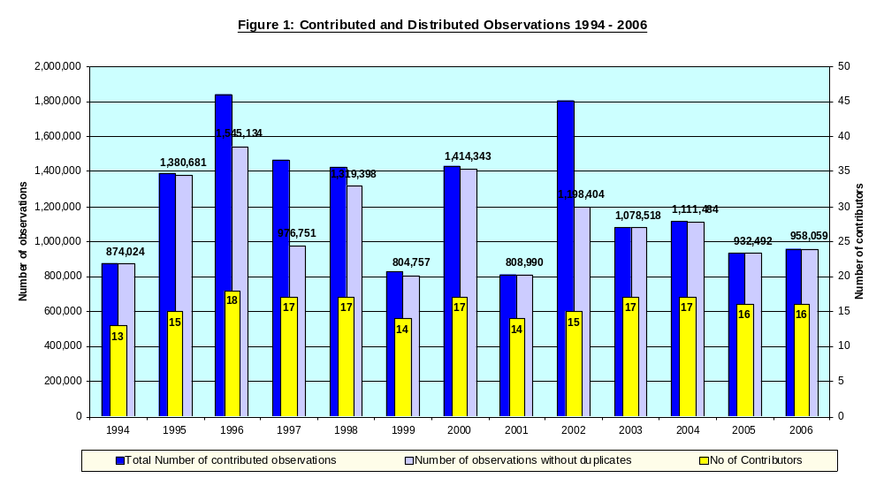
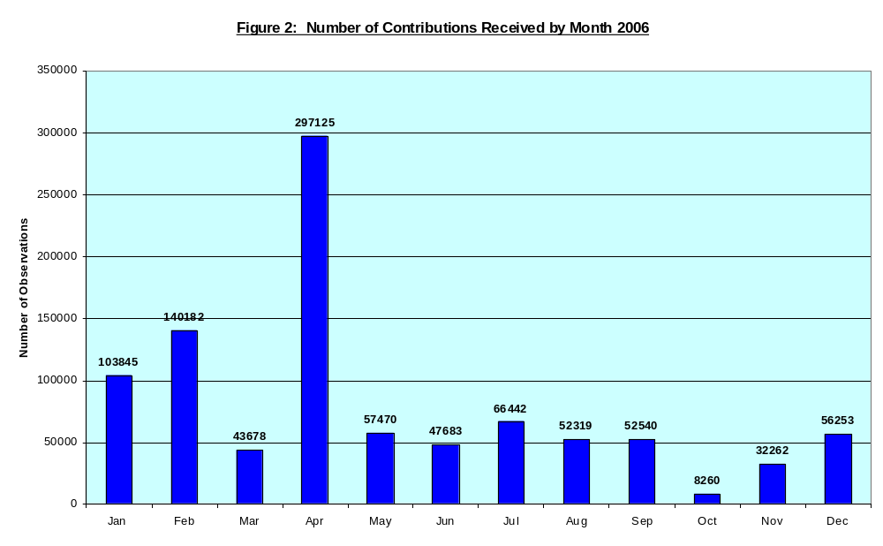
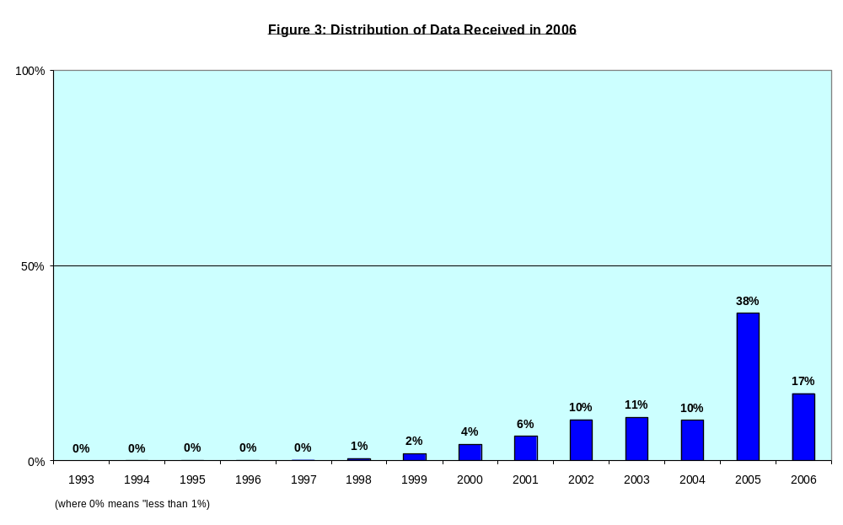
Figure 4: Distribution of Data by Country

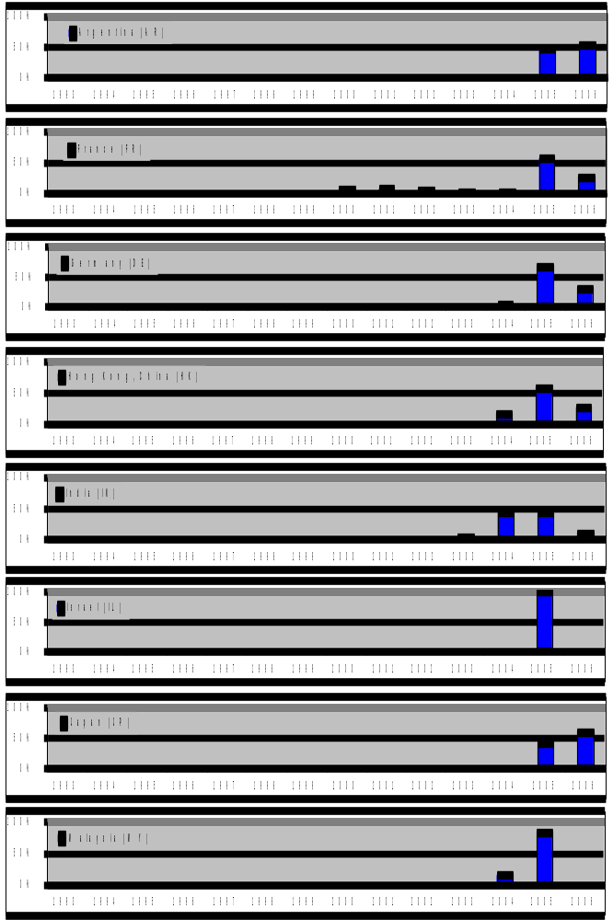
Figure 4 (continued): Distribution of Data by Country

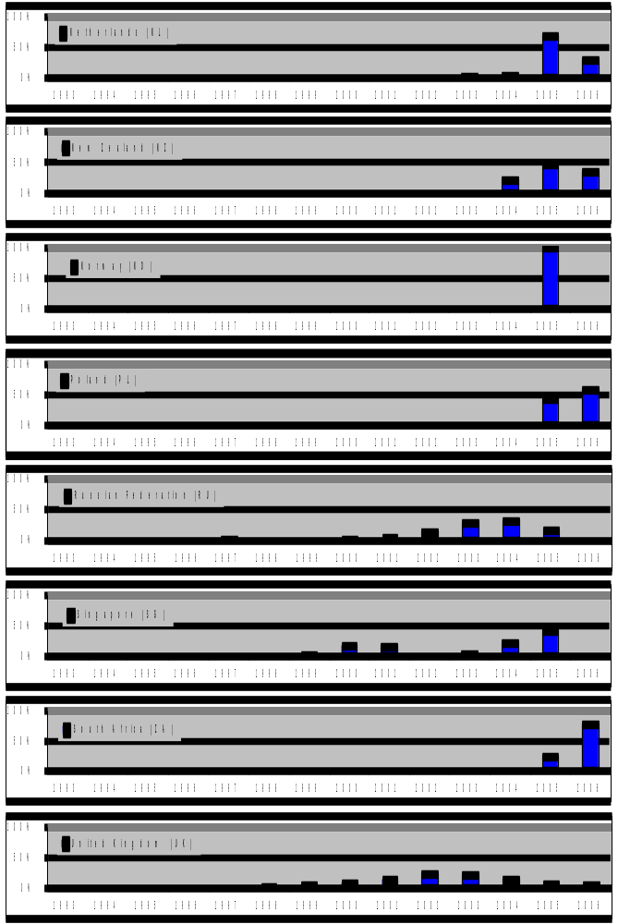
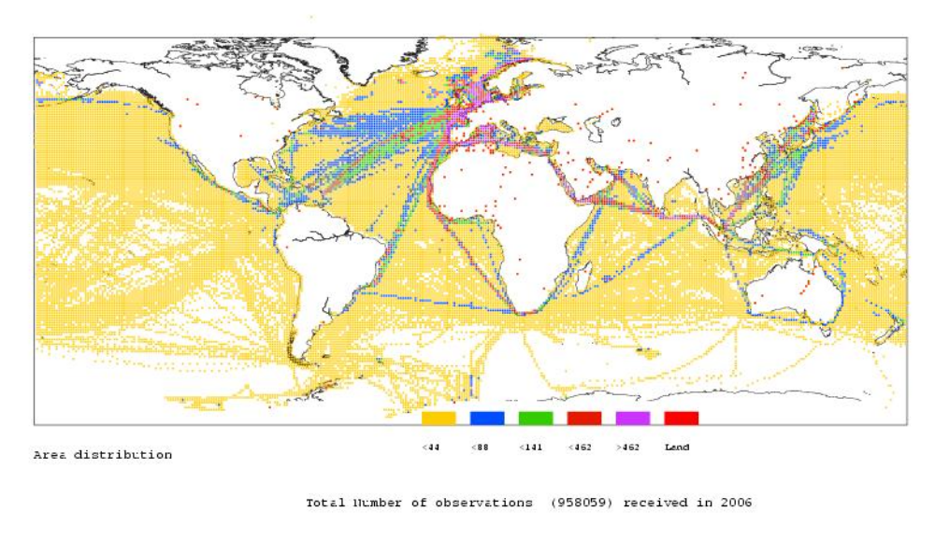
Figure 5: A real Distribution of Reported Positions 2006

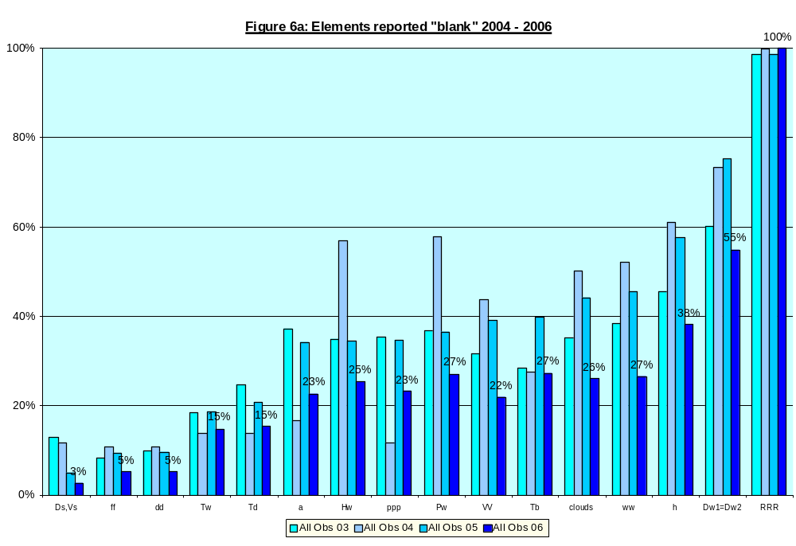
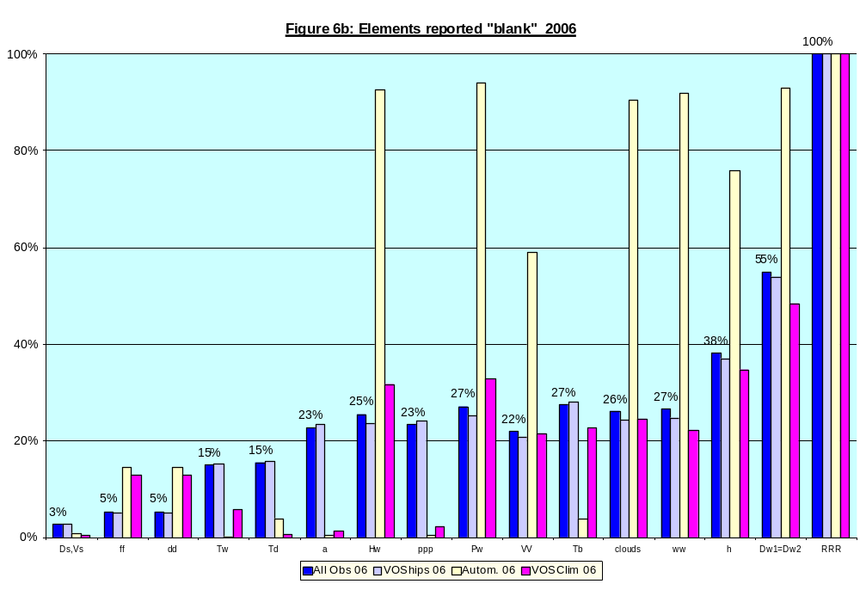
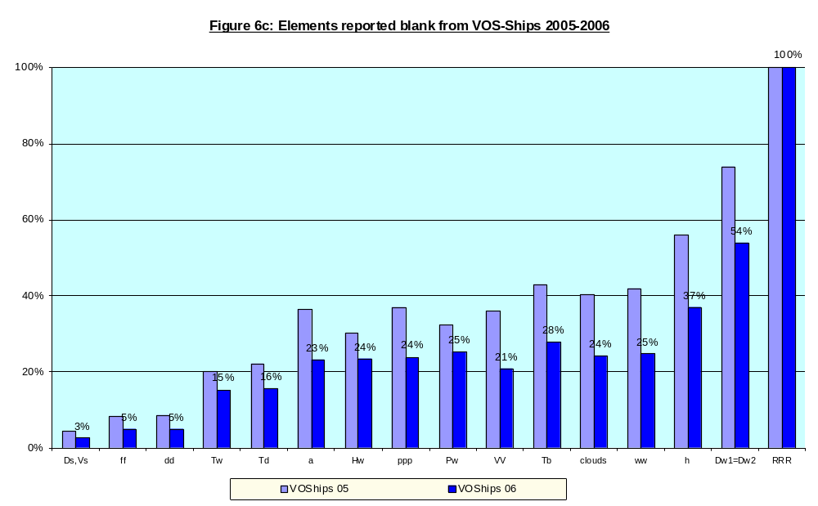
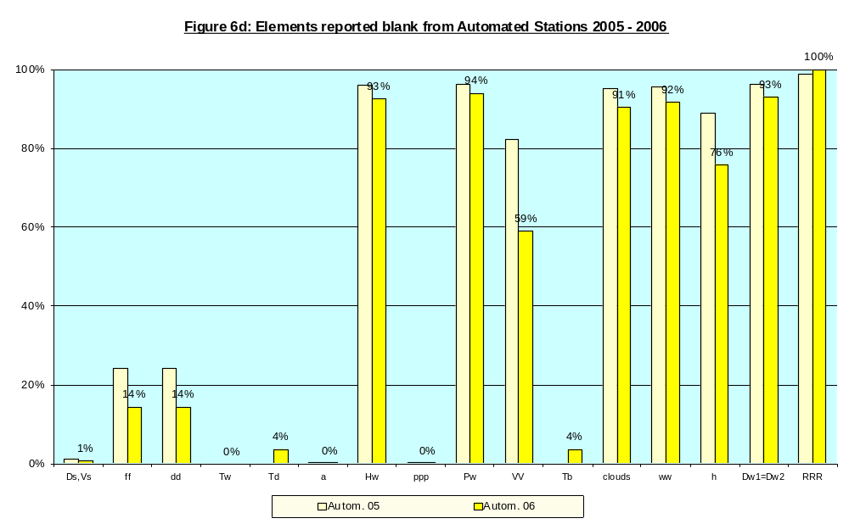
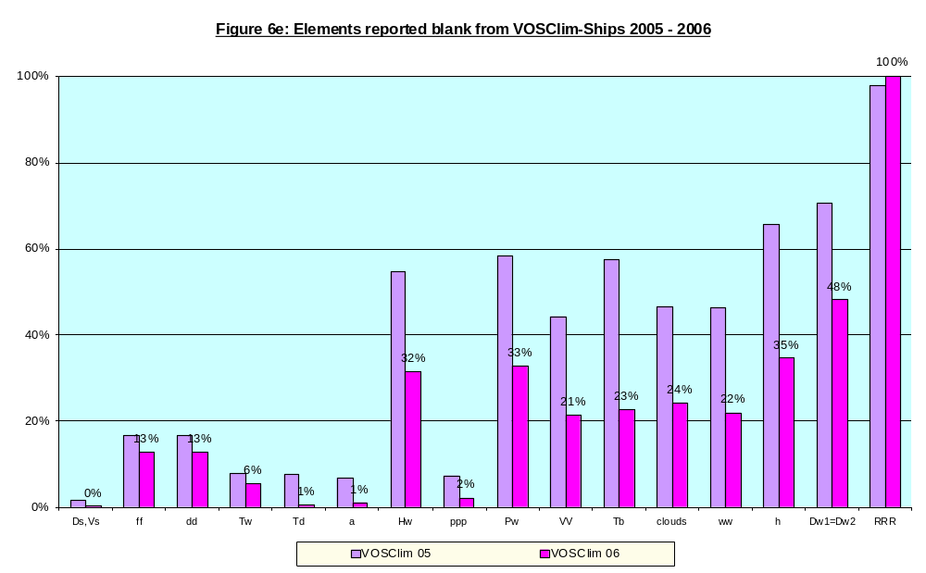

Key

Ds = True Ship Direction (Element 54) Clouds = All Clouds (Elements 12, 46-49)

vs = Average Speed (Element 55) ww = Present Weather (Element 21)

ff = Wind Speed (Element 15) h = Height of clouds (Element 10)

dd = True Wind Direction (Element 13) Dw1/Dw2 = Swell Direction 1 & 2 (Elements 34 & 56)

Tw = Sea Surface Temperature (Element 29) RRR = Precipitation Amount (Element 48)

Td = Dew-point Temperature (Element 19)

a = Pressure Tendency Characteristic (Element 52)

Hw = Wind Wave Height (Element 33)

ppp = Pressure Tendency Amount (Element 53)

Pw = Wind Wave Period (Element 32)

VV = Visibility (Element 11)

Tb = Wet-bulb Temperature (Element 51)

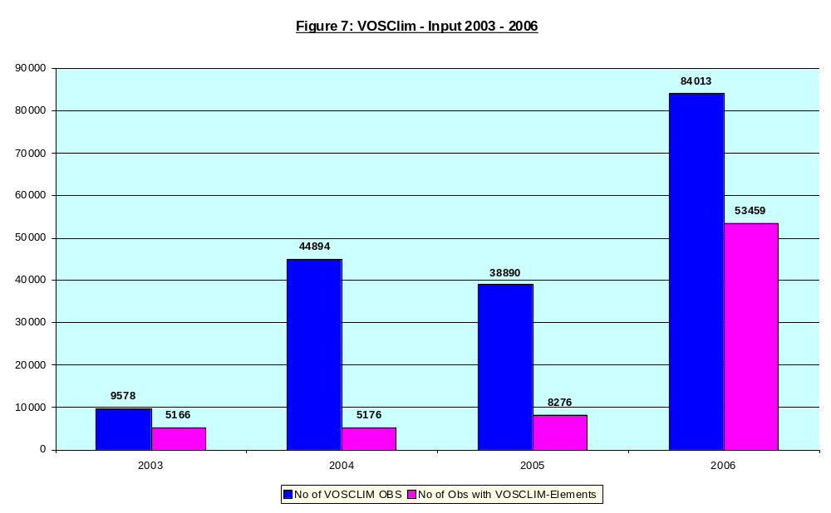
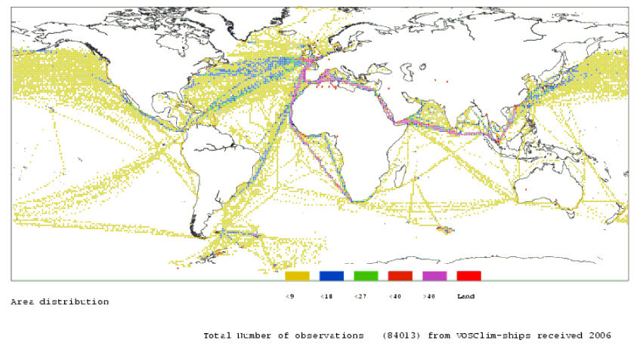

Figure 8: VOSClim Ship Areal Distribution of Reported Positions 2006

Appendix A: Responsible Member Countries

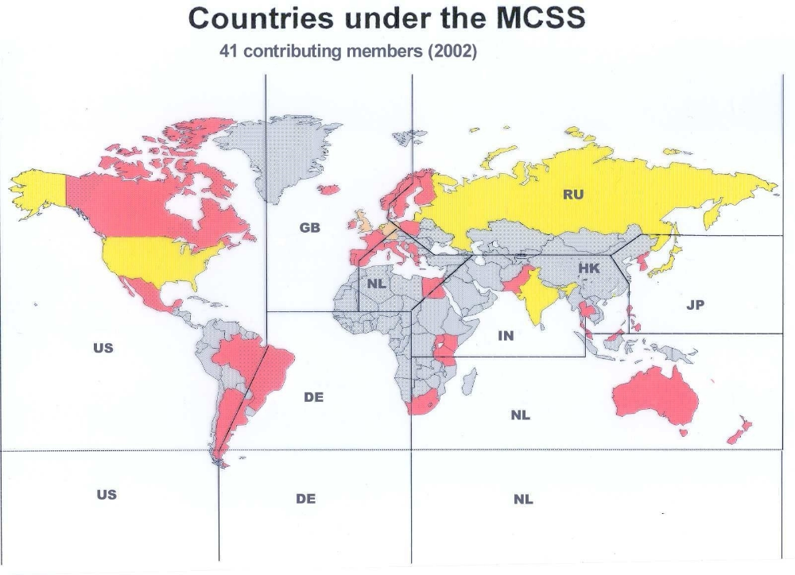

Appendix B: Extract from 1994 GCC Report

“A special problem arises if original flags claim ‘correct’ (flag=1) or ‘value corrected by quality control’ (flag=5) but the MQC check flags as erroneous or dubious. This discrepancy may be real, because MQC is not a sophisticated, high-quality check routine.
This discussion led to the view that such cases may be of interest, especially with respect to climatological extreme values, and so should be highlighted. In order to direct attention to such events the following procedure was applied by GCCs, using the available flag values of 6 and 7.
* flag is set to “6” if the original flag is set “1” (correct) and the value will be classed by MQC as inconsistent, dubious, erroneous or missing,
* flag is set to “7” if the original flag is set “5” (amended) and the value will be classed by MQC as inconsistent, dubious, erroneous or missing.
Otherwise, no original flag will be overwritten.”

Appendix C: Marine Data-Flow
VOS-Ship
VOSClim-Ship
GTS
Nat. Met. Services (CMs)
MQC and Corrections
(PMO Services)
GCCs
DAC
Responsible Members (RM)
Data Acquisition Centre / US
RU
JP
DE
NL
UK
HK
IN
US
VOSClim data only
all VOS data
non real time data

Appendix B

DRAFT
(Revised;November 2006)
LAYOUT FOR THE INTERNATIONAL MARITIME METEOROLOGICAL tape (immt)
[version immt-4]

Element Character Code Element Coding procedure
Number Number

1 1 iT Format/temperature indicator 3=IMMT format with temperatures in tenths of °C
4=IMMT format with temperatures in halves of °C
5=IMMT format with temperatures in whole °C

2 2-5 AAAA Year UTC Four digits

3 6-7 MM Month UTC 01 - 12 January to December

4 8-9 YY Day UTC 01 - 31

5 10-11 GG Time of observation Nearest whole hour UTC, WMO specifications

6 12 Qc Quadrant of the globe WMO code table 3333

7 13-15 LaLaLa Latitude Tenths of degrees, WMO specifications

8 16-19 LoLoLoLo Longitude Tenths of degrees

9 20 Cloud height (h) and visibility (VV) 0 - h and VV estimated
measuring indicator 1 - h measured, VV estimated
2 - h and VV measured
3 - h estimated, VV measured

10 21 h Height of clouds WMO code table 1600

11 22-23 VV Visibility WMO code table 4377

12 24 N Cloud amount Oktas, WMO code table 2700; show 9 where applicable

13 25-26 dd True wind direction Tens of degrees, WMO code table 0877; show 00 or 99
where applicable

14 27 iw Indicator for wind speed WMO code table 1855

15 28-29 ff Wind speed Tens and units of knots or meters per second, hundreds
omitted; values in excess of 99 knots are to be indicated
in units of meters per second and iw encoded accordingly;
the method of estimation or measurement and the units
used (knots or meters per second) are indicated in
element 14

16 30 sn Sign of temperature WMO code table 3845

17 31-33 TTT Air temperature Tenths of degrees Celsius

18 34 st Sign of dew-point temperature 0 - positive or zero measured dew-point temperature
1 - negative measured dew-point temperature
2 - iced measured dew-point temperature
5 - positive or zero computed dew-point temperature
6 - negative computed dew-point temperature
7 - iced computed dew-point temperature

19 35-37 TdTdTd Dew-point temperature Tenths of degrees Celsius

20 38-41 PPPP Air pressure Tenths of hectopascals

Element Character Code Element Coding procedure
Number Number

21 42-43 ww Present weather WMO code table 4677 or 4680

22 44 W1 Past weather WMO code table 4561 or 4531

23 45 W2 Past weather WMO code table 4561 or 4531

24 46 Nh Amount of lowest clouds As reported for CL or, if no CL cloud is present, for CM,
in oktas; WMO code table 2700

25 47 CL Genus of CL clouds WMO code table 0513

26 48 CM Genus of CM clouds WMO code table 0515

27 49 CH Genus of CH clouds WMO code table 0509

28 50 sn Sign of sea-surface temperature WMO code table 3845

29 51-53 TwTwTw Sea surface temperature Tenth of degrees Celsius

30 54 Indicator for sea-surface 0 - Bucket thermometer
temperature measurement 1 - Condenser inlet
2 - Trailing thermistor
3 - Hull contact sensor
4 - ”Through hull” sensor
5 - Radiation thermometer
6 - Bait tanks thermometer
7 - Others

31 55 Indicator for wave measurement 0 - Wind sea and swell estimated
Shipborne 1 - Wind sea and swell measured
wave 2 - Mixed wave measured, swell estimated
recorder 3 - Other combinations measured and
estimated
4 - Wind sea and swell measured
Buoy 5 - Mixed wave measured, swell estimated
6 - Other combinations measured and
estimated
7 - Wind sea and swell measured
Other 8 - Mixed wave measured, swell estimated
measurement 9 - Other combinations measured and
system estimated

32 56-57 PwPw Period of wind waves or of Whole seconds; show 99 where applicable in
measured waves accordance with Note (3) under specification of

PwPw in the Manual on Codes

33 58-59 HwHw Height of wind waves or of Half-meter values. Examples: Calm or less than ¼m
measured waves to be encoded 00; 3½m to be encoded 07;
7m to be encoded 14; 11½m to be encoded 23

34 60-61 dw1dw1 Direction of predominant Tens of degrees, WMO code table 0877; encoded 00
swell waves or 99 where applicable.
Blanks = No observation of waves attempted

35 62-63 Pw1Pw1 Period of predominant Whole seconds; encoded 99 where applicable
swell waves (see under element 32)

36 64-65 Hw1Hw1 Height of predominant swell waves Half-meter values (see under element 33)

37 66 Is Ice accretion on ships WMO code table 1751

38 67-68 EsEs Thickness of ice accretion In centimeters

39 69 Rs Rate of ice accretion WMO code table 3551

40 70 Source of observation 0 - Unknown
1 - Logbook National
2 - Telecommunication channels
3 - Publications
4 - Logbook (electronic)
5 - Telecommunication channels International
6 – Publications data exchange

Element Character Code Element Coding procedure
Number Number

41 71 Observation platform 0 - unknown
1 - Selected ship
2 - Supplementary ship
3 - Auxiliary ship
4 - Automated station/data buoy
5 - Fixed sea station
6 - Coastal station
7 - Aircraft
8 - Satellite
9 - Others ....

42 72-78 Ship identifier Ship’s call sign or other identifier encoded as follows:
7 characters call sign Columns 72–78
6 characters call sign Columns 72–77
5 characters call sign Columns 72–76
4 characters call sign Columns 72–75
3 characters call sign Columns 72–74

43 79-80 Country which has recruited According to the two-character alphabetical codes assigned by
the ship the International Organization for Standardization (ISO)

44 81 National use

45 82 Quality control indicator 0 - No quality control (QC)
1 - Manual QC only
2 - Automated QC only /MQC (no time-sequence checks)
3 - Automated QC only (inc. time sequence checks)
4 - Manual and automated QC (superficial; no automated
time-sequence checks)
5 - Manual and automated QC (superficial; including
time-sequence checks)
6 - Manual and automated QC (intensive, including
automated time-sequence checks)
7 & 8 - Not used
9 - National system of QC (information to be
furnished to WMO)

46 83 ix Weather data indicator 1 - Manual
4 - Automatic If present and past weather data included
Code tables 4677 and 4561 used
7 - Automatic If present and past weather data included
Code tables 4680 and 4531 used

47 84 iR Indicator for inclusion or omission WMO code table 1819
of precipitation data

48 85-87 RRR Amount of precipitation which has WMO code table 3590
fallen during the period preceding
the time of observation, as indicated
by tR

49 88 tR Duration of period of reference for WMO code table 4019
amount of precipitation, ending at
the time of the report

50 89 sw Sign of wet-bulb temperature 0 - positive or zero measured wet-bulb temperature
1 - negative measured wet-bulb temperature
2 - iced measured wet-bulb temperature
5 - positive or zero computed wet-bulb temperature
6 - negative computed wet-bulb temperature
7 - iced computed wet-bulb temperature

51 90-92 TbTbTb Wet-bulb temperature In tenths of degree Celsius, sign given by element 50

52 93 a Characteristic of pressure tendency WMO code table 0200
during the three hours preceding
the time of observation
Element Character Code Element Coding procedure
Number Number

53 94-96 ppp Amount of pressure tendency at In tenths of hectopascal
station level during the three hours
preceding the time of observation

54 97 Ds True direction of resultant WMO code table 0700
displacement of the ship during
the three hours preceding the time
of observation

55 98 vs Ship’s average speed made good WMO code table 4451
during the three hours preceding
the time of observation

56 99-100 dw2dw2 Direction of secondary swell waves Tens of degrees, WMO code table 0877;
encoded 00 or 99 where applicable.
Blanks = No observation of waves attempted

57 101-102 Pw2Pw2 Period of secondary swell waves Whole seconds; encoded 99 where applicable
(see under element 32)

58 103-104 Hw2Hw2 Height of secondary swell waves Half-meter values (see under element 33)

59 105 ci Concentration or arrangement WMO code table 0639
of sea ice

60 106 Si Stage of development WMO code table 3739

61 107 bi Ice of land origin WMO code table 0439

62 108 Di True bearing of principal ice edge WMO code table 0739

63 109 zi Present ice situation and trend of WMO code table 5239
conditions over the preceding three hours

64 110 FM 13 code version 0 = previous to FM 24-V
1 = FM 24-V
2 = FM 24-VI Ext.
3 = FM 13-VII
4 = FM 13-VIII
5 = FM 13-VIII Ext.
6 = FM 13-IX
7 = FM 13-IX Ext.
8 = FM 13-X, etc.

65 111 IMMT version 0 = IMMT version just prior to version number being
included
1 = IMMT-1 (in effect from Nov. 1994)
2 = IMMT-2 (in effect from Jan. 2003)
3 = IMMT-3 (in effect from Jan. 2006)
4 = IMMT-4 (this version)
etc.

66 112 Q1 Quality control indicator for (h) 0 - no quality control (QC) has been performed
in this element
1 - QC has been performed; element appears to be correct
2 - QC has been performed; element appears
to be inconsistent with other elements
3 - QC has been performed; element appears to be doubtful
4 - QC has been performed; element appears to be erroneous
5 - The value has been changed as a result of QC
6 - 8 Reserve
9 - The value of the element missing

67 113 Q2 QC indicator for (VV) - idem -

68 114 Q3 QC indicator for (clouds: - idem -
elements 12, 24–27)

69 115 Q4 QC indicator for (dd) - idem -

70 116 Q5 QC indicator for (ff) - idem -
Element Character Code Element Coding procedure
Number Number

71 117 Q6 QC indicator for (TTT) - idem -

72 118 Q7 QC indicator for (TdTdTd) - idem -

73 119 Q8 QC indicator for (PPPP) - idem -

74 120 Q9 QC indicator for (weather: - idem -
elements 21–23)

75 121 Q10 QC indicator for (TwTwTw) - idem -

76 122 Q11 QC indicator for (PwPw) - idem -

77 123 Q12 QC indicator for (HwHw) - idem -

78 124 Q13 QC indicator for (swell: elements - idem -
34–36, 56–58)

79 125 Q14 QC indicator for (iRRRRtR) - idem -

80 126 Q15 QC indicator for (a) - idem -

81 127 Q16 QC indicator for (ppp) - idem -

82 128 Q17 QC indicator for (Ds) - idem -

83 129 Q18 QC indicator for (vs) - idem -

84 130 Q19 QC indicator for (TbTbTb) - idem -

85 131 Q20 QC indicator for ships’ position - idem -

86 132 Q21 Minimum quality control standards (MQCS) 1 = MQCS- I (Original version, Feb. 1989)CMM-X
version identification 2 = MQCS-II ( Version 2, March 1997) CMM-X11
3 = MQCS-III (Version 3, April 2000) SGMC-VIII
4 = MQCS-IV (Version 4, June 2001) JCOMM-I
5 = MQCS-V (Version 5, July 2004) ETMC-I
6 = MQCS-VI (this version, to be agreed)
etc.
Additional Requirements for the VOSCLIM Project

87 133-135 HDG Ship's heading; the direction to (000-360); e.g.
which the bow is pointing, 360 = North
referenced to true North. 000 = No Movement
090 = East

88 136-138 COG Ship's ground course; the direction (000-360); e.g.
the vessel actually moves over the 360 = North
fixed earth and referenced to True North 000 = No Movement
090 = East

89 139-140 SOG Ship's ground speed; the speed the (00-99); Round to
vessel actually moves over the fixed nearest whole knot
earth.

90 141-142 SLL Maximum height in meters of deck cargo (00-99); report to nearest whole meter
above Summer maximum load line.

Element Character Code Element Coding procedure
Number Number

91 143 s_{L} Sign of departure of reference level 0 = positive or zero, 1 = negative
92 144-145 hh Departure of reference level (Summer (00-99) is the difference to the nearest whole
maximum load line) from actual sea meter between the Summer maximum load
level. line and the sea level.
Consider the difference positive when the
Summer maximum load line is above the level
of the sea and negative if below the water line.

93 146-148 RWD Relative wind direction in degrees Relative wind direction; e.g. 000 = no
off the bow apparent relative wind speed (calm conditions
on deck). Reported direction for relative
wind = 001-360 degrees in a clockwise
direction off the bow of the ship. When
directly on the bow, RWD = 360.

94 149-151 RWS Relative wind speed reported in Reported in either whole knots or whole
units indicated by iw (knots or m/s) meters per second (e.g. 010 knots or 005
m/s). Units established by iw as indicated
in Character Number 27.

Note: Since the relative wind speed can be greater than the true wind speed e.g., iw indicates knots and ff = 98, the relative wind speed may be 101 knots; therefore, three positions must be allocated since iw cannot be adjusted and the relative wind speed converted to meters per second as is done in element 15.

95 152 Q22 Quality control indicator for (HDG) 0 - no quality control (QC) has been performed
in this element
1 - QC has been performed; element appears to be correct
2 - QC has been performed; element appears
to be inconsistent with other elements
3 - QC has been performed; element appears to be doubtful
4 - QC has been performed; element appears to be erroneous
5 - The value has been changed as a result of QC
6 – 8 - Reserved for GCC use
9 - The value of the element missing

96 153 Q23 QC indicator for (COG) - idem –

97 154 Q24 QC indicator for (SOG) - idem –

98 155 Q25 QC indicator for (SLL) - idem –

156 blank

99 157 Q27 QC indicator for (hh) - idem –

100 158 Q28 QC indicator for (RWD) - idem –

101 159 Q29 QC indicator for (RWS) - idem -

Note: Most of the codes (groups of letters) in the IMMT format with the exception of those added for the VOSCLIM project are defined in the Manual on Codes (WMO Pub.No. 306) as they basically mirror the code groups used in FM 13-X Ship code. Because CBS was not persuaded to expand the FM 13-X Ship code for the VOSCLIM project the additional observed elements (selected codes) will not appear in WMO Manual on Codes (Pub. 306). Therefore an effort was made to select unique codes (groups of letters) not defined in WMO Pub. 306 for the elements added to the IMMT-2 format version modified for the VOSCLIM project. This was deliberately done to try and prevent a difference in meaning for a given code group (identical symbolic letters) in Pub. 306 versus that in IMMT. Presumably none of the Character Code formats will be altered in the future by CBS.

Appendix C

DRAFT
MINIMUM QUALITY CONTROL STANDARDS
MQCS-VI (Version 6, November 2006)

NOTE See specification for quality control Indicators Q₁ to Q₂₉ at the end of this appendix
Δ = space (ASCII 32)

Element Error Action
1 i_{T} ≠ 3 – 5, Δ Correct manually otherwise Δ
2 AAAA ≠ valid year Correct manually otherwise reject
3 MM ≠ 01 - 12 Correct manually otherwise reject
4 YY ≠ valid day of month Correct manually otherwise reject
5 GG ≠ 00 - 23 Correct manually otherwise reject
6 Q_{c} ≠ 1, 3, 5, 7 Correct manually and Q₂₀ = 5, otherwise Q₂₀ = 4
Q_{c} = Δ Q₂₀ = 2
7 LaLaLa ≠ 000-900 Correct manually and Q₂₀ = 5, otherwise Q₂₀ = 4
LaLaLa = ΔΔΔ Q₂₀ = 2
8 LoLoLoLo ≠ 0000-1800 Correct manually and Q₂₀ = 5, otherwise Q₂₀ = 4
LoLoLoLo = ΔΔΔΔ Q₂₀ = 2
LaLaLa = LoLoLoLo = ΔΔΔ(Δ) Correct manually otherwise reject

Time sequence checks
Change in latitude > 0.7º/hr Correct manually otherwise Q₂₀ = 3
Change in longitude > 0.7 º/hr Correct manually otherwise Q₂₀ = 3
when lat. 00-39.9
Change in longitude > 1.0 º/hr Correct manually otherwise Q₂₀ = 3
when lat. 40-49.9
Change in longitude > 1.4 º/hr Correct manually otherwise Q₂₀ = 3
when lat. 50-59.9
Change in longitude > 2.0 º/hr Correct manually otherwise Q₂₀ = 3
when lat. 60-69.9
Change in longitude > 2.7 º/hr Correct manually otherwise Q₂₀ = 3
when lat. 70-79.9
9 Indicator ≠ 0-3, Δ Correct manually, otherwise Δ
10 h ≠ 0-9 Correct manually and Q₁ = 5, otherwise Q₁ = 4
h = Δ Q₁ = 9
11 VV ≠ 90-99 Correct manually and Q₂ = 5, otherwise Q₂ = 4
VV = ΔΔ Q₂ = 9
12 N ≠ 0-9, Δ Correct manually and Q₃ = 5, otherwise Q₃ = 4
N < Nh Correct manually and Q₃ = 5, otherwise Q₃ = 2
13 dd ≠ 00-36, 99 Correct manually and Q₄ = 5, otherwise Q₄ =4
dd = ΔΔ Q₄ = 9
dd versus ff
dd = 00, ff ≠ 00 Correct manually and Q₄ or Q₅ = 5 otherwise
Q₄ = Q₅ = 2
dd ≠ 00, ff = 00 Correct manually and Q₄ or Q₅ = 5 otherwise
Q₄ = Q₅ = 2

Element Error Action

14 iw ≠ 0, 1, 3, 4 Correct manually, otherwise Q₅ = Q₂₉ = 4
15 ff > 80 knots Correct manually and Q₅ = 5, otherwise Q₅ = 3
ff = ΔΔ Q₅ = 9
16 sn ≠ 0, 1 Correct manually, otherwise Q₆ = 4
17 TTT = ΔΔΔ Q₆ = 9
If -25 > TTT >40 then
when Lat. < 45.0
TTT < -25 Q₆ = 4
TTT > 40 Q₆ = 3
when Lat.  45.0
TTT < -25 Q₆ = 3
TTT > 40 Q₆ = 4
TTT versus humidity parameters
TTT < WB (wet bulb) Correct manually and Q₆ = 5, otherwise Q₆=Q₁₉= 2
TTT < DP (dew point) Correct manually and Q₆ = Q₇ = 5, otherwise
Q₆ = Q₇ = 2
18 st ≠ 0, 1, 2, 5, 6, 7 Correct manually, otherwise Q₇ =4
19 DP > WB Correct manually and Q₇ = 5, otherwise Q₇=Q₁₉ = 2
DP > TTT Correct manually and Q₇ = 5, otherwise Q₇ = Q₆ =2
WB = DP = ΔΔΔ Q₇ =Q₁₉ = 9
20 930 > PPPP > 1050 hPa Correct manually and Q₈ = 5, otherwise Q₈ = 3
870 > PPPP > 1070 hPa Correct manually and Q₈ = 5, otherwise Q₈ = 4
PPPP = ΔΔΔΔ Q₈ = 9
21 ww = 22-24, 26, 36-39, 48, Correct manually and Q₉ = 5, otherwise Q₉= 4
49, 56, 57, 66-79, 83-88
93-94 Correct manually and Q₉ = 5, otherwise Q₉ = 3
and latitude <20o
if ix = 7:
w_{a}w_{a} = 24 - 25, 35, 47-48, Correct manually and Q₉ = 5, otherwise
54-56, 64-68, 70-78, 85-87 Q₉= 4
and latitude <20o
22, 23 W₁ or W₂ = 7 and latitude <20o Correct manually and Q₉ = 5, otherwise Q₉= 4
W₁ < W₂ Correct manually and Q₉ = 5, otherwise Q₉ = 2
W₁ = W₂ = ww = ΔΔΔΔ Q₉ = 9
24-27 N = 0, and NhC_{L}C_{M}C_{H} ≠ 0000 Correct manually and Q₃ = 5, otherwise Q₃ = 2
N = Δ, and NhC_{L}C_{M}C_{H} ≠ ΔΔΔΔ Correct manually and Q₃ = 5, otherwise Q₃ = 2
N = 9, and not (N_{h} =9 and Correct manually and Q₃ = 5, otherwise Q₃ = 2
C_{L}C_{M}C_{H} ≠ ΔΔΔ
N=Δ, and NhC_{L}C_{M}C_{H}=ΔΔΔΔ Q₃ = 9
28 sn ≠ 0, 1 Correct manually otherwise Q₁₀ = 4
29 TwTwTw =   ΔΔΔ Q₁₀ = 9
if -2.0 > TwTwTw > 37.0 then
when Lat. < 45.0
TwTwTw < -2.0 Control manually and Q₁₀ = 5, otherwise Q₁₀ = 4
TwTwTw > 37.0 Control manually and Q₁₀ = 5, otherwise Q₁₀ = 3
when Lat. ≥  45.0
TwTwTw < -2.0 Control manually and Q₁₀ = 5, otherwise Q₁₀ = 3
TwTwTw > 37.0 Control manually and Q₁₀ = 5, otherwise Q₁₀ = 4

Element Error Action

30 Indicator ≠ 0-7, Δ Correct manually, otherwise Δ
31 Indicator ≠ 0-9, Δ Correct manually, otherwise Δ
32 20 < PwPw < 30 Q₁₁ = 3
PwPw ≥ 30 and ≠ 99 Q₁₁ = 4
PwPw = ΔΔ Q₁₁ = 9
33 35< HwHw < 50 Q₁₂ = 3
HwHw ≥ 50 Q₁₂ = 4
HwHw = ΔΔ Q₁₂ = 9
34 dw1 dw1 ≠ 00-36, 99 Correct manually and Q₁₃ = 5, otherwise Q₁₃ = 4
swell1 = swell2 = Δ Q₁₃ = 9
35 25 < Pw1Pw1 < 30 Q₁₃ = 3
Pw1P w1 ≥ 30 and ≠ 99 Q₁₃ = 4
36 35 < Hw1Hw1 < 50 Q₁₃ = 3
Hw1Hw1 ≥ 50 Q₁₃ = 4
37 Is ≠ 1-5, Δ Correct manually, otherwise Δ
38 EsEs ≠ 00-99,   ΔΔ Correct manually, otherwise ΔΔ
39 Rs ≠ 0-4, Δ Correct manually, otherwise Δ
40 Source ≠ 0-6 Correct manually, otherwise Δ
41 Platform ≠ 0-9 Correct manually, otherwise Δ
42 No call sign Insert manually, mandatory entry
43 No country code Insert manually
44 No Quality Control
45 Q ≠ 0-6, 9 Correct manually, otherwise Δ
46 ix ≠ 1-7 Correct manually, otherwise Δ
47 i_{R} = 0-2 and RRR = 000,  ΔΔΔ Correct manually, otherwise Q₁₄ = 4
i_{R} = 3 and RRR ≠ ΔΔΔ Correct manually, otherwise Q₁₄ = 2
i_{R} = 4 and RRR ≠ ΔΔΔ Correct manually, otherwise Q₁₄ = 2
i_{R} ≠  0- 4 Correct manually, otherwise Q₁₄ = 4
48 RRR ≠ 001-999 and i_{R} = 1, 2 Correct manually and Q₁₄ = 5, otherwise Q₁₄ = 2
49 t_{R} ≠ 0-9, Δ Correct manually and Q₁₄ = 5, otherwise Q₁₄ = 4
50 sw ≠ 0, 1, 2, 5, 6, 7 Correct manually, otherwise Q₁₉ = 4
51 WB < DP Correct manually and Q₁₉ = 5, otherwise Q₁₉=Q₇=2 WB = ΔΔΔ Q₁₉ = 9
WB > TTT Correct manually and Q₁₉= 5, otherwise Q₁₉=Q₆= 2
52 a ≠ 0-8 Correct manually and Q₁₅ = 5, otherwise Q₁₅ = 4
a = 4 and ppp ≠ 000 Correct manually and Q₁₅ or Q₁₆ = 5, otherwise
Q₁₅=Q₁₆=2
a =1,2,3,6,7,8 and ppp=000 Correct manually and Q₁₅ or Q₁₆ = 5, otherwise
Q₁₅=Q₁₆ = 2
a = Δ Q₁₅ = 9
53 250 ≥ ppp > 150 Correct manually and Q₁₆ = 5, otherwise Q₁₆ = 3
ppp > 250 Correct manually and Q₁₆ = 5 otherwise Q₁₆ = 4
ppp = ΔΔΔ Q₁₆ = 9
54 D_{s} ≠ 0-9 Correct manually and Q₁₇ = 5, otherwise Q₁₇ = 4
D_{s} = Δ Q₁₇ = 9
55 v_{s} ≠ 0-9 Correct manually and Q₁₈ = 5, otherwise Q₁₈ = 4
v_{s} = Δ Q₁₈ = 9
56 dw2dw2 ≠ 00-36, 99, ΔΔ Correct manually and Q₁₃ = 5, otherwise Q₁₃ = 4
57 25 < Pw2Pw2 < 30 Q₁₃ = 3
Pw2Pw2 ≥ 30 and ≠99 Q₁₃ = 4
58 35 < Hw2Hw2 < 50 Q₁₃ = 3
Hw2Hw2 ≥ 50 Q₁₃ = 4
59 ci ≠ 0-9, Δ Correct manually, otherwise Δ
60 Si ≠ 0-9, Δ Correct manually, otherwise Δ
Element Error Action

61 bi ≠ 0-9, Δ Correct manually, otherwise Δ
62 Di ≠ 0-9, Δ Correct manually, otherwise Δ
63 zi ≠ 0-9, Δ Correct manually, otherwise Δ
64 version ≠ 0-8, Δ Correct manually, otherwise Δ
65 version ≠ 0-4, Δ Correct manually, otherwise Δ

86 Minimum Quality Control 1= MQCS-I (Original version, Feb. 1989) CMM-X
Standards (MQCS) version 2= MQCS-II (Version 2, March 1997) CMM-XII
identification 3= MQCS-III (Version 3, April 2000) SGMC-VIII
4= MQCS-IV (Version 4, June 2001) JCOMM-I
5= MQCS-V (Version 5, July 2004) ETMC-I
6 = MQCS-VI (this version, to be agreed)

87 HDG ≠ 000-360 Correct manually and Q₂₂ = 5, otherwise Q₂₂ = 4
HDG = ΔΔΔ Q₂₂ = 9
88 COG ≠ 000-360 Correct manually and Q₂₃ = 5, otherwise Q₂₃ = 4
COG = ΔΔΔ Q₂₃ = 9
89 SOG ≠ 00 - 99 Correct manually and Q₂₄ = 5, otherwise Q₂₄ = 4
SOG = ΔΔ Q₂₄ = 9
SOG > 33 Correct manually and Q₂₄ = 5, otherwise Q₂₄ = 3
90 SLL ≠ 00-99 Correct manually and Q₂₅ = 5, otherwise Q₂₅ = 4
SLL = ΔΔ Q₂₅ = 9
SLL > 35 Correct manually and Q₂₅ = 5, otherwise Q₂₅ = 3
91 s_{L} ≠ 0,1 Correct manually and Q₂₇ = 5, otherwise Q₂₇ = 4
92 hh ≠ 00 – 99 Correct manually and Q₂₇ = 5, otherwise Q₂₇ = 4
hh = ΔΔ Q₂₇ = 9
hh >= 13 Correct manually and Q₂₇ = 5, otherwise Q₂₇ = 3
hh < -01 Correct manually and Q₂₇ = 5, otherwise Q₂₇ = 4
93 RWD ≠ 000 - 360, 999 Correct manually and Q₂₈ = 5, otherwise Q₂₈ = 4
RWD = ΔΔΔ Q₂₈ = 9
94 RWS ≠ 000 - 999 Correct manually and Q₂₉ = 5, otherwise Q₂₉ = 4
RWS = ΔΔΔ Q₂₈ = 9
RWS > 110 kts Correct manually and Q₂₉ = 5, otherwise Q₂₉ = 3

RWD versus RWS
RWD = 000, RWS ≠ 000 Correct manually and Q₂₈ or Q₂₉ = 5, otherwise
Q₂₈ = Q₂₉ = 2
RWD ≠ 000, RWS = 000 Correct manually and Q₂₈ or Q₂₉ = 5, otherwise
Q₂₈ = Q₂₉ = 2

Specifications for quality control Indicators Q₁ to Q₂₉

0 No quality control (QC) has been performed on this element
1 QC has been performed; element appears to be correct
2 QC has been performed; element appears to be inconsistent with other elements
3 QC has been performed; element appears to be doubtful
4 QC has been performed; element appears to be erroneous
5 The value has been changed as a result of QC
6 reserved for GCC
7 reserved for GCC
8 Reserve
9 The value of the element is missing

______________

