WORLD METEOROLOGICAL ORGANIZATION  ________________________ | INTERGOVERNMENTAL OCEANOGRAPHIC  COMMISSION (OF UNESCO)  ________________________
JOINT WMO/IOC TECHNICAL COMMISSION FOR OCEANOGRAPHY AND MARINE METEOROLOGY (JCOMM)  SHIP OBSERVATIONS TEAM  FOURTH SESSION  GENEVA, SWITZERLAND, 16 TO 21 APRIL 2007 |  |  | SOT-IV/Doc. IV-3  (15.II.2007)  __________  ITEM IV-3  Original: ENGLISH

VOSP-V
Monitoring and Data Management

RSMC, Exeter, and VOSClim RTMC reports
(Submitted by Colin Parrett)

Summary and purpose of document

This document provides information on the data quality monitoring conducted by the Met Office (RSMC Exeter, UK) which has now been extended to include data timeliness information. The document also provides a status report on the progress made by the the VOSClim Real Time Monitoring Centre (RTMC) since SOT-III/VOSClim-V and requests the meeting to take decisions on a number of monitoring issues (the Met Office (UK) agreed to act as the RTMC at VOSClim-II).

ACTION PROPOSED

The Ship Observations Team is invited to consider the information given in this document and to make comments or suggestions, as appropriate, regarding the current monitoring procedures. In particular the Team is invited to:

- respond to the final point made in paragraph 1.3 of this document;
- respond to the suggestion made in paragraph 1.4 of this document;
- note the timeliness information referred to in paragraph 1.7 of this document;
- consider and take note of the points made in paragraph 1.8 and 1.9 of this document;
- Consider whether it agrees with the changes made by the RTMC and documented in paragraph 2.5 of this report, relating to the continued inclusion in statistics of ship reports made at model land points and the removal of ‘candidate’ ship statistics;
- Consider whether it agrees with the statement in paragraph 2.8 of this report concerning monitoring criteria;
- Discuss the ideas in paragraph 2.9 of this report concerning the availability of remedial actions and suggest a solution.
______________________

Appendices: A. Monitoring of marine surface observations by the Met Office (UK), Monthly Suspect List, Dec 2006;
B. Examples of content of Met Office Observation Monitoring Web Pages;
C. Timeliness of VOS observations received at the Met Office (UK), Dec 2006;
D. Quality monitoring issues related to masking of ship call signs;
E Project Monitoring Criteria;
F. Monitoring Statistics for VOSClim Ships (Jan 2007);
G. Monitoring ‘Suspect’ list for VOSClim Ships (Jan 2007);
H. BUFR template.
DISCUSSION

1. Monitoring the quality and timeliness of VOS observations

1.1 The Met Office (RSMC Exeter), as WMO-designated lead centre for monitoring the quality of surface marine meteorological data (observations from ships, buoys and other in situ marine platforms), compares observations from individual platforms with the Met Office’s global model background 6-hour forecast fields for each variable. Platforms for which the observed values differ from the background by a significant amount are flagged as suspect.

1.2 Monthly lists of suspect platforms are sent to the WMO Secretariat (a recent suspect list for ships, fixed buoys and platforms, dated December 2006, is attached at Appendix A for information). These lists are also exchanged among the 4 lead monitoring centres (Met Office, JMA, NCEP and ECMWF), and other centres, for comparison. Generally there is considerable agreement between the different centres, both in terms of suspect platforms and mean and standard deviation of differences from the background field. Since SOT-III, these monthly lists have been made available via the Met Office web site at :

http://www.metoffice.gov.uk/research/nwp/observations/monitoring/index.html

Examples of the website content together with an extract from the suspect monitoring list for December 2006 are attached at Appendix B. It will be noted that each suspect ship can now be linked to a QC plot covering the previous month, showing time-series of observation-background values. Two examples are shown: the first plot shows a temporary bias in pressure and the second shows a more persistent but variable bias in relative humidity. (N.B. The plots of pressure currently show the values after any corrections have been applied at the Met Office.)

1.3 Initially only mean sea level pressure was monitored, but wind speed, wind direction, sea surface temperature, air temperature and relative humidity have also been added to the information being exchanged on a monthly basis. The current monitoring criteria for the 6 variables are shown in Appendix A. The meeting is invited to confirm that the monitoring criteria continue to be set at the correct levels.

1.4 The Met Office also produces monthly lists of monitoring statistics for the VOS fleets recruited by certain countries. To maintain up to date lists of the VOS fleets for each country concerned, the Met Office now uses WMO Pub 47, which should currently be updated quarterly. However, to ensure that recently recruited VOS vessels are also included, the Met Office also receives monthly fleet updates from a number of countries. These national lists would not be needed if the Pub 47 list could be updated monthly in the future. The Team is therefore invited to consider whether the frequency of Pub 47 procedures should be revised to allow countries to make monthly metadata submissions. This would help to ensure that observational problems can be dealt with in a more prompt manner. (N.B. At the time of writing, the Pub47 list has not been updated for 9 months, between June 2006 and March 2007.)

1.5 National focal points are now notified when the latest VOS monthly monitoring reports and suspect lists become available on the Met Office website by means of an email sent by the Met Office to the SOT, VOS and PMO mailing lists, which are maintained by JCOMMOPS. It is important therefore that focal points wishing to receive this monitoring information check that their JCOMMOPS mailing list information is kept up to date. However, the monthly monitoring statistics continue to be emailed directly to major VOS operating countries, and as mentioned in reports to previous SOT meetings, any other national focal points who may wish to receive directly emailed copies of the monthly monitoring lists or ‘suspect’ ship lists should advise the Met Office of their email address.

1.6 Every 6 months more detailed monitoring reports, for all platforms, are also produced and made available to the WMO Secretariat via the Met Office web site. The statistics relating to suspect VOS operated by specific members are extracted from the report and distributed by the Secretariat to national focal points for the members concerned, under a covering letter requesting that remedial action be taken to correct the problems. Paper copies of the 6-month report are also circulated by the Met Office, but they no longer contain the individual time-series plots for each suspect platform, which made the report very bulky; the general overview and statistics are deemed to be more useful on this time-scale, although the time-series are still available from the Met Office web site.

1.7 Timeliness information for VOS reports received at the Met Office is now also being made available from our web site at

http://www.metoffice.gov.uk/research/nwp/observations/monitoring/marine/TOR/index.html,

where there is a table summarising the data timeliness for each country as well as graphs showing the timeliness of all VOS ships and for the main VOS operating countries. A graphical example for December 2006 data is shown in Appendix C, where it can be seen from the upper graph that the majority of ship reports were received promptly, with over 40% received within 30 minutes and 90% within 90 minutes of the observation time. The cut-off time for operational NWP global data assimilation is typically 90-150 minutes after the analysis times of 00, 06, 12 and 18 UTC, so at least 90% of global VOS data should be received in time to be assimilated. Timeliness information for individual call-signs on the Pub47 list is also available from the website.

1.8 Currently the Met Office's role as CBS Lead Centre for monitoring marine data cannot be properly fulfilled, because Japanese ships cannot be monitored individually due to their unilateral adoption of a ‘SHIP’ masking scheme. For the Met Office to be able to resume monitoring of the Japanese ships will require work to set up special collection of the original data from JMA’s FTP server, once it is available. In addition to the costs this will incur, it will introduce extra complexity into the system and has implications for the timeliness of the data being made available.

1.9 Consequently, to ensure that VOS can continue to be monitored efficiently, Met Office (RSMC Exeter) would prefer that all countries adopt a masking method with a unique masked identifier for each ship. The impact of ship masking on monitoring activities was discussed at the Joint WMO-IMO Consultative Meeting in Geneva in February 2007 and the views of the Met Office are repeated here in Appendix D.

2. VOSClim Real-Time Monitoring Centre (RTMC) report

2.1 The Met Office agreed to act as the Real Time Monitoring Centre (RTMC) for the project at the second meeting of the VOS Climate Project (VOSClim-II).

2.2 In accordance with the Terms of Reference agreed for the RTMC, the observed project variables (i.e. pressure, air temperature, relative humidity, sea surface temperature, wind speed and wind direction) are extracted from the GTS for each project ship and co-located with the associated model field values prior to transfer to the Data Assembly Centre (DAC). In addition, ship monitoring statistics are produced by the RTMC and provided to the DAC on a monthly basis, with statistics for ‘suspect’ ships being sent to the national focal points.

2.3 Further information and details of progress made by the RTMC since the last project meeting are given below.

Monitoring Statistics

2.4 At the last project meeting (SOT-III/VOSClim-V) it was agreed to keep the values for the real time monitoring of the observed variables at the levels given in Appendix E to this report.

2.5 Since the SOT-III/VOSClim-V meeting:

- The RTMC has continued to update its list of project ships, following notification of changes to the list of project ships maintained on the VOSClim website.

- In accordance with the agreement at SOT-III (III-B/2.1.2), the RTMC has modified its software to only include those ship reports made over model sea points in the statistics used for deciding whether a ship is ‘suspect’. However, the complete monthly statistics sent to the DAC still include all ship reports, including those from model land points (otherwise some ships that regularly report close to land would not appear in the list of statistics). The meeting is invited to comment on whether they wish the RTMC to modify its monthly statistics supplied to the DAC to exclude ship reports made at model land points.

- The RTMC has replaced the sending of the monthly statistics and suspect lists to the DAC by e-mail with placement on the Met Office’s external FTP server, ready for the DAC to download.

- The RTMC has recently stopped producing monthly statistics for the list of prospective (or candidate) ships held on the project web site. This has been done because the list has not changed in two years and appears to be of little use in recruiting new ships. As the project is now nearing its initial target of 200 ships, it is suggested that there is no longer a need to monitor these candidate ships and suggested that the list can now be deleted from the VOSClim website.

- Due to major changes in the software used in the monitoring of data at the Met Office, the RTMC has had to modify its monitoring statistics. The normalised standard deviation and the ‘true bias’ can no longer be calculated and have been removed from the 4 variables for which they were previously produced. This has had the side effect of simplifying the system and should reduce confusion among PMOs about the different criteria.

2.6 The RTMC now produces the following monitoring statistics for project ships:

- Monthly Ship Statistics – As mentioned above, a list of monitoring statistics for all participating project ships is put on to the Met Office external FTP server on a monthly basis, ready for the DAC to retrieve for inclusion on the project web-site. A recent example of these statistics, for January 2007, is given in Appendix F (pressure only, to save space).

- Monthly ‘Suspect’ List - A list of monitoring statistics for project ships identified as having submitted 'suspect' observations, is sent to the project focal point in each participating National Met. Service (NMS) on a monthly basis. A copy of the list is also put on to the Met Office external FTP server, ready for the DAC to retrieve for inclusion on the project web site. The suspect lists are based upon the criteria established for the six observed variables (in Appendix E). The lists should enable VOSCLim Focal Points and their associated PMO networks to resolve any quality problems. A recent example of the suspect list, for January 2007, is given in Appendix G.

2.7 In order to ensure that the monitoring process operates effectively it is essential that:

- National focal points to whom the monitoring statistics are to be disseminated are clearly identified, with e-mail addresses kept up to date on the project web site.

- The call signs of ships participating in the project are maintained up to date on the project web-site, as this list is used as the basis for generating monitoring statistics. It would be helpful if updates to this list could also be copied to the RTMC.

2.8 On the basis of almost 5 years of monitoring, the RTMC considers that most of the criteria for the real time monitoring (in Appendix E) have been set at approximately the correct levels. The exception may be the bias limit for relative humidity, which seems to be slightly low. The meeting is asked to consider whether a slightly higher limit of 12% or 15% may be more appropriate (the RTMC favours 12%).

2.9 At previous VOSClim meetings it was suggested that details of any remedial action taken by the PMOs in response to the monitoring information should be sent to the DAC via national focal points. The information could then be made available through the project web-site in order to avoid duplication of effort by PMOs in other countries who may be intending to visit a suspect project ship. Unfortunately, due possibly to pressures on PMO workloads, this does not appear to have been happening. By recording such actions it should be easier to pre-empt such problems from recurring in the future, whilst at the same time allowing an analysis of the type of problems being encountered to be made. The meeting is therefore invited to further consider whether details of remedial actions taken should be made available and how this could best be achieved.

Data Transfer

2.10 The RTMC is also responsible for ensuring the transfer of project ships’ observations, and the associated co-located model data, to the DAC.

2.11 From April 2003 the Met Office has produced the VOSClim BUFR data on a daily basis and transmitted it to Washington via the GTS, from where it is sent on to the DAC.

2.12 Work has begun on putting a backup copy of the daily VOSClim BUFR data onto the Met Office’s operational external FTP server, to be available for the DAC to access in case of problems with the GTS data. This work has been delayed somewhat due to the Met Office changing its external FTP server system.

2.13 The 47 elements included in the BUFR messages have not changed since they were agreed at VOSClim-III in January 2002. For ease of reference the list is attached at Appendix H.

Masked Call signs

2.14 The masking of ship call signs has been discussed elsewhere, including in Item IV-A 3.1, but it should be noted that the use of generic ‘SHIP’ callsigns may cause problems with the data transfer and the monitoring of VOSClim ships.

_____________

Appendices: 8

Appendix A

Example of monthly suspect list

MONITORING OF MARINE SURFACE OBSERVATIONS
MONTHLY SUSPECT LIST - SHIPS, FIXED BUOYS AND PLATFORMS
MONITORING CENTRE: EXETER
MONTH: DECEMBER 2006

Monitoring procedures

Period :One calendar month.
Data monitored :Reports from each unique identifier for ships,
fixed buoys and platforms.
Standard of comparison :Background field from Exeter global model.
Observation times :All hours
Elements monitored :Mean sea level pressure (hPa).
:Wind speed (ms⁻¹).
:Wind direction (degrees).
:Air temperature (ºC).
:Relative Humidity (%).
:Sea surface temperature (ºC).
Parameters monitored
NOBS :Number of observations received, excluding duplicates.
%GE :Percentage of observations with gross errors.
%REJ :Percentage of observations flagged, excluding
those with gross errors.
SD :SD of difference of observations from background values,
excluding those with gross errors.
BIAS :Mean difference of observations from
background values, excluding those with gross errors
(N.B. a positive bias indicates the wind
observation is veered to the background).
RMS :Root Mean Square difference of observations from
background values, excluding those with gross errors.

GROSS ERROR LIMIT :15 hPa (pressure)
:25 ms⁻¹ (vector wind)
:15 ºC (air temperature)
:50% (relative humidity)
:10 ºC (sea surface temperature)

SELECTION CRITERIA :NOBS >= 20 , and one or more of the following:

1.Bias >= 4 hPa (pressure)
>= 5 ms⁻¹ (wind speed)
>= 30 degrees (direction)
>= 4 ºC (air temperature)
>= 15% (relative humidity)
>= 3 ºC (SST)
2.SD >= 6 hPa (pressure)
>= 80 degrees (direction)
>= 6 ºC (air temperature)
>= 25% (relative humidity)
>= 5 ºC (SST)
3.PGE >= 25

N.B. Observations of wind direction are only included in the wind direction statistics if the observed OR background wind speed > 5 ms⁻¹

IDENTIFIER ELEM NOBS %GE %REJ SD BIAS RMS

62147 P 60 0 93 1.7 -4.6 4.9
9VKY3 P 31 0 52 0.7 -5.1 5.2
A8DE3 P 26 0 100 1.4 -4.5 4.7
A8GU7 P 58 2 2 0.7 4.4 4.4
A8HJ4 P 21 0 76 1.7 4.5 4.8

C6FZ6 P 33 0 0 1.2 8.6 8.7
C6PZ3 P 22 0 18 3.5 4.8 6.0
CGDS P 175 1 100 3.8 -5.1 6.3
DEDM P 38 0 66 0.6 4.9 4.9
KS049 P 219 0 0 1.1 -4.2 4.4

LADC2 P 28 36 86 7.2 -6.4 9.6
MLTH5 P 27 0 70 3.4 -4.7 5.8
PBJF P 57 0 65 2.1 4.9 5.3
TEST P 218 100 100
TESTCA7 P 131 0 100 0.7 -11.7 11.7

UCFT P 50 2 12 2.3 -4.3 4.9
UDYN P 34 0 85 2.7 -6.4 7.0
UGOU P 57 0 47 2.9 -4.7 5.5
UICO P 30 20 53 6.1 3.0 6.8
V2AW5 P 34 0 79 9.8 2.4 10.1

V2BN9 P 27 4 4 1.1 -5.7 5.8
V2OB8 P 41 0 41 0.9 4.3 4.4
V7BX3 P 20 0 20 2.2 4.2 4.7
V7FW7 P 27 0 44 2.7 4.3 5.0
VTXK P 43 2 84 2.7 6.6 7.1

WMLG P 28 0 100 6.0 3.1 6.8
WRTF P 39 0 49 1.1 -4.6 4.7

IDENTIFIER ELEM NOBS %GE %REJ SD BIAS RMS

4XGU SPEED 43 2 67 3.5 5.1 6.2
62108 SPEED 727 21 71 3.9 -9.6 10.3
A8CF9 SPEED 30 10 100 4.8 5.4 7.2
C6FN4 SPEED 28 0 4 2.7 5.1 5.8
ELOV9 SPEED 22 9 50 4.4 6.1 7.5

ELXG9 SPEED 23 0 17 3.3 8.5 9.1
FNNB SPEED 32 53 69 4.9 2.3 5.4
OUSE6 SPEED 22 0 14 2.9 5.2 6.0
OWFU2 SPEED 23 35 100 3.6 4.5 5.8
OXRA6 SPEED 33 3 9 2.3 5.1 5.6

PBHU SPEED 31 39 52 4.1 6.4 7.6
SCKM SPEED 21 0 43 3.7 6.8 7.7
VROB SPEED 110 40 62 4.8 2.9 5.6
VTXK SPEED 43 5 65 4.4 5.1 6.7
WQZ9670 SPEED 34 0 0 2.9 5.2 6.0

IDENTIFIER ELEM NOBS %GE %REJ SD BIAS RMS

23173 DIRN. 55 0 0 63.5 141.3 154.9
42362 DIRN. 1194 0 0 32.8 -37.0 49.5
53057 DIRN. 53 0 0 17.5 ***** 126.5
62108 DIRN. 235 66 0 103.6 -22.1 106.0
62116 DIRN. 477 0 0 12.1 35.3 37.3

DCUJ2 DIRN. 33 6 0 95.6 9.1 96.0
FNNB DIRN. 25 68 0 46.7 25.6 53.2
OWFU2 DIRN. 22 36 0 16.4 4.3 16.9
PBHU DIRN. 30 40 0 36.4 0.1 36.4
UCUC DIRN. 42 0 0 25.2 -31.7 40.5

UDYN DIRN. 22 0 0 17.7 -51.4 54.4
VROB DIRN. 68 65 0 68.6 1.8 68.6
VRY09 DIRN. 52 0 0 83.1 -30.2 88.4
VRYO9 DIRN. 34 0 0 91.1 5.6 91.2

IDENTIFIER ELEM NOBS %GE %REJ SD BIAS RMS

44140 T 707 0 100 2.0 5.4 5.7
46088 T 1441 0 100 1.8 5.9 6.2
46131 T 672 0 100 1.4 6.2 6.3
46146 T 720 0 100 1.6 5.8 6.0
CGJK T 210 0 100 2.9 4.3 5.1

TEST T 218 100 100
UCFT T 50 0 100 1.7 -4.6 5.0
WCY2306 T 170 0 100 2.9 4.4 5.3
WXJ63 T 224 0 100 2.6 4.4 5.1

IDENTIFIER ELEM NOBS %GE %REJ SD BIAS RMS

62301 RH 709 13 100 18.2 -15.7 24.1
A8IF4 RH 32 0 100 10.4 19.1 21.7
A8IY9 RH 23 0 100 13.0 19.0 23.1
DACF RH 485 9 100 11.5 -25.0 27.5
ELWX5 RH 189 40 100 18.2 -25.8 31.6

ELXT8 RH 44 0 100 14.4 17.4 22.6
LADY5 RH 32 0 100 13.2 16.4 21.0
MSHE2 RH 57 0 100 8.3 18.2 20.1
OVOT2 RH 104 1 100 8.7 16.6 18.8
OVYA2 RH 44 9 100 10.2 -28.5 30.3

PHET RH 118 3 100 13.8 -17.0 21.9
PMSA RH 54 0 100 10.2 15.3 18.4
VQGQ4 RH 45 0 100 12.2 17.5 21.3
VRVN6 RH 26 0 100 8.8 20.2 22.0

IDENTIFIER ELEM NOBS %GE %REJ SD BIAS RMS

41035 SST 1086 0 89 0.9 -4.1 4.2
41112 SST 1096 0 90 0.6 -3.5 3.5
42007 SST 549 0 93 0.7 -4.0 4.1
44140 SST 523 0 88 1.1 -3.0 3.2
C6IO9 SST 34 0 97 2.6 -3.2 4.1

C6UG4 SST 31 0 100 2.0 -3.3 3.9
DGGV SST 40 0 5 0.7 3.0 3.1
DNDD SST 34 0 100 0.6 3.3 3.4
LADC2 SST 29 0 55 5.1 -1.3 5.2
TEST SST 216 100 100

V2AW5 SST 26 4 100 2.9 -5.8 6.4
V7BW8 SST 37 0 100 0.8 -4.4 4.4
V7IP9 SST 45 0 100 1.4 -7.0 7.1
VRBH8 SST 23 4 30 1.6 -3.0 3.4
WAAH SST 67 0 100 1.1 3.1 3.3

WCY2306 SST 115 0 84 0.6 -3.9 3.9
WDB9444 SST 29 0 45 2.4 3.3 4.1
WZJD SST 46 0 100 1.9 -4.0 4.4

Appendix B

Examples of content of Met Office Observation Monitoring Web Pages

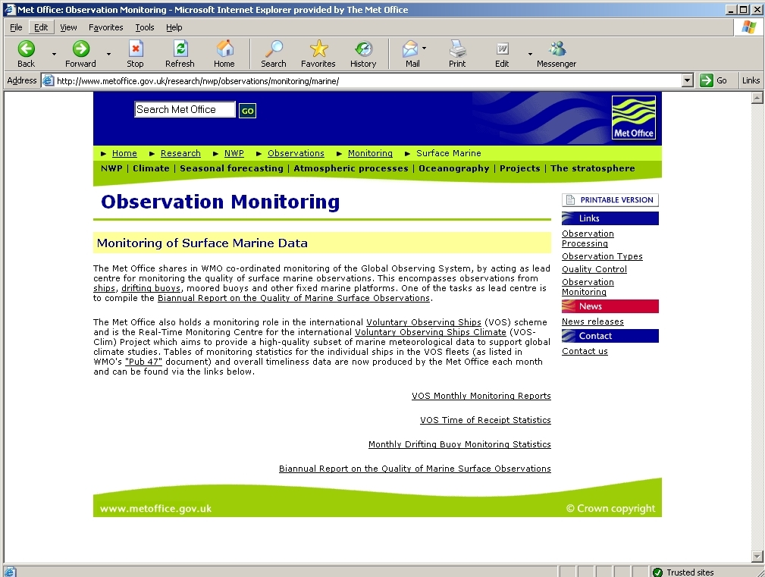

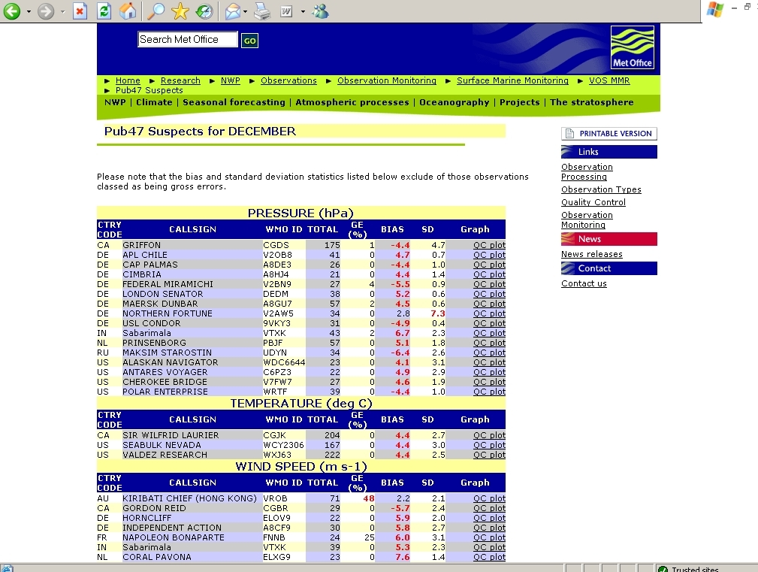

Examples of QC Plots – for Pressure (top) and Humidity (below)

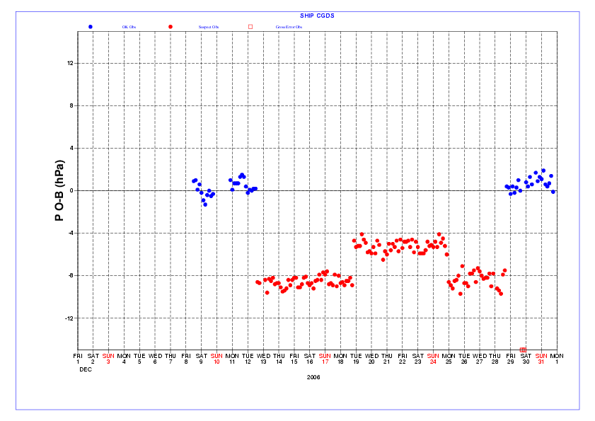

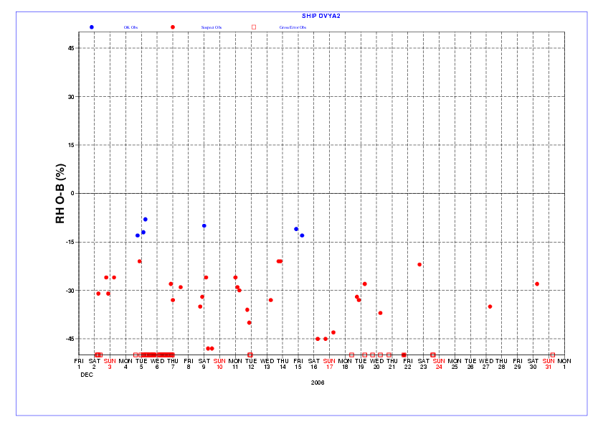
Appendix C

Timeliness of VOS observations received at the Met Office (UK)
Dec 2006

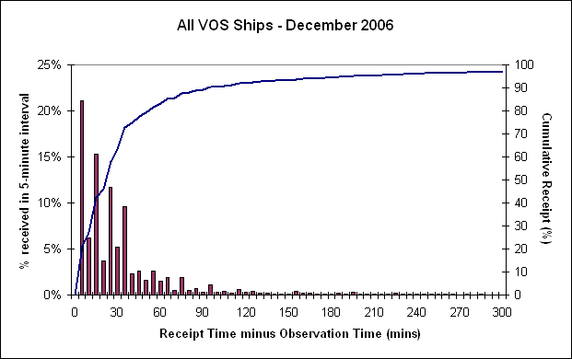

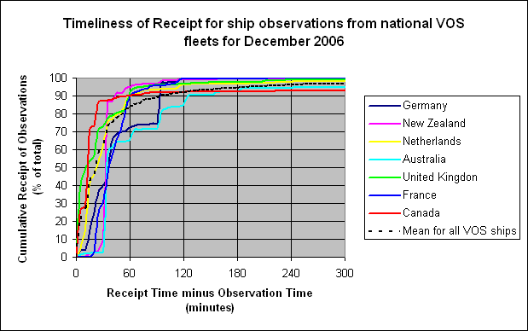

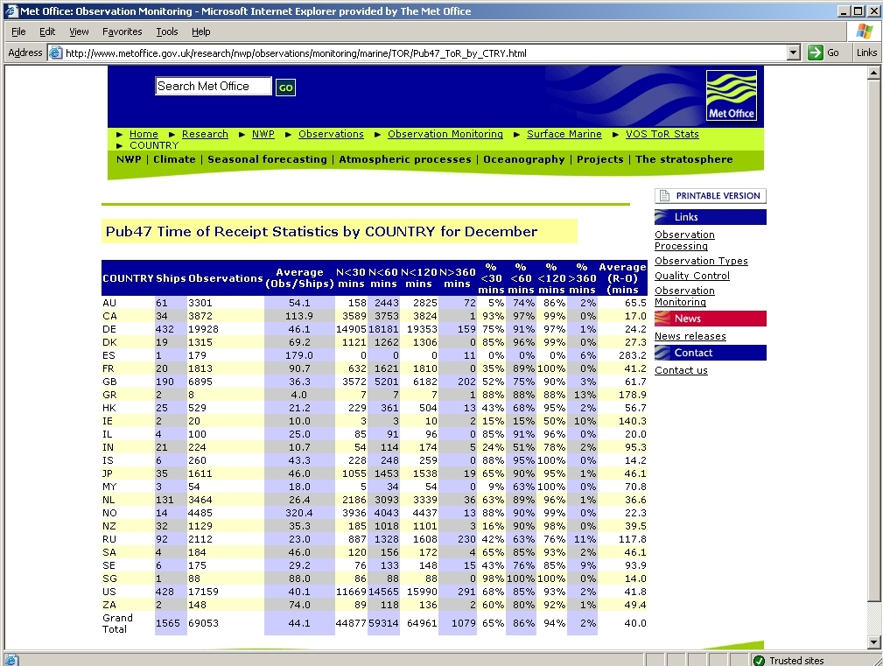

Appendix D

Quality monitoring issues related to masking of ship call signs

- During 2006 several ship call-sign masking systems have been set up, in order to help stop the withdrawal of ships from the VOS fleet over security concerns in having their positions displayed on the internet. However, masking ship identities in meteorological reports can potentially cause problems with the important activity of quality monitoring of individual ships’ weather reports.

- For European ship reports participating in the E-SURFMAR programme a scheme using unique masked call signs has been proposed and is already being used for some ships. Similarly Australia is proposing the use of masked call signs based on a different scheme (built from Australian identification numbers). From a data monitoring view point it will always be preferable to have unique call signs, even if different masking schemes are being used in different parts of the world. The use of the same call sign within two different schemes should therefore be avoided, e.g. there should be no possibility of a clash of call signs between the Australian and E-SURFMAR schemes. Also, monitoring centres will need to have access to a global database of masked call signs located in a single secure repository.

- Japan has set up a non-unique masking system. Ship reports with real call signs are received at their Inmarsat Land Earth Station, where they replace the call sign by the letters ‘SHIP’ and insert the data onto the GTS. Thus GTS users see only the masked ‘SHIP’ reports. JMA is planning to make the original ship data available in near real time on a secure server, from where it can be downloaded via FTP by monitoring centres, who can then discard the GTS ‘SHIP’ data. But this approach relies on the monitoring centres having the necessary infrastructure within their observation processing systems to be able to set this up. At the Met Office, the Message Switching Team will need to set up a system to obtain the data from JMA's server and route it into our meteorological database (MetDB) instead of JMA’s ‘SHIP’ data (RJTD bulletins); the MetDB Team will then need to set up a system to accept and decode the server data and ingest it into the MetDB.

- There is also the risk that other countries may decide to adopt similar schemes to the JMA, and similarly put their data onto dedicated servers. Therefore, if such schemes are adopted more generally, it would be better to have a single secure central server (possibly at JCOMMOPS?) where all countries could place their data and/or their call sign lists.

- In summary, the Met Office (RSMC Exeter) considers that the generic ‘SHIP’ masking solution proposed by JMA will require all monitoring centres to set up special solutions for just the Japanese data (plus more work if other countries adopt similar solutions), which will delay the resumption of the monitoring of the Japanese ship data. In addition to the costs this will incur, it will introduce extra complexity into the system and may have implications for the timeliness of the data being made available. Consequently, the Met Office, as the CBS Lead Centre for the quality monitoring of marine data, would prefer that all countries adopt a masking method similar to that of either E-SURFMAR or Australia, with a unique masked identifier for each ship. Best practice would be to set up an agreed international system of masked call signs.

Appendix E

Monitoring criteria for suspect ships

- For each ship and each variable there should be at least 20 reports during the period (if there are fewer reports the statistics may be unreliable and no action is needed).

- Then, either:

- The number of gross errors should exceed 10% of the number of observation reports (where the observation-background (o-b) limits for individual gross errors are shown in column 4 of the following table); or,

- One of the limits shown in columns 2 and 3 in the table should be exceeded for either:
- the mean value of o-b over the period (absolute value), or
- the standard deviation of o-b over the period

(1)  Variable | (2)  Mean o-b  limit | (3)  Std. Dev. o-b limit | (4)  Gross error  limit
Pressure (hPa) | 2.5 | 5.0 | 15.0
Wind speed (m/s) | 5.0 | 10.0 | 25.0
Wind direction (degrees) | 30.0 | 60.0 | 150.0
Air Temperature (⁰ C) | 2.0 | 4.0 | 10.0
Relative humidity ( % ) | 10.0 | 20.0 | 50.0
Sea surface temp. (⁰ C) | 2.0 | 4.0 | 10.0

- If either of the limits on o-b statistics in columns 2 and 3 are exceeded the project ship's observations will be considered 'suspect' and corrective action will need to be taken (e.g. by the Port Met Officers). Column 4 contains the o-b limits for each ship observation beyond which the observation will be regarded as a 'gross error'.

Appendix F

Monitoring statistics for VOSClim ships for January 2007

Standard of comparison: 6-hour forecast (background) from the Met Office Global NWP Model.

Column headings:

CallSign - Ship's call sign.

NumObs - Number of observations from each ship received during the period of the report.

%GrEr - Percentage of observations with 'gross errors' (excluded from the statistics).

Bias - Mean value of the observation-minus-background (o-b) values.

RMS - Root mean square of the o-b values.

StdDev - Standard deviation (SD) of the o-b values.

Pressure (hPa)

CallSign NumObs %GrEr Bias RMS StdDev

8PNK 17 0.0 1.5 2.3 1.7
9KWH 43 0.0 0.2 0.6 0.6
9KWP 15 0.0 0.2 0.5 0.5
A8CN8 21 0.0 0.6 1.0 0.8
A8ET9 24 0.0 2.0 2.1 0.6
C6IZ7 14 0.0 -1.3 3.0 2.7
C6KD5 51 0.0 -0.7 3.1 3.0
C6KD6 53 0.0 -0.0 1.9 1.9
C6KD7 77 1.3 1.0 2.2 2.0
C6SS3 45 0.0 -0.7 2.0 1.9

CG2958 434 0.0 0.6 1.1 0.9
CGDS 238 0.0 0.5 0.9 0.7
CGJK 233 0.0 0.2 0.9 0.9
CGTF 58 0.0 -0.5 1.2 1.1
DGHX 26 0.0 0.5 1.1 1.0
DGXS 25 0.0 0.2 0.6 0.6
DQVH 46 0.0 -0.1 1.0 1.0
DQVI 27 0.0 -0.8 2.2 2.1
DQVJ 20 0.0 -1.8 2.3 1.5
DQVK 43 0.0 -0.6 0.9 0.7

DQVL 51 2.0 0.4 1.0 0.9
DQVM 36 0.0 -0.6 1.2 1.0
DQVN 63 0.0 -0.5 0.9 0.7
DQVO 8 0.0 -0.1 0.7 0.7
ELXS8 75 0.0 0.3 1.0 1.0
ELXT8 28 0.0 -0.9 1.3 0.9
ELZU8 52 0.0 1.2 1.4 0.7
FNCI 5 0.0 -0.5 0.7 0.5
FNCM 153 0.0 1.2 1.3 0.4
FNJI 109 0.0 0.4 0.8 0.7

GBQM 10 0.0 2.5 3.8 2.8
GBTT 37 0.0 1.0 2.6 2.4
IBPW 25 0.0 1.0 1.3 0.9
JCCX 166 0.0 0.2 0.8 0.8
JDWX 141 0.0 0.0 0.7 0.7
JGQH 307 0.0 -0.1 0.6 0.6
JIVB 204 0.0 0.0 0.6 0.6
JPBN 348 0.0 0.3 0.7 0.6
MHCQ7 31 0.0 -0.1 1.2 1.2
MHMZ8 9 0.0 -1.3 2.1 1.7

MLBB4 15 0.0 0.5 0.8 0.6
MQEC7 52 0.0 -0.2 0.6 0.6
MXBC6 6 0.0 -0.5 1.2 1.1
MXMM5 28 0.0 0.0 0.8 0.8
MYJM3 17 0.0 1.2 2.0 1.6
MYSU5 35 0.0 -0.0 1.6 1.6
MZER8 46 0.0 -0.5 1.1 1.0
MZFC6 39 0.0 0.2 0.6 0.6
MZGK7 19 0.0 -0.3 0.6 0.5
MZIM8 35 0.0 -0.5 1.5 1.4

ONDB 21 0.0 -0.8 1.4 1.1
OVSB2 24 0.0 -0.6 1.4 1.3
OVZV2 19 0.0 0.0 0.6 0.6
OYYK2 16 0.0 -0.3 0.9 0.9
OYYL2 23 0.0 -0.8 1.2 0.9
PCHS 9 0.0 0.1 1.4 1.4
PDHO 48 0.0 -2.7 2.8 0.9
PDHP 11 0.0 0.7 1.1 0.9
PDZS 64 0.0 -0.5 2.1 2.0
PECS 30 0.0 -0.6 0.9 0.7

S6TS 34 0.0 0.4 0.8 0.7
V2FM 21 0.0 0.2 0.9 0.9
VCLM 191 0.0 -0.2 1.2 1.2
VMAL 14 0.0 0.4 3.2 3.2
VNNM 37 0.0 0.4 1.0 0.9
VOCJ 221 0.0 -0.0 0.8 0.8
VQBW2 19 0.0 -0.4 1.1 1.0
VQGB2 26 0.0 0.1 1.1 1.1
VTXG 27 0.0 2.1 2.5 1.3
VTXK 68 0.0 6.5 6.7 1.5

VVGQ 16 0.0 -0.5 1.0 0.9
VVJV 9 0.0 2.0 2.6 1.7
VWNS 9 0.0 0.9 1.6 1.3
VWXG 12 0.0 -0.3 0.6 0.5
WCX8812 39 0.0 -1.3 1.6 0.9
WCX8882 24 0.0 0.6 1.1 0.9
WCX8884 27 0.0 -0.9 1.5 1.2
WFLG 58 0.0 -2.3 2.6 1.3
WNDP 18 0.0 -1.5 2.3 1.8
WRYC 27 0.0 -1.7 1.9 0.9

WRYD 15 0.0 -1.6 2.9 2.4
ZCBD3 27 0.0 1.0 1.3 0.8
ZCBN5 26 3.8 0.2 0.8 0.8
ZCDH7 23 0.0 0.6 3.3 3.2
ZDLP 50 0.0 -0.1 1.0 1.0
ZDLS1 52 0.0 0.2 0.9 0.9
ZNQO3 9 0.0 -0.0 1.8 1.8
ZQAY4 63 0.0 -2.1 2.9 2.0

Appendix G

VOSClim ship suspect list for January 2007

All VOSClim ship data is monitored against background 6-hour forecast fields for all variables except SST, for which analysed fields from the previous day are used.

Key to table below

NumObs : number of observations (obs) from the ship during the month
%GE : percentage of obs with gross errors (for GE limits see below)
StdDvn : standard deviation of obs-background, excluding obs with gross errors
Bias : mean obs-background, excluding obs with gross errors
RMS : root mean square of obs-background, excluding obs with gross errors

Suspect selection criteria for each variable:
at least 20 observations from the ship and one or more of the following:-
%GE > 10%
|Bias| > Bias limit (see below)
StdDvn > StdDvn limit (see below)

Limits: | Press. | Wind Speed / Direct. | Air Temp. | Rel.Hum. | SST |
----------- | (hPa) | (m/s) | (deg) | (deg C) | (%) | (deg C) |
Bias limit | 2.5 | 5 | 30 | 2.0 | 10 | 2.0 |
StdDvn limit | 5.0 | 10 | 60 | 4.0 | 20 | 4.0 |
GE limit | 15.0 | 25 | 150 | 10.0 | 50 | 10.0 |

Callsign Element NumObs %GE StdDvn Bias RMS

PDHO Press 48 0 0.9 -2.7 2.9
VTXK Press 68 0 1.5 6.5 6.7

VCLM Speed 35 11 4.8 4.1 6.3
VTXK Speed 63 0 3.0 7.4 8.0
ZDLP Speed 50 14 2.4 0.5 2.5

CGJK Temp 233 0 1.5 4.1 4.3
PDZS Temp 63 0 2.2 2.3 3.2

CGJK RelHu 233 0 8.8 -10.7 13.8
C6SS3 RelHu 45 0 5.6 12.5 13.7
ELXT8 RelHu 28 0 14.0 20.0 24.4
IBPW RelHu 25 0 7.5 17.1 18.6
PDZS RelHu 62 0 12.6 -13.0 18.1
VOCJ RelHu 221 0 8.2 -10.5 13.3
VTXG RelHu 27 0 9.8 10.0 14.0
ZCBN5 RelHu 25 0 6.1 10.4 12.0

DQVN SST 65 0 0.6 2.1 2.2
VOCJ SST 39 0 2.4 3.3 4.1

Appendix H

BUFR Code Template

CALL_SIGN
LTTD
LNGD
YEAR
MNTH
DAY
HOUR
MINT
COLTN_CNTR
BLTN_IDNY
MSL_PESR
SRFC_WIND_SPED_RCRDG_IDNY
SRFC_WIND_DRCTN
SRFC_WIND_SPED
SRFC_WIND_U
SRFC_WIND_V
SRFC_AIR_TMPR
WET_BULB_RCRDG_IDNY
WET_BULB_TMPR
SRFC_DEW_PONT_TMPR
SRFC_RLTV_HUMDY
HRZL_VSBLY
CRNT_WTHR_TYPE
PRMY_PAST_WTHR_TYPE
TOTL_CLOD_AMNT
LWST_CLOD_AMNT
LWST_CLOD_BASE_HGHT
LOW_CLOD_TYPE
MEDM_CLOD_TYPE
HIGH_CLOD_TYPE
Q3HOUR_SHIP_DRCTN
Q3HOUR_SHIP_SPED
SEA_SRFC_TMPR_RCRDG_IDNY
SEA_SRFC_TMPR
BCKD_YEAR
BCKD_MNTH
BCKD_DAY
BCKD_HOUR
BCKD_FRCT_LNGH
MODL_SRFC_TYPE
MODL_SRFC_HGHT
BCKD_MSL_PESR
BCKD_SRFC_WIND_U
BCKD_SRFC_WIND_V
BCKD_SRFC_AIR_TMPR
BCKD_SRFC_RLTV_HUMDY
BCKD_SEA_SRFC_TMPR

