WORLD METEOROLOGICAL ORGANIZATION  ________________________ | INTERGOVERNMENTAL OCEANOGRAPHIC  COMMISSION (OF UNESCO)  ________________________
JOINT WMO/IOC TECHNICAL COMMISSION FOR OCEANOGRAPHY AND MARINE METEOROLOGY (JCOMM)  SHIP OBSERVATIONS TEAM  FOURTH SESSION  GENEVA, SWITZERLAND, 16 TO 21 APRIL 2007 | SOT-IV/Doc. I-5.3  (15.II.2007)  __________  ITEM I-5.3  Original: ENGLISH

Support Infrastructure

WMO Information System (WIS) and GTS Issues

(Submitted by the Secretariats)

Summary and purpose of document

This document provides information on the WMO Information System and its development.

ACTION PROPOSED

The Ship Observations Team is invited to:

- Note and comment on the information contained in this document, as appropriate;

- Take into account the contents of the report when discussing relevant agenda items.

______________________

Appendices: A. WIS-related Pilot Projects

B. Frequently Asked Questions

DISCUSSION

The WMO Information System (WIS)

Background

Data, comprising in-situ and remote-sensed measurements and observations, as well as value-added information derived there from, is the foundation on which our knowledge of the environment // is built. Data exchange systems and data management practices ensure effective and efficient international use of the data regardless of location or language. Nearly all programmes collect data, transmit data to one or more processing centres, perform quality control, generate products, transmit products to users, and archive data and products for future use.

Already near the end of the 1990’s, it became apparent that the various WMO Programmes either had their own information systems, or were in the process of developing them independently of each other. The resulting multiplicity of systems and practices has since then generated incompatibilities, inefficiencies, duplication of effort and higher overall costs for Members. Continuing uncoordinated development would exacerbate these problems and further isolate the WMO Programmes from each other and hinder the information exchange of a wider international user community. Therefore, the Commission for Basic Systems (CBS) developed the concept of an overarching, integrated WMO Information System (WIS) that would meet the requirements for data exchange of all WMO Programmes, affiliated international organizations and programmes, as well as relevant national non-NMHS users such as disaster prevention and mitigation agencies and research facilities.

The Fourteenth World Meteorological Congress (Cg-XIV, 2003) approved this approach. The Fifty-sixth Session of the WMO Executive Council (EC-LVI, 2004) set up a high-level coordination mechanism, involving all WMO technical commissions to ensure the orderly, coordinated evolution of the WIS. The Fifty-seventh Executive Council (EC-LVII, 2005) identified the WIS as a major contribution of the WMO to the GEOSS // with respect to data exchange and management services.

In the aftermath of the December 2004 Tsunami catastrophe, relevant international organizations and Governments underpinned the importance of the WIS (and its current precursor, the WMO Global Telecommunication System (GTS)). The WIS was seen as the 24/7 operational backbone network for the exchange of information in support of multi-hazard, multi-purpose natural disaster early warning systems.

The EC-LVII (2005) decided to expedite the development of key components of the WIS with a view to beginning implementation, at least in some countries, in 2006 instead of 2008, as originally planned.

WIS concept

The main functional components of WIS are as follows: National Centres (NC), Data Collection or Product Centres (DCPC), Global Information System Centres (GISC) and data communication networks connecting the components. The terms are used for describing the necessary functions, not actual organizational entities. There may be organizations, such as NMHSs, which combine all three functions within their structure.

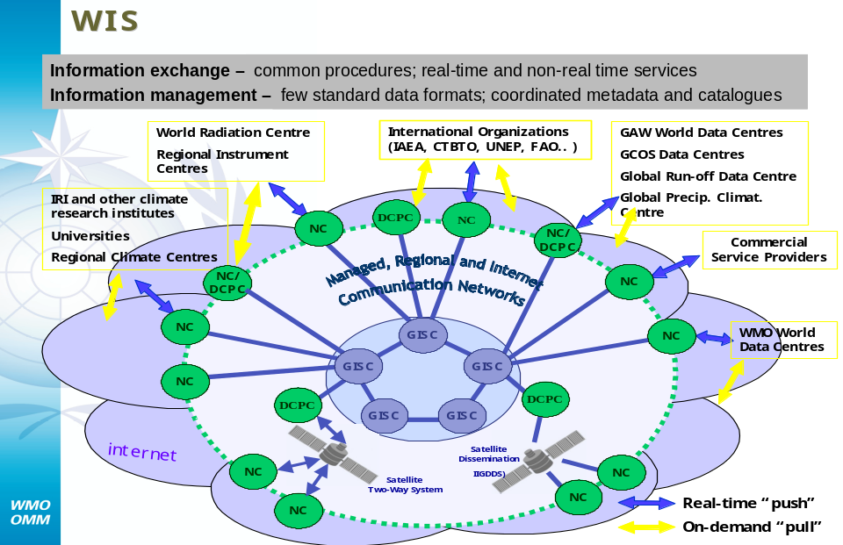

Fig. 1: Functional Structure and User Community of the WIS

The WIS will be based on an improved GTS and integrate satellite two-way systems, alternative dissemination services provided by environmental satellites and the coordinated and free use of the Internet. The WIS architecture (functions and services) will provide a solution for the information exchange needs of the NMHSs, and other national centres (NCs), such as relevant non-NMHS agencies/users, national disaster management platforms, research facilities, and international programme centres. The WIS will offer:

- Routine collection and automated dissemination of operation-critical data (e.g., meteorological, climatological, environmental and hydrological observations, forecasts and warnings), (“GTS function”);
- Timely delivery of high-volume data and processed products (“push”);
- Ad-hoc discovery/access/retrieval services for operation-critical data and value-added information (“pull”);
- Discovery, access, and retrieval services for all data stored by every WMO programme regardless of location;
- Common procedures for real and non-real time data exchange and standardized data formats and metadata.

NC (National Centre)

As is the case in the current GTS of the WMO, the WIS also requires a reliable national centre, generally referred to as “NC”. The NC, operated by the NMHS, is responsible for collecting and distributing observational data and products on a national basis and for providing those data intended for global or regional distribution to their responsible GISC or DCPC. The NC, operated by a NMHS, would normally also coordinate and authenticate access of the other eligible national centers (users). If so decided by the national policy (normally by or through the Permanent Representative of the country with WMO), more than one NC can exist within a country. Globally, there are currently 187 NCs (i.e., one per Member country or territory) and it is anticipated that approximately 150 additional NCs, will be part of the WIS infrastructure.

DCPC (Data Collection and Production Centre)

Centres that fulfill an international responsibility for the generation and provision of international data distribution, forecast products, processed or value-added information, and/or provide archiving services within specific WMO programmes are referred to as Data Collection and Production Centres. The DCPCs also provide basic WIS functions such as metadata catalogues, Internet portals and data access management. Examples of DCPCs are the Regional Specialized Meteorological Centres (RSMC) with activity specialization or geographic specialization, as well as the Regional Climate Centres, the Hadley Centre (United Kingdom), ACMAD, the World Data Centres in Asheville (North Carolina, USA), Obninsk (Russian Federation), the EUMETSAT and the NESDIS. In total, it is expected that approximately 150 centres are to perform DCPC functions.

GISC (Global Information System Centre)

The regional and global connectivity of the WIS structure is guaranteed by the existence of a small number of node centres called Global Information System Centres (GISC). There will be less than ten in total, whose combined areas of responsibility will cover the whole world. These nodes collect and distribute information meant for routine global dissemination, and in addition, serve as collection and distribution centres in their areas of responsibility and provide entry points for any request for data held within the WIS. Similar to the DCPCs, the nodes maintain metadata catalogues of all information available within the WIS and provide a portal for data searches. This service will greatly facilitate data searches by researchers.

Network structure

The data communication network connecting the various parts of the WIS is based on an agreed technology that is commonly available to the participating centres. This network is capable of handling the foreseen traffic. There are satellite communication channels as well as terrestrial links or managed data network services. Generally, TCP/IP is the preferred transmission protocol, but other agreed protocols would be possible, and the WIS is capable of adjusting to any evolving international protocol according to the technological progress. While the WMO code formats will be used for real-time exchange of operation-critical data, the user will be able to select from a wide variety of optional data representation formats. Metadata information should be available in a standard format (e.g., XML). The current diversification of access points and methods would be replaced by a common approach. Furthermore, the portal structure provided by the WIS would make it possible for programmes to present their data to their users in a programme specific query format.

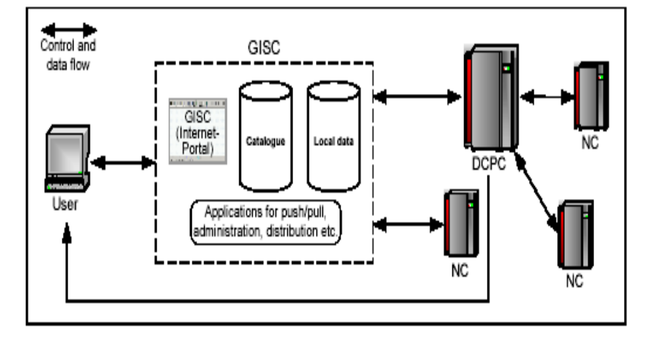
Fig.2: Structure of the WIS

The GTS is being further improved and will evolve into the core network of the WIS. Based on international ICT standards, the WIS will facilitate the coordinated real-time data collection and dissemination service of operation-critical data. In addition, the WIS will provide coordinated “push-pull” services and the information discovery, access and retrieval needs of all WMO and relevant co-sponsored international programmes, as well as eligible non-NMHSs users at a national level. Through the role of the NMHS’s NMC as an NC, the WIS will enhance the visibility and importance of the NMHS in the country. The NMHS gains timely and cost-effective access to information, in particular new data and products, which will enhance its own operations. The National Meteorological Centre (NMC) will also be able to provide other relevant national agencies/users (such as research, disaster mitigation, agriculture, energy and water management) WIS services, in accordance with national policy and practices, and facilitate access to new information that was, in so far, not available to them. Upon agreed operating criteria, the NMC can “push” routine information to said agencies/users (e.g., warnings, advisories, forecast products, selected observations, etc.). By introducing homogeneous formats for data and metadata, the WIS will help users to search, discover and retrieve all sorts of data sets. It will also service information delivery to users, either in the “pulling” mode, or as reply to ad hoc non-real-time request.

By using industry standards, off-the-shelf hardware and software, including open source software, the WIS is a cost-effective solution for all Members and their NMHSs. This means that the initial investment is determined by the cost of PCs and Internet, VPN and VSAT connections, and IGDDS receiving stations, as required. Whether there might be an additional financial burden on the NMC or not will depend on how the national network is organized. There will be no additional cost if “other” NCs (i.e., non-NMHSs national users), are directly connected to the WIS Network Service Provider, as their data would then not flow through the NMC circuits.

The WIS complies with the WMO data policy Resolution 40 (Cg-XII) and Resolution 25 (Cg-XIII)), and its flexible design can follow an evolution of the WMO data policy. In particular, the handling of essential and additional data and products with respect to Resolution 40 (Cg-XII) will be unchanged. Procedures for managing access rights, control of data retrieval, registration and identification of users, etc., can be defined as and when required. Anonymous downloading is technically possible, but depends on whether a NC permits this feature. The WIS has no system-inherent features that would defy international legal frameworks, laws, conventions, copyrights, or patents.

WIS and the Integrated Global Data Dissemination Service (IGDDS)

The IGDDS is both a system and a project.

- The IGDDS, as a system, is the circulation scheme of space-based observation data and products for WMO programmes. The IGDDS concept was initially proposed by the WMO satellite user expert groups and refined by satellite operators within the CGMS. Since the WMO has defined the concept of a WMO Information System (WIS) as an overarching framework for all its data exchange and management; the IGDDS is one of the components of the WIS.

- The IGDDS, as a project, is the set of activities directed towards the definition and operational implementation of the IGDDS system.

Main functions of IGDDS

The following main functions need to be fulfilled for space-based observation data and products:
- Data acquisition. Raw data are acquired from satellites, higher-level data, or products are acquired from product generating centres, and foreign satellite data or products are acquired at an inter-regional scale from re-transmitting centres.

- Data dissemination. Routine near-real time dissemination (PUSH-mode) is a core component of the IGDDS. This relies on Advanced Dissemination Methods (ADMs), on point-to-point message distribution through the GTS and on Direct Broadcast from the meteorological satellites.

- Data access on request: This includes access to data catalogues and metadata. It allows data discovery and delivering data on request (PULL-mode) to authorized users.

- Data and user management. This includes a number of services such as running a Rolling Requirements Review process, maintaining an interoperable catalogue, ensuring service quality, and administering a user database and providing user support.

From a user’s point of view, the IGDDS system is fully integrated into the WIS, since space-based observation data are an integral and central part of meteorological observation data used for the WMO operational and research activities. Moreover, when dealing with “products” (i.e., higher-level processed data), the distinction between space-based and in situ data becomes less relevant, in particular when observation data are merged and analyzed through assimilation models.

This implies that the IGDDS system should rely on the same data distribution capabilities and mechanisms as other components of the WIS, unless there are particular needs or advantages to use specific solutions.

For example, the high data rates required to routinely disseminate satellite imagery has driven the use of cost-efficient, scalable, systems such as Digital Video Broadcast by telecommunications satellites (DVB-S), which are designated within the WMO Space Programme as Advanced Dissemination Methods (ADM). However, there is evidence that these techniques are not used exclusively for dissemination of space-based data and products. They are used by the WMO Members to distribute non-space-based information. In most instances, space-based and non-space-based information are sharing the same support.
Reciprocally, while the point-to-point GTS is massively used to transmit conventional (non-satellite) data, it also supports the transmission of essential space-based products such as satellite soundings or atmospheric motion vectors.

WIS and GEO-Netcast

The GEO-Netcast is an initiative led within the GEO framework by EUMETSAT, NOAA and the WMO to address the global dissemination needs of the GEOSS environmental data in a coordinated way. The GEO-Netcast concept is to use the multicast capability of a global network of communications satellites to transmit environmental satellite and in situ data and products from providers to users within the GEO. Commercially available technology provides cost-efficient solutions with easy to implement terminals, which are widely used for “Direct to Home” digital television. The multicast capability allows different data sets to be handled in parallel regardless of the source. The use of a key access capability enables to respect the data policy of each data provider and to target the distribution at individuals or groups of users, as appropriate, within the footprint of each satellite. The GEO-Netcast builds on the experience gained by the EUMETSAT with the EUMETCast operational dissemination system and on the WMO IGDDS concept. It proposes to expand this approach in order to establish a true global dissemination system responding the needs of all the nine GEO societal benefit areas.

Implementation

The implementation of the WIS builds upon the most successful components of existing WMO information systems, and a smooth and coordinated transition is crucial. The concept of the WIS requires development of the following major functions and the necessary software packages:

- Metadata catalogues;
- Internet portal;
- Data acquisition service;
- Data discovery service;
- Data distribution service: push and pull;
- Monitoring;
- Operational aspects like data synchronisation, back-up, administrative issues, etc.

To that end, valuable work is already being undertaken by various pilot projects under the auspices of WMO Technical Commissions and other relevant Programmes:

- JCOMM: GISC-E2EDM prototype (Obninsk, Russian Federation);
- CBS: VPN Pilot Project in RAs II and V;
- CCl: CliWare (Obninsk, Russian Federation);
- EUMETNET: UNIDART project (Uniform data request interface);
- CBS: RA VI – Virtual GISC project;
- CAgM: WAMIS (World Agrometeoroloigcal Information Service, Republic of Korea); and
- CAS: THORPEX/TIGGE (THORPEX Interactive Grand Global Ensemble).

A summary description of the goals and functions of each of these pilot projects is provided in Appendix A. of the document

In certain countries, it is now possible to achieve a smooth transition from the current GTS-based systems to the new WIS structures running in a semi-operational mode. The following requirements have to be met by participating Members to bring this ambitious goal to realization:

  - Reference implementation WMO Core Profile version of metadata;
  - Integration of metadata structures into pilot GISCs and DCPCs;
  - Internet portal;
  - Basic data acquisition using metadata;
  - Data discovery service;
  - Agreement on specification of data access rights;
  - Data distribution service: push and pull;
- Exchange of monitoring information in agreed format.

The pilot projects are expected to become semi-operational and gather valuable experience with the WIS concept. The newly created GISCs will implement the planned global data exchange. . As a next step, various DCPCs are expected to offer their data for access, and ease the data discovery and retrieval burden for the related Programmes. Furthermore, the WMO Programmes should extend the metadata catalogue held in the GISCs by bringing in their own special data requirements, and use the WIS features to disseminate their products. In this way, the enhanced functions provided by WIS will be gradually introduced and expanded from 2006 onwards.

The Technical Conference on the WMO Information System (TECO-WIS, Seoul, Republic of Korea, 6-8 November 2006), immediately preceded CBS-Ext. (06). The TECO-WIS programme included an actual demonstration of the V-GISC and DCPC prototypes, which were expected to lead to a pre-operational implementation in the near future. The TECO-WIS noted, with much appreciation, the progress made in the development of the V-GISC project, including the SIMDAT project, through the demonstration system that currently supported the discovery and retrieval of datasets and associated metadata cross-cutting different WMO programmes from several NMSs and International Centres, including: DWD, Météo-France, UK Met Office, ECMWF, EUMETSAT, NCAR and NODC. The TECO-WIS reviewed Metadata developments, Information and Communication Technology building blocks and Pilot & Prototype projects. The TECO-WIS programme also included presentations from various stakeholders, including: CAS, CAgM and WMO NDPM Programmes, and from the Information & Communication Technology (ICT) industry. The TECO-WIS noted with appreciation, the significant progress made in the development of the WIS, through the active participation and efforts of the increasing number of NMHSs and the participation and contribution of several WMO Programmes and Technical Commissions, including THORPEX, IPY and JCOMM.

The sixth CBS Extraordinary Session (CBS-Ext. (06), Seoul, Republic of Korea, 9-16 October 2006), recognized that a realistic target date for the start of operation of at least one GISC and several DCPCs was mid-2008.

The CBS-Ext. (06) emphasized that the WIS implementation should be carried out in two phases that would be developed in parallel:

- WIS implementation Phase A was the continued consolidation and further improvements of the GTS for time-critical and operation-critical data, including its extension to meet operational requirements of WMO Programmes in addition to the World Weather Watch (including improved management of services);

- WIS implementation Phase B would provide for an extension of the information services through flexible data discovery, access and retrieval services to all users, as well as flexible timely delivery services.

The CBS-Ext. (06) recognized the good progress that has been made in demonstrating the technological solutions for the WIS, but emphasized that much work remains to be done before an operational version of the WIS can be realised in the WMO community. The CBS-Ext. (06) was pleased to learn that the establishment of a full-time WIS Project Manager, was also making good progress, with the foreseen contribution from a Member through expert secondment, which has been confirmed.

Outlook

A concerted effort by the WMO Members that crosscuts over related WMO Programmes and integrates their information exchange needs is currently being pursued to reach these goals. In this regard, the WMO Executive Council stated in 2003: “The support and involvement of regional associations and technical commissions [are] needed, as early as possible, in all phases of the WIS development in order to ensure a full and shared ownership of the project, and its effective implementation.”

Furthermore, industrial involvement and effective project coordination are crucial. A cross cutting activity has been launched and a WIS Coordination Office has been established in the Secretariat, which should proactively work towards reaching the following major goals by the end of 2008: (i.) Enhancement of awareness and knowledge on WIS functions and services with emphasis on the non-WWW-affiliated user communities and partner agencies, (ii.) strengthening the WIS coordination with other relevant international organizations and programmes, and (iii.) preparing developing countries for their participation in WIS through a specific outreach programme. The Office should also act as a liaison to the industry to channel relevant information. It will also facilitate that all sessions of the Technical Commissions and Regional Associations that are held in 2006 to 2008, will receive special briefings and documents on the WIS. Finally, at the Technical Conference that was held in connection with the CBS-Ext.(06) Session (November 2006), the WIS conceptual functions and services have been further developed and the status of the implementation reviewed.

JCOMM perspective

The CBS-Ext. (06) agreed upon recommended governance procedures, in principle, for the designation of the Global Information System Centres (GISC) and the Data Collection or Production Centres (DCPC). According to these procedures, the relevant Technical Commissions are expected to consider the service offers by potential DCPCs under their respective WMO Programmes, and to endorse their programmes’ candidate DCPCs for submission to the ICG-WIS, CBS and then to the Executive Council. The Session invited each TC to establish a process for identifying potential DCPCs under the IMOP Programme, and for endorsing relevant candidate DCPC for submission to the ICG-WIS, CBS and then to the Executive Council.

CBS-Ext. (06) urged WMO Technical Commissions and other bodies representing the participating programmes to state their requirements for WIS services.

The JCOMM Data Management Coordination Group, at its Second Session (DMCG-II, Geneva, Switzerland, 10-12 October 2005), agreed that there was a need to bring more centres into the JCOMM End-to-End Data Management (E2E). The requirements for being accredited as a WIS DCPC were formally discussed. An important requirement is to ensure that a candidate for the DCPC would provide for interoperability and appropriate interface to the WIS, while meeting the Technical Commission’s requirements. Therefore, the Technical Commission’s endorsement for the candidate was required as well. The DMCG will prepare a checklist for candidate centres for review and adoption by the Nineteenth Session of IODE (IODE-XIX, Trieste, Italy, 12-16 March 2007). The NODCs attending the IODE meeting will have opportunities to review and comment, as appropriate.

_____________

Appendices: 2
APPENDIX A

WIS-related Pilot Projects

- JCOMM GISC-E2EDM prototype (Obninsk, Russian Federation);
- CBS VPN Pilot Project in RAs II and V;
- CCl CliWare (Obninsk, Russian Federation);
- EUMETNET UNIDART project (Uniform data request interface);
- CBS RA VI – Virtual GISC project;
- CAgM WAMIS (World Agrometeoroloigcal Information Service, South Korea);
- CAS THORPEX/TIGGE (THORPEX Interactive Grand Global Ensemble).

JCOMM GISC-The E2EDM system is a “virtual marine data centre” involving product generation, assembly, archiving and collection, based on the best data management practices. Included are: Grid technology metadata management concept, DiGIR (OBIS) request/response protocol database access service, OPeNDAP (NetCDF) format for “transport” data files, utilities for coding/encoding data, ESIMO (Russia) data model, navigation services, data search mechanism and visualization tools, data file access service, NercDG object segmentation ideology, Sea Sea-Search CDI (Common Data Index), WMO Core Search CDI (Common Data Index), WMO Core Metadata and the E2EDM Global XML Schema.

E2EDM “End-to-End Data Management” prototype (Obninsk, Russian Federation);

CCl CliWare (Obninsk, Russian Federation);
CliWare is an information system for climate data providing a 24/7 operational-mode via the public Internet. Included are formats such as MeteoXml, HTML, text tabulated data, graph images, GML features, Map coverage, Geo images, and WMO FM codes. CliWare retrieves requested data from its database and generates an output data set in the requested form and format. To dissemination service can use HTTP (request reply method), WMO FTP (request reply method), SMTP (push method by e-mail) and SMS (push method by cell phone).

CAgM WAMIS (World Agrometeoroloigcal Information Service, Republic of Korea)
CAgM established a Web portal called WAMIS. Participating countries are Italy, Republic of Korea and the USA. It provides an extension of WIS functions and services tailored to meet the needs of the agrometeorological community. This includes databases, simulation models, and tools for GIS.

CBS–coordinated Regions II/V Pilot Project on Internet Virtual Private Network (Internet-VPN)
Led by Japan, this project conducts a feasibility study by simulating several of the technical requirements and functions required in WIS. The project. 11 countries participate. The study has already demonstrated the feasibility of using Internet-VPN in WIS; further studies will address simplified VPN techniques suitable for very small National Centres, encryption, authorization, privilege levels and authentication for security of data; the ability of a NC to enter its observational data directly through the system (with conversion to BUFR and generation of necessary metadata), the capability for an NC to request data such as satellite imagery or NWP output suitable for display under SATAID ^{[1]}, interfaces to other projects such as VGISC and UNIDART in Europe.

EUMETNET UNIDART project
UNIDART (UNIform DAta Request InTerface) is a Data Communication Programme that services data requests between users and meteorological data centres. The programme will be implemented as a Web portal application where registered users can log on and access the data stored in more than one data centre. The data access will further be under the control of each data centre. Participants are Finland (FMI), Norway (DNMI), the Netherlands (KNMI), the UK Met Office and Météo-Swiss and Germany (DWD).

CBS RA VI – Virtual GISC project
The basic task of a GISC is the control of global data exchange using WMO - and Internet standards in the data transmission. The project demonstrates that a GISC can consist of a number of regional GISC partners, which are linked to a virtual VGISC. A VGISC provides a uniform external interface to the user and appear to the user as one centre. Special synchronisation and control functions are needed for this purpose. As a result of such “parallelization” the performance and availability of the overall system is increased, the data traffic is better distributed and the computer cost of the individual partner centres is lower. Backup increases the operational resilience because the other partners take over in case of failure. The user communicates with a VGSIC in the same way as with a GISC using Web browser, FTP and e-mail. By end-2006, the NMHSs of Germany, France and the UK will form a VGISC and ECMWF, EUMETSAT and centres in RA II, IV and V interconnect.

TIGGE: THORPEX Interactive Grand Global Ensemble
Currently (2006), this global multi-model ensemble system consists of three models (CMA, ECMWF and NCAR). It is expected to be distributed over a number of repository sites and offer the user transparent and efficient access to the products. The challenge with respect to data exchange and management is formidable and important insights are expected from this project as regards the required operational capabilities of WIS.

---------------------------
[1] SATAID is a satellite data presentation software package provided by JMA

APPENDIX B

FREQUENTLY ASKED QUESTIONS

What is the relationship between the WIS and GEOSS//?

EC-LVII (2005) identified that WIS as WMO’s contribution to the GEOSS with respect to data exchange and management services. The WMO will work through the established governance and coordination mechanisms of GEO to coordinate the integration of the WIS into the GEOSS as the global information exchange network for data related to weather, climate and water. GEO has been invited to participate in the WIS planning and implementation activities of the WMO. In addition, GEO has started plans for the GEO-NetCast, a service for broadcasting GEOSS data from communication satellites. Coordination between GEO and WMO will ensure that the components, functions and services of the WIS and GEO-NetCast are complementary, interoperable and cost-effectiveness.

Will WIS include Internet connectivity?

The WIS will be based on an improved GTS, which integrates virtual private networks, satellite two-way systems, dissemination services provided through environmental satellites, and the coordinated and free use of the Internet. The WIS functions and services will offer the following services:
- Routine collection and automated real-time dissemination of operation-critical data (e.g., meteorological, climatological, environmental and hydrological observations, forecasts, and warnings), (“GTS function”);
- Timely delivery of high-volume data and processed products (“push”);
- Access/retrieval services for operation-critical data and value-added information (“pull”);
- Ad hoc discovery/access/retrieval services for all data stored by every WMO programme regardless of location;
- Common standards and procedures for real and non-real time data exchange, data formats, metadata, and metadata catalogues.

The real-time information exchange with guaranteed data delivery relies on the GTS and its procedures and protocols. Ad hoc discovery/access/retrieval services will be made available over the Internet. Some retrieval services, for instance for large volume data sets, may be provided through satellite broadcast services.

How will the NMHSs of developing countries connect to WIS?

At present, the physical connection would be achieved through the GTS and the Internet. The type of GTS connection depends on the specific situation of a country, and does not necessarily need to be changed (e.g., leased circuits, connection to a virtual private network, satellite links). The Internet connection with specific browser/portal software is required for the additional WIS services. As of today on the GTS, the NMHS will be the National centre of the WIS, and will as such, be responsible for collecting and distributing observational data and products on a national basis and for providing those data intended for global or regional distribution to their responsible GISC or DCPC. In the current GTS, this is the RTH. The NMHS would normally also coordinate and authenticate access to the WIS of the other eligible national centers (users). The WIS will enhance the visibility and importance of the NMHS in the country. The National Meteorological Centre (NMC) will also be able to provide other relevant national agencies/users (such as research, disaster mitigation, agriculture, energy and water management) WIS services in accordance with national policy and practices and facilitate for them access to information that was, so far, not available to them. Upon agreed operating criteria, the NMC will “push” to them routine information (e.g., warnings, advisories, selected measurements, etc.), and help discover, select and channel relevant information to the users, either ad hoc, in the “pulling” mode, or in reply to a non-real-time request.

Will the WIS improve access to needed data and products, in particular in developing countries?

The WIS will improve the real-time services of the GTS. This will, in general terms, increase the availability of data on the GTS and benefit each county. The NMHS will gain timely and cost-effective access to information, in particular new data and products, which will enhance its own operations. Examples are value-added information and data sets related to climate and the environment, as well as satellite data and derived products. Specifically with respect to specialized NWP products related to short-term, high-impact weather forecasting and disaster prevention, more data will be made available more timely, which are particularly valuable for tropical cyclone forecasting and warning. In addition, the WIS will offer new services for discovery/access/retrieval via the Internet for all data stored in any centre participating in the WIS, irrespective of its geographic location. Examples are interdisciplinary data (oceanography, seismology, geology, hydrology, and civil engineering) needed for disaster mitigation and prevention work. This will enable the NMHS and other relevant institutions in DCs and SIDS to obtain of wealth of new data that could enhance their activities and contributions to sustainable development, environmental protection, civil engineering, etc.

What is the WIS timetable and when do Members need to become involved in WIS development and implementation?

The Fourteenth World Meteorological Congress (Cg-XIV, 2003) approved the concept of the WIS. In the aftermath of the December 2004 Tsunami catastrophe, relevant international organizations and Governments underpinned the importance of the WIS (and its current precursor, the WMO Global Telecommunication System (GTS)). The WIS was seen as the 24/7 operational backbone network for the exchange of information in support of multi-hazard, multi-purpose natural disaster early warning systems. The Fifty-seventh Executive Council (EC-LVII (2005)) decided to expedite the development of key components of the WIS with a view of beginning implementation, at least in some countries, in 2006 instead of 2008, as originally planned. Subsequently, under the overall coordination of the Inter-commission Coordination Group on WIS (set up by the EC), the CBS in close collaboration with the other technical commissions have stepped up the pace of development, within the resources available in the WMO. Several Member countries have engaged in developing and implementing a series of demonstration projects. It is expected that some of these demonstration projects will transit from test to operational status in 2006, for example the virtual GISC (integrating Exeter, United Kingdom, Offenbach, Germany, and Toulouse, France) in RA VI. With the framework of, and led by the Regional Working Groups on Planning and Implementation of the WWW, Members should immediately set up a mechanism for developing and coordinating the regional and national plans and requirements, including the definition of the WIS role of the regional programme centres, so that WIS software developers can integrate the specificities of the centres in the WIS portals and other software package, metadata catalogues, products lists, etc.

What costs are involved? What are the strategies to assist DCs/SIDS?

By using industry standards, off-the-shelf hardware and software, including open source software, the WIS is a cost-effective solution for all Members and their NMHSs. This means that the initial investment is determined by the cost of PCs and Internet, VPN and VSAT connections, and the IGDDS receiving stations, as required. Whether there might be an additional financial burden on the NMC or not, will depend on how the national network is organized. There will be no additional cost if, ”other” NCs (i.e. non-NMHSs national users), are directly connected to the WIS Network Service Provider, as their data would then not flow through the NMC circuits.

In the framework of the Action Plan for Enhancement of WIS Development and Implementation, which was launched by the Secretariat, a developing country outreach programme, intended primarily, but not only for their NMHSs, is being developed, which should ensure that all DCs will be enabled to effectively participate in the WIS. It is expected that the VCP, bilateral and multilateral WIS projects will be set up, which will provide assistance in capacity building, including training. The WMO will also pursue options to mobilize assistance from other international organizations or coordinate telecommunication projects sponsored by them, with a view to make them WIS interoperable. An example is the Indian Ocean GTS upgrade, funded by the UN and some donor countries as contributions to the Tsunami Early Warning System.

Will WIS contribute to narrowing the digital divide?

Normally, the NMHS will play a leading role in the country as administrator for other national centres (users) access to the WIS. The WIS will offer to all relevant user communities and disciplines (such as research, disaster mitigation, agriculture, energy and water management) access to a wealth of new data. This will be further enhanced through the eventual interoperability with the GEO-Netcast. Increased knowledge in ICT and a broader use of geo-data will result from this, which will enhance sustainable development and narrow the digital divided.

Will activities for improving data and product availability to developing countries need to continue to be done in parallel with the WIS implementation?

All efforts carried out by the various WMO Programmes to increase the availability of data and products are important and need to be continued. The WIS will offer information communication and data management services, but the generators and users of specific data are and remain the experts who need to decide in which way WIS should be employed to that their goals are fully met. It should be noted that the key elements of a network are not the computers, but the people who know how to use them to their benefit.

3 July 2006

_____________

Environment in the context of WMO comprises phenomena of weather, climate and water
Global Earth Observation System of Systems (GEOSS)
Global Earth Observation System of Systems (GEOSS)

