WORLD METEOROLOGICAL ORGANIZATION  ________________________ | INTERGOVERNMENTAL OCEANOGRAPHIC  COMMISSION (OF UNESCO)  ________________________
JOINT WMO/IOC TECHNICAL COMMISSION FOR OCEANOGRAPHY AND MARINE METEOROLOGY (JCOMM)  SHIP OBSERVATIONS TEAM  FOURTH SESSION  GENEVA, SWITZERLAND, 16 TO 21 APRIL 2007 |  |  | SOT-IV/Doc. I-3.2  (15.II.2007)  __________  ITEM I-3.2  Original: ENGLISH

Report ON Associated Programmes and Requirements for Ship-Based Observations

Report by Associated Programmes

(Submitted by the Secretariats)

Summary and purpose of document

This document includes reports from associated programmes or projects, including a report of the International Ocean Carbon Coordination Project (IOCCP) and its relationship with the SOT; a report of the Shipboard Automated Meteorological and Oceanographic System (SAMOS); a report on GODAE High Resolution SST Pilot Project (GHRSST); a report on the Ferrybox Project; a report on the SeeKeepers Society; and a report on the Alliance for Coastal Technologies (ACT); a report on a proposed Scientific Committee on Oceanic Research (SCOR) Panel on the use of merchant marine vessels for instrumented oceanographic surveys, and its potential relationship with the SOT; the Scholar Ship programme. Feedback will be requested from the SOT on areas of common interest and potential common actions.

ACTION PROPOSED

The Ship Observations Team is invited to:

- review and comment on the activities of the associated programmes;

- take their recommendations into account and make specific recommendations or take specific actions accordingly during the plenary sessions of VOSP and SOOPIP to enhance the cooperation with these programmes or projects;

- Take note of the proposed SCOR panel to encourage the development of merchant marine optimized ocean instrumentation, improve links and partnerships between scientists and the maritime industry, and nurture an institutional infrastructure for such an observing network;

- To identify common goals and areas of potential cooperation between the JCOMM SOT, its sub-panels, and the proposed SCOR panel; as well as identifying other interested parties;

- To outline common actions based on the identified areas of cooperation.

______________________

Appendices: A. Shipboard Automated Meteorological and Oceanographic System (SAMOS)
- Alliance for Coastal Technologies (ACT)
- Proposed SCOR Panel on Merchant Marine Oceanographic Surveys
- The Scholar Ship Programme
- Underway Ocean Carbon Programs (report by IOCCP)
- GODAE high resolution sea surface temperature pilot project (GHRSST-PP)
- The Ferrybox Project

DISCUSSION

Individual reports are given in the appendices.

_____________

Appendices: 6

Appendix A

Shipboard Automated Meteorological and Oceanographic System (SAMOS) Initiative

(Submitted by Mr. Shawn R. Smith)

Center for Ocean-Atmospheric Prediction Studies, The Florida State University, Tallahassee, Florida
smith@coaps.fsu.edu

Summary and purpose of document

This document provides SOT with a summary of the recent activities of the SAMOS initiative

Action proposed

- SOT is invited to review and comment on the activities of the SAMOS initiative.
- The SAMOS initiative asks the SOT to help draft a letter to research vessel operators to show the importance of VOS observations and encourage their participation in VOS or VOSClim.
- SOT is asked to work with SAMOS to draft a message to research vessels participating in VOS stating the importance of correctly identifying the source instrumentation for each marine report from those ships with multiples sets of instrumentation.
- SOT is invited to read the “Guide to making climate quality meteorological and flux measurements at sea” and make comments, especially in comparison to the guidelines provided to VOS operators for mean meteorological observations.

1. Objectives

The shipboard automated meteorological and oceanographic system (SAMOS) initiative aims to improve the quality of meteorological and near-surface oceanographic observations collected in-situ on research vessels (R/Vs) and select merchant ships. Scientific objectives of SAMOS include (1) creating quality estimates of the heat, moisture, momentum, and radiation fluxes at the air-sea interface, (2) improving the understanding of the biases and uncertainties in global air-sea fluxes, (3) benchmarking new satellite and model products, and (4) providing high quality observations to support modeling activities (e.g., reanalysis) and global climate programs.

To achieve the science objectives, the SAMOS initiative seeks to (1) improve access to quality assured SAMOS data for scientific and operational users by providing free and open access to data and metadata, (2) expand availability of SAMOS observations collected in remote ocean regions (e.g., Southern Ocean), (3) improve the accuracy and calibration of SAMOS measurements, (4) provide standards for data and metadata collected on SAMOS equipped vessel, (5) ensure routine archival of SAMOS data at world data centers, (6) develop documentation and training materials for use by data collectors and the user community, (7) support comparison studies between in-situ platforms (e.g., R/Vs, VOS, buoys), and (8) develop partnerships in the international marine community.

2. Data collected by SAMOS Initiative

The SAMOS initiative currently focuses on meteorological and near-surface oceanographic data collected by scientific instrument systems permanently installed on R/Vs. We use the acronym SAMOS to define these science instrument systems. A SAMOS typically is a computerized data logging system that continuously records navigation (ship’s position, course, speed, and heading), meteorological (winds, air temperature, pressure, moisture, rainfall, and radiation), and near ocean surface (sea temperature, salinity, conductivity, florescence) parameters while the vessel is at sea. The SAMOS initiative receives measurements that are recorded at 1-min intervals. These data must be differentiated from the typical voluntary observing ship (VOS) reports that occur at 1-, 3-, or 6-hourly intervals. The VOS reports are generally created using a separate set of instruments (sometimes manually read) than those that comprise the SAMOS (science system). One problem that occurs on R/Vs is that the crew may record their VOS observation using either the ship’s bridge instruments or the SAMOS, and the source instrumentation of the observation is not routinely reported. SOT should consider how to address this reporting problem.
The SAMOS data center at the Florida State University (FSU) currently receives data transmissions from two R/Vs operated by the Woods Hole Oceanographic Institution (WHOI). Data flows from vessels in the form of a daily email attachment that contains all 1-min data records for the previous day. These daily transmissions are sent as soon as possible after 0000 UTC and take advantage of 24/7 broadband communications. Once received at FSU, the observations (1) are automatically formatted and combined with vessel metadata (sensor types, locations, units, etc.) stored in a ship profile database, (2) undergo automated quality evaluation, and (3) are posted to web (http://samos.coaps.fsu.edu) and ftp servers within 5 minutes of receipt. Vessel operators and at-sea technicians are notified via email when an analyst at FSU notes problems (through automated error logs or subsequent visual data inspection).
Starting in 2007 the SAMOS data center anticipates receiving data from 6-8 NOAA research and marine fisheries vessels, 2 U. S. operated polar R/Vs, and possibly several additional R/Vs in the U. S. university fleet. Now that the SAMOS data processing system is operational, we hope to ingest observations from interested international R/V operators.

3. Improving data accuracy

Current activities focus in two areas: development of a Portable Seagoing Air-sea Flux Standard (PSAFS) and implementing computational fluid dynamics (CFD) modeling of the flow over R/Vs. The PSAFS combines a set of state-of-the-art instruments to sample the air-sea fluxes of heat, momentum, fresh water, and radiation and a suite of wireless instruments to make standard meteorological measurements side-by-side with the SAMOS that is permanently installed on a the R/V. The flux measuring system, which NOAA Earth System Research Laboratory (ESRL) is developing, will be ready for deployment in 2007. The wireless instrumentation, being developed by WHOI, is in preliminary design stage. Deployment of the PSAFS will piggyback on previously scheduled science or transit cruises and, when possible, will coincide with cruises to regions of high scientific interest for fluxes. Through collaboration with the National Oceanography Centre, Southampton (UK) and NOAA/ESRL, the SAMOS initiative is proposing a program of CFD modeling of R/Vs. The primary focus of the CFD modeling is to identify the accelerations/decelerations of the wind flow over the vessel structure, allowing sensors to be moved to the “best” possible exposure on the vessel. Optimally locating meteorological sensors on a vessel can have a profound impact on the quality of the observations.

4. Educational Initiatives

In collaboration with the World Climate Research Program Working Group on Surface Fluxes, the SAMOS initiative aided development of a “A guide to making climate quality meteorological and flux measurements at sea’. This guide is primarily aimed at sea-going scientists and technicians who are responsible for maintaining meteorological instruments on ships. It will also provide background for scientists and students interested in ship-based meteorological and air-sea flux measurements. Topics include instruments types and calibration, proper sensor location and exposure, measurement problems specific to ships, event documentation and metadata, monitoring and maintenance, bulk flux methodology, and measurement error. Version 1 of the guide was first distributed at the International Marine Technicians Symposium held at Woods Hole in October 2006. The guide is available on-line at: http://samos.coaps.fsu.edu/html/docs/NOAA-TM_OAR_PSD-311.pdf. Future plans call for a dynamic, on-line version of the handbook and training workshops for marine technicians.

5. Collaboration with GOSUD

A framework for a data exchange between the SAMOS and GOSUD data centers was outlined at the 1st Joint GOSUD/SAMOS workshop held in Boulder, CO in 2006. As proposed, the exchange would send meteorological (TSG, other underway ocean) data collected by GOSUD (SAMOS) to the SAMOS (GOSUD) data center for quality evaluation. These data would then be recombined through some form of joint distribution system. A wide range of details will need to be worked out between these two centers and with NODC (which has volunteered to serve as a joint archive). Firstly, the two centers will identify sample data sets to exchange so that each group can become familiar with the observations collected by the other center. The SAMOS and GOSUD data centers will establish a method of versioning and uniquely identifying data sets that will allow for the separated ocean and atmospheric data to be recombined at the archive center. A pilot data exchange is planned for 2007. SAMOS and GOSUD also plan to compare metadata specifications to identify gaps in information and the to exchange quality control techniques. Additional information can be found in the full report from the workshop (http://www.coaps.fsu.edu/RVSMDC/marine_workshop3/docs/report_final.pdf).

Acknowledgements

The NOAA Office of Climate Observation through a NOAA Applied Research Center supports the SAMOS activities at the Florida State University.

Appendix B

Alliance for Coastal Technologies (ACT)

(Submitted by Mario Tamburri)

ACT is supporting NOAA mission by

- Transitioning emerging new ocean observation technologies to operational use rapidly, efficiently, & effectively.
- Identifying technology needs, finding new technologies, documenting technology potential, and evaluating technology performance.
- Providing IOOS agencies with guidance on cost-effective synergistic sensor systems.
- Brokering dialogue between operational technology users, technology providers, & R&D communities.

ACT is the national resource for evaluating environmental instruments:

- In just 3 years, it has evaluated the performance of 17 instruments in three sensor classes – dissolved oxygen, chlorophyll, and turbidity – from 12 companies, in the laboratory and at seven diverse ACT Partner sites for a total of 136 individual instrument tests. Downloads of test results exceed 25,000.
- It is launching an evaluation of 8 in situ nutrient analyzers.
- It is working with NOAA NDBC and USACE to design an evaluation of wave sensor systems.

ACT is Inspiring new technology business practices:

- Users are making more informed choices.
- Companies have altered instrument packaging, features, and software and are reporting expanding markets and increased sales.

It is creating new communication networks:

- 34 technology workshops have hosted over 1,000 participants from coastal and ocean management agencies, technology companies, and environmental science and engineering institutes to share their knowledge on where we are now, where we should go, and how we should get there.
- 4 different needs and use assessments have been conducted to let ACT and industry know what technology users really need.
- Over 2,500 instruments and 400 technology companies listed and linked by the ACT public online technology clearinghouse.

It is helping technology innovation and discovery:

- NOAA’s Small Business Innovation Research (SBIR), the National Ocean Partnership Program (NOPP), the Cooperative Institute for Coastal and Estuarine Environmental Technology (CICEET), and more use ACT for guiding their investment in new technology development.

More information on ACT can be found at www.act-us.info.

Headquarters Location:
Chesapeake Biological Laboratory
University of Maryland Center for Environmental Sciences
One Williams Street, Solomons, MD 20688
Appendix C

Proposed SCOR Panel on Merchant Marine Oceanographic Surveys

(Submitted by Thomas Rossby)

Summary: The Scientific Committee for Oceanic Research (SCOR) is a body of the International Council for Science (ICSU) focused on promoting international cooperation in planning and conducting oceanographic research, and solving methodological and conceptual problems that hinder research. A proposal has been submitted to SCOR to form a scientific panel with the goal of developing a new paradigm for working with the shipping industry for the systematic and sustained observation of the upper ocean water column such as currents, temperature, and biomass. The overall objective will be to establish and manage a network of ocean observation platforms on selected merchant marine vessels, complementing and adding to the work of the JCOMM SOT and other observing programs based on merchant ships. The partnership between scientists and the shipping industry will be mutually advantageous: observations reported in real time will be used in the short-term to enhance ocean forecasting services for the shipping industry on the one hand, and to improve our understanding of the ocean’s structure and variability for weather and climate studies on the other. To achieve this it is proposed to establish a SCOR panel to develop i) the procedures to encourage development of merchant marine optimized ocean instrumentation, ii) the links and partnerships with the maritime industry for optimal implementation, and iii) the institutional infrastructure to operate and nurture this ocean interior observing system.

Background: Numerous ships are equipped to make observations of the ocean surface and marine atmosphere under the VOS and other programmes, and subsurface ocean temperature under SOOP. In more recent years some vessels have also been equipped to measure upper ocean currents on a systematic basis, as well as other biogeochemical and ocean ecosystems variables. The experience from these efforts has been mixed. Repeat and regular sampling has revealed striking interannual patterns of variation in upper ocean heat content, salinity and currents. Further, the high-resolution sampling in the horizontal afforded by some techniques has shown that the ocean despite eddy activity can harbor remarkably detailed structure in the mean. On the other hand these programs have been demanding to maintain for lack of instrumentation optimized for use on merchant marine vessels. They require maintenance and in certain cases require a technician onboard greatly adding to cost and thus discouraging its use. Yet it need not be this way. Satellite technology shows us that it is possible to build instrumentation for multi-year operation. We think it is appropriate to think of merchant marine vessels as satellites orbiting earth at sea level. With appropriate equipment these ‘satellites’ can probe the interior of the ocean on a repeat and regular basis.

Proposal: We propose to establish a SCOR Panel to develop the concept of a merchant marine-based global observing system of the ocean interior. The panel would bring together experts from science, technology, and the marine industry to develop an entirely new paradigm for working with the merchant marine. Rather than thinking in terms of ships of opportunity, we propose a pro-active or purposeful approach, namely the development of new technologies and modes of cooperation with the merchant marine.

A fundamental point should be emphasized here: Experience has shown that merchant marine vessel operators are quite receptive to the presence of ocean and atmosphere observing instrumentation onboard their vessels. They only require that the equipment make no demands on their time, people or operations. This is where the analogy with orbiting satellites comes in: satellite-borne instrumentation has been designed, optimized and testing for these platforms before they fly so that they can and will perform without any need for human intervention. The panel will identify suitable scientific objectives and translate these into what might be called ‘mission’ requirements. It should identify mechanisms for stimulating the development of ‘mission-proof’ instrumentation. It should explore and spell out appropriate communications requirements and develop parameters for selecting vessels to be equipped (vessel type, route, hull shape, etc). And perhaps most important of all, develop a flexible, easy-to-implement international infrastructure for cooperation between the merchant marine and the institutions responsible for the instrumentation (but see last paragraph).

Specifics: At this stage we propose that the SCOR panel be organized around three central themes, organization, observation, and communication. The first refers to developing appropriate frameworks for collaboration between the maritime industry and the marine research communities, the second to the development and implementation of observational programs, and the third to shore-based supervision of shipboard systems, and data transfer, distribution and archiving. Each of these areas spans a wide-range and overlapping set of issues. The following subheadings: scientific requirements, instrumentation, networking, platforms and institutional links show how intimately they are linked.

Scientific requirements: What aspects of the ocean interior do scientists think are the most important ones to get a start on? For example, which is more important, scalar or vector information? Historically, scalar or state variables have occupied center stage for good reason: one wants to know what the ocean looks like. But if we are interested in change, vector information has lot to offer for changes in currents presage future changes in state. Experience has also taught us that long-term averages of Eulerian time series of currents do not settle down due to the red nature of the velocity spectrum. By averaging currents across space degrees of freedom accumulate far more rapidly. Repeat sampling at high-resolution of biological parameters such as upper ocean phytoplankton and zooplankton distributions allows one to track and inventory where and how these vary spatially and temporally. This is just a brief hint of what could be done.

Instrumentation: Identify and encourage the development of technology for ocean interior sampling. What technologies might be realized to measure currents at depth - even if at low vertical resolution? How about techniques to monitor thermocline biomass variability? How about low cost (recall that unit cost is a very steep inverse function of volume) probes of temperature, conductivity, oxygen, ..., that telemeter their data back acoustically to a dedicated hydrophone in the hull of the ship?

Networking: These issues include i) networks in ships, make sure fiber optic networks between bridge, engine room and hull areas are built into vessels at time of vessel construction, ii) communications with the outside world to monitor system performance and data transfer, and iii) communication and management of data. This is a huge topic, but other data-intensive communities have done much in this area.

Platforms: Vessel designs, advantages and disadvantages of different hull forms. Features built into a vessel at construction in anticipation of use might include standardized seachests and cofferdams to accommodate expected hull-mounted instrumentation, hydrophones, plumbing for ferryboxes and other water analysis equipment. At construction time these costs are very modest, not so later.

Institutional: This is a large and very important topic with many subtopics: First, institutional links between research or government agencies charged with ocean monitoring and shipping companies. Almost certainly this will require a program office that searches for, develops and provides liaison between appropriate ship operators and observing offices, whether operated by a government or academic institution. Second, development of formal arrangements or letters of understanding to avoid misunderstandings and/or confusion. This might best be done through a memorandum of understanding with the International Maritime Organization? Third, in our new world of heightened security concerns it will be important for equipment operators and technicians to have personal contact with the people onboard the vessels they work with. Fourth, it will be important to educate each community of the operational, personnel and logistical needs of the other. It has been our experience that shipping companies and the captains of vessels do not at all mind our presence onboard as long as we make no demands on their time or operations. Vessel operators recognize that an improved understanding of the ocean is in the best interest too. Key to success is recognizing each other’s needs and concerns.

At the risk of seeming either naïve or presumptuous, I can imagine that the SCOR panel will recommend the establishment of ‘Ocean Space Centers’ like ESA and NASA to implement these ideas. These agencies identify the science, they contract with industry and academia to develop the technologies needed to meet the science mission requirements, they coordinate with the ‘satellites’, and they maintain in-house science to provide the long-term support needed to follow these goals through.

The input of the SOT is sought: in sharing their experiences; in identifying common goals and areas of potential cooperation; in identifying other interested parties; and in outlining common actions based on those identified areas of cooperation.
APPENDIX D

The Scholar Ship Programme

(Submitted by Ms Sarah North)

The Scholar Ship is an ocean-going academic program for international students aboard a passenger ship dedicated exclusively to undergraduate and postgraduate education. The Ship will carry 600 students over two voyages each year. Each cruise covers half the globe and lasts for 16 weeks, calling in at 7 ports per voyage. Further details are available at :

http://www.thescholarship.com/

Dr. Ravinder S. Bhatia, Director of The Scholar Ship Research Institute has already held discussions with a number of research institutions and organisations about the opportunities this initiative offers for oceanographic and meteorological observation programmes. In this respect the UK Met Office has recently agreed to recruit the ship chosen for this venture (the Mona Lisa) to the UK Voluntary Observing Fleet, and is also considering its potential for future drifting buoy and Argo float deployments.

Recognising that the ScholarShip plans are likely to be of interest to the Ship Observations Team, and with a view to encouraging wider participation in the initiative, Dr Bhatia has issued the attached invitation to participate. Details of the ships itinerary and specifications are also attached.

Accordingly the meeting is invited to consider the potential of the ScholarShip to promote the SOT's objectives. Individual members are also invited to contact Dr Bhatia if they wish to participate in the program.

Dr. Ravinder S. Bhatia
RBhatia@TheScholarShip.org
www.TheScholarShip.com

The Scholar Ship
34 Leylands, 2 Viewfield Road, London SW18 1NF, UK
Office +44 208 877 0100
Cell +44 7747 076 250

Invitation to Participate

The Scholar Ship Research Institute Programme in Oceanography

07 February 2007

The Scholar Ship is an ocean-going cruise liner for teaching and research. The Ship will carry 600 undergraduate and postgraduate students over two voyages each year. Each cruise covers half the globe and lasts for 16 weeks, calling in at 7 ports per voyage.

Planned research projects include

- deployment of Argo floats, surface buoys and XBTs
- meteorological observations
- measurements of SST, salinity, chlorophyll-fluorescence and oxygen
- plankton sampling
- aerosol and airborne dust measurements
- surveys of cetacea and other marine life.

Outreach activities will be

- on-ship, to science and non-science students
- web-based, to universities, schools and the general public
- in-port, to local oceanography institutions.

Capacity development workshops will

- focus on developing human capacity through training
- be held on the Ship in ports of call in developing and transitional countries.

We request your participation

- through supply of instruments for installation on-ship
- through supply of sensors for deployment over part or all of our global voyages
- as our Oceanographer-in-Residence over one or two legs of each voyage, where you will co-ordinate all onboard research, support outreach efforts, and give guest seminars to the students
- in the development and implementation of the educational outreach programme
- in hosting our Sustainable Development students during academic fieldwork in ports of call
- in developing teaching and research partnerships between your institution and The Scholar Ship
- in encouraging students to apply to the programme.

I hope this invitation is of interest, and look forward to hearing from you.

Yours Sincerely,

Dr. Ravinder S. Bhatia
Director, The Scholar Ship Research Institute
Associate Vice President for Academic Affairs and Research, The Scholar Ship

Itinerary for The Scholar Ship

Voyage 1 - September 2007
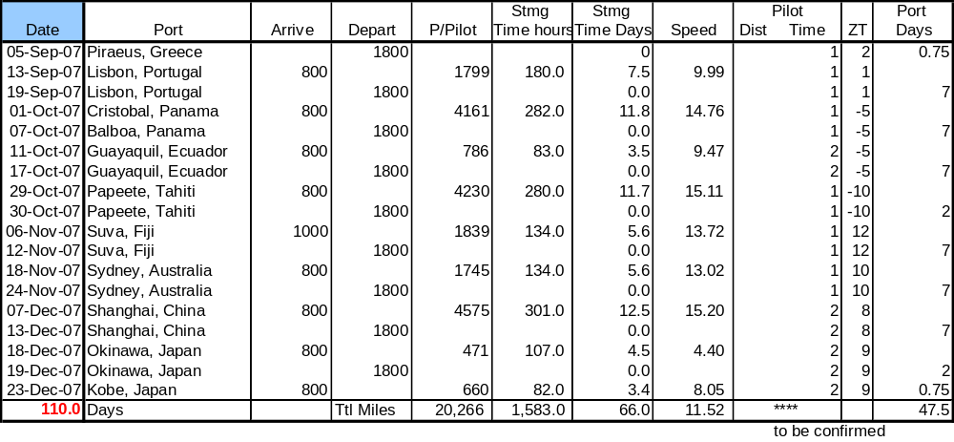

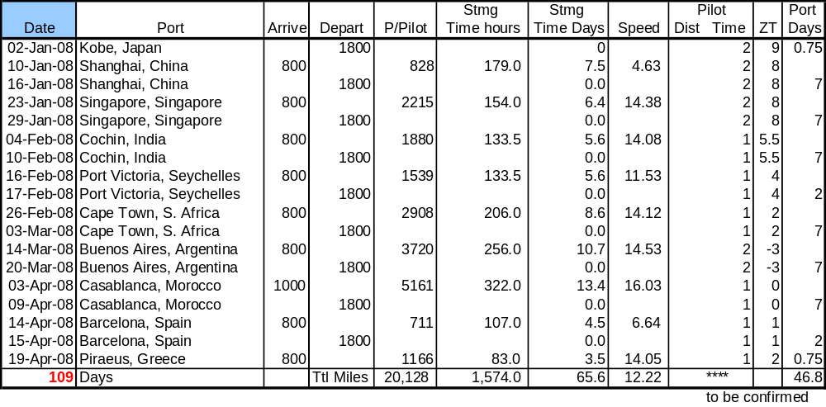
Voyage 2 – January 2008

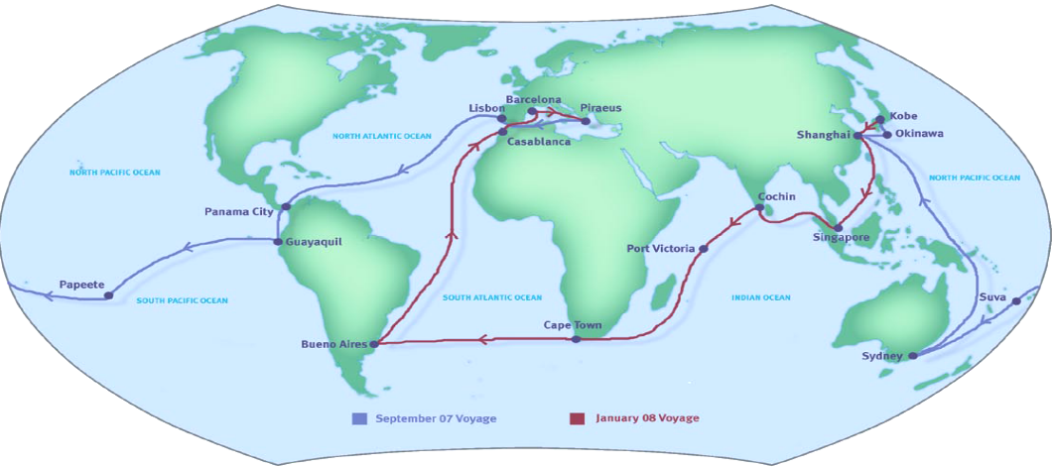
Appendix E

Underway Ocean Carbon Programs

A report prepared by the International Ocean Carbon Coordination Project
March 2007

Introduction

The International Ocean Carbon Coordination Project (IOCCP) promotes the development of a global network of ocean carbon observations for research through technical coordination and communication services, international agreements on standards and methods, advocacy, and links to the global observing systems. The IOCCP is co-sponsored by the Intergovernmental Oceanographic Commission of UNESCO and the Scientific Committee on Oceanic Research.

The underway carbon network has steadily grown and now includes an estimated 55 programs in all ocean basins, including several round-the-world tracks. Most of the systems on these ships are still developed, installed, and operated manually or in semi-automated mode by research groups or trained members of ships’ crews. Some programs now receive near real-time summary data and diagnostics from the CO₂ systems. The carbon community has developed a common format database of historical pCO₂ data holdings and has agreed to use these data reporting formats to facilitate continuous assimilation of data into the global database. Several national, regional, and global research programs are discussing scientific synthesis activities, and several studies have been undertaken to determine the optimal sampling strategy to meet research needs.

A workshop on “Ocean Surface CO₂ Variability and Vulnerability” is being sponsored by the IOCCP, the SOLAS-IMBER Joint Carbon Group, and the Global Carbon Project to review the current knowledge base and enhance international cooperation to resolve the magnitude, variability and processes governing ocean sources and sinks of carbon from observations, process-based models and atmospheric and oceanic inversions. Part of this workshop will focus on surface CO₂ observing strategies, updating inventories of on-going and planned activities, and development of synthesis groups for surface CO₂.

I. Status of underway pCO₂ programs

A new inventory of underway pCO₂ programs is being prepared to update the 2005 inventory and should be available in May 2007. National reports provide the following information about underway carbon programs:
- Atlantic Ocean = 17 regular routes, 3 irregular routes, 5 coastal routes;
- Pacific = 16 regular routes, 3 new planned for late 2007;
- Indian Ocean = 1 regular route;
- Southern Ocean = 8 regular routes;
- Artic / Nordic Seas = 4 regular routes;
- Global round-the-world tracks = 4 regular routes, 4 irregular routes.
(where regular routes implies that the routes are repeated at least yearly; irregular implies cruises with irregular tracks and schedules, typical of research vessels.)

This represents a large increase from 2005, which is in part due to better communication with Japanese and Chinese colleagues, but also concerted efforts in the EU and US communities to establish a strong Atlantic network as part of the CarboOcean and NOAA’s Climate Observing Program, respectively. The most-often used design for underway CO₂ system is also now commercially available (the Neill system, in partnership with General Oceanics (“GO system”)). Initial orders for the GO systems are around 24 but it is not clear how many programs will be prepared to purchase these once they have been proven in the field. These systems do have an option for satellite data transmission as well as the Idronaut 7 Parameter Sensor Module (T, S, pH, redox, two O₂ sensors, and an auxiliary port) at an added cost (http://www.generaloceanics.com/genocean/8050/8050.htm). Only a couple of the initial orders included these options. Maps and tables of this information will be generated following the April 2007 workshop.

II. Data Management / Synthesis Activities

The carbon community has developed recommended file formats for metadata and data for underway pCO₂ measurements, available at:
http://ioc.unesco.org/ioccp/Docs/TsukubaWSdocs/IOCCPRecFormats.pdf

The CarboOcean program is using these formats to develop a common-format pCO₂ database from all the historical data holdings at the Carbon Dioxide Information and Analysis Center (CDIAC) Ocean CO₂ Program. A Live Access Server to NOAA surface pCO₂ data is also available, and plans are underway to use this system to provide access to all pCO₂ data holdings as soon as the common format database is completed. http://cdiac.esd.ornl.gov/oceans/global_pco2.html

Synthesis activities will be discussed at the April 2007 workshop.

III. System Research & Development Status

In order to combine the results of individual programs into a global observing network, it is first necessary to make measurements of known accuracy from a variety of different systems. It is unfortunately not practical to make liquid standards for pCO₂ measurements, and so we must have a detailed understanding of how different systems behave relative to each other under a variety of conditions and compared with results from a laboratory-based system of known accuracy.

At the 2003 pCO₂ system intercomparison experiment and the 2004 follow-up workshop, the participants identified several key areas of errors and biases in the eight system designs and outlined solutions for resolving these discrepancies. In general, it was found that well-designed and operated systems agreed with each other to within ± 2 μatm, which is close to the estimated accuracy of the measurements from the at-sea systems. The goal is to be able to make an estimate of the annual mean uptake of ocean CO₂ with an uncertainty of about 10%, or ±0.2 Pg C yr⁻¹. Based on existing seasonal pCO₂ climatologies and wind speed distributions, basin average ΔpCO₂ must be resolved to 3-10 μatm.

At present, pCO₂ systems can be installed on a ship in approximately one week’s time if suitable plumbing and access to a clean water supply is already available. Installation and routine maintenance in port requires groups familiar with the pCO₂ systems. Once installed, the pCO₂ systems are sufficiently robust to be used routinely on VOS or SOOP that have observers on board to monitor system performance (e.g., to monitor potential problems related to the ship’s plumbing and the system installation such as water flow, warming between the intake and equilibrator, how much water vapour is in the gas stream being measured, etc.). System performance is also monitored remotely, but at present, it is still important to have someone on the ship who can monitor the system directly.

In order for underway pCO₂ measurements to become more routine and robust, the community needs to agree on a single system design that can be produced commercially. At present, however, there is no agreement on the best system design and performance, and more development and intercomparison exercises will be needed to identify sources of error and the best designs. The GO system has promise since approximately 10 of the original Neill designs are in the field and another 24 of the GO systems are on order, but the GO systems have not been delivered yet and they need to prove themselves in the field before the community will buy off on them.

Status of Activities:

- As a result of the January 2004 IOCCP workshop, a US proposal was funded to examine the “Optimal network design to detect spatial patterns and variability of ocean carbon sources and sinks from underway surface CO₂ measurements.” Other countries have also worked on developing sampling strategies, and results from these projects will be presented at the April 2007 workshop.

- In 2003 NOAA scientists and Craig Neill (University of Bergen) designed and built thirteen pCO2 systems that were installed and are being used around the world. This has helped develop a common and robust system for underway measurements with near real-time data transmission, and also helped in the development of common formats for the data.

- In 2005, Craig Neill and Rik Wanninkhof (US NOAA / AOML) began working with General Oceanics to develop a commercially available version of the Neill underway pCO₂ system. Those systems can now be ordered. There is a significant backlog at the moment, but they anticipate a wait of approximately 3 months for delivery once they are in full production.

- PICES and the IOCCP have co-sponsored the revision and update of the original 1994 DOE Handbook of Methods for ocean CO₂ measurements. This “Guide of Best Practices for Oceanic CO₂ Measurements and Data Reporting” is in final review and is expected to be published by Summer 2007. There is one chapter devoted to underway CO₂ measurements.

- In April 2007, the IOCCP, SOLAS-IMBER Joint Carbon Group, and Global Carbon Project are hosting a workshop that will address surface CO₂ observation strategies and data synthesis activities, as well as update inventories of on-going and planned underway programs.

IV. Links to the Global Observing System

The underway pCO₂ programs are, at present, operating on an individual PI basis and/or as part of research programs. Development of a common format database is underway, and underway programs have agreed to adhere to this common format to facilitate continuous assimilation into the global database. There are plans to develop basin and global scale synthesis activities in the near future.

The possibility of making temperature and salinity data from the carbon programs available in real-time was discussed with JCOMM SOT in 2006. There are now a few underway carbon programs receiving near real-time diagnostics on the CO₂ systems, which may eventually prove sufficiently useful to justify the costs of real-time data transmission for all data types. The majority of lines, however, do not currently have this facility.

Appendix F

The GODAE high resolution sea surface temperature pilot project
(GHRSST-PP)

(Submitted by Craig Donlon, Met Office Hadley Centre, United Kingdom)

A new generation of integrated sea surface temperature (SST) data products are now being provided by the Global Ocean Data Assimilation Experiment (GODAE) High-resolution SST Pilot Project (GHRSST-PP). The international community to implement a Regional/Global Task Sharing (R/GTS) international framework for the GHRSST-PP which is now delivering SST data products and services in real time has invested over $10M. The primary aim of the GHRSST-PP is to develop and operate a distributed system that will deliver high-resolution (better than 10 km and ~ 6 hourly) global coverage SST data products operationally in near real time. SST data products are derived by combining complementary satellite and in situ observations in real time. There are obvious synergy benefits to such an approach but their practical realisation is complicated by characteristic differences that exist between measurements of SST obtained from subsurface situ sensors, satellite microwave radiometers and, infrared radiometer systems. Furthermore, diurnal variability of SST within a 24-hour period, manifest as both warm layer and cool skin deviations, introduces additional uncertainty for direct inter-comparison and the implementation of data merging strategies. A suite of on-line satellite SST diagnostic systems are available within the GHRSST-PP to consider these and other issues and a re-analysis project will deliver the first of a series of reanalysis time-series (ultimately covering the period 1983-present) in early 2007. All GHRSST-PP products are served to the international user community free of charge through a variety of data transport mechanisms and access points. This paper provides an overview of the GHRSST-PP structure, activities and data products. For a complete and up-to-date review of the GHRSST-PP see http://www.ghrsst-pp.org.

INTRODUCTION

It is only in recent times that nations have begun to recognise the size, diversity and complexity of the ocean industries and their importance. It is estimated that over 90% of world trade is carried over the ocean. Oceanographic research has grown significantly in response to developing concerns over the role of the oceans within the climate system and the growing demand for metocean data as more industries move offshore. Major growth in the marine industry is expected in the sectors of:

- marine transportation; | - the ports industries
- the leisure industries; | - offshore oil & gas industry;
- marine foods and services; | - submarine cables;
- mineral exploitation; | - marine biotechnology;
- underwater vehicles; | - marine information technology;
- renewable energy; | - Research and development.

The Global Ocean Data Assimilation Experiment (GODAE) is an international project to develop operational global ocean analysis and prediction systems to serve these industrial sectors, to save lives and property and to further oceanographic research and development. The vision behind GODAE is that these societal and economic advantages cannot be realized without implementing the concept of:

"A global system of observations, communications, modeling and assimilation, that will deliver regular, comprehensive information on the state of the oceans in a way that will promote and engender wide utility and availability of this resource for maximum benefit to society."

Through the period 2003-2007, through international co-operation, GODAE products, services and activities will demonstrate the benefits and utility of global ocean data and forecast products. Ultimately, the new generation of ocean forecast products and services will be transitioned into operational systems under the guidance of the World Meteorological Organization (WMO) Joint Commission on Oceanography and Marine Meteorology (JCOMM) amongst others.

One of the most important dependencies for ocean forecasting systems is on sea surface temperature (SST) products that are required to properly constrain the upper ocean circulation and thermal structure. SST data products need to be accurate (better than 0.4K), be available in near real time and have high spatial (<10km) and temporal (6-12 hours) resolution. In addition, they should properly address the difficult issue of SST at the sea ice edge and diurnal variability (delivering SST foundation products that are free of diurnal variability and approximate to a mixed layer temperature of the upper 10-20m of the ocean surface). In 2000, no SST products could satisfy these requirements for the global domain. As a direct response the international GODAE steering team (IGST) initiated a GODAE High Resolution SST Pilot Project (GHRSST-PP).

The primary aim of the GHRSST-PP is to develop and operate a distributed system that will deliver high-resolution (better than 10 km and ~ 6 hourly) global coverage SST data products operationally in near real time for the diverse needs of GODAE and the wider scientific community. Figure 1 shows the distributed system (caller the Regional/Global Task Sharing (R/GTS) system) that has been implemented by the GHRSST-PP. The R/GTS is based on an operational distributed system in which the data processing operations that generate and distribute global coverage high-resolution SST data sets are shared by Regional Data Assembly Centres (RDAC). Several RDAC projects now are at various stages of implementation in Europe, Australia, Tropical regions, USA and Japan. In the future, RDAC systems in China, India and Brazil will become particularly important as satellite systems with enhanced SST measurement capability are successfully launched by these nations.

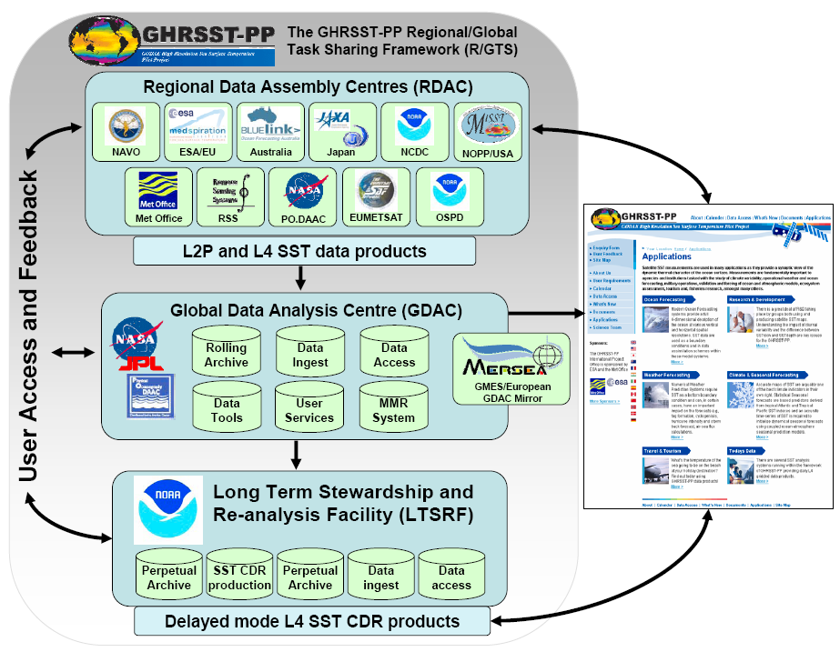
Figure 1: The GHRSST-PP regional/global task-sharing (R/GTS) framework. The R/GTS establishes an international set of Regional Data Assembly Centres (RDACs), each of which delivers data to a Global Data Assembly Center (GDAC, http://ghrsst.jpl.nasa.gov) and the regional user community. Data are served from the GDAC to near real time users and applications for 30 days before the data are sent to the GHRSST Long Term Stewardship and Reanalysis Facility (LTSRF, http://ghrsst.nodc.noaa.gov) for long-term archive, stewardship, provision to delayed mode users, and future Climate Data Record (CDR) production. A mirror GDAC will be established in Europe as part of the extensive Global Monitoring for Environment and Security (GMES, http://www.gmes.info/) initiative of the European Commission.

RDAC ingest, quality control and merge many diverse satellite and in situ SST data sources to generate consistent format regional coverage quality controlled SST data products in real-time. Each RDAC produce data products to the same specification in terms of quality control methods applied to input data, auxiliary data used to help interpret SST observations and error estimates based on the GHRSST-PP Data Processing Specification (GDS, Donlon et al., 2006). GHRSST-PP L2P data products do not alter the provided SST data themselves but complement these observations by (a) providing a extensible common interface format data set that is internet ‘aware’ (appropriate for Live Access Server applications amongst others) and (b) adding value through metadata and auxiliary fields that greatly aid the application and interpretation of the SST observations. A L2P data record, provided for every pixel in a L2P data product, includes the native (can be either swath or gridded) SST, an estimate of the bias error and standard deviation of error based on a large match up database of co-located satellite and in situ data), surface wind speed, aerosol optical depth (AOD), surface solar radiation (SSI), sea ice (SI) concentration, time of observation and a set of quality control flags. Auxiliary fields are provided as dynamic flags that can be used by different user communities to filter data that are not suitable for a given application. For example, wind speed and surface solar radiation data can be used to determine the likelihood of thermal stratification and estimate the extent of any diurnal temperature variability in the afternoon. Aerosol data may be used to set an appropriate threshold above which infrared SST data from satellite are considered unreliable. The purpose of providing fields rather than binary mask flags is that user communities, have shown many times that they are the most appropriate community to decide if a given SST observation is fit for purpose. The role of the GHRSST-PP is to facilitate this decision as far as possible. L2P data products provide the basic data product of the GHRSST-PP from which all others are generated including L4 analyses that capitalise on the synergy of complementary satellite observations to produce combined SST analysis product. RDAC L2P data products are assembled together at Global Data Analysis Centres (GDAC, as shown in Figure 1) where they are integrated and analysed to provide L4 global coverage combined analysis products that are consistent and free of gaps. Data products are served to the user community via dedicated applications and user services tailored to operational and scientific user requirements at both RDAC and GDAC.

Figure 2 illustrates the basic passage of in situ and satellite SST data products through the GHRSST-PP R/GTS. Native data products provided by agencies in a varied format with limited error estimates are processed to observation and analysis products in a common format together with uncertainty estimates and supporting ancillary data. The generation of an international common format data product is extremely important as this enables user communities to invest in the generation of data access and manipulation tools that, through the GHRSST-PP, can make full use of all satellite data. This is especially true of operational National Meteorological Services (NMS) where even small code changes in an operational system constitute a significant investment. In summary, the GHRSST-PP processes SST data derived from several different satellite systems into a set of data products that represent the best measure of SST, presented in a form that can be assimilated into forecasting models. The convergence of QC data processing and format within the GHRSST-PP R/GTS system is a considerable advantage to user communities tasked with maintaining ingest and QC code bases as reported at GHRSST-PP user consultancy meetings which are held every 6-10 months. The GHRSST-PP considers user feedback from these meeting essential to maintain a useful set of data products that are able to respond to user requests and concerns in a rapid and innovative manner.

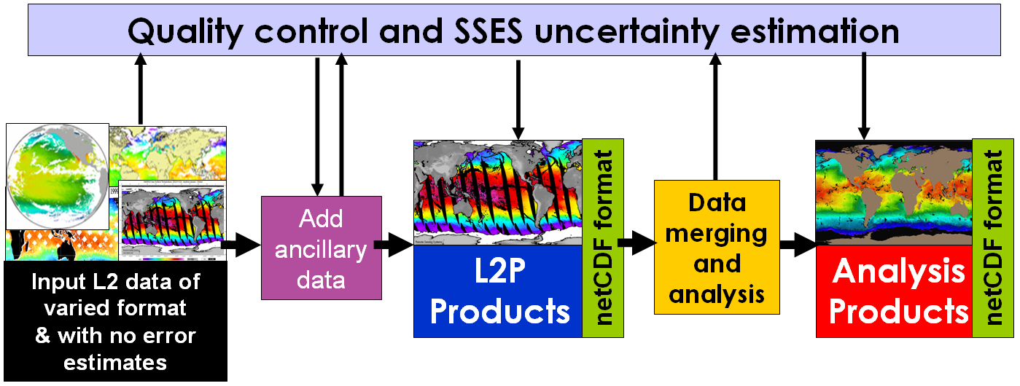

Figure 2: The data processing strategy of the GHRSST-PP. Satellite and in situ data SST data of varied format and with limited error estimates, if any, are first quality controlled and error estimates added along with several other auxiliary fields to provide observational data products in a common netCDF [CF-1.0] data format. Data are then merged together to provide complete analysis products.

L2P OBSERVATIONAL DATA PRODUCTS

The Medspiration Project is a European initiative funded by the European Space Agency (ESA) to provide a GHRSST-PP RDAC for Europe. It has implemented the GDS system for the Atlantic Ocean and European shelf seas providing L2P products to European users and the GHRSST-PP in an RDAC function. Full details of the Medspiration project can be found at http://www.medspiration.org. Figure 3 shows an example L2P data set and associated auxiliary fields generated by the Medspiration project derived from the EUMETSAT Spinning Enhanced Visible and Infra-Red Imager (SEVIRI) instrument flown on the Meteosat second-generation geostationary satellite. The benefit of an integrated data product is clear from this figure which graphically shows the relationship between variables included within the L2P product. To address the impact of diurnal variability on SST analysis and data assimilation systems, the GHRSST-PP has a dedicated diurnal warming technical advisory group tasked with providing the best method to account for diurnal variations in satellite SST. This is necessary so that an estimate of the Foundation SST (the SST free of diurnal warming and similar to that of the Mixed Layer temperature generally required by ocean forecasting models and analysis systems) can be made. The MSG-SEVIRI system provides observations every 15 minutes for the entire earth disk that could provide significant information describing diurnal variability. However, managing such a large volume of data is a challenge for most user communities and instead products provide a 3 hourly integrated observational data set including the best available data within the 3-hour period. For the purpose of the GHRSST-PP this is acceptable but far from optimal for the detailed study of diurnal SST variability, essential to produce an estimate of the foundation SST. To facilitate R&D a separate data product providing hourly SST from MSG-SEVIRI is also being generated to investigate diurnal variations of SST. These are important in their own right to some user communities; for example the World Aviation Forecast Centre (WAFC) team based at the Met Office, Exeter UK, are extremely interested in SST hot spot maps in the tropics and Mediterranean area that could trigger Cumulonimbus activity and clear air turbulence above.

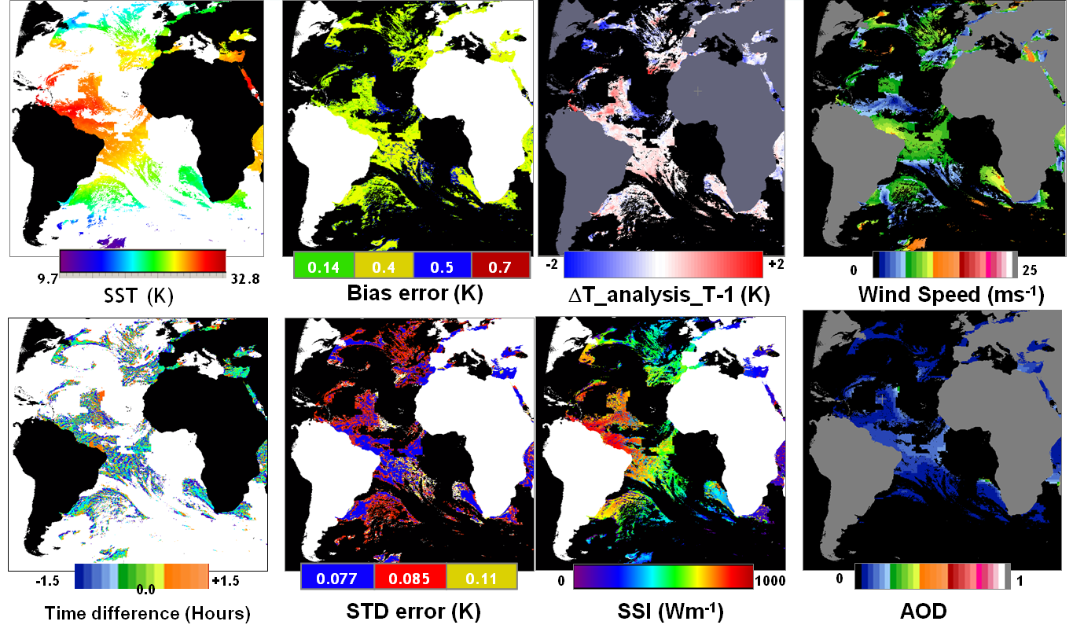

Figure 3: Example GHRSST-PP L2P data set derived using Meteosat second Generation SEVIRI SST data collected over a 3-hour period. Shown (from top left to bottom right) are SST, SST bias error, difference from previous reference SST analysis field, surface wind speed (ECMWF), time of observation within a 3 hour window (SEVIRI makes observations every 15 minutes), standard deviation of SST error, surface solar irradiance (from SEVIRI visible channels) and aerosol optical depth (NEDSIS).

L2P SST UNCERTAINTY ESTIMATION

Within the GHRSST-PP system, L2P SST uncertainty estimation is based on matching satellite retrieved SST with in situ observations co-located in space and time to within 25 km of the in situ measurement and 6 hours temporal separation. A large matchup database of co-located data is generated for each satellite instrument which is periodically analyzed to derive a mean bias and standard deviation. In order to provide a more realistic uncertainty estimate, a proximity confidence value is derived for every SST observation based on the most likely source of error for a given satellite instrument. In the generic case of infrared satellite SST retrievals, the most likely source of error is cloud contamination. A confidence value (on a scale of 1-5 (value 6 is reserved for a ‘cool-skin’ effect)), is assigned based on the distance to the nearest cloud in a given scene and the magnitude of anomaly defined against a coldest SST climatology (currently derived from NASA Pathfinder SST). In the case of microwave SST retrievals (currently form the AMSR-E and the TRMM TMI sensors), proximity confidence data are derived from knowledge of side lobe contamination in the coastal zone, radio frequency interference and flagged rainfall (which prohibits retrieval of SST) are the primary sources of error. In either case, every pixel in a scene is assigned a proximity confidence value based on objective criteria (e.g., clouds, deviation from climatology, rain, sidelobe or RF) and, using the matchup database, a bias and standard deviation (SD) uncertainty estimate is derived for each proximity confidence value on a regular basis spanning a suitable time window when sufficient in situ data are available. These time-bound bias and SD values derived from the matchup database can then be assigned to all pixels in a given scene based on the relationship between proximity confidence value, time-bound bias and standard deviation. This process is referred to as a Single Sensor Error Statistic (SSES) and provides an uncertainty linked to in situ observations (taken as ‘truth’) facilitating the use of GHRSST-PP products in the climate record (which is also referenced to in situ measurements).

Figure 4 shows the proximity confidence map generated for an example MSG-SEVIRI SST data set. Clearly seen in this example are high confidence values in cloud free regions and degraded confidence values in the proximity of clouds. Shown to the right are the SSES bias and SD estimates for each confidence value (1-5 corresponding to cloudy through to excellent in the proximity confidence map legend) for the SEVIRI over a 6-month period showing how higher confidence values are associated with lower bias and reduced SD. While the SSES process is not able to account for all errors (particularly with microwave SST observations which require special attention on a regular basis), it provides an optimised method for uncertainty estimation that is functional in a real time environment and far better than simply taking the latest published figures from sparsely available ad hoc in situ validation studies. Furthermore, it is expected that as more experience is gained with the SSES process, better error estimates will be generated. This is a priority area of study for the USA GHRSST-PP RDAC project called Multi-instrument SST (MISST, see http://www.misst.org) sponsored by the US National Ocean Partnership Program (NOPP) and for the European MERSEA-IP EC integrated project (see http://www.mersea.org) tasked with defining the scope and content of operational oceanography within the evolving European Global Monitoring for Environment and Security (GMES, see http://www.gmes.info) system, the European component of the Group on Earth Observations (GEO, see http://earthobservations.org).

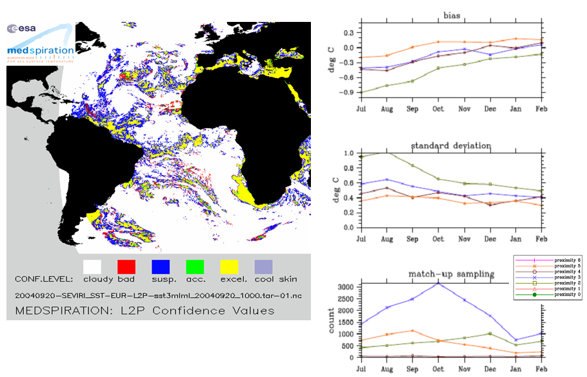
Figure 4: L2P data proximity confidence product produced from the ESA Medspiration SEVIRI LML product shown in Figure 3. To the right is the SST error plotted with the GHRSST-PP proximity confidence values for a 7-month period in2004. (P. LeBorgne)

GHRSST-PP L4 GLOBAL ANALYSIS

Several global analysis systems are now operating on a daily basis within the GHRSST-PP framework. For example, the global analysis system developed by Remote Sensing Systems using only Microwave SST data (see http://www.remss.com/sst/microwave_oi_sst_data_description.html). Figure 5(a) shows a global L4 SST analysis produced by the Met Office, UK in support of the GHRSST-PP based on available L2P and in situ observations for the 20 November 2005. The analysis, called the Operational SST and Sea Ice Analysis (OSTIA, see http://ghrsst-pp.metoffice.com/pages/latest_analysis/ostia.html) is produced each day persistence based Optimal Interpolation scheme providing SST on a 1/20° global grid (~5km) and. At present OSTIA uses fixed x and y correlation length scales (order 100km representing synoptic and 10km representing meso-scale) in a two pass process that first computes synoptic scale innovations followed by mesoscale innovations that provides a good approach to preserving SST gradients. (Figure 5(b) shows the corresponding SST anomaly computed against a Pathfinder SST weekly climatology derived from AVHRR SST data covering the period 1985-2001. These types of products are extremely useful for monitoring seasonal forecast products (e.g., http://www.metoffice.gov.uk/research/seasonal/index.html) that have strong dependencies on tropical region SST patterns and magnitudes.
Figure 5 is the result of combined use of GHRSST-PP L2P data products generated TRMM TMI, EOS-AQUA AMSR-E, NOAAA AVHRR, MSG- SEVIRI and ENVISAT AATSR observations. The OSTIA system has been made possible as all of these products are provided in a common data format greatly enhancing their utility, requiring only a single read/archive software configuration. In the near future, data from the EOS-AQUA MODIS sensor, geostationary NOAA GOES E and W imagers and the Japanese MTSAT-1R imager will also be available as GHRSST-PP L2P observation products. In 2006/7, EUMETSAT Polar System (EPS) data will be made available in GHRST-PP format so that EPS SST data can be used immediately within GHRSST-PP applications.
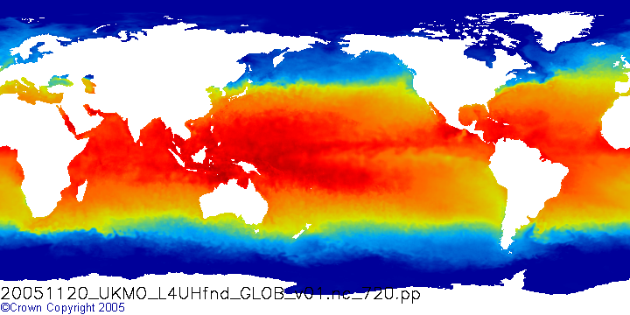 | 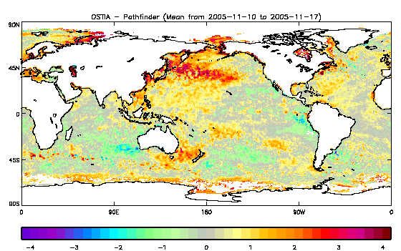
Figure 5: Scale is in Degrees C. (a) Pre-Operational SST foundation L4 product (OSTIA) produced by the Met Office based on GHRSST-PP data products for 20/11/2005. (b) OSTIA – NASA Pathfinder climatology (1985-2001) for 10-17/11/2005. (Data sets generate by John Stark © Met Office 2005)

Accurate maps of SST are arguably one of the best climate indicators in their own right and many statistical seasonal forecasts are based predictors derived from tropical Atlantic and Tropical Pacific SST indices. An accurate and sufficiently long time-series of SST is required to initialise dynamical seasonal forecasts using coupled ocean-atmosphere seasonal prediction models. The GHRSST-PP is also engaged in a re-analysis project that will develop a long-term satellite derived SST data set at high resolution that builds on the synergy between complementary satellite and in situ data sets. The GHRSST-PP re-analysis project is working towards a combined 4km global coverage data sets spanning 1983-present with the first basic set of re-analysis products available in 2007.

Finally, the GHRSST-PP has various diagnostic systems that are being used to assess the quality of data products used within the GHRSST-PP. The Medspiration RDAC system provides on-line access to a comprehensive product assessment web site for L4 analysis products within the Mediterranean area (see http://www.medspiration.org/tools/validation/). In addition, the GHRSST-PP hosts an on-line high-resolution diagnostic data set (HR-DDS, see http://www.hrdds.net) where real-time SST data products, ocean model data sets and other supporting data sets can be viewed and analysed interactively. This type of application ensures that users and scientist alike have ready access to information that can be used to diagnose faults and problem issues immediately and in a well-defined format tuned to specific areas and issues.

CONCLUSIONS

The GHRSST-PP is a large international project that provides a framework for the exchange, processing and application of satellite SST products. It has over €10 million invested by projects in Europe, Japan, Australia France and the USA. The GHRSST-PP is making full use of international satellite SST and in situ SST outputs and recognises the importance of the rapidly growing operational SST user and producer services that are now provided by agencies all over the world. Operational sea ice concentration, surface solar irradiance, aerosol optical depth, and wind speeds are all operational inputs to the GHRSST-PP and constitute the core data sets for the GHRSST-PP RDAC services. For studies of diurnal SST variability, hourly products of SST and SSI at full SEVIRI native resolution are now becoming available. A dedicated re-analysis program is now developing within the GHRSST-PP and a set of on-line diagnostic services are available. Full details of the GHRSST-PP, its data products and services are available at http://www.ghrsst-pp.org. Operational agencies are engaging with GHRSST-PP as it now transits to sustained operations. For the future, the GHRSST-PP International Science Team requests that SST user and producer communities consider the GHRSST-PP L2P format and methods as a baseline standard for the present and next generation of satellite SST data products and services which represents the best international scientific consensus opinion on SST data format and quality control procedures. This would allow users to be fully prepared for the application of these data using a standard set of well documented I/O utilities that are common to all satellite SST data sets with obvious benefits to the application community.

REFERENCES

1. Donlon, C J. and the GHRSST-PP Science Team, The GHRSST-PP Data processing Specification version 1.7, available form the GHRSST-PP International Project Office, Met Office, Exeter, UK or at http://www.ghrsst-pp.org, pp 241 (2006).
2. Thiébaux, Jean, Rogers, Eric, Wang, Wanqiu, Katz, Bert, A New High-Resolution Blended Real-Time Global Sea Surface Temperature Analysis Bulletin of the American Meteorological Society ,84, 645-656, (2003).

Appendix G

The FerryBox Project

GODAE: Global Ocean Data Assimilation Experiment

