WORLD METEOROLOGICAL ORGANIZATION  ________________________ | INTERGOVERNMENTAL OCEANOGRAPHIC  COMMISSION (OF UNESCO)  ________________________
JOINT WMO/IOC TECHNICAL COMMISSION FOR OCEANOGRAPHY AND MARINE METEOROLOGY (JCOMM)  SHIP OBSERVATIONS TEAM  FOURTH SESSION  GENEVA, SWITZERLAND, 16 TO 21 APRIL 2007 | SOT-IV/Doc. I-2.5  (15.II.2007)  __________  ITEM I-2.5  Original: ENGLISH

Report by the SOT Coordinator

(Submitted by Ms Hester Jane Viola, SOT Coordinator, with input from the former Technical Coordinator, Mr Etienne Charpentier)

Summary and purpose of document

This document summarizes activities by the SOT Coordinator in support of the SOOP Programme during the past intersessional period.

ACTION PROPOSED

The Ship Observations Team is invited to:

- Note and comment on the information provided, as appropriate;

- Advise the Coordinator on additional actions required, as necessary.

______________________

Appendix A: Monthly activities by the Technical Coordinators.

DISCUSSION

1. Introduction

This report covers the periods during the last SOT intersessional period (1 February 2005 to 31 January 2007). During this period the Technical Coordinator (TC) of the Ship-of-Opportunity Programme (SOOP) role was expanded to include the entire Ship Observations Team (SOT).

The Technical Coordinator role was vacated by Mr Etienne Charpentier in January 2006 and remained vacant until the arrival of Ms Hester Jane Viola in July 2006. The TC normally spent approximately one third of the time on SOOPIP matters, 10% on JCOMM & JCOMMOPS issues and about 3% on JCOMMOPS/Argo related matters. The remainder of the time was spent on Data Buoy Cooperation Panel (DBCP) related issues. Time spent on the JCOMM was directly related to DBCP and SOT activities. Some work was undertaken with the Argo Coordinator to develop the JCOMMOPS and explore synergies between the DBCP, SOT and the Argo Project.

2. During the Period of 1 March 2005 to 31 January 2006

During this timeframe, Mr Etienne Charpentier was the Technical Coordinator of the Data Buoy Cooperation Panel (DBCP) and the Ship-Of-Opportunity Programme (SOOP) and was based in Toulouse, France at the CLS, Service Argos, and was employed by the United Nations Educational, Scientific and Cultural Organisation (UNESCO). As previously agreed, approximately 30% of Mr Charpentiers time was spent on SOOP-related issues. Mr Charpentier provided three months advance notice of his resignation and finished his tenure on 31 January 2006. During these three months, he assisted the Panels in the recruitment process of the new Technical Coordinator.

2.1 The following SOT related issues were stressed during this period are as follows:

- Provided user/customer assistance;
- Completed the SOOP Semestrial survey (January-December 2004);
- Completed the SOOP Semestrial survey (January-June 2005);
- Completed the SOOP monthly maps and reports;
- Updated the SOOP operations guide to include information on ship visit rules;
- JCOMMOPS: provided information system operations and maintenance (database, web servers); maintained information system reliability; transferred of some SOOPIP webpages to the JCOMMOPS. Updated the SOT and JCOMMOPS website to include: SOT certificate of appreciation, VOS recruit presentation (by Mr Steve Cook), and the SOT-III Final Report. Developed the dynamic maps (available in Universal Polar Stereographic projections (North and South)) in addition to existing flat square models. Updated the new JCOMMOPS quarterly map to show upper ocean thermal profile data by country;
- Participated in Observing System Monitoring Centre (OSMC) discussions;
- Dealt with Argos-related issues (mainly for the DBCP, but also a small number of SOOPIP ships reporting via Argos to include: delays, requirements for satellite covering orbit occupied by NOAA-K, Argos GTS sub-system (BUFR compression bug fixing, GTS sub-system monitoring, BUFR template for wave data included in database, and the DBCP Technical Document update);
- Prepared documents on the DBCP, SOT, and JCOMMOPS for the JCOMM-II;
- Provided Dr Elizabeth C. Kent with comments regarding proposal for compilation of retrospective ODAS metadata and blending with ICOADS;
- Prepared a workshop for the establishment of a Pilot Project to collect metadata regarding SST and temperature profile data;
- Liaised with the United Kingdom Met Office and Ms Julie Fletcher regarding VOS quality monitoring and feedback;
- Prepared for the Expert Team on Data Representation on Codes meeting: IOC, JCOMM, Argo, and DBCP requirements;
- Assisted with recruitment of the new Technical Coordinator;
- Prepared the workplan for the new Technical Coordinator (i.e., Action Plan, list of routine and non-routine tasks, configured tools and TC computer, and sorted out relevant historical documents);

2.2 Missions and Visits:

- From 3 to 4 March 2005, visited by Mr Steve Cook and Mr Derrick Snowden at the JCOMMOPS; discussed DBCP and SOOP-related issues, and in particular, the preparation for upcoming SOT meeting;
- On 17 March 2005, visit of Ms Julie Fletcher and Mr John Burman at the JCOMMOPS;
- From 25 to 29 April 2005 (Silver Spring, Colorado, USA), OCO System review meeting and OCG informal meeting;
- From 2 to 6 May 2005 (San Diego, California, USA) SIO, revise SVPB design manual with Mr Bill Scuba; visit Pacific Gyre; discussed SOOPIP-related issues with Mr Steve Cook;
- From 19 to 23 September 2005 (Halifax, JCOMM-II meeting; 22 September
- From 7 to 8 November 2005 (Ostend, Belgium), IOC MLA2 meeting;
- 18 November 2005 (Paris, France), IOC, JCOMM issues, TC/DBCP recruitment, DBCP users and technology workshop preparation;
- From 5 to 8 December 2005 (Oman), Expert Team on Data Representation and Codes. Represented the IOC and JCOMM. Submit the DBCP proposal for a new BUFR template for directional and non directional wave data;
- From 13 to 15 December 2005 (Washington, D.C., USA). Attended the POGO Research cruise database workshop (useful for deployment opportunities). Met with Mr Mike Johnson, Mr Steve Piotrowicz, and Mr Stan Wilson to discuss the future of the JCOMMOPS. Additionally, met with Mr Gary Soneira to discuss SOOPIP-related issues and Mr Bill Woodward to discuss Service Argos-related issues.

3. The Period of 1 February 2006 to 30 June 2006

During the period of 1 February 2006 to 30 June 2006, there was no Technical Coordinator for the Team, however, some limited support could continue to be provided thanks to:

- The WMO (i.e., by the former TC) for user assistance, liaison with SOT Members (and provision of materials for their annual meetings); Panel Members and Service Argos, maintenance of the SOT mailing lists, assistance regarding recruitment of the new Technical Coordinator, coordination of SOBP commitments and proposal of a new scheme for WMO numbers;
- The IOC for assistance regarding recruitment of the new Technical Coordinator;
- The DBCP Chairperson for assistance regarding recruitment of the new Technical Coordinator;
- Mr Mathieu Belbeoch providing continued operations of the JCOMMOPS Information System, routinely updating JCOMMOPS database with buoy related information, data tuning, producing monthly JCOMMOPS maps, writing specifications for cruise database and establishing new mailing lists (jcomm-news@jcommops.org);
- Météo-France (Pierre Blouch) for user assistance; and
- Service Argos for user assistance and system monitoring.

4. The Period of 1 July 2006 to 31 January 2007

During the period 1 July 2006 to 31 January 2007, Ms Hester Jane Viola was recruited as the new Technical Coordinator, and thus became the third Technical Coordinator of the Data Buoy Cooperation Panel (DBCP) and the new SOT TC. Ms Voila was based in Toulouse, France at the CLS and was employed by the United Nations Educational, Scientific and Cultural Organisation (UNESCO).

4.1 During these months, Ms Viola’s time (relating to SOOP/SOT) was distributed in the follow ways:
- Familiarisation with the technological tasks of the SOT TC role;
- Familiarisation with stakeholders in the DBCP, SOT and JCOMM and previous meetings/sessions;
- Increasing familiarity with the organizational tasks of the TC role;
- Training and handover from the former TC;

- Introductions to Members of the community and meeting individuals in Paris, Toulouse and Geneva;
- Maintained mailing lists – updating erroneous addresses and adding new recipients as necessary;
- Made minor changes to the SOT and SOOP websites for a more consistent look and feel. Created a draft page for the ASAPP;
- Created http://w4.jcommops.org/WebSite/SOTM web-mapping application for the SOT enabled Web map services for all web-mapping applications;
- Produced monthly maps and developed templates (based on existing Argo Standards) for new monthly maps formats introduced at the beginning of 2007;
- Made some minor changes to the SOOP, SOT and JCOMMOPS webpages;
- Met key people at CLS Argos;
- Familiarisation with the JCOMMOPS website, read past reports and presentations, JCOMMOPS operations manual, reviewed documentation and priorities of former TC, assimilated email communications between Panel Members;
- Contacted mailing list members and individuals by way of introduction;
- Training and hand over for one week, with the former Technical Coordinator, Mr Etienne Charpentier at the JCOMMOPS, to learn the technologies and processes behind the JCOMMOPS Information System. Solved some technical problems with computer and software set up. Went through the following issues:
- Database structure;
- Server configurations;
- Various data loading processes (routine and manual);
- Argos’ GTS Subsystem;
- JCOMMOPS online query and monitoring applications;
- Loaded the latest Publication No. 47 Ship metadata file into the JCOMMOPS database;
- Familiarisation with the Quality Control Email Relay utility. Modified some Ship metadata to ensure it worked efficiently for the two ships which had changed from the VOS-Netherlands to VOS-USA (based on a request from Météo-France (Mr Pierre Blouch));
- Worked on data loading and analysis for the SOOP Semestrial survey for 2005. Completed a draft of the SOOP Semestrial for 2005 survey: ftp://ftp.jcommops.org/SOOP/Survey/2005-First-Draft or http://wo.jcommops.org/cgi-bin/WebObjects/SOOPIndicators, including updating the yearly SOOP maps. Sought feedback on the draft SOOP Survey Report for 2005 and requested metadata to be sent for 2006. Started to upload 2006 data. Discussed the metadata provision from the AOML for SEAS XBT SOOP data (Dr Gustavo Goni), providing templates for preferable data formats, beginning 2006. Discussed the SOOP metadata requirements with people and thought about possible different approaches in this regard;
- Familiarisation with the planned process and reviewed draft agenda for the SOT-IV in 2007 (from information provided by the Chairperson of the SOT Mr Graeme Ball).

4.2 Missions and Visits:

- On July 2006, (UNESCO, Paris, France), met with many colleagues and discussed the expectations of the TC role and the role of IOC;
- On July 2006 (WMO Headquarters, Geneva, Switzerland), training and hand over for one week, with Mr Etienne Charpentier to learn the organizational aspects of the DBCP, SOT and JCOMM;
- From 14 October to 3 November 2006 (United States of America)
  - The Ninth meeting of the International Buoy Programme for the Indian Ocean (IBPIO), which was held at 9am on Saturday, 14 of October, 2006, in La Jolla, California, USA.
  - The annual meeting of the North Pacific Data Advisory Panel (NPDAP) on Sunday, 15 October 2006, in La Jolla, California, USA.
  - The Twenty-second Session of the DBCP, which was held in La Jolla, California, USA, from 16 to 20 October 2006, and the Twenty-sixth Argos Joint Tariff Agreement (JTA) Session (with the same venue) from 24 to 27 October 2006.
  - Informal meeting with Ship Observations Team (SOT) Chairperson, SOOPIP Chairperson, WMO Secretariat and others relevant Members to discuss the proposed agenda for the upcoming SOT meeting (Geneva, Switzerland, 16-21 April 2007).
  - Scripps Institute of Oceanography, meeting with Mr Steve Cook, Chairperson of the SOT Ship of Opportunity Implementation Panel, La Jolla, California, USA, 25 October 2006.
  - Pacific Marine Environmental Laboratory, University of Washington, Seattle, Washington, from 26 to 27 October 2006.
  - CLS America, NOAA Office of Climate Observation, Office of Oceanic and Atmospheric Research, Washington, D.C., from 30 to 31 October 2006.
  - Atlantic Oceanographic and Meteorological Laboratory and Global Drifter Center, Miami, Florida, USA, from 1to 2 October 2006.
  - Navoceano and the NOAA National Data Buoy Center, Stennis Space Centre, Missouri, USA, from 2 to 3 November 2006.
- From 13 to 14 December 2006 Brest, France, visited Météo-France (SHOM), IFREMER and IRD.

5. Comment on the Period 1 February 2006 to 30 June 2006

The long period of vacancy (from 1 February 2006 to 30 June 2006) in the TC role had many immediate impacts and will continue to impact on the SOT and the JCOMMOPS information system well into the next intersessional period.

The main impacts for the ship observations community have been:

- Delays in uploading data for and in producing Semestrial surveys;
- Missing information in the JCOMMOPS database (e.g., monitoring statistics, ship callsigns/ship names, metadata especially for ships not reporting via Argos) hence limiting usefulness of some of the data entry tools, monitoring tools and reports produced (e.g., monthly maps);
- Limited user assistance – The SOT/SOOP community members have no doubt been negatively impacted by the lack of a TC for assisting with specific questions and the lack of utility within the monitoring and reporting tools previously available on the JCOMMOPS website;
- Missing data, incomplete or incorrect metadata (ship names, contacts for platforms, etc.) and periods where manual data processing was not completed has had a cumulatively negative impact on the manageability of the database and data loading processes, meaning that it will take many more working days (and more resources overall) to return to a usable state than it would have taken to maintain the data during those months;
- Manual feedback of quality information could not be provided for ship data. Incorrect contact details for platform operators has meant quality feedback may not be received correctly (web page, mailing list);
- Development of JCOMMOPS website was minimal, apart from the Argo Information Centre site upgrade.
- Delay in producing the monthly maps (a few weeks, and some of them could not be produced at all because investigation of issues in the production processes could not be completed with the resources available);
- Delays in pursuing longer term aims of the SOT (e.g., metadata collection, data quality control and monitoring);
- Delays in implementing new initiatives;
- Limited follow up regarding the implementation of the new Argos GTS data processing system (Argos 2001, Phase 3) or support for SOT Members in developing new Argos communications templates or file formats.

6. Monitoring reports

6.1 The SOOP monthly BATHY report, which is based on inputs from Australia, France, Japan, USA, are available in Excel and via a web based query form (http://w4.jcommops.org/cgi-bin/WebObjects/GTSReport). The web form also permits to access statistical information regarding other code forms (i.e., BUOY and TESAC). Statistics by the MEDS on the different versions of BATHY (JJXX/JJYY/JJVV) and TESAC (KKXX/KKYY) are also available via the web form. Mr Charpentier also checked the JJYY and MEDS QC reports and stated problems to the originators when they could be identified. Only some of this was continued by the new Technical Coordinator.

6.2 SOT monthly maps

A new format was adapted in January 2007, and new maps were created specifically for the VOS and ASAPP.

6.2.1 SOOP/XBT Profiles:
http://wo.jcommops.org/cgi-bin/WebObjects/JCOMMOPS.woa/wa/map?type=SOOPM_GTS
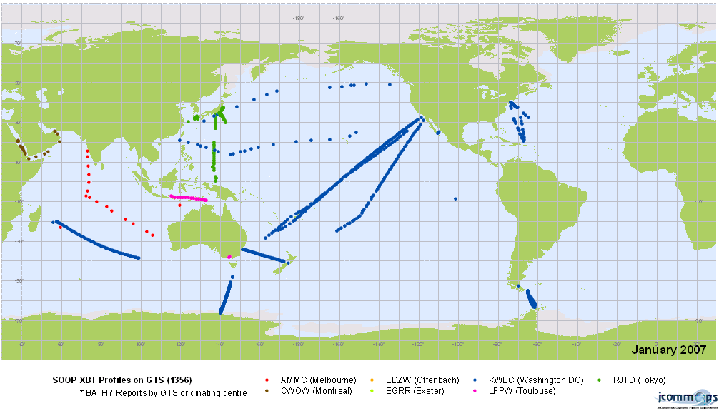
6.2.2 VOS Ship Locations:
http://wo.jcommops.org/cgi-bin/WebObjects/JCOMMOPS.woa/wa/map?type=GTSM_VOS
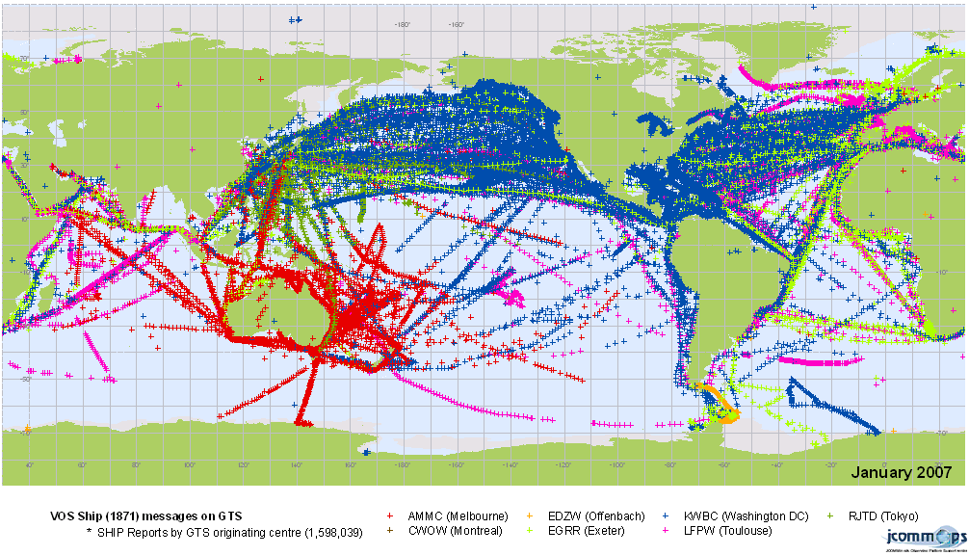

6.2.3 ASAP Observations:
http://wo.jcommops.org/cgi-bin/WebObjects/JCOMMOPS.woa/wa/map?type=GTSM_ASAP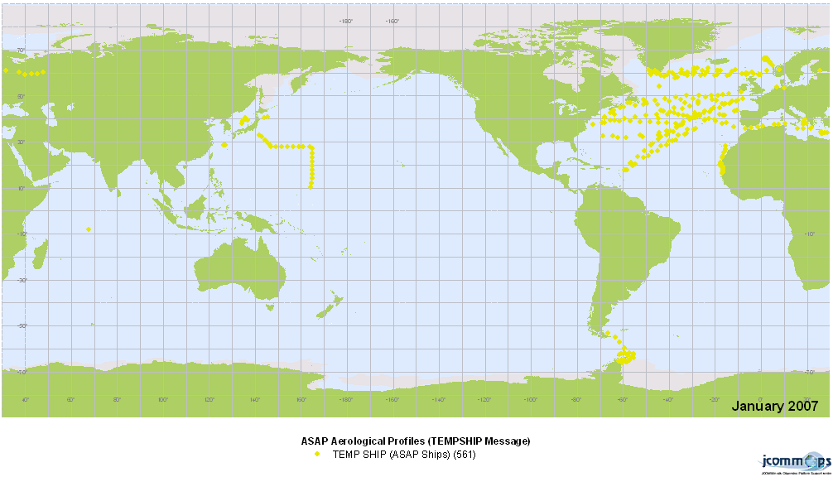
6.2.4 JCOMM Maps

6.2.4.1 All in situ marine observations:
http://wo.jcommops.org/cgi-bin/WebObjects/JCOMMOPS.woa/wa/map?type=GTSM_FMT
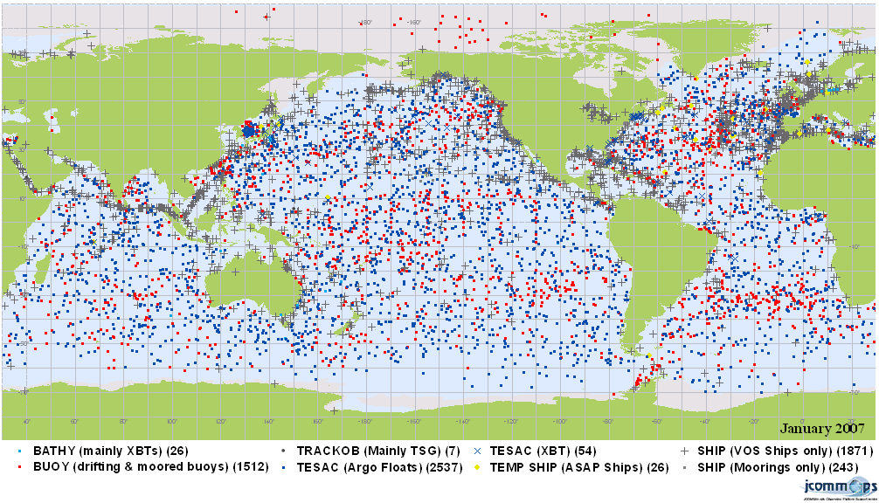
6.2.4.2 Sub-surface temperature profiles:
http://wo.jcommops.org/cgi-bin/WebObjects/JCOMMOPS.woa/wa/map?type=GTSM_TZ
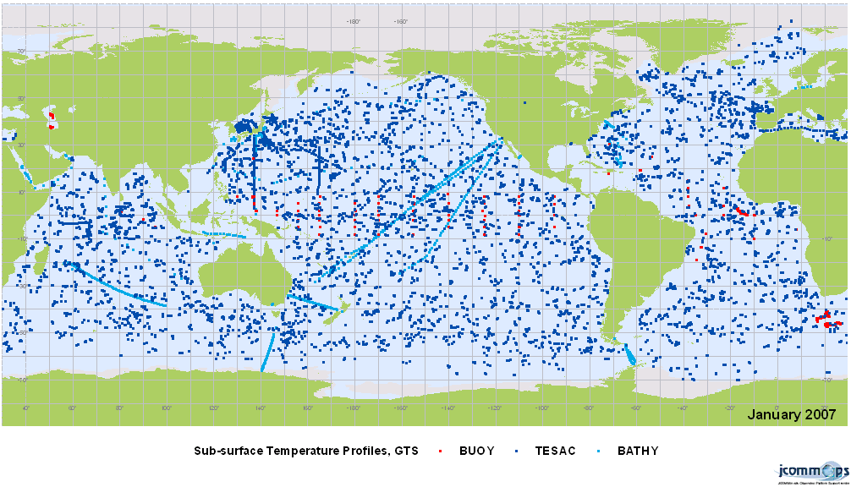

6.3 The SOOP Survey. Report is based on data and metadata submitted by the SOOP participants on a semestrial basis. Submitted data need to be carefully checked, and sometimes completed with additional information (e.g., line numbers). The SOOP line sampling indicators, a map, and 2D sampling tables and graphics are computed. Precise analysis (line by line) permits to identify where sampling is adequate, where lines are over-sampled, and where they are under-sampled. The following surveys were conducted during the last intersessional period:

January – June 2005
http://wo.jcommops.org/cgi-bin/WebObjects/SOOPIndicators
January – December 2005 – results online at
http://wo.jcommops.org/cgi-bin/WebObjects/SOOPIndicators
January – December 2006 survey had not been completed at the time of writing the report (January 2007) because not all of the required data were available as SOOP participants have until 31 March 2007 to submit required data and metadata.

The Technical Coordinator would be interested to further discuss changing the frequency of the report from twice to once per annum.

7. Information Exchange

7.1 Mailing list:

Existing mailing lists:

- SOT mailing list sot@jcommops.org
- SOOP mailing list soopip@jcommops.org
- Voluntary Observing Ship Programme: vos@jcommops.org
- VOS Clim: vosclim@jcommops.org
- Port Meteorological Officers: pmo@jcommops.org

7.2 News section on the web site:

SOOP news section available at:
http://wo.jcommops.org/cgi-bin/WebObjects/JCOMMOPS.woa/wa/news?prog=SOOP.
No news added since May 2005.

7.3 Websites

Only minor cosmetic changes were made to the SOOPIP website: (http://www.jcommops.org/soopip/) 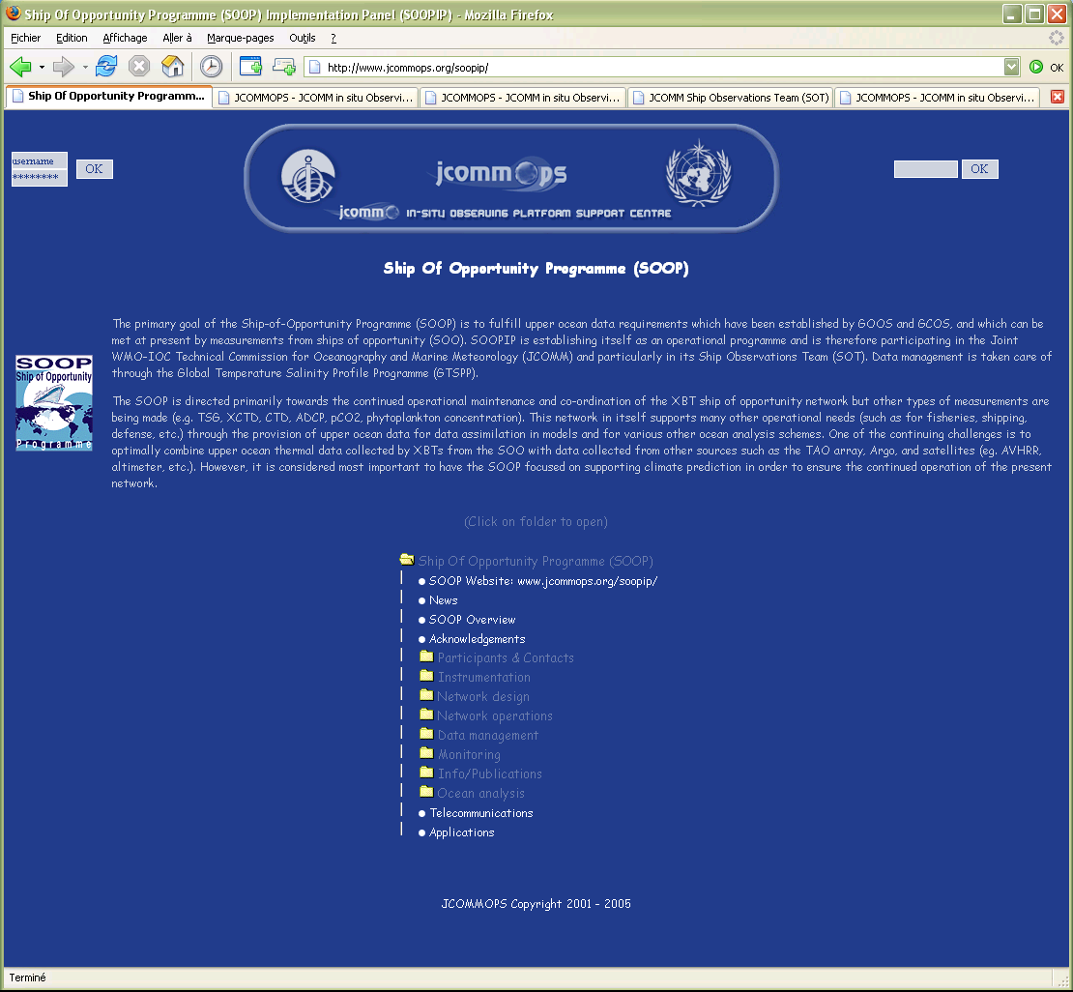

and SOT (http://www.jcommops.org/sot/) web sites apart from contact details, etc.
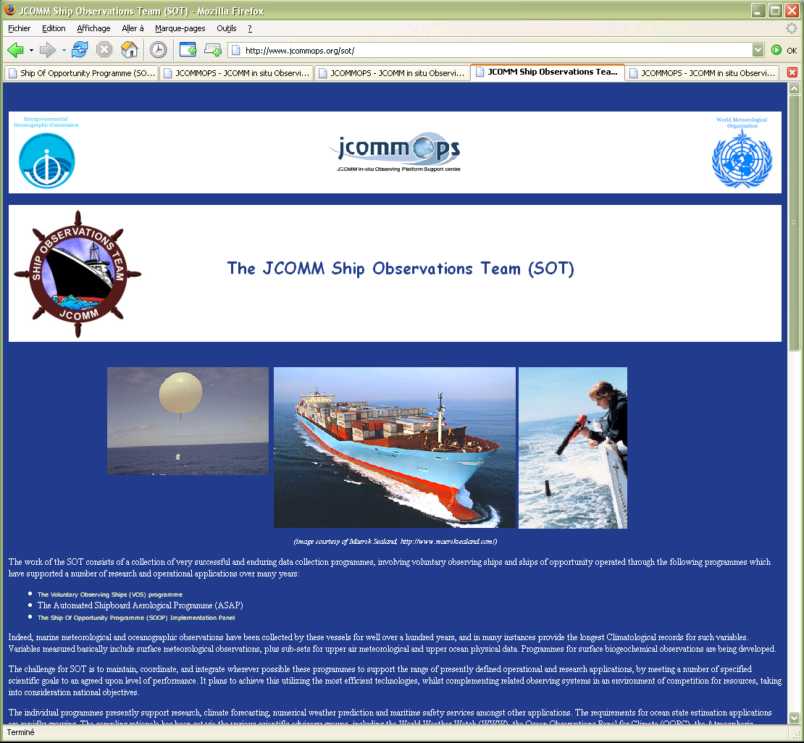

A draft website was created for the ASAP (http://www.jcommops.org/sot/asapp)
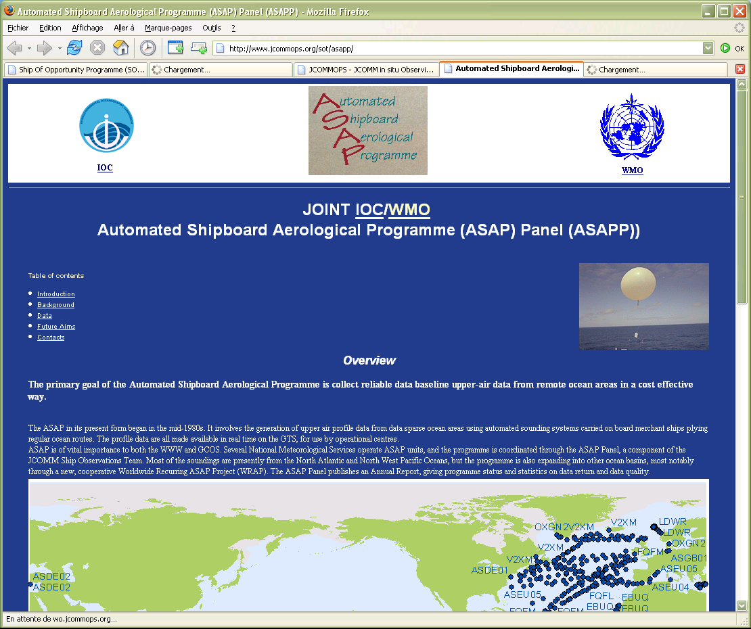

8. SOOP database

The SOOP database is operational at the JCOMMOPS.

The database is routinely updated with appropriate data from various sources. The database particularly includes: information on ships (call signs, ship names, allocation dates), SOOP lines and types of lines, national ship of opportunity programmes, agencies, contact points, statistics, information on data quality (from the GTSPP), GTS statistics from monitoring centres (Australia, Canada, France, Japan and USA), GTS BATHY reports received by Météo-France, a list of individual observations (including some metadata) made by the SOOP participants and also uploaded to the SOT Coordinator on a semestrial basis. Miscellaneous tools and query forms permit access to the database online via the JCOMMOPS website.

In order to keep the database up to date, the SOOP operators are invited to routinely provide the SOOP Coordinator with the list of ships they operate as well as metadata. The database has suffered from the vacancy in the SOT Coordinator position so metadata is not up to date in many cases.

9. Real-time metadata

Streams being considered which relate to the SOT include SOOP and VOS:
http://marinemetadata.org/examples/external/meta-t
See also the JCOMM Meeting Report 41, available in digital format on the WMO website at: http://www.wmo.int/web/aom/marprog/Publications/publications.htm#JCOMM%20MEETING%20REPORT%20SERIES. The JCOMM/Observations Coordination Group (OCG) Workshop to Establish a Pilot Project for the Collection of Real-Time Metadata Regarding Sea Surface Temperature and Water Temperature Profile Data Reading, United Kingdom, from 28 to 29 March 2006.

Appendix A

TC DBCP & SOOP/SOT activities by month
for the period February 2005 to January 2007

- February 2005

- 9-12 February 2005, Paris, JCOMM MAN-IV meeting.
- Apple Xserve G5 dual-processor 2.3 GHz ordered for deploying JCOMMOPS dynamic web applications (WebObjects).
- Argos Multisat service for all buoy users increases substantially number of BUOY reports distributed on GTS.
- Tools to import routinely WMO Publication 47 in JCOMMOPS database.
- New search tools via JCOMMOPS web site: platforms, wmo numbers, ships, GTS statistics, buoy monitoring statistics.
- Assistance to LMD regarding ECMWF BUFR encoding software (aeroclipper).
- Change coefficients to IGRF2005 for Geo-magnetic variation model used by Service Argos.
- Prepare user and reference guides for buoy metadata collection system and make it available via the web.
- Provide username/passwords to buoy operators and manufacturers for using buoy metadata collection system and provide some explanations on how to use the system.
- Finalize application to make collected metadata available in XML on a daily basis (ftp://ftp/jcommops.org/XML). Same data are also made available in CSV format (http://ftp.jcommops.org/CSV/).
- Produce GLOSS map for 2004 and make it available on-line.
- Preparation for SOT-III meeting.

- March 2005

- 3-4 March, visit of Steve Cook and Derrick Snowden at JCOMMOPS; discuss DBCP and SOOP issues and in particular preparation for SOT meeting.
- 7-12 March 2005, Brest, 3rd JCOMM SOT meeting.
- 17 March, visit of Julie Fletcher and John Burman at JCOMMOPS.
- Explain buoy metadata collection system to buoy operators.
- Suggest evaluation of quality of air pressure from mini-hull SVPB (following comments by Sergey Motyzhev).
- Continue work with CLS on Argos 2001-phase 3 project (i.e. redesign of GTS sub-system). Operational implementation planned early 2006.
- Provide BUFR decoder to Météo-France.
- Provide NOAA OCO with drifting buoy and float data for mapping project.
- Transfer some of SOOPIP web pages to JCOMMOPS.
- Investigate with Argo possibility to have DBCP meeting held in Peru in conjunction with Argo South American workshop.
- Configure new Mac OSX Xserv server and web configuration.

- April 2005

- 25-29 April 2005, Silver Spring, OCO System review meeting and OCG informal meeting.
- Continue work with CLS on Argos 2001-phase 3 project (i.e. redesign of GTS sub-system). Operational implementation planned early 2006.
- Collect missing inputs for SOOP semestrial survey, January-December 2004. Compile draft survey and seek comments.
- 11 April, student Julien Bourcier starts 3-month training period at JCOMMOPS to work on platform life-times; study, suggest methodology and supervise work.
- Buoy metadata collection: take user comments into account and correct bugs.
- Provide IOC with feedback/comments on I-GOOS.
- Re-organize JCOMMOPS web site structure, particularly monitoring and mapping sections.
- New map showing barometer drifting buoys by country now routinely produced by JCOMMOPS on a monthly basis.
- Tune WebObjects application and source code, and move JCOMMOPS web site and other dynamic applications to new Mac OSX Xserv server.

- May 2005

- 2-6 May 2005, San Diego, SIO, revise SVPB design manual with Bill Scuba; visit Pacific Gyre.
- Finalize SVPB desing manual.
- Finalize SOOP semestrial survey, January – June 2004.
- Finalize background document on JCOMMOPS for JCOMM-II.
- Import GDC metadata file (from GDC web site) into JCOMMOPS database
- Get list of mini-size drifters from GDC.
- Liaise with company in charge of new developments for the Argos GTS sub-system (BUFR compression).
- Provide Elizabeth Kent with comments regarding proposal for compilation of retrospective ODAS metadata and blending with ICOADS.
- Drifter life time study with student Julien Bourcier
- Start compiling information from buoy operators on calibration procedures.
- Begin document explaining rationale regarding JCOMMOPS location.
- Update SOOP operations guide to include information on ship visit rules.
- Make suggestions regarding DBCP-21 agenda (deployment strategies, technology workshop, OceanSites, Tsunami warning system, new Argos developments with regard to GTS data processing).
- Prepare documents on DBCP, SOT, and JCOMMOPS for JCOMM-II.
- Provide OCO with drifters and XBTs data.
- Produce new monthly map showing barometer drifters by country.
- Provide contact point information (NOAA/PMEL) to Malaysia regarding Tsunami buoys.
- Edit DBCP document on implementation strategy, and include latest information. Publish document via the DBCP and JCOMMOPS web sites.
- Edit DBCP document on satellite data telecommunication systems (by David Meldrum). Publish document via DBCP and JCOMMOPS web sites.
- DBCP brochure available on DBCP web site.
- Louis Vermaak demise on 30 May 2005. Great loss for the DBCP and ISABP programmes. Louis was ISABP Coordinator.

- June 2005

- 3 June 2005, Seattle, visit PMEL to discuss GTS distribution of TAO data and JCOMMOPS/OSMC cooperation.
- IABP meeting, Seattle, 6-8 June 2005.
- Inform buoy community about Louis Vermaak demise. Suggest ISABP to meet in Buenos Aires in conjunction with DBCP meeting as Louis was the Coordinator for the programme.
- Liaise with IBPIO and NPDBAP regarding organization of annual meeting in conjunction with DBCP meeting in Buenos Aires.
- SOT & JCOMMOPS web site updated to include SOT certificate of appreciation, VOS recruit presentation (by Steve Cook), and SOT-III final report.
- Drifter life time study with student Julien Bourcier.
- Re-design and re-structure JCOMMOPS web site with student Marianne Barrailh. Implementation planned in July.
- Work on proposed BUFR template for directional wave data based upon existing template used for GTS distribution of Spanish buoys and existing WAVEOB format.
- Liaise with company in charge of new developments for the Argos GTS sub-system (BUFR compression).
- Look for candidates to represent the DBCP at the next IPAB meeting in New Zealand, 12/2005.
- BOM now producing buoy monitoring statistics on a monthly basis.
- Provide assistance to CLS, Service Argos regarding development of database scripts to transfer automatically technical files from the existing Argos GTS sub-system to the new Argos data processing system which is being developed (Argos 2001-phase 3).
- SST & T profile metadata collection in real-time: look for candidates in the working group (OOPC, GOSUD, Argo DM, OceanSites).
- Investigate feasibility for organizing a buoy technology workshop in 2006. Look for candidates (OOPC, ECMWF).
- Turkey setting up a moored buoy programme (4 buoys initially). Provide technical assistance (satcomm).
- Prepare documents for DBCP meeting: Information Exchange, Technical Development workshop, Deployment opportunities and strategies, buoy Metadata collection scheme, SST and T profile metadata distribution in real-time.
- Get information from Christian Meinig, NOAA/PMEL, regarding new DART-II Tsunami monitoring buoy.
- Send DBCP workshop announcement to DBCP mailing lists.
- I was asked by GDC to make a GDP presentation at CLIVAR workshop in Concepcion, Chile, October 2005.

- July 2005

- Provide assistance to CLS, Service Argos regarding development of database scripts to transfer automatically technical files from the existing Argos GTS sub-system to the new Argos data processing system which is being developed (Argos 2001-phase 3).
- 11 July: participation in evaluation committee at Toulouse University for student Julien Bourcier’s work on buoy life times. Developed application has been integrated in JCOMMOPS web site.
- 12 July: New version of JCOMMOPS web site implemented. New navigation, new look, more comprehensive information included. Life-time computation and model component included in new web site.
- Prepare documents for DBCP meeting: Code matters, JCOMMOPS, QC, TC report.
- Accept that JCOMMOPS provides some technical advice regarding CLS, Service Argos, SIGMA project.
- IABP alerting DBCP that while Argos multi-satellite service is free, using it involves additional costs for Argos distribution system (ADS).
- Liaise with Met Office and Julie Fletcher regarding VOS quality monitoring and feedback.
- Check for ISABP status and possible meeting in Buenos Aires in conjunction with DBCP-21.
- In preparation for DBCP meeting, collect information on South Ocean buoy deployments planned for 09/2005 to 08/2006 (SOBP).
- 18-30 July: Vacation

- August 2005

- Prepare documents for DBCP meeting: GTS delays and Argos ground receiving network.
- JCOMMOPS moving to another office within CLS, Service Argos buildings.
- BUFR compression within Argos GTS sub-system. Participate in the tests with CLS and company in charge of the developments. Tests conclusive. Operational implementation planned in early September 2005.
- Continue working on BUFR template for directional wave data.
- Continue collecting information on buoy calibration procedures.
- Finalize document on impact of JCOMMOPS relocation.
- Review draft WMO guide on methods of observations, and particularly part dealing with data buoys.
- Prepare draft report and summary and compile annexes for DBCP annual report for 2004.
- Evaluate new software module required for Pacific Gyre Minimet (exponential function) for implementation within Argos GTS sub-system (hurricane drifters).
- Review Marlin BT technical file for GTS distribution of temperature profile data.
- Investigate status of Svalbard & Barrow ground receiving stations.
- Participation in Observing System Monitoring Centre (OSMC) discussions.
- September 2005

- 18 September: deployment of drifter “1250”. Specific news prepared for JCOMMOPS web site.
- 19-23 September, Halifax, JCOMM-II meeting; 22 September, visit of Met Ocean.
- Write document on life-time study for presentation at DBCP workshop.
- New version of Argos GTS sub-system with BUFR compression capability implemented 6 September 2005; effective 28 September 2005. Test reports made available via JCOMMOPS FTP site.
- Develop dynamic maps available in Universal Polar Stereographic projections (North and South) in addition to existing flat square ones.
- SOOP Semestrial survey, Jan-June 2005.
- Work on Argos GTS sub-system template for hurricane drifters (SIO).
- Discuss GDP Chair nomination with Peter Niiler, David Meldrum.
- Revision 1.6 of Argos GTS sub-system reference guide.
- Finalize document on GTS delays and Argos ground receiving network. Prepare presentations for DBCP-21.
- Work on JCOMMOPS web site reliability.
- Lessons learned from Rita and hurricane drifters: (i) prototype Argos message formats must be validated beforehand, and (ii) Service Argos must develop strong expertise for creating and debugging Argos GTS sub-system templates.

- October 2005

- Work on article on buoy vandalism to be published in METMAR.
- Preparatory document on vandalism for DBCP session.
- Preparation for CLIVAR, IBPIO, NPDBAP, DBCP, JTA meetings.
- 13 October, Conception, Chile, CLIVAR South Pacific Workshop. Make presentation on Global Drifter Program.
- 16-26 October, Buenos Aires, Argentina, IBPIO-8 (15 Oct), NPDBAP-4 (16 Oct), DBCP-21 (17-21 Oct.), JTA-25 (24-26 Oct.) meetings.
- SOOP Semestrial Survey, Jan.-June 2005 (new inputs).

- November 2005

- 7-8 Nov., Ostend, IOC MLA2 meeting.
- 18 Nov., Paris, IOC, JCOMM issues, TC/DBCP recruitment, DBCP users and technology workshop preparation.
- Assist with recruitment of new TC/DBCP-SOOP Technical Coordinator. Draft recruitment notice, discussion, seek comments.
- Preparation for ET on Data Representation on Codes meeting: IOC, JCOMM, Argo, and DBCP requirements.
- Service Argos operational problems reported by users.
- Analysis if why BUFR compression is causing performance problems.
- Argos GTS sub-system bug fixes and performance improvements.
- DBCP workplan for the next intersessional period.
- Prepare documents & PowerPoint presentation for Julie Fletcher and Graeme Ball on DBCP activities for IPAB meeting in Dunedin, NZ.
- SAWS looking for buoy data in 2000. MEDS providing data.
- Provide assistance to Norway regarding Bouvet Island AWS.
- JCOMMOPS temporarily allocating WMO numbers on behalf of WMO.
- Preparation of workshop for establishment of Pilot Project to collect in real-time metadata concerning SST and profile data. Workshop to be held at ECMWF, 28-29 March 2006.
- Discuss preparation of DBCP Users & Technology workshop with DBCP Chair.
- Barometer upgrade issue: risk for less barometer upgrade opportunities for other countries than USA in case USA deploys too many barometers in certain regions (e.g. North Atl., Indian Ocean).

- December 2005

- 5-8 Dec. Oman, ET on Data Representation and Codes. Represent IOC and JCOMM. Submit proposal by DBCP for BUFR template for buoy directional wave data; submit Argo proposal for new profiling float BUFR template.
- 13-15 Dec., Washington-DC. Attend POGO Research cruise database workshop (useful for deployment opportunities). Meet with Mike Johnson, Steve Piotrowicz, and Stan Wilson to discuss future of JCOMMOPS. Meet with Gary Soneira to discuss SOOPIP issues. Meet with Bill Woodward to discuss Service Argos issues.
- Assess DBCP financial situation.
- New DBCP definitions uploaded on web site (new definitions of life-times according to E-SURFMAR).
- 19-31 December, vacation.

- January 2006

- Prepare transition for the next TC/DBCP&SOOP; prepare documentation; configure new TC/DBCP portable computer and install appropriate tools; sort out DBCP & SOOP historical documents.
- New JCOMMOPS quarterly map to show upper ocean thermal profile data by country.
- Assist with recruitment of new TC/DBCP-SOOP TC in coordination with IOC.
- Correct bug in Argos GTS sub-system regarding coding of WMO numbers (WMO region 7, Antarctica was coded 7 in BUFR, i.e. missing, instead of 0).
- Problem in ECMWF monitoring statistics: bias was artificially removed before statistics computation. As ECMWF to change software.
- Requirements for Argos satellite covering orbit presently occupied by NOAA-K.
- Performances problems at Service Argos regarding GTS sub-system. Database tuned, some of the BUFR temporary tables reduced in size to fix problem.
- Add new BUFR descriptors and templates in Argos GTS sub-system database and JCOMMOPS database. This includes buoy wave template and new Argo template. Changes will be required in the Argos GTS sub-system in order to be able to process water pressure data as “level” data.
- Information on NOAA-K potential lost impact on Argos constellation, delays and data return submitted to Météo-France; requirement for Microsat expressed.
- 31 January, end of Etienne Charpentier’s contract as TC of the DBCP and SOOP, after many years of enjoyable work with DBCP and SOOP members and others. Thanks to all for your contributions, dedication, responsiveness and involvement in the work of the Panels.

- February 2006

- TC DBCP/SOT Position vacant.

- March 2006

- TC DBCP/SOT Position vacant.
- 27-28 March, Reading, UK, DBCP data users and Technology workshop with participation from Chair, Vice-Chair, Panel Members and the former Technical Coordinator.
- 28-29 March, Reading, UK, meeting for the establishment of META-T Pilot Project, with participation from Chair, Vice-chair, Panel Members and former Technical Coordinator.

- April 2006

- TC DBCP/SOT Position vacant.
- 24-26 April, Bremerhaven, Germany, 16th meeting of the IABP.

- May 2006

- TC DBCP/SOT Position vacant.
- 30 May – 2 June, Buenos Aires, Argentina, 11th meeting of the ISABP.

- June 2006

- TC DBCP/SOT Position vacant – Hester Viola to begin 1st July 2006.
- 13-14 June, Galway, Ireland, E-SURFMAR DB-TAG meeting.
- Coordination of SOBP commitments.
- New WMO numbering scheme drafted

- July 2006

- Visited IOC, Paris for two days. Met with many colleagues and discussed expectations of the TC role and the role of IOC.
- Met key people at CLS Argos.
- Familiarisation with JCOMMOPS web site, read past reports and presentations, JCOMMOPS operations manual, reviewed documentation and priorities of former TC, assimilated email communications between panel members.
- Contacted mailing list members and individuals by way of introduction.
- Training and hand over for one week, with the former Technical Coordinator, Etienne Charpentier at JCOMMOPS, to learn the technologies and processes behind the JCOMMOPS information system. Solved some technical problems with computer and software set up. Went through
  - Database structure,
  - Server configurations
  - Various data loading processes (routine and manual),
  - Argos’ GTS Subsystem,
  - JCOMMOPS online query and monitoring applications.
- Worked on data loading for the SOOP Semestrial survey for 2005.
- Training and hand over for one week, with Etienne Charpentier at WMO, to learn the organizational aspects of DBCP, SOT and JCOMM.
  - Discussed the role of the TC and reporting mechanisms
  - Familiarisation with:
    - The DBCP, its implementation strategy and priorities.
    - The DBCP Action Groups and their priorities.
    - The SOT, its structure, the sub-Panels (VOSP, ASAPP, SOOPIP) and their current issues and priorities. VOSClim.
    - Applications of buoy and ship data (NWP, climate variability and predictability, GODAE, satellite, operational and research).
    - Conclusions from the Upper Ocean Thermal review (1999).
    - Status of in situ marine observing networks, data sparse areas, potential for further developing the networks to better meet user requirements.
    - Data management and distribution including the GTS and WIS, migration to table driven code forms, collection of metadata.
    - Requirements for standardisation (documentation, best practices, metadata, instrumentation).
    - Satellite data telecommunication requirements.
    - WMO Publication 47.
    - WMO identification numbers for buoys.
  - Reviewed documents from previous DBCP sessions and looked at documentation for DBCP 22.
  - Met with many people, to become more familiar with WMO, particularly World Weather Watch and the Applications Programme Department but also the various Climate and Oceanographic collaborative programs.

  - Went through the DBCP web site structure and development principles and the Metadata Entry Web pages.
  - Discussed future issues for DBCP.

- August 2006

- Familiarisation with JCOMMOPS web site, read past reports and presentations, JCOMMOPS operations manual, reviewed documentation and priorities of former TC, assimilated email communications between panel members.
- Worked on data loading and analysis for the SOOP Semestrial survey for 2005. Worked extensively on correcting errors in data and identifying transects.
- Discussed delays in satellite telecommunications with DBCP Chair.
- Updated contact details on (most) websites. Made some minor changes to DBCP web page.
- Organised several visits within the USA following DBCP 22.
- Discussed delays in satellite telecommunications with DBCP Chair.
- Preparation for DBCP 22 and Action Group meetings, documents and presentations.
- Confirmed with DBCP Chair of intent to continue in the role for 2007 under the same conditions (Depending on contract).
- Maintained mailing lists – updating erroneous addresses (which were bouncing) and added new recipients.
- Produced monthly maps.
- Loaded monthly Buoy Monitoring statistics into the JCOMMOPS database.

- September 2006

- Preparation for DBCP 22 and Action Group meetings, documents and presentations. Produced figures for and reviewed documents 8.3 and 8.6.2 for CLS (Philippe Gros). Prepared a PowerPoint template for all JCOMMOPS presentations.
- Organised travel for DBCP22 including writing a derogation report for UNESCO due to the length of the planned trip. Prepared paperwork for visits to secure sites. Organised appointments for meetings following DBCP throughout the USA.
- Generated reports for WMO (Etienne Charpentier) on the number of VOS ships recruited by African countries (RA-I) and the amount of GTS data produced.
- Produced some introductory text for the JCOMM newsletter for IOC (Candyce Clarke).
- Loaded the latest Publication 47 Ship metadata file into the JCOMMOPS database.
- Familiarisation with the Quality Control Email Relay utility and modified some Ship metadata to ensure it worked for two ships which had changed from VOS-Netherlands to VOS-USA, based on a request from Météo-France (Pierre Blouch).
- Investigated why a buoy was reporting on the GTS with an Australian WMO number, though Australia (Graeme Ball) was not using that number. Number was not in use by any other nation but something was erroneously shown as transmitting from Canada (presumably unintentionally) then Australia.
- Modified a presentation about JCOMMOPS for use by Johannes Guddal to present to representatives of the offshore resources industry:ftp://ftp.jcommops.org/jcommops/Presentations/JCOMMOPS-2006.zip.
- Maintained mailing lists – updating erroneous addresses and added new recipients.
- Produced monthly maps. Began reviewing Metadata in the JCOMMOPS database to improve the maps, regarding identifying Countries and Agencies for all Buoy Platforms.
- Loaded monthly Buoy Monitoring statistics into the JCOMMOPS database.
- Worked on data loading and analysis for the SOOP Semestrial survey for 2005.
- . Completed a draft of the SOOP Semestrial for 2005 survey:ftp://ftp.jcommops.org/SOOP/Survey/2005-First-Draft or http://wo.jcommops.org/cgi-bin/WebObjects/SOOPIndicators including updating the yearly SOOP maps at http://w4.jcommops.org/WebSite/GLOSS/.
- Discussed the metadata provision from AOML for SEAS XBT SOOP data (Gustavo Goni), providing templates for preferable data formats, beginning 2006.
- Familiarisation with the planned process for SOTIV in 2007 (from information provided by the Chair Graeme Ball). Reviewed draft agenda.
- Drafted some work assignments for UNESCO Performance Monitoring process.
- Made minor changes to SOOP, DBCP and JCOMMOPS websites.

- October 2006

- Maintained mailing lists – updating erroneous addresses and added new recipients.
- Produced monthly maps.
- Loaded monthly Buoy Monitoring statistics into the JCOMMOPS database.
- Continued reviewing Metadata in the JCOMMOPS database to improve the maps, regarding identifying Countries and Agencies for all Buoy Platforms.
- Continued discussions with AOML (Gustavo Goñi) about data formats from AOML for SEAS XBT SOOP metadata with, providing templates for preferable data formats beginning 2006.
- Attended monthly meeting with CLS.
- Travelled to USA for DBCP22, JTA26 and other appointments.
  - Attended meeting of the IBPIO to attain a greater understanding of Data Buoy requirements and experiences specific to the Indian Ocean.
  - The annual meeting of the North Pacific Data Advisory Panel allowed for familiarity with the DBCP activities relating to the North Pacific.
  - The 22nd session of the DBCP, which was held in La Jolla, CA from 16 – 20 October 2006. Reported on activities as Technical Coordinator of the DBCP reported on several topics (implementation, information exchange, quality control, deployment opportunities, satellite data telecommunications, JCOMMOPS etc) and participated in additional discussions during and after meetings.
  - Attended discussions about Pilot projects such as the Iridium Pilot project.
  - Meeting with Ship Observations Team chair and others to discuss the proposed agenda for the SOT meeting in 2007.
  - Meeting with Steve Cook, Chair of SOT Ship of Opportunity Implementation Panel to discuss some background and future plans for the panel.
  - Attended the 26th Argos Joint Tariff Agreement (JTA) session allowing for a greater understanding of the challenges facing Argos users and more familiarity with how Argos usage is managed.
  - Visited Pacific Marine Environmental Laboratory.
  - Visited Applied physics Laboratory, University of Washington included an informal discussion with Ignatius Rigor about the aims and future plans of the Arctic Buoy Programme (IABP). Visited the School of Ocean Sciences focussed on Instrumentation relating to Argo and prototype instruments such as Gliders.
  - Met (along with Mathieu Belbeoch) with CNES Education Officer to discuss data for educational programme called Argonautica. The program will track data from Buoys and Floats and potentially deploy floats, for school children to study.

- November 2006

- Continued travel in the USA and other appointments:
  - Washington DC, the first visit was to the NOAA Office of Climate Observation for a discussion about requirements and the role of JCOMMOPS with Mike Johnson. Also visited Office of Oceanic and Atmospheric Research, AOML office, for a more practical understanding of the logistics involved in the XBT program run by the USA. Gary Soneira provided a lot of information about work completed in the past and how data was managed currently. Visited CLS America to meet the team representing North American Argos users.
  - Atlantic Oceanographic and Meteorological Laboratory and Global Drifter Center I discussed the logistics and practicalities of Drifter Deployment, Data quality and the SOOP programme.
  - Visited NDBC, which was very informative in the areas of Quality Control of data, logistics and practicalities of Moored Buoy maintenance, the US VOS and the overall role of NDBC within the US programme. Visited Navoceano and discussed future requirements with the colleagues of Elizabeth Horton.
- Maintained mailing lists – updating erroneous addresses and added new recipients.
- Produced monthly maps. Worked on Metadata within JCOMMOPS database based on information provided by CLS and buoy operators.
- Sourced Metadata from France (Pierre Blouch) and Canada (Yvonne Cook and Bruce Lohnes) about Moored Buoys. Added and modified the data in the JCOMMOPS database based on this information.
- Loaded monthly Buoy Monitoring statistics into the JCOMMOPS database.
- Attempted to update GLOSS network status and Yearly maps without success.
- Reviewed Iridium Pilot Project whitepaper. Began putting together a Wiki site (this was moved to a static webpage eventually) see Draft Web page at http://www.jcommops.org/DBCP/iridium-pp/index.html.
- Arranged for a new email list for the Iridium Pilot Project iridium-pp@jcommops.org and added initial addresses.
- Attempted to resolve issues with Wikipedia web page for Meta-T pilot project (without success). Fortunately the site could be moved to http://marinemetadata.org/examples/external/meta-t
- Updated DBCP mailing lists and contact details in the JCOMMOPS database for attendees at DBCP22.
- Provided information to the future chair of the DBCP Evaluation group (Bill Burnett) about the groups participants and email list.
- Distributed International Arctic Buoy Programme (IABP) deployment plans for the International Polar year to interested parties. Updated the deployment plans web page. http://www.jcommops.org/depl_opport/depl_opport.html.
- Reviewed the functionality and aims of the NOAA Observing System Monitoring Center. http://osmc.noaa.gov/OSMC/.
- Prepared DBCP Workplan for 2007 Intersessional Period including incorporating tasks from the previous year and the workshops in Reading, UK in 2006. Distributed the plan to all attendees at the DBCP.
- Attended monthly meeting with CLS.

- December 2006

- Maintained mailing lists – updating erroneous addresses and added new recipients.
- Updated contact details for manufacturers.
- Produced monthly maps. Requested additional metadata from Buoy operators. Worked on Metadata within JCOMMOPS database based on information provided by CLS and buoy operators. Metadata for active Moored and Drifting Buoys is now far better than it had been since the TC role was vacated by Etienne at the start of the year. Requested the CLS (Fernand Cid) delete incorrect data in the Argos GTS Subsystem.
- Loaded monthly Buoy Monitoring statistics into the JCOMMOPS database.
- Made minor changes to SOOP, DBCP and JCOMMOPS websites.
- Monthly meeting with CLS. Identified many issues with data in the GTS sub system, which was affecting the metadata in the JCOMMOPS database and therefore the metadata needed for Map products produced. Problem was resolved and CLS agreed to check this problem regularly.
- Assisted JTA Chair (Yves Tréglos) with ways to manage documentation for JTA in the future.
- Visited Météo-France, IFREMER and IRD in Brest, France.
- Responded to an email from a participant in the “Windwalker II” cruise (Pablo Mejia) who was offering to collect SOOP data on the cruise. Suggestion from Australia (Graeme Ball) was that they should mount a drifter on the boat to collect some data during the cruise. Could also be used for deployments. Referred Pablo to AOML for sourcing a buoy and to discuss deployments.
- Reviewed proposals from DBCP Chair and Training workshop plans for 2007.
- Contacted Turkish Met Office regarding the Moored buoy program.
- Updated information about South African Deployment opportunities.

- January 2007

- Updated GLOSS network status and Yearly maps for 2006: http://w4.jcommops.org/WebSite/GLOSS/ and http://wo.jcommops.org/cgi-bin/WebObjects/JCOMMOPS.woa/wa/map?type=GLOSS_Y.
- Reviewed notes about Drifting Buoy and SOOP metadata for the Meta-T project.
- Made minor changes to SOOP website for a more consistent look and feel.
- Updated the deployment plans web page for Cape Verde vessel 2007.http://www.jcommops.org/depl_opport/depl_opport.html
- Along with Mathieu Belbeoch worked on enabling Web Map Services from ArcIMS mapping applications on JCOMMOPS website. EG. Dynamic Map of DBCP monthly status: http://w4.jcommops.org/wmsconnector/com.esri.wms.Esrimap?request=getMap&ServiceName=DBCP&Service=wms&Version=1.1.1&Layers=0,12,13,1,By%20country&SRS=EPSG:AUTO&bbox=-180,-90,180,90&width=800&height=400&Format=image/png.
- Produced monthly maps. Worked on Metadata within JCOMMOPS database based on information provided by CLS and buoy operators. There are now only a handful of buoys without information about country and agency due to the fact that they do not use Argos.
- Described the Quality Control relay process to Bruce Lohnes and Bill Burnett based on a request about GTS data errors going to NDBC.
- Attended monthly meeting with CLS.
- Responded to a query from Japan about data from their XBT samples on line PX40, which do not appear to be on the GTS. Problem was found to be at the source as data is erroneous.
- Discussed ways to manage JTA contacts and national reports with CLS (Philippe Gros) potentially using JCOMMOPS web page and applications.
- Minor updates to the Web Mapping applications for DBCP and SOOP. Developed templates for new monthly maps to be trialled in beginning of 2007.
- Reminded SOOP participants to review the draft report for 2005 and requested metadata be sent for 2006.
- Began reviewing the DBCP Brochure (from 2001) to implement updates.
- Began testing and reviewing the functionality and aims of the latest beta version of the NOAA Observing System Monitoring Center: http://osmc.noaa.gov/OSMC/ to be fed back to NDBC and PMEL. Reviewing documentation provided by NDBC.
- Met with Loic Petit La Villeon about SOOP metadata requirements.
- Discussed and saw a demonstration of the CLS Argos User Office system with CLS (Philippe Gros) and requested a list of programmes with contacts and countries to try to resolve metadata issues with “Programs” in the JCOMMOPS database.

