WORLD METEOROLOGICAL ORGANIZATION  ________________________ | INTERGOVERNMENTAL OCEANOGRAPHIC  COMMISSION (OF UNESCO)  ________________________
JOINT WMO/IOC TECHNICAL COMMISSION FOR OCEANOGRAPHY AND MARINE METEOROLOGY (JCOMM)  SHIP OBSERVATIONS TEAM  FOURTH SESSION  GENEVA, SWITZERLAND, 16 TO 21 APRIL 2007 | SOT-IV/Doc. I-2.2  (9.III.2007)  __________  ITEM I-2.2  Original: ENGLISH

SOT-IV
COMMON SESSION: REPORTS

Report by the Observations Programme Area Coordinator

(Submitted by Mr Michael Johnson, Coordinator, JCOMM Observations Programme Area)

Summary and purpose of document

This document contains a report from the JCOMM Observations Programme Area (OPA) Coordinator, outlining goals and progress made towards: achieving global coverage by the in situ networks, system-wide monitoring and performance reporting, and funding to meet implementation targets.

ACTION PROPOSED

The Ship Observations Team is invited to: note the information provided and discuss as necessary; provide feedback to the OPA Coordinator; place actions on itself; request actions of the OPA Coordinator or of the Secretariat.

______________________

Appendices: A. JCOMM Observations Program Area Strategic Work Plan (Draft March 2007)
B. Status of in situ ocean observing networks
C. Quarterly performance reports for sea surface temperature, sea surface salinity,
temperature profiles, salinity profiles, and near-surface currents
D. Recommendation 3 (JCOMM-II): Consumables for Ship-based Observations
E. WMO Resolution 7 (EC-LVIII): Ship Owners and Masters’ Concerns with Regard to VOS Data Exchange

DISCUSSION

1. Introduction

1.1 The Observations Program Area (OPA) of the Joint WMO-IOC Technical Commission for Oceanography and Marine Meteorology (JCOMM) includes three implementation panels - the Data Buoy Cooperation Panel (DBCP), the Ship Observations Team (SOT), and Global Sea Level Observing System Group of Experts (GLOSS GE). These panels sponsor sub panels, task teams, and action groups to coordinate work on specific technical and regional issues. The OPA maintains the linkage with other international implementation panels, which also provide important contributions to the global ocean observing system even though they are not officially part of JCOMM: (i.) the Argo Steering Team (profiling floats), (ii.) the OceanSITES Steering Team (long-term, deepwater ocean reference stations), and the International Ocean Carbon Coordination Project (IOCCP).

1.2 Each of the implementation panels continues to deal with issues specific to their ongoing operations such as: data formats, instrument inter-calibrations and testing, deployment logistics, etc. At the same time, three observing system issues are common across all elements of the OPA, and its Observations Coordination Group (OCG) has chosen to give priority attention to these:

- Achieving global coverage by the in situ networks
- System-wide monitoring and performance reporting
- Funding to meet implementation targets

2. Achieving global coverage by the in situ networks

2.1 A draft Strategic Work Plan for the OPA is attached as Appendix A. This plan lays out an initial strategy for phased implementation of the JCOMM/OPA contributions to the composite global ocean observing system as defined in the GCOS Implementation Plan for the Global Observing System for Climate in support of the UNFCCC (GCOS-92). The GCOS-92 has been endorsed by the UNFCCC, and the ocean chapter has been endorsed as the ocean backbone of the Global Earth Observation System of Systems (GEOSS). The draft plan will be considered by the Second Session of he Observations Coordination Group (OCG-II, Geneva, Switzerland, from 23 to 25 April 2007), and the SOT is invited to review this draft and provide comments and suggestions via the SOT Chairperson.

2.2 Although the backbone system specified by GCOS-92 is designed to meet climate requirements, marine services in general will be improved greatly by implementation of the global coverage called for by this design. The system will support global weather prediction, global and coastal ocean prediction, marine related multi-hazard warning systems, marine environmental monitoring, and many other non-climate users.

2.3 The JCOMM is identified as the implementing agent, or a contributing implementing agent, for twenty-one of the specific actions listed in the GCOS-92 ocean chapter. These specific actions now provide an excellent roadmap, and the OPA Work Plan is be based on implementing the ocean chapter of GCOS-92. The GCOS-92 goals are essentially the same that the JCOMM OPA has been pursuing since JCOMM-I (Akureyri, Iceland, 19-21 June 2001) – global coverage by the moored and drifting buoy arrays, profiling floats, tide gauge stations, and ship-based networks (plus continuous satellite missions – not the direct responsibility of the JCOMM, but essential to global ocean observation).

2.4 Continuity in the observing system is recognized by the OPA as being of central importance for climate applications. The OPA accepts the GCOS Climate Monitoring Principles as best practice. The work of the DBCP, SOT, and GLOSS GE is conducted in accordance with the GCOS Climate Monitoring Principles wherever possible.

2.5 Tide gauge stations and moored buoys for tsunami warning and storm surge are now a priority for the international global observing system. Opportunities for the JCOMM OPA support to the marine related international multi-hazard warning systems include: real-time reporting from GLOSS tide gauge stations, coordinated deployment of ocean buoys, and the use of common platforms and logistics infrastructure for multiple observational purposes. Implementation of observational components in support of the comprehensive marine related international multi-hazard warning systems will also be a main requirement driver for the OPA work plan over the next several years.

2.6 An Expert Meeting on Possible JCOMM Contributions to the Development and Maintenance of Marine Multi-Hazard Warning Systems (J-MMWS), Geneva, Switzerland, from 1 to 3 February 2006, to help chart this part of the work plan. Several specific actions were identified where the OPA is already working in cooperation with the international tsunami and Arctic groups, and others where the OPA could offer to help. Some immediate actions already underway include: 1.) The GLOSS Group of Experts is working with the Data Management Area to establish standard protocols and formats for GTS transmission of tide gauge data in real-time, 2.) The DBCP sponsored a technical workshop in October 2006, in conjunction with the DBCP annual meeting, at which tsunami warning buoys (DART) were highlighted. Coordination of DART operations with the other data buoy operations was a major topic of discussion at the DBCP meeting.

2.7 A major milestone was achieved by the DBCP in 2005. The global drifting buoy array reached its design goal of 1250 buoys in sustained service. Thus, the global drifting buoy array became the first component of the Global Ocean Observing System (GOOS) to be completed. This milestone was celebrated in conjunction with Second Session of the JCOMM (JCOMM-II in Halifax, Canada, 18 September 2005). A major challenge facing the DBCP at the present time is developing an operational implementation strategy for maintaining the array evenly spaced (i.e., minimizing the gaps in global coverage). The SOT must be a major player in helping to develop this implementation strategy, since most drifting buoys are deployed by ships-of-opportunity.

2.8 A DBCP Data Users and Technology Workshop was held in Reading, United Kingdom, from 27 to 28 March 2006, to take stock of the present capabilities of the global data buoy array and plan for future optimizing of buoy designs, and maximizing the usefulness of usefulness of buoy data in terms of impact on weather and climate forecasts. The need to develop new generations of sensors and platforms to address spatial and temporal sampling requirements, smart in situ data selection, communications options, and data processing were also addressed. One immediate finding of the workshop was that the NWP users recommended that the entire drifting buoy array should be equipped with barometers. The goal for the global drifting buoy array has been adjusted in response to this user request, from the former 600 barometer upgrades to now target 1250 barometer upgrades globally.

2.9 Following previous discussions with the DBCP, the SOT, OCG, and the Fourth Session of the JCOMM Management Committee (MAN-IV), the Water Temperature Metadata Pilot Project (META-T PP) was established by the JCOMM/OCG Workshop (Reading, United Kingdom, 28-29 March 2006). Ms Elanor Gowland from the United Kingdom Met Office is currently chairing the Pilot Project Steering Team. The goals of the Workshop were: (i.) to consider user requirements, metadata relevant for the pilot project, and to draft the list of required metadata and categorization, (ii.) to identify the metadata information that needs to be available in real-time, (iii.) to identify centre(s) to host/serve metadata, and (iv.) to develop an action plan for advancing the pilot project. The Meeting reviewed all of the in situ ocean observing systems and data management counterparts delivering SST and temperature profile data, including the GOSUB, GTSPP, Argo, DBCP, SOT, OceanSITES, ODAS. A large number of user requirements have been considered, including the NWP, SST analysis and GHRSST, data assimilation and ocean field analysis, ocean modeling, ocean modeling validation, climate forecast, seasonal to decadal climate variability, satellite validation, operational activities (e.g., weather forecasters, disaster response), quality assurance activities serving above applications, and diagnostic by platform operators.

2.10 The Workshop proposed three categories of metadata, such as: (i.) metadata required for real-time distribution along with the observational data, (ii.) metadata required for real-time use but not necessarily being transmitted along with the observational data (available via servers), and (iii.) other metadata not required in real-time. Possible types of metadata have been identified and cross-checked with the user requirements. So an initial categorization could be drafted. The Steering Committee has then refined categories definitions and categorization. The Workshop noted with considerable appreciation the offer made by the National Marine Data & Information Service (NMDIS, China), to host metadata servers for the Pilot Project. The Workshop also recommended that the JCOMM/OCG address the issue of metadata collection, in view of its eventual integration through the JCOMM ODAS metadata centre. The National Data Buoy Center (NDBC, NOAA) also expressed its interest to participate in this pilot project by offering to hosting a mirror server, and would investigate feasibility of this issue.

2.11 Ship owners and masters’ concerns regarding availability of VOS ship’s positions on public websites not controlled by the NMHS is an issue that has been discussed since early 2005. They justify their concerns because of piracy acts in certain regions as well as because of commercial competitiveness reasons (e.g., fisheries). It is a matter of concern that because of this situation, ship owners and masters may withdraw their vessels from the VOS Scheme. The International Chamber of Shipping (ICS) recently explained that it would certainly prefer to find a solution that addresses ship owners' concerns and at the same time continues to support the excellent work of the forecasting and weather reporting services. This serious problem, if not adequately addressed, could therefore ultimately lead to a substantial decrease in the number of recruited VOS ships and threaten the programme. At its Fifty-eighth Session, the WMO Executive Council (Geneva, Switzerland, June 2006), adopted Resolution 7 (EC-LVIII) – Ship owners and masters’ concerns with regard to VOS data exchange. The Resolution (see Appendix E) authorized, in particular, for a trial period of one year Members to mask the ship’s call signs from FM-13 SHIP reports provided that they provide access to a secured database with ship’s identification. At the same time, the Council requested the Secretary-General, to establish a high level dialogue on the issue, involving in particular affected Members, shipping companies, the IMO, ICS, JCOMM, CBS, and to report at the Fifty-ninth Session of the Executive Council (EC-LIX) in 2007. It can be noted that unique ship identification is absolutely needed the following issues: (i.) delayed-mode and real-time quality monitoring, (ii.) quality information feedback from monitoring centres to the ship operators or Port Meteorological Officers, and (iii.) global climate studies. Quality monitoring activities are being undertaken by: (i.) the RSMC, Exeter, as CBS lead centre for the quality monitoring of surface marine data, (ii.) VOSClim RTMC for the real-time monitoring of VOSClim data, and (iii.) operational data assimilation centres (black listing, and automatic bias correction). Masking schemes being implemented include:

- Australia: Unique identifier based on BOM numbering of its network of observing stations (i.e., AU9nnnn). Care was taken to avoid duplication with actual ship’s call signs.
- E-SURFMAR: Unique identifier is formatted to include the name of the country responsible for recruiting the ship and the type of data acquisition system being used.
- Japan: Generic letters “SHIP” to replace the actual ship’s call sign in reports inserted on GTS from Inmarsat Land Earth Stations (LES). Hence, unique identification is lost.
- USA: Generic “SHIP” masking for ships recruited by a foreign country asking to do so for the VOS reports inserted on the GTS from USA.

2.12 Operational technical implications of ship’s call sign masking are important and complex. Technical discussions with the SOT Members, RSMC, Exeter, VOSClim RTMC, and some of the operational data assimilation centres are suggesting that unique ship’s call sign masking should perhaps be a preferable approach compared to generic “SHIP” masking. Solution to this problem is a major challenge facing the SOT.

2.13 Progress regarding the in situ networks is summarized in Table 1. Implementation status and the challenges remaining to achieve global coverage are given. Status maps are available on the JCOMMOPS website; the latest reports on illustrated in Appendix B. Overall the system is now estimated to be 57% complete.

Table 1: OPA implementation status and global coverage targets (the SOT statistics will be updated according to reports delivered at the April 2007 SOT meeting).

 | 2006 status | Target for global coverage
Surface drifting buoys | 100% | 1250
Barometer drifting buoys | 25% | 1250¹
Tropical moorings | 65% | 119
VOS ships | 910 ships reporting at least 25 observations per month | As many ships as practicable²
VOSClim ships | 57%³ | 200⁴
ASAP ships | 34 ships (about 400 profiles per month) | To be defined in complement to AMDAR⁵
High density and frequently repeated XBT lines | 76%⁶ | 51
GCOS Reference Stations, Real-time | 48% | 170
Argo Profiling Floats | 84% | 3000
Reference time series stations | 21% | 58
Global reference mooring network | 48% | 29
Repeat hydrography and carbon inventory | 43% | Full ocean survey in 10 years

Notes:

¹: Original target was set to 600 barometers to cover extra-tropical regions only. A new target of 1250 barometers was proposed by the DBCP data users and technology workshop, Reading, UK, 27-28 March 2006.

²: A fixed target number of ships for the VOS fleet have not been specified because it is dependent on the health of world shipping and their willingness to participate in the VOS scheme. This is a moving target, i.e. as many ships as are willing to join the VOS.

³: 57% of the targeted number of VOSClim ships are now part of the fleet. However, efforts remain to be made for those ships to submit all of their data according to the requirements and in appropriate format.

⁴: The 200 ships target for the VOSClim will probably be revised upward by scientific advisers.

⁵: AMDAR provides for cost effective ascent and descent profiles where airports are located so availability of such reports over the oceans is limited to coastal regions and some islands. ASAP can provide for complementary aerological profile data but the technology remain relatively expensive. E-ASAP (EUCOS, Europe) is targeting 18 ships to provide for some 5800 profiles yearly in the North Atlantic and Mediterranean Sea.

⁶: 76% of the targeted lines are occupied but not all of these are well sampled. Efforts remain to be made to sample the lines according to the requirements.

3. System-wide monitoring and performance reporting.

3.1 A major challenge for the OPA is to develop easy to understand performance reports that can help in evaluating the effectiveness of the observing system and help in efforts to convince governments to provide the funding needed to meet global implementation targets. It will not be possible to achieve global coverage of Earth’s oceans with existing resources. Governments need to commit additional resources if the JCOMM is to achieve global coverage. The JCOMM in situ Observing Platform Support Centre (JCOMMOPS) was established to facilitate the Implementation of operational in-situ ocean and marine meteorology observing systems associated with the Data Buoy Cooperation Panel (DBCP), the Ship Observations Team (SOT), and the Argo Science Team (AST). The JCOMMOPS and the OCG are working to develop standard base maps showing required global coverage against what is presently in place, to evaluate observing system status and effectiveness, and to develop summary reports illustrating how advancements toward global coverage improve the adequacy of the observational information.

3.2 In addition to platform statistics calculated by the JCOMMOPS, quarterly performance reports are now available for sea surface temperature, sea surface salinity, temperature profiles, salinity profiles, and near-surface currents (Appendix C). The OPA is working to incorporate reports for other ocean variables that have been specified by the GOOS and GCOS. Access to these reports can be viewed via the JCOMMOPS website at: www.jcommops.org/network_status.

3.3 The OPA is now routinely reporting observing system monitoring and performance metrics in cooperation with the GOOS Project Office of the IOC. A consolidated Progress Report with Contributions by Countries is available at: www.jcommops.org/network_status, which lists the 68 countries and the European Union that maintain elements of the composite global ocean observing system, and the number of in situ platforms and expendables contributed by each country. All JCOMM Members/Member States are invited to routinely review this report and provide corrections, as needed, to: opa@jcommops.org. Note: national contributions are included in this report only if they provide data to the international community in accordance with WMO and IOC data policies. This report was used to estimate the summary of total system percent complete (as noted in Table 1).

3.4 A web page is under development that provides a single entrance portal to link to all relevant websites being maintained by counties contributing to implementation of the global ocean observing system. This single entrance portal is intended to illustrate to users the “system of systems” that is being implemented by the JCOMM and partners. This portal to national center web sites is available through the JCOMMOPS access point at the follow address: www.jcommops.org/network_status. Members/Member States are encouraged to review the website and provide suggestions, corrections and additions as appropriate and/or necessary: opa@jcommops.org.

3.5 A new experimental near-real-time system-monitoring tool has been developed for use by observing system managers. The “Observing System Monitoring Center” (OSMC) database gathers its primary information from the GTS via the U.S. GODAE server system at Monterey. This database this allows comparison with the GTS access via Météo-France, which is the primary data source for the JCOMMOPS database. Additional non-GTS data sources are in process of being added to the OSMC. The OSMC allows users to monitor observing system status in near real-time (the database is updated daily) and sort platform reports by county, variable, time frame, and platform type. Ship reports are suppressed for the most recent 48 hours to provide location security. The JCOMM observing system managers are encouraged to test the experimental Beta version of the OSMC and provide feedback and recommendations for improvement to: opa@jcommops.org. The OSMC is available via the JCOMMOPS access point at the following web address: www.jcommops.org/network_status.

3.6 An informal JCOMMOPS Strategy Roundtable meeting was held 9 May 2006 in Silver Spring USA. The purpose of the meeting was to bring together representatives of the programs that are presently using the JCOMMOPS and other global programs that could potentially benefit from using the JCOMMOPS, to do some strategic long-range brainstorming. Representatives from the OCG, DBCP, SOT, GLOSS, Argo, OceanSITES, IOCCP, and POGO participated in the event. The Group generally agreed that implementation of the GOOS could be enhanced by evolving JCOMMOPS into a global observation program support centre servicing all systems. System-wide coordination, cooperation, and efficiencies could be improved by all systems working together to manage global implementation issues. A preliminary estimate of the personnel requirements to provide the support needed by the global programs was seven people, versus the present JCOMMOPS staff of two. The Group also discussed the idea of possibly relocating the JCOMMOPS from its present offices to a National Centre where the host institution might be willing and able to provide infrastructure and in-kind support for JCOMMOPS to supplement the contributions by the programmes; the contributions by programmes would be proportionate to amount of support needed by each programme. The Roundtable recommended that the OCG should develop a specification of requirements for the short-term and the long-term, anticipating that the JCOMMOPS may evolve over the next few years into a global systems operations centre. National Centres would then be invited to submit proposals to provide a future home for the JCOMMOPS based on that specification of requirements. The draft minutes of the Roundtable discussion will be discussed under Agenda Item I-5.1.1 – the minutes of this informal meeting will not be published as an official JCOMM document. The OCG will consider the draft specification of requirements at its meeting, during the upcoming OCG meeting to be held in Geneva, Switzerland, from 23-25 April 2007.

4. Funding to meet implementation targets

4.1 The JCOMM must help in efforts to convince governments to provide the funding needed to meet global implementation targets. Global coverage cannot be achieved with the resources that are presently being applied. For example, to date, the baseline GCOS-92 system is only 57% complete. Much work remains to be done and additional resources are needed to complete this project. One way the OPA can help is to develop easy to understand statistics and reports that the decision makers will be able to use to justify new funding. Efforts in this regard are summarized above.

4.2 The JCOMM-II authorized the establishment of a common fund for consumables, initially focused on XBTs but other expendables could be added in due course. The Commission noted that the provision of ship time, as well as expendables, was necessary to build contributions to the global observing system by developing countries. The need for counties to support the SOOP XBT programme was a concern of the JCOMM, including the concern that countries were beginning to divert resources from the XBT programme to pay for other new programmes such as Argo. In response to this, Recommendation 2 (JCOMM-I) strongly recommended Members/Member States to “increase the resources committed to supplying expendables for ship observations in support of international implementation plans.”

4.3 Accordingly, the JCOMM-II passed Recommendation 3 (JCOMM-II) - Consumables for Ship-Based Observations for the establishment and management of a JCOMM Trust Fund to provide a simple mechanism to help more counties contribute to the international observing system and complete the global XBT network. This Recommendation is reproduced in Appendix D to this document. Based on similar previous experience with purchasing radio-sounding equipment on behalf of Member Countries, the WMO has agreed to run the trust fund on behalf of the SOT as soon as Member Countries are willing to commit to these efforts. It is suggested that any proposed expenditure should be authorized by the way of a letter from the Chairperson of the SOT to the WMO. Expenditures would then be made by the WMO, provided that sufficient funds existed in the trust fund. The WMO would report on the use of the trust fund to the SOT at its regularly scheduled meetings accordingly.

_____________

Appendix A

[DRAFT March 2007]

JCOMM Observations Program Area

Strategic Work Plan
for Building a Sustained Global Ocean Observing System
in Support of the Global Earth Observation System of Systems

1.0 Scope

There is presently significant international momentum for implementation of a global ocean observing system. The GCOS Implementation Plan for the Global Observing System for Climate in support of the UNFCCC (GCOS-92) has now been endorsed by the United Nations Framework Convention on Climate Change (UNFCCC) and by the Global Earth Observation System of Systems (GEOSS) 10-Year Implementation Plan Reference Document. The ocean chapter of GCOS-92 provides specific implementation targets for building and sustaining an initial global ocean observing system.

This initial ocean observing system represents the climate component of the Global Ocean Observing System (GOOS), and the ocean component of the Global Climate Observing System (GCOS). The Joint WMO/IOC Technical Commission for Oceanography and Marine Meteorology (JCOMM) is the intergovernmental body that has primary responsibility for implementation of the in situ elements. The work plan that follows details how the JCOMM Observations Programme Area plans to do its part to help implement the initial ocean observing system in support of the GOOS and GCOS, and consequently contribute to the Global Earth Observation System of Systems.

2.0 System Design

The ocean observing system documented in the GCOS-92 is a composite system of systems, made up of sustained high-quality satellite measurements of the atmosphere and ocean surface, in situ measurements of the ocean surface and the sub-surface ocean, and in situ measurements of the atmosphere over the ocean. Each component subsystem brings its unique strengths and limitations; together they build the composite system of systems. Figure 1 illustrates this initial global ocean observation system of systems. In addition to the platforms illustrated in Figure 1, two more components are essential: data and assimilation subsystems, and product delivery.

Although this baseline system is designed to meet climate requirements, marine services in general will be improved by implementation of the systematic global observations called for by the GCOS-92 plan. The system will support global weather prediction, global and coastal ocean prediction, marine hazard warning, marine environmental monitoring, naval applications, and many other non-climate uses.

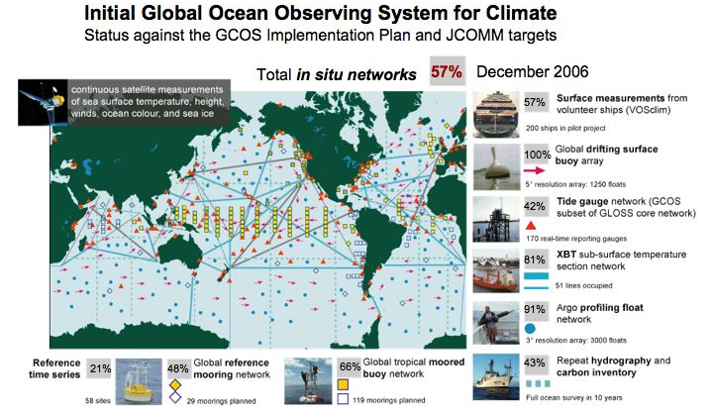

Figure 1: A schematic of the initial composite ocean observing system design, including the current status against the goals of the GCOS Implementation Plan (GCOS-92).

An urgent and fundamental need identified by the GCOS-92 – endorsed by the UNFCCC and the GOESS 10-Year Implementation Plan Reference Document – is the need for achieving global coverage by the in situ networks. The in situ networks include moored and drifting buoys, tide gauge stations, profiling floats, and ship-based systems. Coordination of national contributions to implementation of these networks is the job of the JCOMM, in cooperation with other global programmes. Within the ocean chapter of the GCOS-92, the JCOMM is identified as the implementing agent, or a contributing implementing agent, for 21 of the specific actions. These specific actions for implementation of the in situ elements have been adopted by the JCOMM as an implementation roadmap. The initial work plan described below outlines the ongoing work and the challenges ahead for the JCOMM in building the global ocean component a Global Earth Observation System of Systems.

3.0 Milestones

In order to achieve global coverage as soon as possible, the following schedule has been established. It is an ambitious schedule based on the initial system design and projections of adequate funding. Global coverage cannot be achieved with existing resources. Accomplishment of this plan will require substantial additional investment by the Members/Member States. The milestones will be updated annually to reflect evolution of the design as knowledge and technology advance, and to reflect the realities of funding availability.

 | 2002 | 2003 | 2004 | 2005 | 2006 | 2007 | 2008 | 2009 | 2010
System Percent Complete: | 40 | 45 | 48 | 53 | 57 | 66 | 77 | 88 | 99

The following sections indicate individual network improvements that work toward building the observing system as a whole. The ocean observing system is a composite of complementary networks; most serve multiple purposes. One of the primary goals of the JCOMM is to look for efficiencies to be gained by utilizing common platforms/sites/data infrastructure for several objectives in parallel. Although individual network priorities are described below, they must all go forward together as a system. For example, the global Argo array of profiling floats is a primary tool for documenting ocean heat content; yet deployment of the floats in the far corners of the ocean cannot be achieved without the ships-of-opportunity and dedicated ship elements; and the Argo array cannot do its work without global over-flight by continued precision altimeter space missions; while the measurements taken by all networks will be rendered effective only through the data and assimilation subsystems, and effective product delivery.

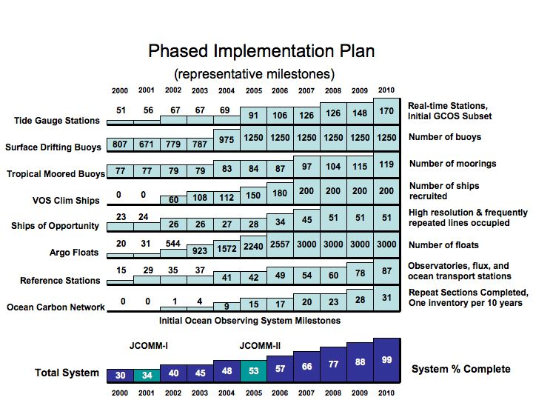

Figure 2: Phased Multi-year Implementation Plan: The history and future plan showing representative milestones for the implementation of the in situ elements of the ocean observing system. The Plan envisions completion of the initial ocean climate observing system by 2010, which will require substantial additional investment by the Members/Member States.

3.1 Tide Gauge Network: Tide gauges are necessary for accurately measuring long-term trends in sea level change and for calibration and validation of the measurements from satellite altimeters, which are assimilated into global climate models for predicting climate variability. Many tide stations need to be upgraded with modern technology. Permanent GPS/DORIS receivers will be installed at a selected subset of stations, leading to a geocentrically located subset expansion from the present 69 GPS/DORIS sites to 170 sites globally. These 170 GCOS Climate Reference Stations will also be upgraded for real-time reporting, not only for climate monitoring, but also to support marine hazard warning (e.g., tsunami warning). Cooperating with the Member(s)/Member State(s) will maintain a global network of 290 tide gauge stations, including the GCOS subset noted above, for measuring tides and storm surges, tsunami warning, validation of satellite retrievals, validation of climate model results, documentation of seasonal to centennial variability in the El Nino Southern Oscillation, Indian Ocean and Asian-Australian monsoons, tropical Atlantic variability, North Atlantic Oscillation, North Pacific variability, high latitude circulation, western boundary currents, and circulation through narrow straits and chokepoints.

International
Goal
 | 2003 | 2004 | 2005 | 2006 | 2007 | 2008 | 2009 | 2010
Operational GLOSS stations | 168 | 185 | 204 | 216 | 231 | 251 | 273 | 290 | 290
GPS/DORIS installation | 37 | 53 | 55 | 69 | 75 | 90 | 130 | 170 | 170
Real-time reporting | 67 | 69 | 79 | 91 | 106 | 126 | 148 | 170 | 170

3.2 Drifting Buoy Array: Sea surface temperature is used to drive all forecast models. Data sparse regions of the global ocean are a major source of uncertainty in the seasonal forecasts and are also a major uncertainty in the detection of long-term trends in global sea surface temperature, which in turn is an indicator of global change. Data gaps must be filled by surface drifting buoys to reduce these sources of error to acceptable limits. The JCOMM will extend the global SST/velocity drifting buoy array to data sparse regions, maintaining 1250 buoys while adding wind, pressure, and salinity measurement capabilities to serve short term forecasting, as well as climate research, seasonal forecasting, and assessment of long term trends. The JCOMM achieved the design target of 1250 buoys in sustained service in 2005. The global drifting buoy array thus became the first component of the GOOS to be completed.

International
Goal
 | 2003 | 2004 | 2005 | 2006 | 2007 | 2008 | 2009 | 2010
Operational buoys | 620 | 870 | 1250 | 1250 | 1250 | 1250 | 1250 | 1250 | 1250
Barometer upgrades | 82 | 184 | 279 | 350 | 450 | 500 | 800 | 1250 | 1250
Wind sensors | 42 | 42 | 50 | 50 | 50 | 60 | 70 | 80
Salinity sensors |  |  | 9 | 150 | 200 | 300 | 300 | 300 | 300

3.3 Tropical Moored Buoy Network: Most of the heat from the sun enters the ocean in the tropical/sub-tropical belt. The advanced understanding of the role of the tropics in forcing mid-latitude weather and climate was learned primarily through the observations of the tropical moored buoy array (TAO/TRITON) in the Pacific. A similar array in the Atlantic basin (PIRATA) now offers the potential of even better understanding, improved forecasts, and improved ability to discern the causes of longer-term changes in the Oceans. In addition to monitoring the air-sea exchange of heat, the moored buoys provide platforms for supporting instrumentation to measure carbon dioxide and rainfall in the tropics. The global tropical moored buoy network will be expanded from 83 to 119 stations and will ultimately span all three oceans - Pacific, Atlantic, and Indian Ocean.

International
Goal
 | 2003 | 2004 | 2005 | 2006 | 2007 | 2008 | 2009 | 2010
Operational buoys | 79 | 83 | 86 | 91 | 97 | 104 | 115 | 119 | 119
Indian Ocean expansion | 2 | 6 | 7 | 10 | 13 | 18 | 29 | 33 | 33
Atlantic Ocean expansion | 0 | 0 | 3 | 6 | 8 | 8 | 8 | 8 | 8
Add salinity sensors | 10 | 10 | 10 | 65 | 80 | 100 | 115 | 119 | 119
Add flux capability | 0 | 0 | 0 | 5 | 7 | 7 | 7 | 7 | 7

3.4 Volunteer Observing Ships and Ships of Opportunity: The global atmospheric and oceanic data from Ships of Opportunity (SOOP) have been the foundation for understanding long-term changes in marine climate and, together with the marine meteorology observations from Volunteer Observing Ships (VOS), are essential input to climate and weather forecast models. Improved instrument accuracy, automated reporting, and improved information about how the observations were taken (the VOSClim Project) will greatly enhance the quality of these data, reducing both systematic and random errors. The JCOMM will improve meteorological measurement capabilities on the global volunteer fleet for improved marine weather and climate forecasting in general, and will concentrate on a specific subset of high accuracy SOOP lines to be frequently repeated and sampled at high resolution for systematic upper-ocean and atmospheric measurement. This climate-specific subset will build from 34 lines presently occupied to a designed global network of 51 lines and will provide measurements of the upper ocean thermal structure, sea surface temperature and chemistry, and surface meteorology of high accuracy. Additionally, the volunteer fleet is the primary vehicle for deployment of the drifting arrays.

International
Goal
 | 2003 | 2004 | 2005 | 2006 | 2007 | 2008 | 2009 | 2010
VOS reporting regularly | 900 | 900 | 900 | 950 | 1000 | 1500 | 2000 | 3000
High resolution XBT lines | 16 | 17 | 17 | 23 | 25 | 26 | 26 | 26 | 26
Frequently repeated lines | 11 | 11 | 11 | 11 | 20 | 25 | 25 | 25 | 25
Salinity systems | 2 | 2 | 7 | 12 | 15 | 20 | 26 | 26
Auto-met systems | 0 | 0 | 40 | 100 | 200 | 250 | 300 | 500
VOSClim ships | 108 | 112 | 150 | 180 | 200 | 200 | 200 | 200 | 200

3.5 Argo array of profiling floats: The heat content of the upper 2000 meters of the world’s oceans, and the transfer of that heat to and from the atmosphere, are variables central to the climate system. The Argo array of profiling floats is designed to provide essential broad-scale, basin-wide monitoring of the upper ocean heat content. Three thousand floats will be deployed worldwide by 2007. Glider technology will replace standard drifting Argo floats in the boundary currents and targeted deep circulation regions.

International
Goal
 | 2003 | 2004 | 2005 | 2006 | 2007 | 2008 | 2009 | 2010
Argo floats in operation | 923 | 1500 | 2240 | 2557 | 3000 | 3000 | 3000 | 3000 | 3000
Gliders | 3 | 3 | 3 | 3 | 10 | 40 | 80 | 100

3.6 Ocean Reference Stations:

3.6.1 Subtask 1: The JCOMM, together with international OceanSITES, will implement a global network of ocean reference station moorings, expanding from the present six pilot stations to a permanent network of 29 (including 7 within the tropical moored buoy network). The OceanSITES will provide the major piece of the infrastructure needed for this network, establishing high-capability moored buoys in remote ocean locations. The JCOMM will maintain long-term weather and climate instrumentation aboard the OceanSITES platforms.

3.6.2 Subtask 2: Monitoring the transport within the ocean is a central element of documenting the overturning circulation of fresh water and heat and carbon uptake and release; heat and carbon generally are released to the atmosphere in regions of the ocean far distant from where they enter. Long-term monitoring of key choke points, such as the Indonesian through-flow, and of boundary currents along the continents, such as the Gulf Stream, must be established to measure the primary routes of ocean heat, carbon, and fresh water transport.

3.6.3 Subtask 3: Monitoring thermohaline circulation is a central element of documenting the ocean’s overturning circulation and a critical need for helping scientists understand the role of the ocean in abrupt climate change. It is essential that the ocean observing system maintain watch at a few control points at critical locations. Key monitoring sites have been identified by the OceanSITES Team of scientists for deployment of long-term subsurface moored arrays and repeated temperature, salinity, and chemical tracer surveys from research vessels.

International
Goal
 |  | 2003 | 2004 | 2005 | 2006 | 2007 | 2008 | 2009 |  | 2010
Flux moorings |  | 2 | 2 | 6 | 7 | 9 | 15 | 22 |  | 29 | 29
Time series stations |  | 26 | 26 | 28 | 30 | 35 | 45 | 50 |  | 58 | 58
Transport sections |  | 9 | 9 | 9 | 9 | 10 | 12 | 14 |  | 15 | 15

3.7 Coastal Moorings: Improved off shore measurements from moored buoys are critical to coastal forecasting, as well as to linking the deep ocean to regional impacts of climate variability. The boundary currents along continental coastlines are major movers of the ocean’s heat and fresh water (e.g., the Gulf Stream). Furthermore, the coastal regions are critical to the study of the role of the ocean in the intensification of storms, which are key to the global atmospheric transport of heat, momentum and water, and are a significant impact of climate on society. Coastal arrays are maintained by many nations making this a “global” network of “coastal” stations. A climate subset of this network will be improved by augmenting and upgrading the instrument suite to provide measurements of the upper ocean as well as the sea surface and surface meteorology. Of these moorings, many will serve as platforms-of-opportunity for the addition of carbon sampling instrumentation and other biochemical measurements.

International
Goal
 | 2003 | 2004 | 2005 | 2006 | 2007 | 2008 | 2009 | 2010
Upgrade w/climate sensors | 0 | 0 | 0 | 20 | 40 | 60 | 80 | 105

3.8 Ocean Carbon: Understanding the global carbon cycle and the accurate measurement of the regional sources and sinks of carbon are of critical importance to international policy decision making, as well as to forecasting long term trends in climate. Projections of long-term global climate change are closely linked to assumptions about feedback effects between the atmosphere, the land, and the ocean. To understand how carbon is cycled through the global climate system, ocean measurements are critical. The JCOMM will coordinate with the IOCCP and OceanSITES for addition of autonomous carbon dioxide sampling to the moored arrays and the VOS fleet to analyze the seasonal variability in carbon exchange between the ocean and atmosphere, and in cooperation will help implement a program of systematic global ocean surveys that will provide a complete carbon inventory once every ten years.

International
Goal
 | 2003 | 2004 | 2005 | 2006 | 2007 | 2008 | 2009 |  | 2010
Inventory lines per decade | 4 | 9 | 15 | 17 | 20 | 23 | 28 |  | 31 | 37
Time series moorings | 2 | 4 | 8 | 10 | 15 | 22 | 32 |  | 45
Flux on ships of opportunity | 4 | 12 | 28 | 29 | 29 | 33 | 33 |  | 33

3.9 Arctic and Antarctic Observing Systems: Given the sensitivity of the Arctic and Antarctic environment to climate variability and change, it is in these regions that early indications of the future progression of climate change are likely to be first detected. A program of observations of this area is being developed for the International Polar Year (IPY) through dedicated and shared ship-based cruises and oceanographic moorings, supplemented by acquisition and analysis of historical data sets. The long-term goal is to detect climate-driven physical and ecological change, especially due to changes in sea ice extent and duration, and in ocean density and circulation that together may lead to changes in ocean heat transport, productivity, and food web structure. Ice-tethered buoys and bottom-mounted moorings are deployed to monitor the drift of sea ice and to determine its thickness. The long-term goal is to provide an accurate record of changes in sea ice thickness that, together with satellite observations of sea ice extent, can provide an estimate of changes in sea ice volume.

International
Goal
 | 2003 | 2004 | 2005 | 2006 | 2007 | 2008 | 2009 |  | 2010
Ice buoys and Ice Stations | 24 | 24 | 24 | 24 | 34 | 40 | 45 |  | 54
Subsurface moorings | 4 | 4 | 4 | 4 | 8 | 12 | 14 |  | 16
Ship transects maintained | 1 | 1 | 1 | 1 | 2 | 6 | 7 |  | 10

3.10 Dedicated Ships: Ship support within the international research fleets for deployment of the moored and drifting arrays, and for deep ocean surveys is an essential component of the global ocean observing system. The deep ocean cannot be reached by SOOP and Argo, yet quantification of the carbon and heat content of the entire ocean column is needed to solve the climate equations. In addition to providing the survey and deployment platforms for the autonomous arrays, the research fleet will maintain sensor suites on a small core of vessels in coordination with the VOSClim project as the highest quality calibration points for validation of the other system measurements.

International
Goal
Operating days at sea | 2003 | 2004 | 2005 | 2006 | 2007 | 2008 | 2009 |  | 2010
Tropical Moored Buoys | 414 | 414 | 428 | 463 | 477 | 484 | 498 |  | 498
Carbon survey | 148 | 148 | 148 | 220 | 228 | 228 | 228 |  | 228
Reference Stations | 94 | 94 | 94 | 120 | 204 | 240 | 360 |  | 480
Deployment of drifting arrays | 0 | 60 | 60 | 60 | 80 | 80 | 120 |  | 120
Thermohaline circulation | 340 | 340 | 340 | 340 | 340 | 340 | 340 |  | 340

3.11 Satellites: The initial ocean observing system for climate depends on space based global measurements of: 1.) sea surface temperature, 2.) sea surface height, 3.) surface vector winds, 4.) ocean colour, and 5.) sea ice. These satellite contributions are detailed in other international plans, but continued close coordination with the in situ systems is essential for comprehensive ocean observation.

3.11.1 Sea surface temperature: Satellite measurements provide high-resolution sea surface temperature data. Both infrared and microwave satellite data are important. Microwave sea surface temperature data have a significant coverage advantage over infrared sea surface temperature data, because microwave data can be retrieved in cloud-covered regions while infrared cannot. However, microwave sea surface temperatures are at a much lower spatial resolution than infrared. In addition microwave sea surface temperatures cannot be obtained within roughly 50 km of land. A combination of both infrared and microwave data are needed because they have different coverage and error properties. Drifting buoy and other in situ data are critically important in providing calibration and validation in satellite data, as well as providing bias correction of these data. Satellite biases can occur from orbit changes, satellite instrument changes and changes in physical assumptions on the physics of the atmosphere (e.g., through the addition of volcanic aerosols). Thus, drifting buoy and other in situ data are needed to correct for any of these changes.

3.11.2 Sea surface height: The value of spaced-based altimeter measurements of sea surface height has now been clearly demonstrated by the TOPEX/Poseidon and Jason missions. Changes in sea level during major El Nino events can now be discerned at high-resolution and provide realistic model initializations for seasonal climate forecasting. The same data, when calibrated with island tide gauge observations, are also able to monitor the rate of global sea level change with an accuracy of 1 mm per year. The planned NPOESS altimeter will be adequate for shorter-term forecasting, but the NPOESS altimeter will not fly in the same orbit as the TOPEX/Poseidon and Jason; and for monitoring long-term sea level change, continuation of precision altimeter missions in the TOPEX/Poseidon/Jason orbit is necessary. Jason follow-on altimeter missions (Ocean Surface Topography Mission, OSTM) are necessary to continue the long-term sea level record.

3.11.3 Surface vector winds, ocean colour, and sea ice: The best methods of sustaining satellite measurement of surface vector winds, ocean colour, and sea ice are still research and development questions. During the next five years, the satellite agencies will weigh the alternatives and determine the long-term strategy for maintenance of these elements.
Appendix B

Status of in situ ocean observing networks

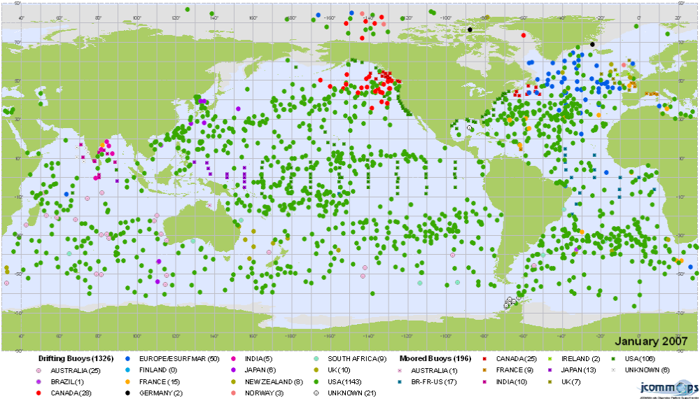

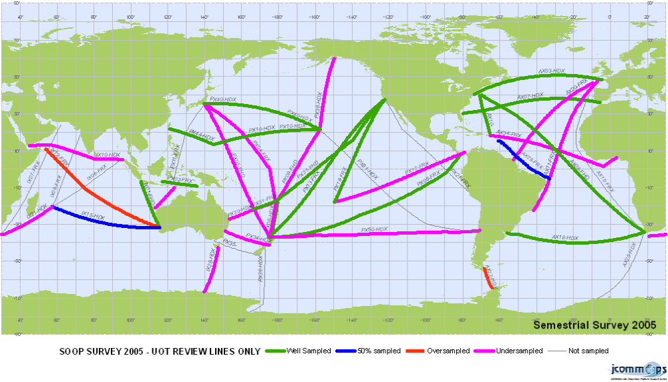

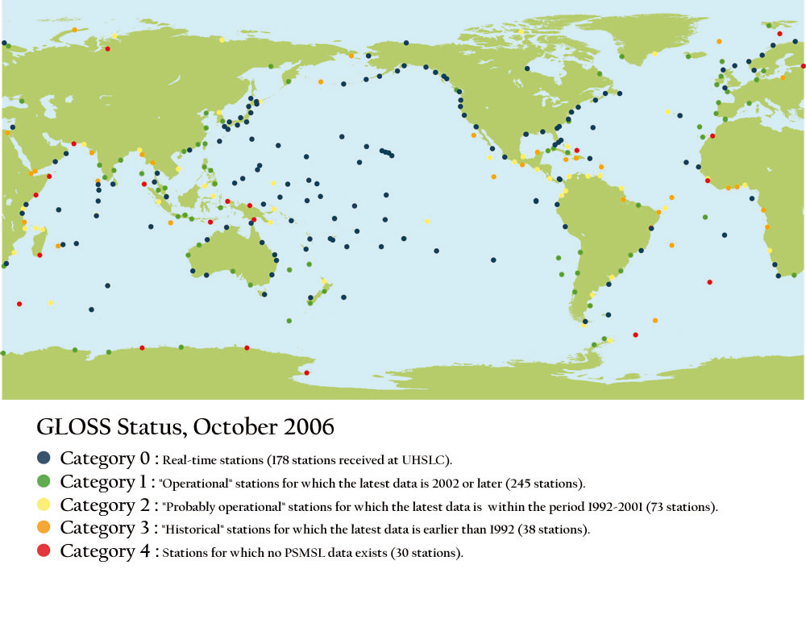

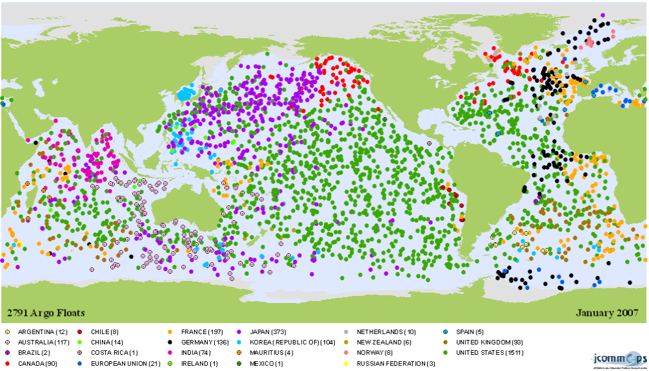

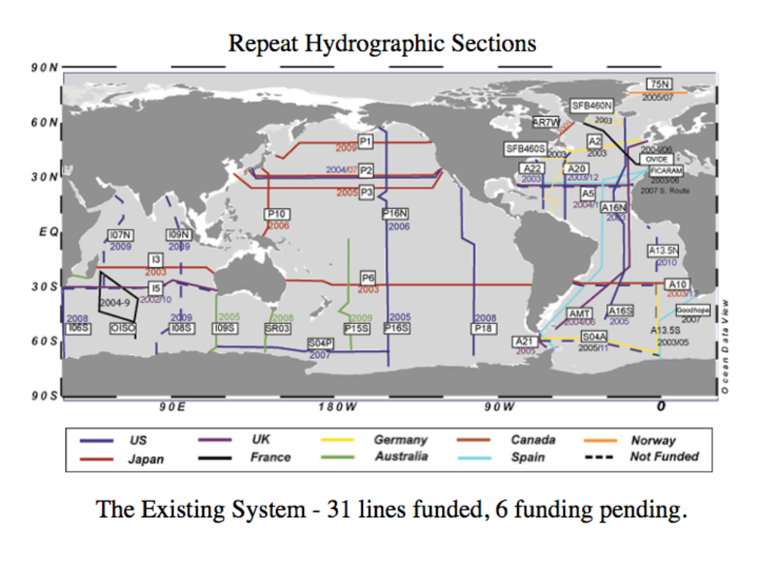

OceanSITES

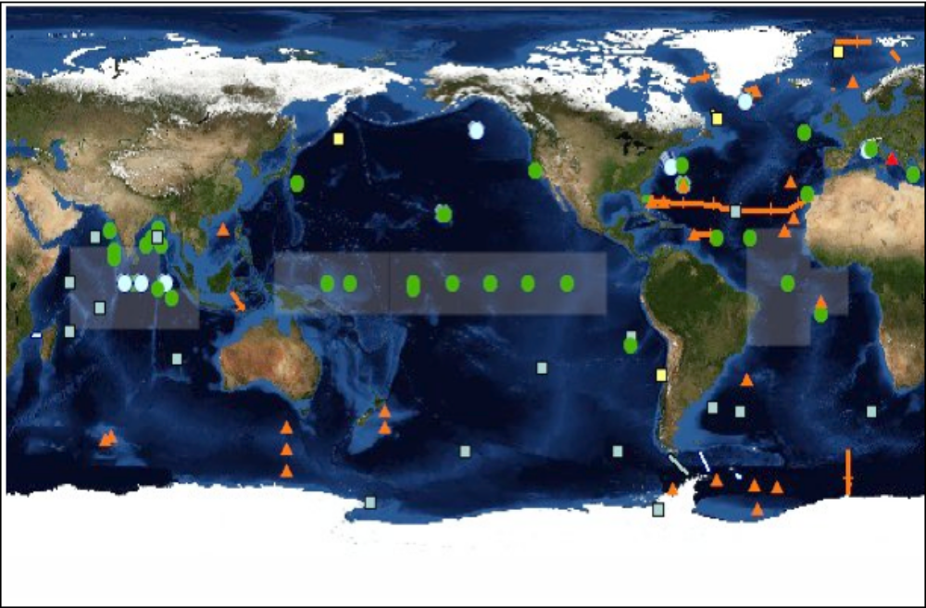

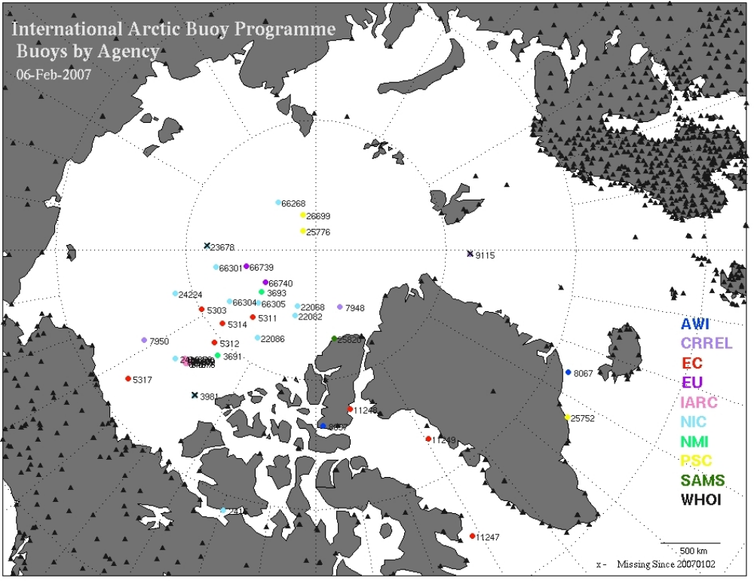
Appendix C

Quarterly performance reports for sea surface temperature, sea surface salinity, temperature profiles, salinity profiles, and near-surface currents

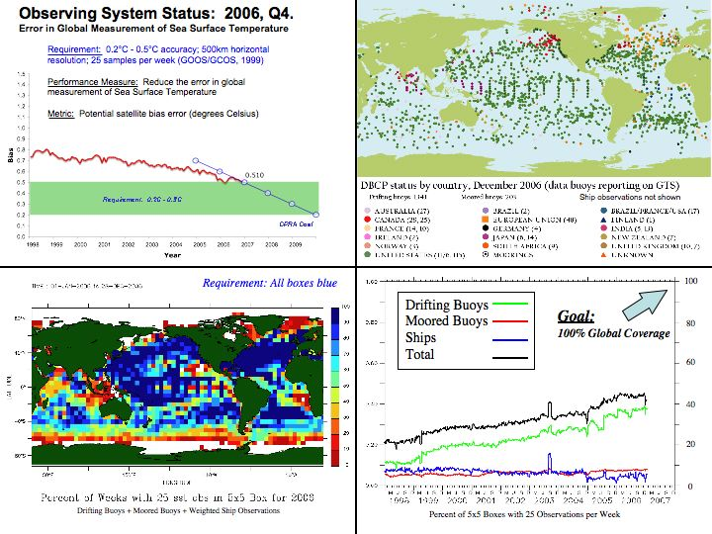

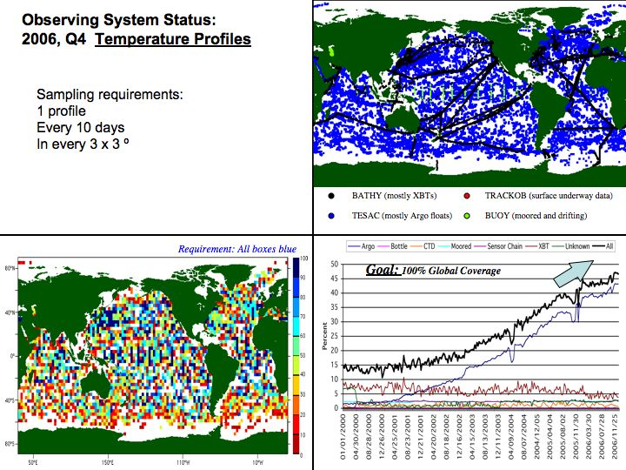

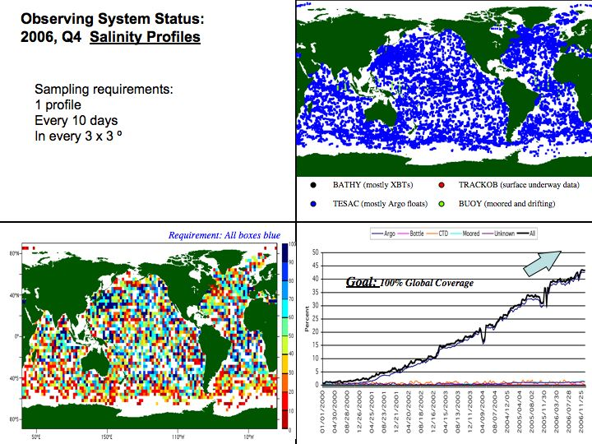

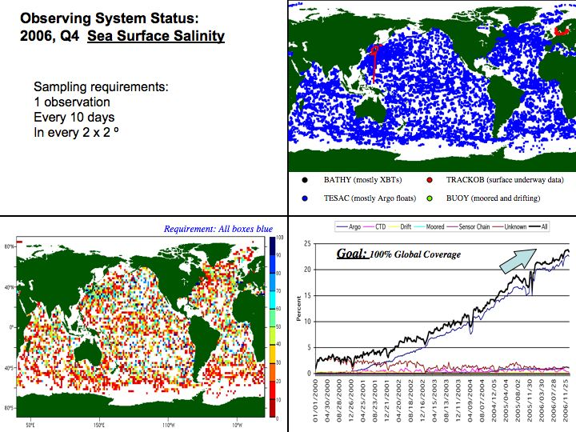

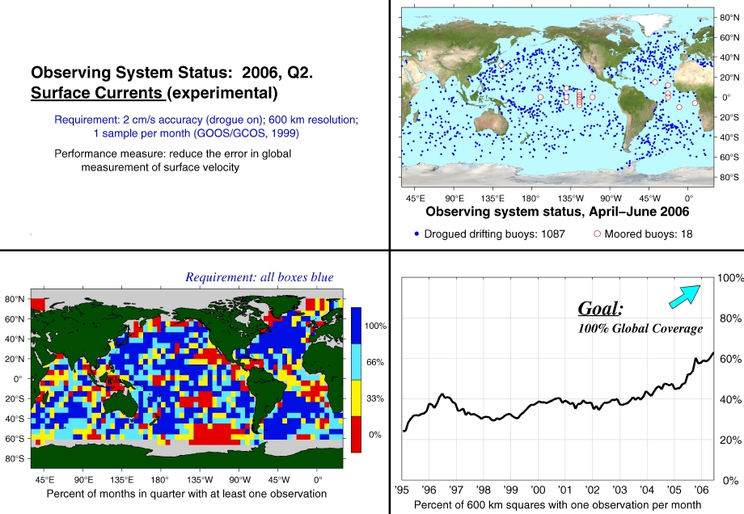
Appendix D

RECOMMENDATION 3 (JCOMM-II)
CONSUMABLES FOR SHIP-BASED OBSERVATIONS

THE JOINT WMO/IOC TECHNICAL COMMISSION FOR OCEANOGRAPHY AND MARINE METEOROLOGY,

Noting:
(1) Recommendation 2 (JCOMM-I) - Resources for Ship-Based Observations,

- Final report of the third session of the Ship Observations Team, JCOMM Meeting Report No. 35,
- The report of the Observations Programme Area Coordinator to JCOMM-II,

Recognizing:
- That many components of the operational, in situ ocean observing system coordinated by JCOMM are currently well short of requirements, including in particular the XBT network coordinated by the Ship Observations Team,
- That currently only a small number of Members/Member States contribute to the maintenance of the observing system,
- That the cost of the purchase and supply of consumables (such as XBTs) represents a major obstacle to the enhanced involvement of maritime countries in the system;

Considering:
- That the implementation of the observing system could be enhanced through the establishment of a simple mechanism to encourage more countries to contribute to the system and complete the global XBT and other networks,
- That considerable cost savings could be achieved through the bulk purchase and supply of consumables for ship-based observations, including in particular XBTs,
- That the provision of consumables from a common pool would greatly assist maritime countries wishing to contribute to the implementation and maintenance of the observing system, in support of national, regional and global interests and programmes;

Recommends:
- That a scheme for the bulk purchase and supply of consumables for ship-based observations be developed, and a special trust fund be established for that purpose;
- That Members/Member States which are in a position to do so, contribute to this trust fund, in support of the full implementation and maintenance of the ocean observing system coordinated by JCOMM, and the enhanced involvement of maritime countries in this work;
- That at the same time, Members/Member States continue to procure and supply consumables for ship-based observations through their existing national procedures;

Requests:
- The Observations Programme Area Coordinator, in consultation with the chairman of the Ship Observations Team, the co-presidents of JCOMM, the JCOMM Secretariat and relevant Members/Member States, develop a plan for the bulk purchase and supply of consumables for ship-based observations, for consideration and approval by the Management Committee;
- The Secretary-General of WMO and the Executive Secretary IOC to support the implementation of this plan through the establishment of a special trust fund for this purpose.

Appendix E

WMO Resolution 7 (EC-LVIII)

RESOLUTION

Res. 7 (EC-LVIII) – SHIP OWNERS AND MASTERS’ CONCERNS WITH REGARD TO VOS DATA EXCHANGE

THE EXECUTIVE COUNCIL,

Recalling the request made by EC-LVII for the JCOMM Ship Observations Team (SOT) to assess the risks associated with allowing Voluntary Observing Ships (VOS) call signs and position data being made freely available on external Websites not maintained by the National Meteorological or Hydrometeorological Services (NMHSs), and to provide options to address the problem, as appropriate,

Noting the proposals prepared by PMO-III and endorsed and submitted to the Executive Council by the JCOMM Co-presidents,

Acknowledging;

(a) The seriousness of the problem which, if not adequately addressed, could ultimately lead to the disappearance of the majority of VOS reports available on the GTS,

(b) The concerns on the issue expressed by ship owners and masters,

Recommends:

(a) Members which, in consultation with ship owners, wish to protect the identity of VOS may implement ship call sign masking, for a trial period of one year, a process which would facilitate open distribution of masked data on the GTS;

(b) All Members implementing such a process to provide for the secure exchange of ship call signs and reports affected by the masking process, so as to assist in resolving real time monitoring and climate analysis problems;

Requests the Secretary-General, as a high priority issue, to establish a high level dialogue, involving affected Members, the International Maritime Organization, the International Chamber of Shipping, shipping companies, and relevant organizations and technical commissions (e.g. Joint WMO/IOC Technical Commission for Oceanography and Marine Meteorology, Commission for Basic Systems), in order to determine if there is a link between VOS data availability on external Web sites and piracy and other ship security issues; to review the implementation and impact of masking; and to propose a general and universally acceptable solution to the issue that would address ship owners and masters’ concerns as well as the data monitoring and quality information feedback requirements, for consideration by the fifty-ninth session of the Executive Council in 2007.

