REVISED OPERATIONAL SOOP NETWORK

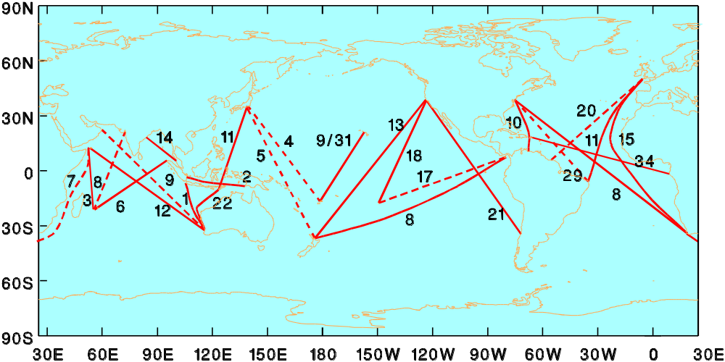

Figure 1: Recommended frequently repeated XBT network.

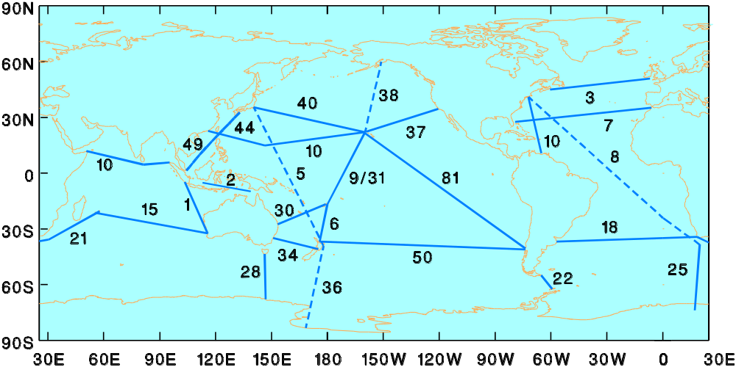
Figure 2: Recommended high-density XBT network.

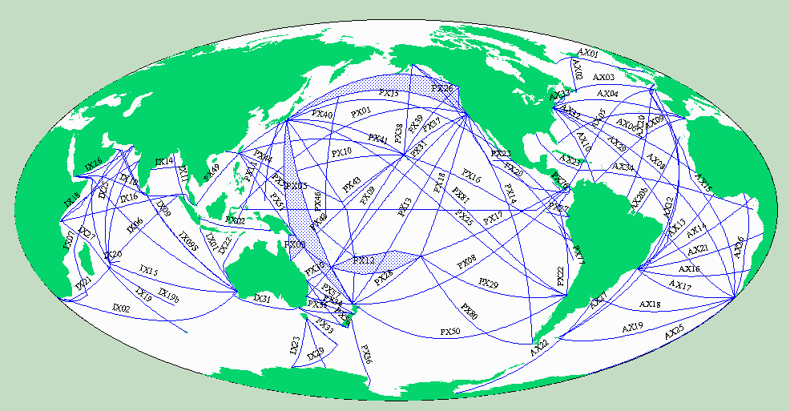Figure 3: XBT line numbering scheme.

